LEGAL NOTICE

CITY OF TUPELO

Sealed bids will be received in the Purchasing Office, 1st Floor of City Hall, PO Box 1485, Tupelo, MS 38802-1485; 71 East Troy, Tupelo, MS 38804 until 10:00 a.m. Thursday, October 13, 2022, for the sale of the following:

Bid No. 2022-036WL

1995 Ditch Witch JT820 Boring Machine w/Trailer, S/N 2M1810

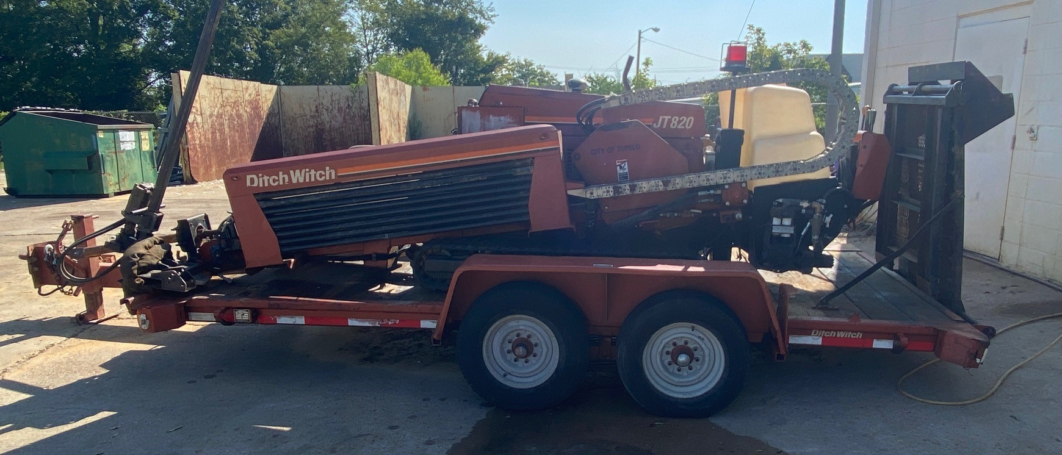

Electronic bids may also be submitted at www.tupelomsbids.com.

If you have any questions regarding this equipment or would like to set up an appointment to view this equipment, you may contact Tommy Monts with Tupelo Water and Light at 662-841-6463 or via email at tommy.monts@tupeloms.gov.

CITY OF TUPELO
PURCHASING
JENNIFER SHEMPERT
662-841-6456
Jennifer.Shempert@tupeloms.gov

Please run the legal ad stated above on September 23, 2022, and again on September 30, 2022.

