Notice of Intent to Certify Sole Source

To: Interested Parties

From: William P. Stitt
Chief Supply Chain

Date: November 20, 2017

Re: Sole Source Certification Number SS5135 for BioRad PCR Reader, accessories and commodities

Contact Email Address: solesource@umc.edu

Sole Source Certification Award Details

Regarding UMMC Sole Source Certification Number SS5135 for BioRad PCR Reader accessories and commodities, please be advised that UMMC intends to award the purchase of the PCR Reader, accessories and commodities to BioRad as the sole source provider of the for BioRad PCR Reader, accessories and commodities.

UMMC issues this notice in accordance with Mississippi state law, policy, and procedures for sole source procurements.

Sole Source Criteria

- Where the compatibility of equipment, accessories, or replacement parts is the paramount consideration (and manufacturer is the sole supplier).
- Where a sole supplier’s item is needed for trial use or testing.
- Where a sole supplier’s item is to be required when no other item will service the needs of UMMC.

Schedule

Task | Date
First Advertisement Date | November 20, 2017
Second Advertisement Date | November 27, 2017
Response Deadline from Objectors | December 6, 2017, at 3:00 p.m. Central Time
Notice of Award/No Award Posted | Not before January 3, 2017

Project Details

- Describe the commodity that the agency is seeking to procure:
The University of Mississippi Medical Center (UMMC) seeks to purchase a BioRad PCR reader, accessories and commodities.
The BioRad PCR reader, accessories and commodities are needed for its capability to quantitatively detect gene expression by measuring the copy number of MRNA for specific genes.

- Explain why the commodity is the only one (1) that can meet the needs of the agency:
The BioRad PCR reader is the first of its kind for measuring gene expression. It will be used by multiple principle investigators at the University who expect to produce up to 150 samples per day. This specific model is the only one available for high throughput gene expression. The BioRad PCR reader output is not restricted by the number of samples it can accept per day.

- Explain why the source is the only person or entity that can provide the required commodity:
Bio-Rad manufactures the BioRad PCR reader and the proprietary components and disposables for proper use of the system. BioRad is the sole manufacturer and supplier of the ChemidocMP Imaging system. They are not available to the University from any other distributor. See supporting letter from BioRad, Attachment A.

- Explain why the amount to be expended for the commodity is reasonable:
The estimated amount to be expended is for the purchase of the BioRad PCR reader, accessories and commodities is $200,000. This amount is within the expected price range for these products.

- Describe the efforts that the agency went through to obtain the best possible price for the commodity:
Through market intelligence, UMMC was able to negotiate best pricing for these products. All applicable discounts were explored and applied.

Submission Instructions and Format of Response from Objecting Parties

Interested parties who have reason to believe that the Bio-Rad PCR reader, accessories and commodities, (hereafter, “Products”) should not be certified as a sole source should provide information in the Vendor Form for the State to use in determining whether or not to proceed with awarding the sole source to BioRad. The Vendor Form may be found at http://www.dfa.state.ms.us/Purchasing/documents/ObjectiontoSoleSourceDetermination.pdf.

Objections must include the certification in Attachment B.

Comments will be accepted at any time prior to Wednesday, December 6, 2017, at 3:00 p.m. (Central Time) to solesource@umc.edu. Responses may be delivered via email to solesource@umc.edu. UMMC WILL NOT BE RESPONSIBLE FOR DELAYS IN THE DELIVERY OF RESPONSES. It is solely the responsibility of the Interested Parties that responses reach UMMC on time. Responses received after the deadline and responses that lack all required information will be rejected. UMMC reserves the right to inspect Interested Party’s commodity for comparison purposes.

If you have any questions concerning the information above or if we can be of further assistance, please contact solesource@umc.edu.

Attachment A: Vendor Correspondence
Attachment B: Objection Certification

Attachment A

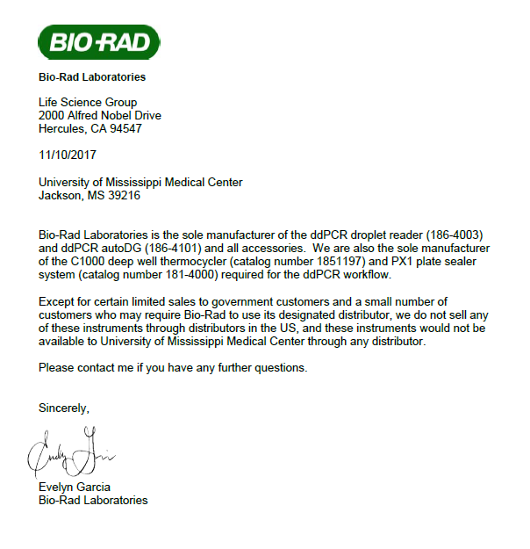

Attachment B

SUBMITTED IN RESPONSE TO
Sole Source Certification No. SS5124
Accepted until December 6, 2017, at 3:00 p.m.

I certify that the information contained in this objection is true and accurate to the best of my knowledge. I understand that UMMC will investigate all statements made in this objection and that any false or misleading information provided may result in adverse action.

__________________________________
Objector Name
Objector’s title

__________________________________
Date

