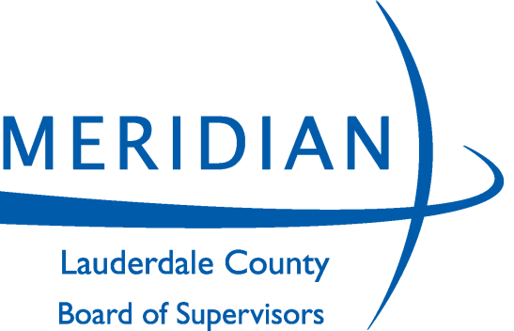
BOARD OF SUPERVISORS

JONATHAN WELLS, DISTRICT 1
WAYMAN NEWELL, DISTRICT 2
JOSH TODD, DISTRICT 3
JOE NORWOOD, DISTRICT 4
KYLE RUTLEDGE, DISTRICT 5

CAROLYN MOONEY
Chancery Clerk

CHRIS LAFFERTY
County Administrator

LEE THAGGARD
Board Attorney

410 Constitution Avenue, 11th Floor Meridian, MS 39301
Telephone: (601) 482-9746 Fax: (601) 482-9744
www.lauderdalecounty.org

ADVERTISEMENT FOR BIDS
The Lauderdale County Board of Supervisors will receive competitive sealed bids to be filed with the Purchasing Agent, 11th Floor Courthouse Annex, 410 Constitution Avenue, Meridian, MS, until 9:00 A.M. on Friday, April 9, 2021 for the period of May 1, 2021 through April 30, 2022 for the following contracts:

BID NO: 3890 – CORRUGATED METAL PIPE
3891 – CONCRETE PIPE
3892 – HDPE CORRUGATED PLASTIC PIPES
3893 -- GRAVEL, STONE, CONCRETE, ETC.
3894 – ASPHALT
3895 – SCRUB SEAL / MICRO SURFACING
ALL BIDS MUST BE ON LAUDERDALE COUNTY BID FORMS AND SUBMITTED IN DUPLICATE.

Detailed specifications and bid forms/documents can either be downloaded from Lauderdale County Board of Supervisors website at, www.lauderdalecounty.org/ or Central Bidding at www.centralbidding.com. To be a valid delivery, sealed bids must be delivered electronic by Central Bidding or in accordance with the specifications and procedures available with Central Bidding, by mail via USPS, by courier service i.e., FedEx or by hand to the Lauderdale County Board of Supervisors, Purchasing Agent, 11th Floor Courthouse Annex, 410 Constitution Avenue, Meridian, MS., during the hours of 8:00 a.m. to 5:00 p.m., Monday through Friday up until 9:00 A.M. on April 9th. Bid packets not properly completed will be rejected for failure to comply. For any questions relating to the electronic bidding process, please call Central Bidding at 225-810-4814.
ENVELOPES MUST BE LABELED CORRECTLY.
The Lauderdale County Board of Supervisors reserves the right to accept or reject any and/or all bids and waive informalities.
Lauderdale County Board of Supervisors,
By: Kyle Rutledge
MERIDIAN STAR:
PLEASE PUBLISH THE ABOVE LEGAL
ADVERTISEMENT ON March 16, 2021, March 20, 2021 & March 23, 2021 AND FURNISH US PROOF OF PUBLICATION….

