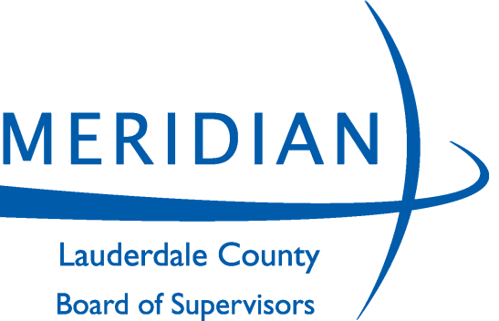
BOARD OF SUPERVISORS

JONATHAN WELLS, DISTRICT 1
WAYMAN NEWELL, DISTRICT 2
JOSH TODD, DISTRICT 3
JOE NORWOOD, DISTRICT 4
KYLE RUTLEDGE, DISTRICT 5

CAROLYN MOONEY
Chancery Clerk

CHRIS LAFFERTY
County Administrator

LEE THAGGARD
Board Attorney

410 Constitution Avenue, 11th Floor Meridian, MS 39301
Telephone: (601) 482-9746 Fax: (601) 482-9744
www.lauderdalecounty.org

ADVERTISEMENT FOR PROPOSAL

The Lauderdale County Board of Supervisors is soliciting proposals to be filed with the Purchasing Agent, 410 Constitution Avenue, 11th Floor Courthouse Annex, Meridian, MS, until 9:00 A.M. on Monday, September 13, 2021, for the following:

RFP NO: 003-2021 - INMATE HEALTH SERVICES

ALL PROPOSALS MUST BE SUBMITTED IN DUPLICATE
Detailed specifications and bid forms/documents can either be downloaded from Lauderdale County Board of Supervisors website at, www.lauderdalecounty.org by clicking on the BIDS link or Central Bidding at www.centralbidding.com. To be a valid delivery, sealed bids must be delivered electronically by Central Bidding or in accordance with the specifications and procedures available with Central Bidding, by mail via USPS, by courier service i.e., FedEx or by hand to the Lauderdale County Board of Supervisors, Purchasing Agent, 11th Floor Courthouse Annex, 410 Constitution Avenue, Meridian, MS., during the hours of 8:00 a.m. to 5:00 p.m., Monday through Friday up until 9:00 A.M. on Monday, September 13, 2021. Bid packets not properly completed will be rejected for failure to comply. For any questions relating to the electronic bidding process, please call Central Bidding at 225-810-4814.

The purchasing department will not accept facsimile (fax) or email transmissions of bids.
The purchasing department is not responsible for late bids/proposals due to a delay in the delivery of mail.

The Lauderdale County Board of Supervisors reserves the right to accept or reject any and/or all bids and waive informalities.
Lauderdale County Board of Supervisors,
By: Kyle Rutledge
MERIDIAN STAR:
PLEASE PUBLISH THE ABOVE LEGAL
ADVERTISEMENT ON August 17, August 21 & August 24, 2021, AND FURNISH US PROOF OF PUBLICATION….

