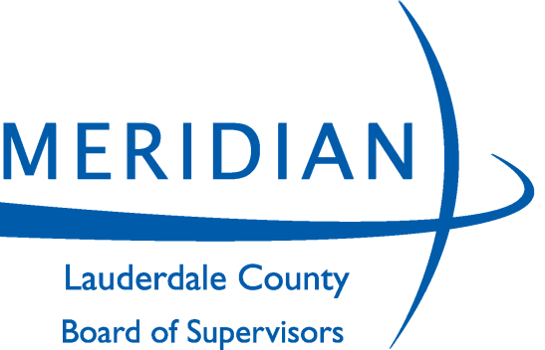
BOARD OF SUPERVISORS

JONATHAN WELLS, DISTRICT 1
WAYMAN NEWELL, DISTRICT 2
JOSH TODD, DISTRICT 3
JOE NORWOOD, DISTRICT 4
KYLE RUTLEDGE, DISTRICT 5

CAROLYN MOONEY
Chancery Clerk

CHRIS LAFFERTY
County Administrator

LEE THAGGARD
Board Attorney

410 Constitution Avenue, 11th Floor Meridian, MS 39301
Telephone: (601) 482-9746 Fax: (601) 482-9744
www.lauderdalecounty.org

ADVERTISEMENT FOR BIDS

The Lauderdale County Board of Supervisors Road & Bridge will receive competitive sealed bids to be filed with the Purchasing Agent, 410 Constitution Avenue, 11th Floor Courthouse Annex, Meridian, MS, until 9:00 A.M. on Friday, October 22, 2021, for the following:

BID NO: 3901 – ROAD STRIPING: FIVE (5) SPECIFIED ROADS

ALL BIDS MUST BE ON LAUDERDALE COUNTY BID FORMS AND SUBMITTED IN DUPLICATE
Detailed specifications and bid forms/documents can either be downloaded from Lauderdale County Board of Supervisors website at, www.lauderdalecounty.org or Central Bidding at www.centralbidding.com. To be a valid delivery, sealed bids must be delivered electronic by Central Bidding or in accordance with the specifications and procedures available with Central Bidding, by mail via USPS, by courier service i.e., FedEx or by hand to the Lauderdale County Board of Supervisors, Purchasing Agent, 11th Floor Courthouse Annex, 410 Constitution Avenue, Meridian, MS., during the hours of 8:00 a.m. to 5:00 p.m., Monday through Friday up until 9:00 A.M. on Friday, October 22, 2021. Bid packets not properly completed will be rejected for failure to comply. For any questions relating to the electronic bidding process, please call Central Bidding at 225-810-4814. Bids cannot be faxed or emailed and will be rejected if submitted as such. Envelopes must be labeled correctly.

BID OPENING WILL BE AT 10:00 A.M. ON FRIDAY, OCTOBER 22, 2021
The Lauderdale County Board of Supervisors reserves the right to accept or reject any and/or all bids and waive informalities.
Lauderdale County Board of Supervisors,
By: Kyle Rutledge
MERIDIAN STAR:
PLEASE PUBLISH THE ABOVE LEGAL
ADVERTISEMENT ON September 28, 2021, October 02 & October 05, 2021 AND FURNISH US PROOF OF PUBLICATION….

