ADVERTISEMENT FOR BID
Sealed bids will be received by the Board of Trustees of the Natchez-Adams School District, until 10:30 A.M. on Thursday, August 8, 2019 at the office of the Superintendent of Schools, 10 Homochitto Street, Natchez, MS 39120, for the purchase of:
Graduation Cap & Gown
Details and information may be secured by contacting Delanea' S. Young, at 601-445-2809.
The Board of Trustees reserves the right to reject any and all bids and to waive any informalities.
All bids are to be sealed, plainly addressed to the Board of Trustees and marked "GRADUATION CAP & GOWN" to be opened Thursday, August 8, 2019 at 10:30 A.M.
Board of Trustees
Natchez-Adams School District
By:
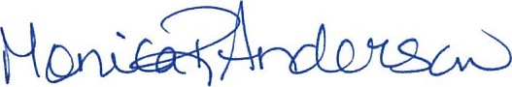
Monica R. Anderson
Business Manager
Publication Dates: Thursday, July 18, 2019
Thursday, July 25, 2019
The Natchez Democrat

