NOTICE TO BIDDERS
SEALED PROPOSALS
The Board of Mayor and Aldermen of the City of Vicksburg, Mississippi, will receive sealed proposals for the Iowa Avenue Headwall Replacement until 9 o'clock a.m. local time on Tuesday, June 5, 2023, at the office of the City Clerk, City Hall, 1401 Walnut Street, Post Office Drawer 150, Vicksburg, Mississippi 39180. All proposals will be publicly opened and read aloud by the Board of Mayor and Aldermen of Aldermen of the City of Vicksburg, Mississippi in Board meeting at 10 o'clock a.m. on Tuesday, June 5, 2023.
Bidders are cautioned that the City Clerk does not receive the Daily U.S. Mail on or before 9:00 a.m. Bids will be time-stamped upon receipt according to City Clerk's time clock.
The work in this project consists generally of earthwork, removal of existing concrete headwall, wingwalls and apron, removal of corrugated metal pipe, new corrugated metal pipe, new concrete headwall, wingwalls and apron, and site grading.
All documents required for bidding purposes, including plans and specifications, may be obtained from TRC Engineers Inc., 4545 Sherwood Common Blvd., Bldg. 3, Suite A, Baton Rouge, LA 70816, 225.372.1172.
Electronic bids can be submitted at www.centralbidding.com. Official bid documents can be downloaded from Central Bidding. Electronic bids are due at the same time and date as sealed bids. For any questions relating to the electronic bidding process, please call 225-810-4814.
A copy of the plans and specifications may be examined at: the Office of the Engineer, 4545 Sherwood Common Blvd. Bldg. 3, Suite A, Baton Rouge LA 70816; City Hall, Vicksburg, Mississippi; Associated General Contractors Plan Room in Jackson, Mississippi; Associated Builders and Contractors Plan Room in Jackson, Mississippi.
Each bid shall be accompanied by a Certified Check on a solvent bank or a Bidder's Bond issued by a Surety Company licensed to operate in the State of Mississippi, in the amount of five percent (5%) of the total bid price, as a guarantee that if the bid is accepted, the Bidder will enter into a contract and execute the Performance and Payment Bonds in the form and within the time specified.
The successful Bidder will be required to execute a Performance Bond and a Payment Bond, each in the amount of 100 percent of the Contract, issued by a Surety Company licensed to operate in the State of Mississippi.
Each Bidder shall have a Certificate of Responsibility to bid on contracts for public projects in which the bid price exceeds $50,000.00 and for private projects in which the bid price exceeds $100,000.00 as required by the laws of the State of Mississippi. Each Bidder shall show on the outside of the envelope containing his bid; his current Certificate of Responsibility number, or if applicable, a statement certifying that the bid enclosed does not exceed $50,000.00 for a public project or $100,000 for a private project; his name; and the name of the Contract for which the bid is submitted. Failure to show these items on the outside of the envelope containing the bid will result in the bid being returned to the Bidder unopened. Public funds are involved in this project.
No Bidder may withdraw his bid for a period of sixty (60) days after date of actual bid opening, without Owner's consent.
Nonresident bidder shall comply with Mississippi State Board of Contractors Rules and Regulations Section 31-3-21. Contractor shall provide all documentation and their state's non-resident bidder law requirements with the bid.
Contractor is required to comply with the Mississippi Employment Act, sec 71-11-1 of the Mississippi Code of 1972, as amended, by registering with and utilizing the status verification system operated by the US Department of Homeland Security known as the E-Verify Program. Contractor must provide proof of

NOTICE TO BIDDERS

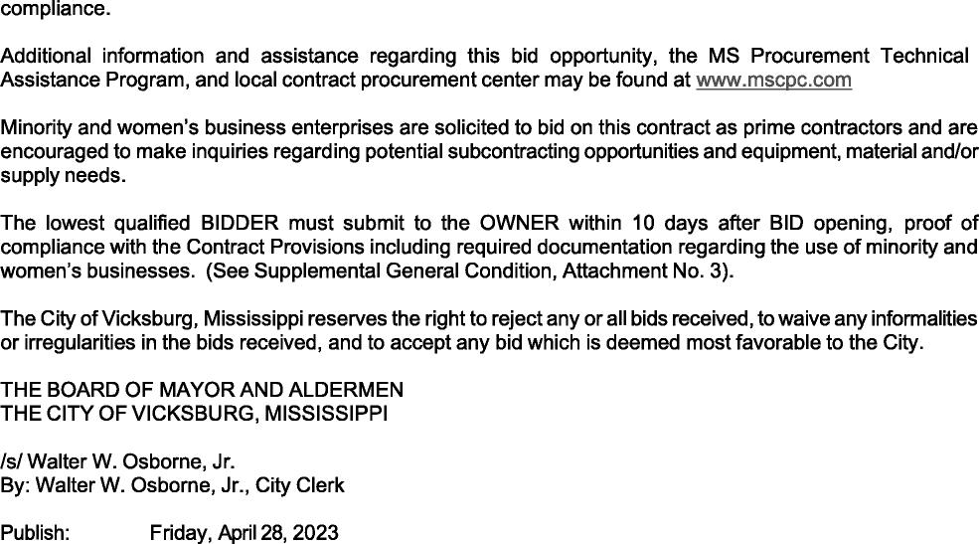
Friday, May 5, 2023

