Request for Proposals for Lease or Management Agreement SAENGER THEATER
170 Reynoir Street
Biloxi, MS 39530

RESPONSE DUE DATE:

NOTICE OF REQUEST FOR PROPOSALS:
11:00 AM (local time) July 15, 2019

Invitations are extended for responses using the attached format.

CONTACTS:

SCOPE OF REQUEST:

COMPLETED RESPONSES MUST INCLUDE:
Peter Abide, City Attorney City of Biloxi
140 Lameuse Street
Biloxi, Mississippi 39530
Telephone: (228) 435-6252
E-mail: PAbide@curriejohnson.com

The City of Biloxi, Mississippi (referred to herein as the "City") is considering alternatives to being the sole source of funding for repairs and renovations to the Saenger Theater. The Saenger Theater may be eligible for historic tax credits and other credits that may be best utilized in a public/private partnership. Accordingly, the City is seeking proposals for the opportunity to lease or manage certain surplus real property-Le., the historic Saenger Theater, 170 Reynoir Street, Biloxi, MS 39530, being composed of land and improvements on a portion of Tax Parcel #1410K-03-
047.000. (The paved parking area of this Tax Parcel is NOT included in this RFP, but the availability of parking may be utilized as part of the proposal).

- Submission by 11:00 AM, local time, July 15, 2019, IN A sealed envelope labeled "PROPOSAL: SAENGER THEATER" (original and two copies) addressed to:

Keith Stuart City of Biloxi
Mayor's Office, 2"d Floor, City Hall Attn.: Legal Department
140 Lameuse Street
Biloxi. Mississippi 39530

- A signed and dated Submission Form;
- A certified check in the amount of $500.00 earnest money to be applied against any future payments.

Agreement:
The successful submitter (the 11Submitter') will enter with the City into a definitive Contract, depending upon the City's decision, in its sole discretion. whether to select a proposal and enter into an agreement.

Award Criteria: The City intends to select a proposal based upon the following criteria that will be evaluated, weighted and measured in the City's sole and absolute discretion:
  - Amount of management fee or lease rental, either as lease payments or in conjunction with renovation offsets/historic tax credits and other tax credits, and/or offset by repair and renovation costs ;
  - Whether the proposed use of the property for the purpose

for which it is to be sold, conveyed or leased will promote and foster the development and improvement of the community and the civic, social, educational, cultural, moral, economic or industrial welfare thereof and is in the best interest of the economic growth and development of the City; as well as the resulting direct and indirect economic benefits to the City;
  - Whether the proposed use is consistent with city ordinances applicable to the downtown area in which the site is located;
  - Whether the proposed use of the Saenger Theatre and lot will comply with laws and ordinances pertaining to historic buildings;
  - Submitter's commitment to repair, rehabilitate, and renovate the Saenger Theater, and the amount of private investment to be provided;
f) Submitter's knowledge and experience in dealing with historic tax credits and other tax credits;
- Submitter's acquiescence in providing a certain number of City-sponsored events per year;
- Submitter's experience in managing or developing similar properties; and
- Any other factors or criteria that the City deems appropriate for evaluation in the circumstances.

No Oral or Implied
·contracts:
Acceptance or Rejection:

Open Records Law:

Prohibition of Gratuities:

Third Party Beneficiaries:

No Liability:
There shall be no oral or implied contracts relating to this request for proposals.
The City reserves the right to select, accept or reject any or all proposals or part of a proposal, with or without cause; to waive any informalities or technicalities; clarify any ambiguities in proposals; and to modify any criteria in this request for proposals.
All responses become the property of the City. Unless specific material is designated confidential or 'trade secret', all information contained in the responses shall become open for public review.
Neither the successful submitter nor any person, firm or corporation employed by the successful submitter shall offer or give any gift, money or anything of value or any promise of future award or compensation to any of the City's officials, officers, directors, or employees at any time.

This request for proposals and resulting agreement shall not be construed as providing an enforceable obligation to any third party

The City shall have no liability and no obligation to any person nor shall it be compelled to enter into any agreement or any other arrangement as a result of issuing this request for proposals.

Request for Proposals for SAENGER THEATER Submission Form

Proposed Lease Term and Rental Payments/Management Fee: (Attach a detailed statement of terms and payments); or

Proposed Lease-Management Terms :(Attach a detailed statement of terms and structure of payments.)

Attach a narrative description of your proposed use of the subject real property and any proposed renovation, addition, alteration,or new improvement, your commitment to fund the repairs and renovation, and describe how your proposed use and improvements would satisfy the Award Criteria stated in the RFP.

Submitter's Name and Title: Address:

Phone Number:
; E-mail Address:

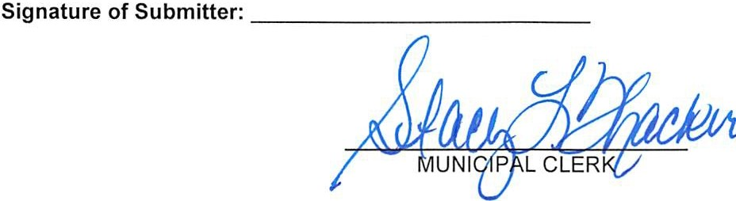
Publish Once: June 24, 20 19. Send Proof of Publication.

