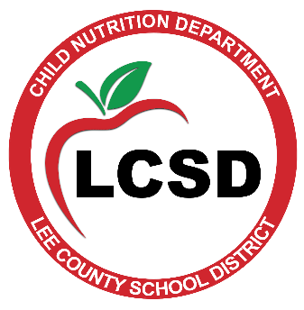
Child Nutrition Department
706 Westmoreland Drive, Tupelo, MS 38801
P.O. Box 1100, Verona, MS 38879-1100
Phone: (662) 680 – 5770 Fax: (662) 680 – 5776
Coke Magee, Superintendent Valerie Weivoda, Child Nutrition Director
INVITATION FOR BID
The Lee County School District will accept un-priced bid qualification specifications until 2:00 PM on Wednesday, April 21, 2021, online at www.centralbidding.com for the purpose of participating in an Electronic Reverse Auction for the following:
Reverse Auction: CN21.01
Project: One (1) Walk-In Cooler/Freezer Combo, Shelving and Dunnage.
Location: Verona Elementary School
212 College Avenue, Verona, MS 38879
The Electronic Reverse Auction will be held Friday, April 30, 2021 from 9:00 - 9:30 AM CST. Official project documents may be obtained from www.centralbidding.com for a fee or by contacting the Child Nutrition Director, Valerie Weivoda, by email at valerie.weivoda@leecountyschools.us.
Submissions will be evaluated, and qualified vendors will be invited to submit priced proposals via reverse auction. Inquiries regarding the project specifications should be directed to: Valerie Weivoda, Director of Child Nutrition, at the following email: valerie.weivoda@leecountyschools.us. For any questions relating to the reverse auction process, please call Central Bidding at (255)810-4814. The right to reject any/and all bids, waive informalities, extend the prequalification timeline, and to accept the lowest/best bid proposal is reserved by the Board of Trustees of the Lee County School District.
Performance Dates:
Advertise: April 7, 2021
Advertise: April 14, 2021
Bid Qualification Specification Due: No later than 2:00 PM CST, April 21, 2021
Reverse Auction Bid Date: April 30, 2021
Reverse Auction Bid Time: 9:00 AM CST
This institution is an equal opportunity provider. Complaint Procedure available upon request.

