EFFECTIVE DATE: 04/05/2021

STATE OF MISSISSIPPI TRAVEL AGENCY SERVICES PRICE LIST

Travel Agency Name: Christopherson Business Travel Reservations Phone Number: Toll Free: (855) 788-1034
Website: _www.cbtravel.com Email: mytravel@cbtravel.com

Fax: (801) 327-7606

Contact Person: Kevin Lee, Business Development Manager

Fees & Services

Airline – domestic | $ 28 per transaction
Airline – international | $ 33 per transaction
Airline – exchange | $ 30 per transaction
Amtrak | $ 10 per transaction
Vehicle Rental – non-commissionable | $ 10 per transaction
Lodging – non-commissionable | $ 15 per transaction
Visa processing (per country) | $ per transactionª
All other services when used in conjunction with air travel booked by the agency | $ 0 per transaction
ª Visa processing is provided through a third party.

*Write in fees only when the fee is less than the fee set by the Department of Finance and Administration, Office of Purchasing, Travel, and Fleet Management as listed above.

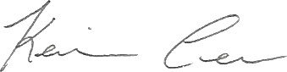

June 1, 2021

(Signature of Authorized Representative for Agency) (Date)

