|  |  |  |  |
| --- | --- | --- | --- |
| **No. 02**-00005  **Revision Level: A** | |  | |
| Equipment Specification  **Title:**  Dust Collection System  **Product:**  Carbon Fiber Composites and Associated Thermoset Resin Components  **Program / Application:**  Various / FOD Control, Composites & Tooling Machining | | | |
| **Proprietary Rights:**  Information contained herein includes data confidential and proprietary to the Advanced Composites Institute herein referred to as ‘ACI’. Reproduction or disclosure shall be only with the written consent of ACI, will not be used for purposes other than transactions with ACI and shall be returned with all further use discontinued upon request by ACI. | Prepared / Date:  D. Welch / 10 May 2023 | | Checked / Date:  C Hardin / 11 May 2023 |
| Eng Approval 2 / Date:  W. Huberty / 11 May 2023 | | Released by / Date:  D. Welch / 11 May 2023 |

|  |  |  |  |
| --- | --- | --- | --- |
| **Revision Level** | | | |
| **Rev** | **Revision Summary** | **Approval** | **Date** |
|  |  |  |  |
| A | ECN 4E756-00001  Revised and reformatted section 3.0 | DW, WH | 5/23/2023 |
|  |  |  |  |
|  |  |  |  |
|  |  |  |  |
|  |  |  |  |
|  |  |  |  |
|  |  |  |  |
|  |  |  |  |
|  |  |  |  |
|  |  |  |  |
|  |  |  |  |
|  |  |  |  |
|  |  |  |  |
|  |  |  |  |
|  |  |  |  |
|  |  |  |  |
|  |  |  |  |
|  |  |  |  |
|  |  |  |  |
|  |  |  |  |
|  |  |  |  |
|  |  |  |  |
|  |  |  |  |
|  |  |  |  |
|  |  |  |  |
|  |  |  |  |
|  |  |  |  |
|  |  |  |  |
|  |  |  |  |
|  |  |  |  |
|  |  |  |  |
|  |  |  |  |
|  |  |  |  |
|  |  |  |  |
|  |  |  |  |
|  |  |  |  |
|  |  |  |  |
|  |  |  |  |
|  |  |  |  |

###### 

# Table of Contents

Table of Contents 3

1.0 Scope 4

2.0 Applicable Documents 4

3.0 Requirements 4

# **1.0 Scope**

This requirements description covers an electrically powered dust collection system of sufficient capacity to support a 5 axis router system, defined herein, dedicated to machining operations for carbon fiber-reinforced plastic [CFRP] composite and similar materials. Explosion protection, meeting current industry regulations, shall be an element of the system design, along with replaceable filtration elements configured for optimum containment of carbon fiber residue.

# **2.0 Applicable Documents**

ACI Documents

Customer Documents

Industry Specifications, Standards and Handbooks

Combustible Dust National Emphasis Program. OSHA Directive CPL 03-00-008

NFPA 69 Standard on Explosion Prevention Systems, National Fire Protection Association

Abbreviations, Acronyms and Terms used in this document are in accordance with ASME Y14.38M, Abbreviations and Acronyms.

# **3.0 Requirements**

3.1 General Requirements

The dust collection system shall be applied for mitigation of both environmental safety of personnel and foreign object damage potential of product from dust and particles resulting from machining operations on carbon fiber composite and thermoset resin materials. Note: Carbon fiber dust is a potentially explosive media, [Kst<200] – Class ST-1. The overall system, structure, electrical and control elements support a demonstrated capability of meeting the requirements defined herein and operating under an AS9100 controlled facility environment. There shall be a legacy heritage available as delivered examples of similar product upon request displaying successful installations into operating environments for the same or similar dust / FOD environments.

3.2 Key Features, Interfaces and Performance Rating

* Eight thousand [8,000] cubic feet per minute [CFM] minimum through a distributed interface with a CR Onsrud Model F144Q17 5-Axis QUBE Series 5 axis router of four [4] pick up duct collection points of eight [8] inch [nominal] diameter as shown in Figures 1 A and 1B.

* System noise shall be below 78 db
* Fourteen [14] replaceable filtration elements with a provision for periodic automated compressed air pulse cleaning during operation of the system.
  + Replacement access of the filers shall be from the clean air side of the unit.
  + Filtration levels shall be sufficient under the projected dust particle environment from machining of carbon fiber, vinyl-ester, epoxy or plastic media tooling board to allow for an option of recirculation to the HVAC controlled environment of the facility shop vs. to the exterior in consideration of shop environmental control efficiency.
  + Filters shall be of an antistatic format. Clean air emissions value to be: < 0.5 mg/m3.
  + Targeted operational life of the filter set under rated conditions to be up to 20,000 hours.
* Single waste collection point into a separable container. An electrically actuated locking mechanism shall be utilized to provide pressure sealing between the collector and waste disposal vessel.
* 460 VAC, 3 Phase, 60 Hz supply unless otherwise agreed to by the Customer. Control voltage shall be 24V.
* Primary structure shall be of welded steel construction for frame, collector, fan mounting section and similar load bearing / containment structures segments. Corrosion protection shall be by chemical process surface treatment and / or paint suitable for either interior unconditioned space or external to the facility under an open shelter structure, i.e. roof but open sides.
* Direct drive motor type fan, top mounted and include a noise reduction suppressor. Fan motor shall be UL rated and the assembly shall incorporate multiple sensors for overheat detection.
* Passive provisions for decoupling of explosive flame and pressure in accordance with NFPA 69 requirements and guideline 94/9/EC [ATEX] or Underwriters Laboratories [UL] and NFPA equivalents. Ducting shall be reinforced in sections as required to meet the standards. Sensors shall be incorporated for wear and debris deposits to facilitate preventive maintenance monitoring.
* Interface ducting and its installation between collector and router, separate from the reinforced ducting associated with the explosion protection provision, may included as a line item separate from the primary system. See Figures 1 A & B and 2 for references on the location of router and facility features.

3.3 Representative Installation, References

Quotations submitted shall contain a list of systems of identical or similar configuration for dust collection of carbon fiber reinforced plastic machining operations in aerospace or defense related facilities as references. Where possible, with client’s permissions, contacts should be included for the prior deliveries.

Figures 1A & 1B Dust collection Interface Points for CR Onsrud QUBE 5 Axis Router





Figure 2 Router Installation Area

Thru wall & hanger door duct route

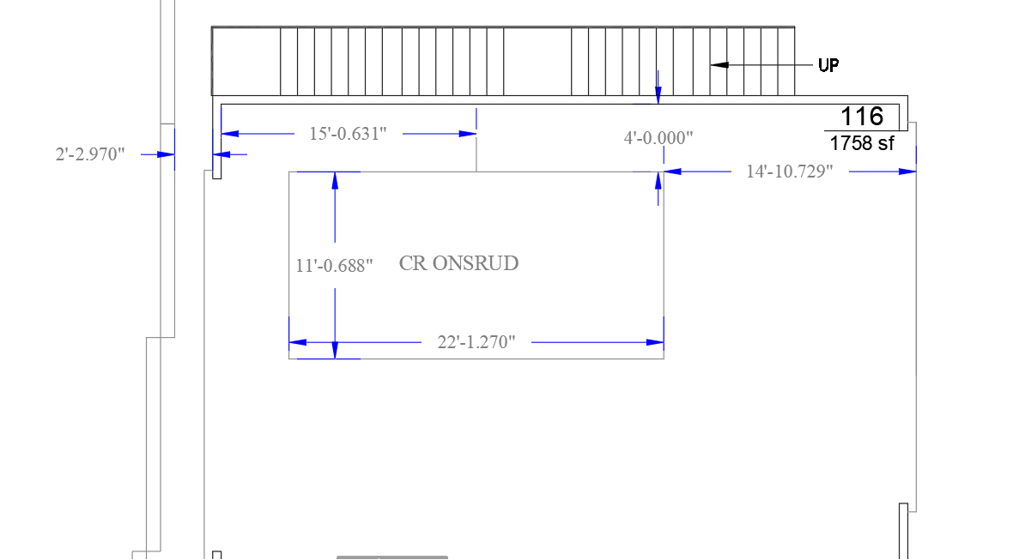

Space available for shop interior install of dust collector

pad & shelter

Exterior location for

pad & shelter

Corner Thru Wall Router Room

Exterior Location for Pad & Shelter

Corner Thru Wall Router Room

Aisleway Hanger Door & Router Room Wall

Figure 1Shop Wall of Router Room