Amendment One To:
Invitation for Bids
RFx No. 3160002255
Smart No. 1450-18-R-RAEX-00001
Marine Patrol Vessel
Questions and Answers

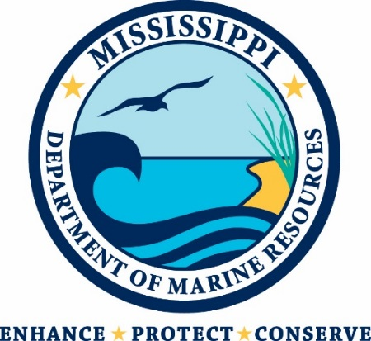

Mississippi Department of Marine Resources

1141 Bayview Avenue

Biloxi, Mississippi 39530
Contact: Rick Kinnard – Procurement@dmr.ms.gov

THIS IS AMENDMENT ONE TO THE INVITATION FOR BIDS. YOU MUST ACKNOWLEDGE THIS AND ALL FUTURE AMENDMENTS WITH YOUR BID OR, IF YOUR BID HAS ALREADY BEEN SUBMITTED, BY LETTER. YOUR ACKNOWLEDGMENT OF ALL AMENDMENTS MUST BE RECEIVED BY THE MDMR BY THE DEADLINE FOR RECEIPT OF YOUR BIDS.

- Will the Department of Marine Resources accept an aluminum hulled vessel as an alternative to fiberglass?
- For this IFB, the MDMR will only accept fiberglass hulled vessels.

- What brand of engines would be supplied for installation on this boat?
- The MDMR has Mercury and Yamaha engines on state contract. We would be able to supply either one of these brands.

