Mississippi State University
Invitation for Bid 23-15, Composite Ply Cutter
Addendum One

January 24, 2023

The following questions were received pertaining to the above bid file. See answers below and bid accordingly. Acknowledge this addendum by writing the number and date of the addendum on the bid form.
- Regarding paragraph 2 in section 3.2: It is our understanding the machine will be installed in a “clean room.” Do you require a silicone-free installation for the clean room environment?
  - The area that the machine will be installed in will be treated as an aerospace Class 7 clean room environment. However, this will not be a certified environment during the installation of the machine. ACI prefers to not use uncured silicones, however some silicones may be used during the installation process provided the installation area is fully segregated from any production activities. If silicones are to be used during the installation, ACI personnel will be notified and will take appropriate measures.
- As standard, the manufacturer supplies an On/Off button for the machine’s control cabinet and blower motor. An equipment manufacturer is not permitted nor licensed to provide nor install the Main Electrical Disconnect. This is the customer’s / facilities responsibility. Please confirm you will supply the Main Electrical Disconnect, which will power the machine’s control cabinet and blower motor.
  - ACI will provide electrical disconnects within ten (10) feet of the table.
- As standard, a manufacturer is not licensed or permitted to make the final connections from the control cabinet to the main electrical disconnect nor make final connections from the blower motor to the main electrical disconnect. Please confirm your licensed facilities electrician will make the final electrical utility connections as mentioned above.
  - MSU Facilities will provide final connection to the blower and/or the control cabinet.
- Regarding section 3.3: The bid documents state the maximum material size is 62 inches, however the minimum width of the table must be 72 inches. Shall we quote a machine that can accommodate 62-inch material or 72 inch material?
  - ACI desires a 72 inch wide table.

- What should the minimum addressable cutting length be and what should the minimum pick zone be?
  - As this is a static table, ACI would like to maximize the addressable cutting length and minimize the pick zone. ACI has requested a minimum 12 foot table length, with a nominal length of 15 feet. However, due to the modular construction of these types of tables, it is understood that each table segment length may be 36 inches to 48 inches nominal length. ACI desires a proposal to get as close to 15 feet overall table length as practical while maximizing addressable cutting length. Please note the addressable length in the response for the vendor’s proposed solution.
- Please clarify “automated material cloth feeder / rack” How should the rack be automated? Is it required to have automatic edge / alignment control?
  - ACI has requested an option for an automated material cloth feeder. It is intended to be equivalent to any commercial-off-the-shelf (COTS) solution the vendor may have. Ideally, this cloth feeder would be able to dispense the material onto the table without the need for a technician to manually pull the material onto the tabletop. Automatic edge/alignment control is preferred but not required. As this is an optional request, if the vendor does not a have a standard COTS option, then it may be no-quoted without impact to the overall bid.
- Regarding the statement concerning cutting surface contamination. Is it desired to have multiple surfaces to switch between for different materials?
  - No, ACI requests only a standard stiffened belt material tabletop of similar construction to those found on conveyor-style machines. Plastic tabletops with adhesive joints are not desired.
- Regarding the vacuum system. As standard with our design, the blower is within and beneath the table structure. With that said, is it still desired to install the blower externally? If so, please provide a drawing or sketch showing the location and dimensions and distance of where the blower will be installed so we may properly quote additional components. If installed externally, will the plumbing be installed above ground or below ground in a trench? What is the intent of installing the blower externally? Is it noise reduction? Reduction of footprint?
  - If possible, ACI would like to mount the vacuum system in a separate location from the table unit as we are concerned about noise levels in a closed room. The proposed location of the vacuum system is shown below. Alternatively, the vendor may quote alternate noise reduction system and keep the vacuum located under the table. It is desired to keep ambient vacuum noise levels under 80dB during the machine operation.

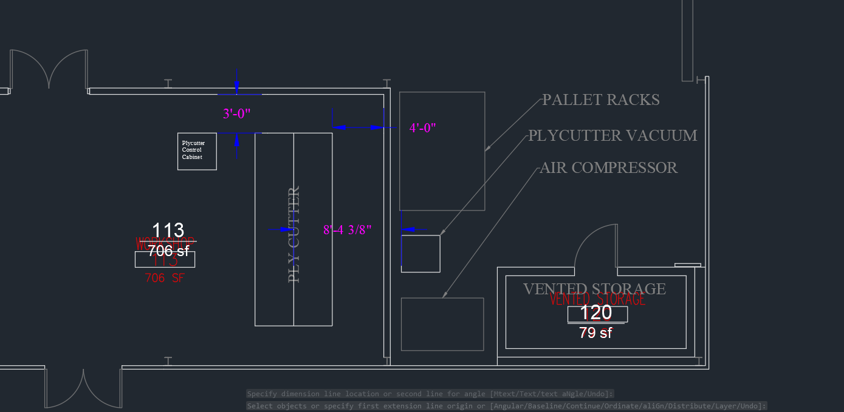
- Regarding tooling, The specification states a drag knife and a “driven” roller cutting device. A “driven” cutting device is unusual for the materials mentioned in the specification. We recommend a pressure cut blade, not driven. Please confirm whether a “driven” blade shall be supplied or not.
  - This machine will be used to cut a wide variety of aerospace material ranging from dry fabric to prepreg material to film adhesives, as it is intended to be a workforce development training machine. Depending on the industry partner, we could be cutting a wide variety of materials. To best mimic the equipment found most commonly in the local aerospace industry, we would like to have standard a drag knife and a round knife cutting solution.
- Regarding the optional inkjet printer: What is the minimum character height that is required to be printed? Please define everything that needs to be printed (text, barcode etc…) Does the ink need to be aerospace approved ink?
  - ACI has requested an optional inkjet printer for this machine. Please quote your standard COTS solution that closest matches the following parameters: The minimum desired character height is 0.5 inch, text only print, standard inkjet cartridges allowed. Does not need to be aerospace approved ink.

- Regarding installation: As standard, the customer is responsible for offloading the equipment. Can the offloading of equipment requirement be waived? If the requirement cannot be waived, please provide contact information for local, authorized material handling and rigging companies permitted to do business with The University – as this work will need to be subcontracted out and will increase the price of the project.
  - ACI will waive the equipment rigging and offloading requirement. ACI will need estimated freight/crate sizes and weights to assist in getting the correct equipment/personnel onsite for rigging and offload.
- Regarding section 3.5 When will the machine accuracy test need to be performed? Prior to delivery or After installation?
  - The accuracy test will be performed after installation at ACI once the equipment has been initially calibrated. The machine will perform a circle/diamond/square cut to verify toolpath accuracy +/- 0.030 inch profile, smoothness of cuts, circular interpolation (i.e. does the circle begin and end at the same spot), verify no corner “hangers”, and legibility of the text.
- Regarding section 3.7 Please clarify “the supplier shall incur all expenses associated with such service” Please clarify “all expenses”
  - In the event of a covered equipment failure during the warranty period, if the equipment cannot be repaired remotely, ACI requests onsite service at the expense of the vendor. This includes but is not limited to travel costs, parts, and labor.
- Regarding section 3.8 Please clarify what is required within “Engineering Drawing Manual”
  - Engineering drawing manual is defined as a dimensioned schematic of the proposed system. If this information is included within other requested manuals or information, this requirement may be waived as a unique manual.

