MAGIC Reverse Auction Bidders Training Guide

The MAGIC Reverse Auction Bidders Training Guide provides instructions for vendors to participate in Reverse Auctions. Vendors have the ability to submit bids electronically and view real time bid ranking. The identity of participating bidders will not be displayed to other bidders throughout the online auction process. However, bidders will be able to see the current best bid.

Contents
Technical Requirements 2
Login Procedure 2
View Available Reverse Auctions 3
Search for Auction(s) 3
Display Auction Details 5
Display Line Items 6
Display Notes and Attachments 8
Participating in a Live Auction 8
Live Auction Cockpit 9
Chat and System Messages 11
Pausing and/or Resuming an Auction 12

Technical Requirements

Bidders are responsible for ensuring technical requirements are met.
Acceptable Internet Browser(s)
- Microsoft Internet Explorer (IE) version 11
- Microsoft Edge

Google Chrome versions 49 and above

Unsupported Internet Browser(s)
- Microsoft Internet Explorer (IE) version 10 or below
- Safari
- Firefox

Note: Pop-up blocker must be turned off.

Login Procedure
Vendors must be registered in MAGIC in order to receive a User ID and password to log in. Vendors who are new to MAGIC may visit the Vendor Information page on DFA’s Web Site, or register online, Vendor Registration.

To Log into MAGIC, open the following URL: https://portal.magic.ms.gov/irj/portal. Enter User ID and Password. The password is case sensitive.
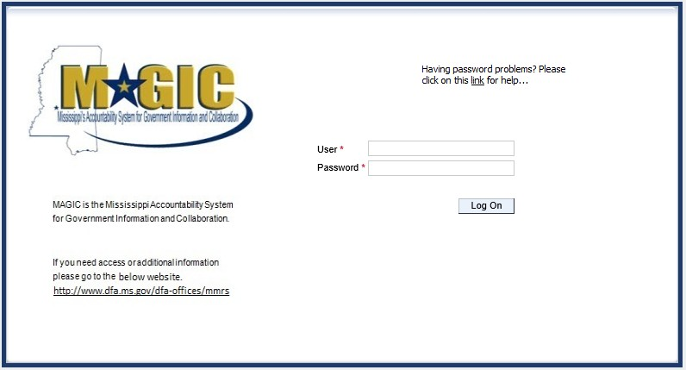

View Available Reverse Auctions

Search for Auction(s)

Listed below are the steps to search for a bid response.

- Bidders must first respond to the RFx (RFQF) to be able to participate in the Reverse Auction. Instructions for creating a response to an RFx are available here, RFx Response -Supplier Self Service.

  - The RFx (RFQF) – Bid Specifications will provide details for qualifying criteria. Only bidders qualified through the RFx (RFQF) will be invited to participate in Reverse Auctions.

- To search for auctions, click on the Suppliers Self-Service tab.

- Select RFx and Auctions in the navigation menu on the left of the screen.

- Select the Published link on the eAuctions line of the Active Queries section.

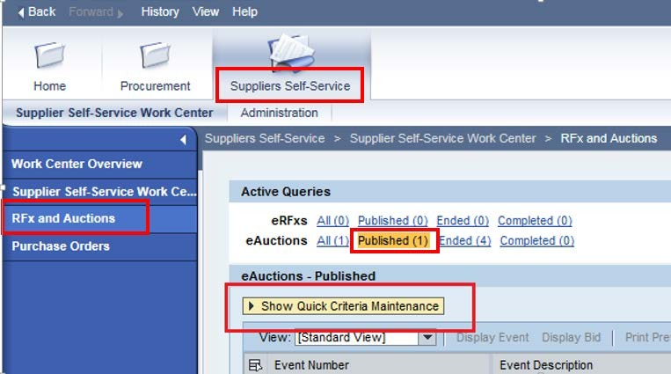
Note: If the search fields are not visible, click the button to expand the search criteria.

- Enter the search criteria. To find all available bid opportunities, skip to step (f).

- Select All or Published to search for available Events (eAuctions).

- Enter the appropriate Quick Criteria Maintenance fields: Event Number (Auction number) or complete any optional relevant search criteria.

- Click on Apply to view all Auctions based on your search criteria.

- To generate an updated search using the same selection criteria, click Refresh
or skip to step (7).

- Click Apply to find available bid opportunities.

- In the results list, click on the Event Number to open the Auction details in a separate window. (Pop-up blocker must be turned off.)
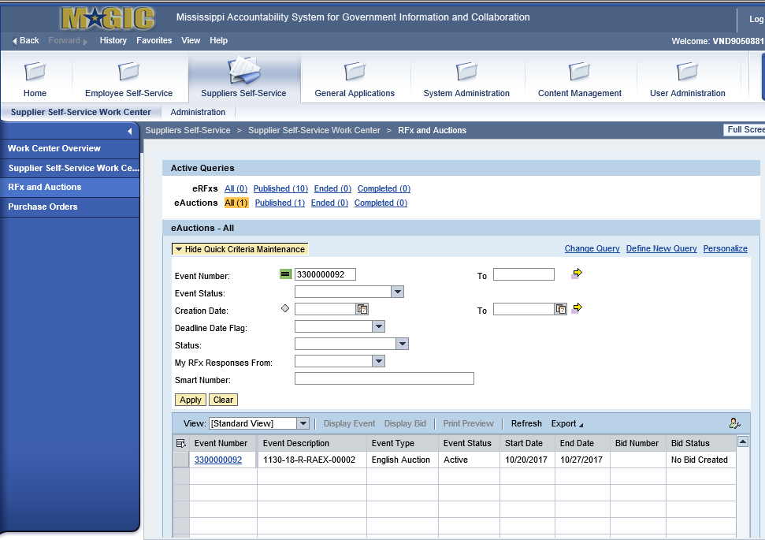

Display Auction Details
Listed below are the steps to view the auction details and information regarding the auction.
- The Auction Details screen will be displayed. It is important to review the details prior
to the auction start time. Bidding will not be available prior to the Auction Start Date/Time.
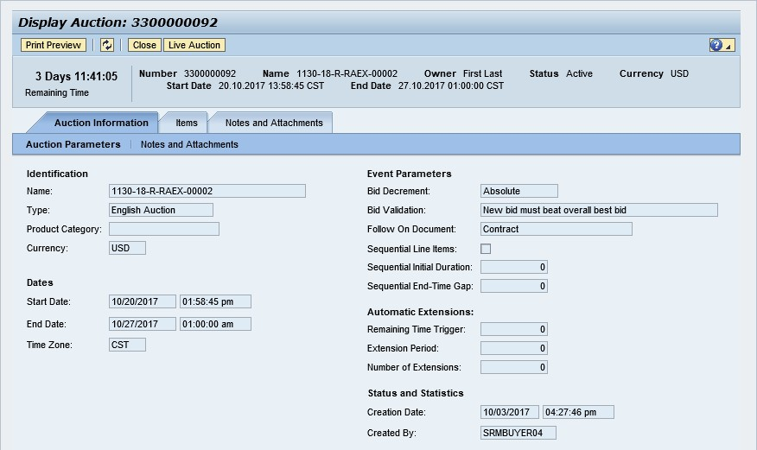

The table below lists the fields and a brief description of the information available on the Auction Parameters sub-tab of the Auction Information tab.

Section | Field Name | Description
Identification | Name | Smart Number with details related to the RFx
 | Type | English Auction is the standard for State of Mississippi
 | Product Category | The 5 digit NIGP code (optional)
 | Currency | US Dollar (USD)
Dates | Start Date | Begin Date and Time for the Live Auction
 | End Date | Date and Time of Live Auction completion
 | Time Zone | Central Standard Time (CST)
Event Parameters | Bid Decrement | The amount/percentage by which the next bid must decrease relevant to the current lowest bid.
 | Bid Validation | Logic used to determine if the bid is valid.
 | Follow On Document | Contract or Purchase Order
 | Sequential Line Items | Enables sequential line item functionality to stagger end times.
 | Sequential Initial Duration | The amount of time in between each line item end time.
 | Sequential End-Time Gap | The time between item end times.
Automatic  Extensions | Remaining Time Trigger | The time period before the end of the auction where an extension can be triggered due to bid activity.
 | Extension Period | Number of minutes, for which the auction will be extended if a bidder submits an offer within the Remaining Time Trigger period.
 | Number of Extensions | The number of times an auction can be extended by bid activity within the Remaining Time Trigger.
Status and  Statistics | Creation Date | The date and time the auction was created.
 | Created By | The User ID of the Agency Buyer who created the auction.
Display Line Items

Listed below is information regarding the line items associated with the auction.
- Click the Items tab to view the line items.
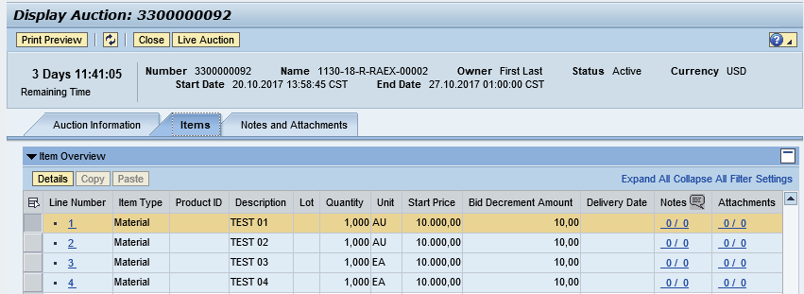
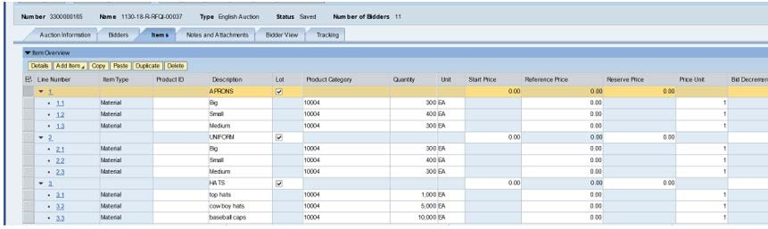
If the items are Lots, the main items will be listed with individual lot items below.

- To view additional details for a line item, select the desired line and click the button.

- The details for the line item will be displayed.

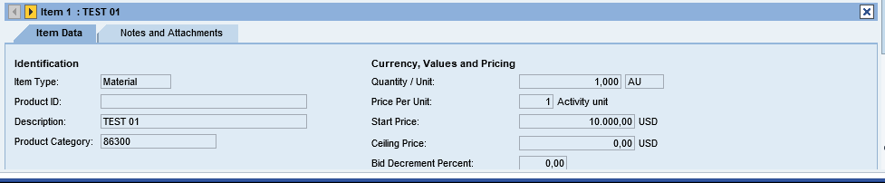

The table below lists the fields and a brief description of the information available for each line item.

Section | Field Name | Description
Identification | Item Name | Type of item (Material)
 | Product ID | 11 digit material number
 | Description | Detailed description of the item
 | Product Category | The 5 digit NIGP code
Currency, Values, and Pricing | Quantity /Unit | The number of items / the Unit of Measure (i.e. EA for each)
 | Price Per Unit | The individual price based on the Unit of Measure indicated.
 | Start Price | Starting bid price of the item (Bids higher than the start price will not be accepted.)
 | Ceiling Price | Ceiling Price is not used.
 | Bid Decrement Percent | Bid decrement amount if percentage option is selected.
 | Bid Decrement | Bid decrement amount if dollar amount option is selected.

Display Notes and Attachments

Click the Notes and Attachments tab to view supporting documents and/or notes associated with the auction.
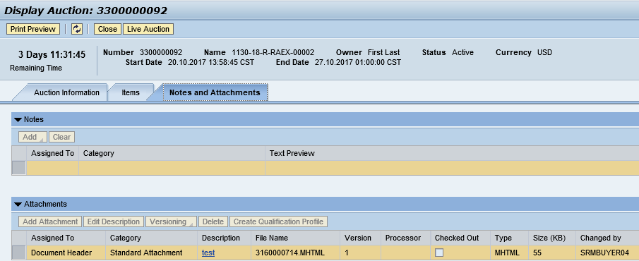

Participating in a Live Auction

After completing the steps above to find a desired auction, the steps below can be used to participate in the Live Auction process.
- In the Display Auction screen, click the Live Auction button.

- A pop-up window will appear containing terms and conditions to participate in the Live Auction. Review all terms and conditions. If you agree, click Accept. If you click Decline you will not be allowed to participate in the Live Auction.

If the agency did not establish terms and conditions this screen will not be displayed.

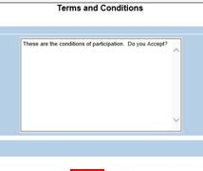

- The Live Auction Cockpit screen will be displayed. If you receive any error messages, please ask your company’s system administrator to verify your computer’s technical requirements.
Live Auction Cockpit
Listed below is information regarding key items for the Live Auction Cockpit. The steps for submitting a response are located on the next page.

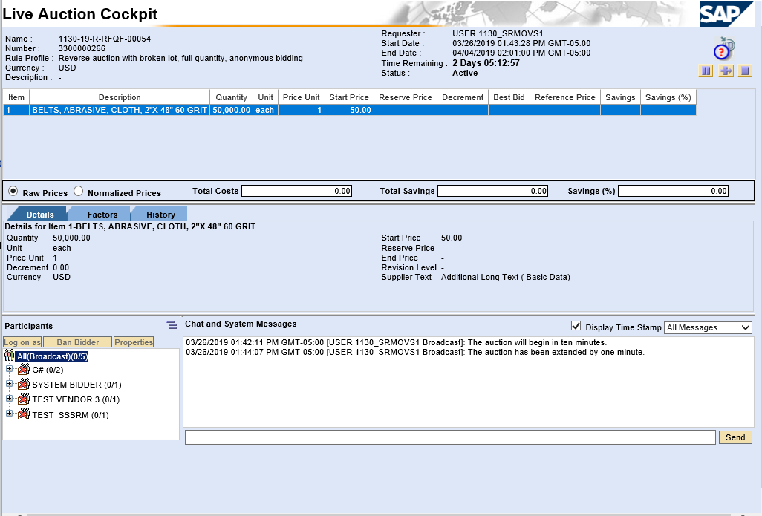

Field Name | Description
Start Date | Date and Time the Live Auction starts
End Date | Date and Time the Live Auction ends
Time Remaining | The time remaining for the Live Auction
Description | Line item description
Quantity | Line item quantity
Unit | Line item unit
Price Unit | Line item price per unit
Start Price | The initial price for the line item.
Best Bid | The lowest bid that has been submitted, to date, for that line item. This field will be blank until the first bid has been submitted.
Next Valid Bid | The next price that is allowed to be bid for that line item. It is determined by subtracting the decrement amount from the best bid  amount.
Bid Price | Your bid for the item. Your bid should be equal or less than the next valid bid field.  For instructions on how to enter your bid price, see the next page.

Submitting a Bid Response

The steps below must be completed for each separate line item you wish to bid on.
- Click desired line item.

- Enter the price in the Bid Price field(s) for the items you wish to bid on. Note: Do not enter “0” in the Bid Price field for an item you do not wish to bid on.
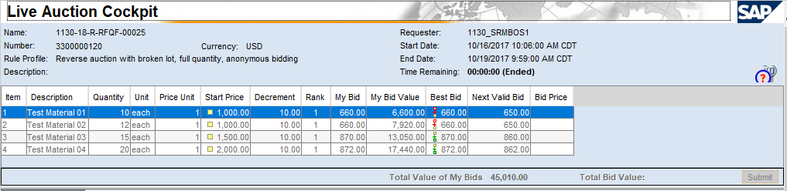

- Click the Submit button. The submit button may be used to enter a bid for each line item individually or to enter bids for multiple line items at once.
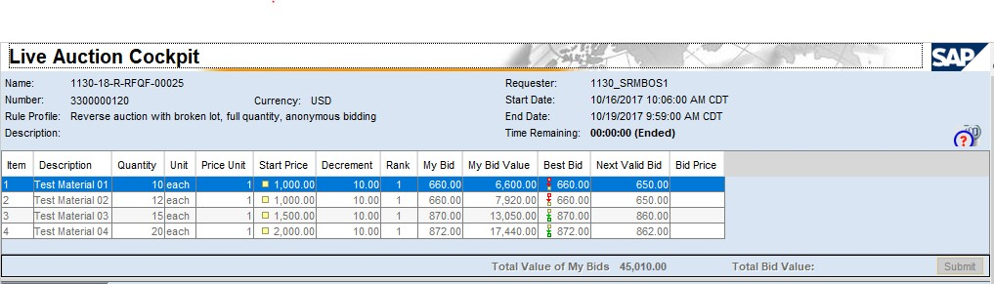

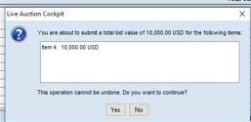
- A confirmation pop-up window will be displayed. The bid value (by line item) will display the total of the Unit Price times the Quantity for that item. If the bid amount(s) are correct, click Yes. If the bid amount(s) are incorrect, click No and repeat the steps above to enter the correct bid amounts.

- A confirmation of a successful bid submission will be displayed in the Chat Window.

Note: Erroneous bids may be deleted by the agency during the live auction.
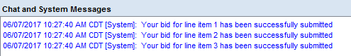
- Repeat steps 1 – 5 for each desired line item.

Chat and System Messages
The Chat and System Messages area is used for viewing chat messages from an agency buyer and information messages automatically generated by MAGIC.
Below are helpful hints in using the chat feature.
A bidder CAN: | Send a message to an agency buyer.  Type the message in the message box and click Send.
 | See broadcast messages from the agency buyer to ALL bidders.
 | See messages regarding the status of the auction (e.g. paused, resumed, or extended)
A bidder CANNOT: | Send a message to other bidders of the auction.
 | See messages sent to an agency by other bidders.
 | See messages sent to other bidders from the agency buyer.

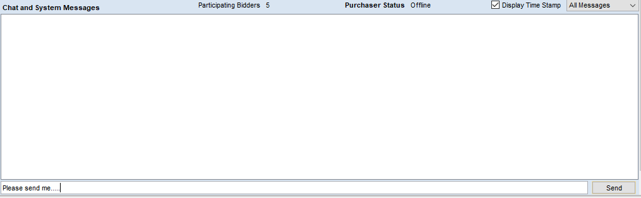

Pausing and/or Resuming an Auction
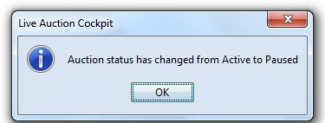
If necessary, the agency buyer can pause the Live Auction bidding. In such cases, the auction status will be changed from “Active” to “Paused”. A system alert will appear on the screen.

The countdown clock will not stop running while the auction is paused. The time remaining and end date / time are not affected or extended automatically.

When the agency buyer resumes the auction the auction status will be changed from “Paused” to “Active”. A system alert will appear on the screen.

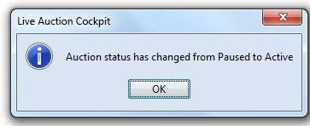

Once the auction has ended, a notification will display.
