Thank you for choosing Bridgestone Americas Tire Operations for your Government and Utility Fleets!
We have created a new website to help you better serve our customers.
Easily access all of the tools and resources you need:
- Approved/Contract Pricing,
- Authorized Dealers
Get Started today, it’s quick and easy.
- Visit www.batogovtires.com
- Scroll through the landing page to see what’s new
- Sign up by either choosing LOGIN or REGISTER
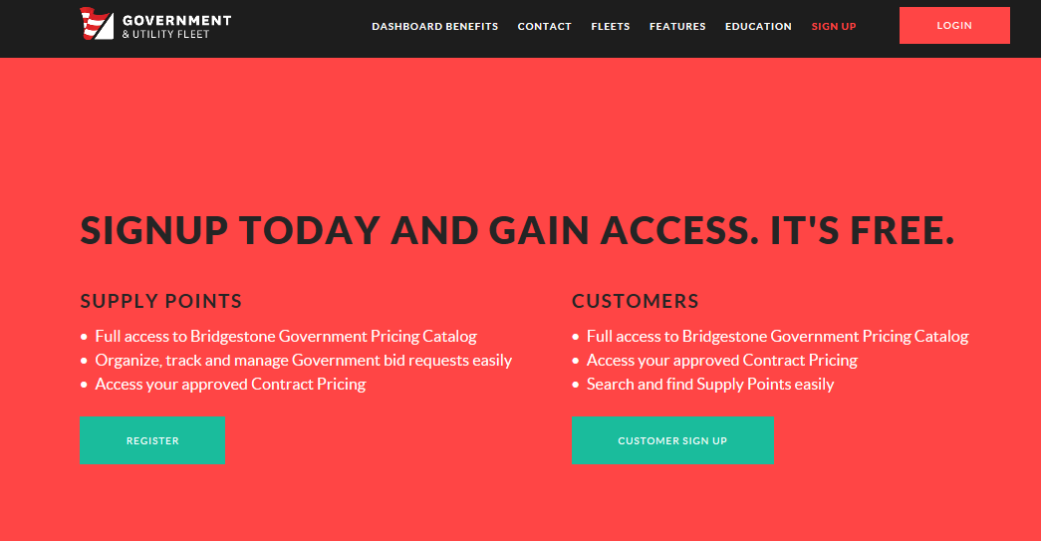

- Click on REGISTER FOR AN ACCOUNT
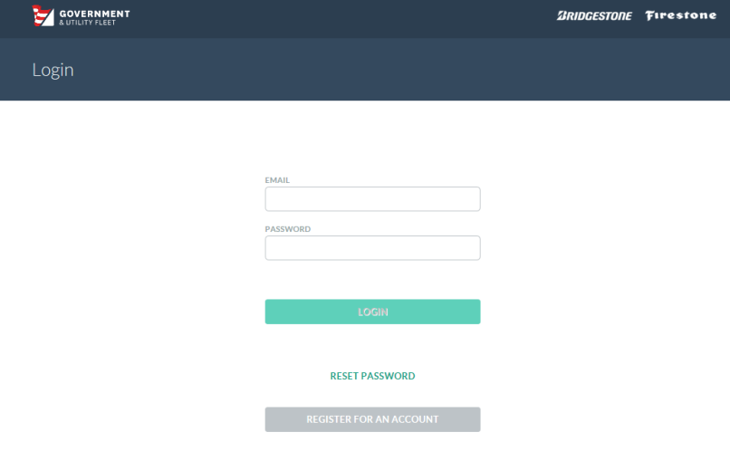

- Complete the Registration: Make sure to click Customer.
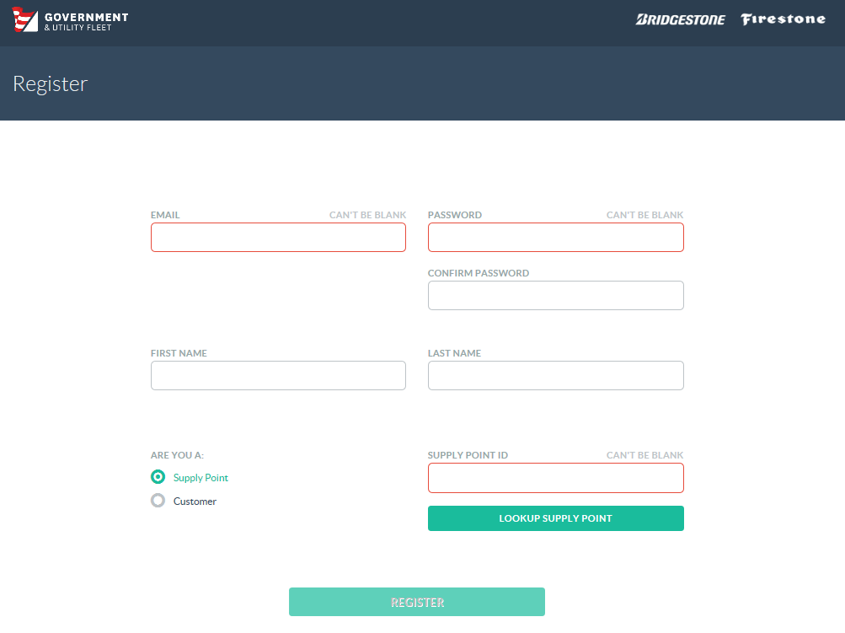

- Bridgestone will notify you when your new registration is approved.

