Bid # 24-01
University of Southern Mississippi
Lease Area - Oyster Reef Plot Creation

1.0 Introduction

The University of Southern Mississippi (USM) Gulf Coast Research Laboratory is seeking to procure a contractor to create multiple one-acre oyster-reef plots (6 per lease area) within four 50-acre lease areas. The 24 one-acre plots will receive base applications of #4 limestone gravel distributed evenly at a uniform flat thickness of 6”in the late fall, early winter of 2023.

2.0 Specifications

2.1 GENERAL PERFORMANCE SPECIFICATIONS

Adherence to timing and precision of gravel application within the delineated plots is critical to the success of this project. Prescribed quantities of material must be spread uniformly across created reef plots within boundaries defined by NAD83 CRS GPS coordinates specified in Table 2 below. The contractor must promptly notify the USM project manager of any anticipated deviation from the specified times and places for gravel applications. Such deviations will require mutually agreed upon remediation measures. Oversight monitoring will occur during reef creation and a quality control survey will follow reef creation activity to ensure all specifications are met.

The Vendor should quote the lead time required for obtaining materials and the time required for completing the contract. Required materials for construction should be acquired as a one-time purchase. Initiation of reef construction cannot proceed before all required permits are obtained and leasing agreements made by the contractee. The deadline for receiving sealed bid responses is before 2:00 PM CDT on Friday, August 11, 2023. (See specifics below)

2.2 REQUIREMENTS

The following specifications are given to ensure that the contractor understands the scope and accuracy of the tasks required to satisfy project objectives. Any deviation from the prescribed specifications must be documented and rectified.

The contractor should meet the following specifications:

- Deployment
  - To deploy within four 50-acre lease areas
  - Two in western MS Sound and two in Eastern MS Sound
  - Geographic coordinates of lease areas given below
  - Two sets of three precise one-acre plots per lease area (= six plots per lease area)
    - Base reef for 24 one-acre reef plots
      - To be completed in late fall, early winter of 2023
    - For each lease area, two plots receive no base application (See Fig. 1 below)
  - Predetermined GPS coordinates defining corners of individual plots are provided.
    - See Tables 1 and 2 below for GPS coordinates of lease areas and plots in NAD83 CRS
      - Or in NAD 83 Mississippi State Plane feet
    - See Figures 1 and 2 below for layout configuration of plots within lease areas:
      - One-acre plots are arranged around the perimeters of 50-acre lease areas.
      - Bare substrate areas are interspersed with created reef plots.
- Reef Material
  - #4 LIMESTONE GRAVEL – predominant size range from 1.5" – 2.5"
    - Estimated 1 cu yd = 1.2 ton
    - Total particle size range of 0.5 – 3.5”
  - six one-acre plots per lease area (see Tables 1 and 2, and Figs. 1 and 2 below)
  - applications of limestone gravel to be made to uniform thickness within predefined boundaries of experimental plots.
    - uniform flat thickness of 6” for base applications (i.e., 800 cubic yards per one-acre plot)
- Plot specifications
  - Six plots per lease area receive the base application.
    - at 800 cubic yards per acre (≈6” base depth)
    - four lease areas * six base plots = 24 base acres
    - Twenty-four base acres * 800 cubic yards/acre = 19,200 cubic yards base #4 limestone
  - Labor and deployment costs:
    - Deploy base reefs at same time in late fall, early winter of 2023.
    - Bidder should provide Itemized breakdowns of estimated labor and material costs along with the bid.
- Performance criteria:
  - Subtidal depth range estimates for the four lease sites:
    - Western North; UEBN = 5-7 feet;
    - Western South; UEBS = 7-9 feet;
    - Pascagoula West; UEPW = 6-7 feet;
    - Pascagoula East; UEPE = 5-6 feet.
  - Prescribed quantities of material must be spread uniformly within boundaries of created reef plots.
  - Timing requirements of gravel applications to within bi-weekly designated periods
  - Spatial accuracy of applications to within 10 m of designated boundaries
  - Contractor must immediately notify USM project manager of any anticipated deviation from the specified times and placements of gravel applications.
  - On site monitoring by project representatives to occur during reef deployment
  - A quality control procedure will follow deployments to ensure specifications were followed accurately.
  - Non-compliance with contract specifications subject to nonpayment.

Table 1. Lease area boundary GPS coordinates (CRS = NAD83)

Zone | Lease | Site | Corner | Latitude | Longitude
Bay St. Louis | Northern | UEBN | NE | 30.3050 | -89.2986
Bay St. Louis | Northern | UEBN | SE | 30.3009 | -89.2986
Bay St. Louis | Northern | UEBN | SW | 30.3009 | -89.3034
Bay St. Louis | Northern | UEBN | NW | 30.3050 | -89.3034
Bay St. Louis | Southern | UEBS | NE | 30.2626 | -89.3041
Bay St. Louis | Southern | UEBS | SE | 30.2576 | -89.3041
Bay St. Louis | Southern | UEBS | SW | 30.2576 | -89.3089
Bay St. Louis | Southern | UEBS | NW | 30.2626 | -89.3089
W Pascagoula R | Eastern | UEPE | NE | 30.3331 | -88.6470
W Pascagoula R | Eastern | UEPE | SE | 30.3289 | -88.6490
W Pascagoula R | Eastern | UEPE | SW | 30.3304 | -88.6533
W Pascagoula R | Eastern | UEPE | NW | 30.3348 | -88.6512
W Pascagoula R | Western | UEPW | NE | 30.3383 | -88.6615
W Pascagoula R | Western | UEPW | SE | 30.3343 | -88.6615
W Pascagoula R | Western | UEPW | SW | 30.3343 | -88.6664
W Pascagoula R | Western | UEPW | NW | 30.3383 | -88.6664

Table 2. Specification of plot coordinates in addition to assigned plot numbers and eventual treatment applications within the designated lease areas (see diagram below) – Plots are numbered from left to right starting from upper left corner of each site and going across and down – corners of plots: UL – upper left; UR upper right; LL – lower left; LR - lower right. NA – not applicable; Base application – base reef 800 cubic yards per acre (≈6” base depth); Trtmnt1 – TBD; Trtmnt2 - TBD (see diagram below). GPS coordinate reference system = NAD83 CRS.

Zone | Relative  Position | Lease | Trt  Plot | Base  Late Fall  (2023) | Trmnt1  Late Spring  (2024) | Trtmnt2  Early Fall  (2024) | UL  Lat | UL  Long | UR  Lat | UR  Long | LL  Lat | LL  Long | LR  Lat | LR  Long
Bay St SL | Northern | UEBN | BN-1 | NA | NA | NA | 30.304381 | -89.302653 | 30.304381 | -89.301993 | 30.303810 | -89.302653 | 30.303810 | -89. 301993
Bay St SL | Northern | UEBN | BN-2 | YES | NA | NA | 30.304381 | -89.301333 | 30.304381 | -89.300673 | 30.303810 | -89.301333 | 30.303810 | -89.300673
Bay St SL | Northern | UEBN | BN-3 | YES | NA | YES | 30.304381 | -89.300013 | 30.304381 | -89.299353 | 30.303810 | -89.300013 | 30.303810 | -89.299353
Bay St SL | Northern | UEBN | BN-4 | YES | NA | YES | 30.303238 | -89.302653 | 30.303238 | -89.301993 | 30.302667 | -89.302653 | 30.302667 | -89.301993
Bay St SL | Northern | UEBN | BN-5 | YES | YES | NA | 30.303238 | -89.300013 | 30.303238 | -89.299353 | 30.302667 | -89.300013 | 30.302667 | -89.299353
Bay St SL | Northern | UEBN | BN-6 | YES | NA | NA | 30.302095 | -89.302653 | 30.302095 | -89.301993 | 30.301524 | -89.302653 | 30.301524 | -89.301993
Bay St SL | Northern | UEBN | BN-7 | YES | YES | NA | 30.302095 | -89.301333 | 30.302095 | -89.300673 | 30.301524 | -89.301333 | 30.301524 | -89.300673
Bay St SL | Northern | UEBN | BN-8 | NA | NA | NA | 30.302095 | -89.300013 | 30.302095 | -89.299353 | 30.301524 | -89.300013 | 30.301524 | -89.299353
Bay St SL | Southern | UEBS | BS-1 | NA | NA | NA | 30.261533 | -89.308153 | 30.261533 | -89.307493 | 30.260961 | -89.308153 | 30.260961 | -89.307493
Bay St SL | Southern | UEBS | BS-2 | YES | NA | NA | 30.261533 | -89.306833 | 30.261533 | -89.306173 | 30.260961 | -89.306833 | 30.260961 | -89.306173
Bay St SL | Southern | UEBS | BS-3 | YES | NA | YES | 30.261533 | -89.305513 | 30.261533 | -89.304853 | 30.260961 | -89.305513 | 30.260961 | -89.304853
Bay St SL | Southern | UEBS | BS-4 | YES | NA | YES | 30.260390 | -89.308153 | 30.260390 | -89.307493 | 30.259818 | -89.308153 | 30.259818 | -89.307493
Bay St SL | Southern | UEBS | BS-5 | YES | YES | NA | 30.260390 | -89.305513 | 30.260390 | -89.304853 | 30.259818 | -89.305513 | 30.259818 | -89.304853
Bay St SL | Southern | UEBS | BS-6 | YES | NA | NA | 30.259247 | -89.308153 | 30.259247 | -89.307493 | 30.258675 | -89.308153 | 30.258675 | -89.307493
Bay St SL | Southern | UEBS | BS-7 | YES | YES | NA | 30.259247 | -89.306833 | 30.259247 | -89.306173 | 30.258675 | -89.306833 | 30.258675 | -89.306173
Bay St SL | Southern | UEBS | BS-8 | NA | NA | NA | 30.259247 | -89.305513 | 30.259247 | -89.304853 | 30.258675 | -89.305513 | 30.258675 | -89.304853
Pascagoula | Western | UEPW | PW-1 | NA | NA | NA | 30.337731 | -88.665604 | 30.337731 | -88.664944 | 30.337159 | -88.665604 | 30.337159 | -88.664944
Pascagoula | Western | UEPW | PW-2 | YES | NA | NA | 30.337731 | -88.664284 | 30.337731 | -88.663624 | 30.337159 | -88.664284 | 30.337159 | -88.663624
Pascagoula | Western | UEPW | PW-3 | YES | NA | YES | 30.337731 | -88.662964 | 30.337731 | -88.662304 | 30.337159 | -88.662964 | 30.337159 | -88.662304
Pascagoula | Western | UEPW | PW-4 | YES | NA | YES | 30.336588 | -88.665604 | 30.336588 | -88.664944 | 30.336016 | -88.665604 | 30.336016 | -88.664944
Pascagoula | Western | UEPW | PW-5 | YES | YES | NA | 30.336588 | -88.662964 | 30.336588 | -88.662304 | 30.336016 | -88.662964 | 30.336016 | -88.662304
Pascagoula | Western | UEPW | PW-6 | YES | NA | NA | 30.335445 | -88.665604 | 30.335445 | -88.664944 | 30.334873 | -88.665604 | 30.334873 | -88.664944
Pascagoula | Western | UEPW | PW-7 | YES | YES | NA | 30.335442 | -88.664284 | 30.335445 | -88.663624 | 30.334873 | -88.664284 | 30.334873 | -88.663624
Pascagoula | Western | UEPW | PW-8 | NA | NA | NA | 30.335445 | -88.662964 | 30.335445 | -88.662304 | 30.334873 | -88.662964 | 30.334873 | -88.662304
Pascagoula | Eastern | UEPE | PE-1 | NA | NA | NA | 30.333642 | -88.651054 | 30.333422 | -88.650444 | 30.333112 | -88.651314 | 30.332892 | -88.650704
Pascagoula | Eastern | UEPE | PE-2 | YES | NA | NA | 30.333212 | -88.649834 | 30.332992 | -88.649224 | 30.332672 | -88.650084 | 30.332462 | -88.649464
Pascagoula | Eastern | UEPE | PE-3 | YES | NA | YES | 30.332772 | -88.648614 | 30.332552 | -88.648004 | 30.332242 | -88.648864 | 30.332032 | -88.648244
Pascagoula | Eastern | UEPE | PE-4 | YES | NA | YES | 30.332582 | -88.651574 | 30.332372 | -88.650954 | 30.332052 | -88.651824 | 30.331842 | -88.651204
Pascagoula | Eastern | UEPE | PE-5 | YES | YES | NA | 30.331712 | -88.649104 | 30.331502 | -88.648494 | 30.331182 | -88.649344 | 30.330972 | -88.648724
Pascagoula | Eastern | UEPE | PE-6 | YES | NA | NA | 30.331522 | -88.652074 | 30.331312 | -88.651464 | 30.330992 | -88.652324 | 30.330767 | -88.651714
Pascagoula | Eastern | UEPE | PE-7 | YES | YES | NA | 30.331102 | -88.650844 | 30.330902 | -88.650224 | 30.330572 | -88.651104 | 30.330352 | -88.650494
Pascagoula | Eastern | UEPE | PE-8 | NA | NA | NA | 30.330692 | -88.649604 | 30.330482 | -88.648984 | 30.330162 | -88.649854 | 30.329952 | -88.649234

Figure 1. Experimental plot numbering from left to right starting at upper left and going across and down: top row from left to right: Plot 1, Plot 2, Plot 3; middle row from left to right: Plot 4, Plot 5; bottom row from left to right: Plot 6, Plot 7, Plot 8. GPS. All plots except for non-reef control plots (i.e., plots 1 and 8) are slated to receive the base application as described herein. See table 1 for lease area coordinates and table 2 for plot coordinates, site affiliations, and treatment designations.

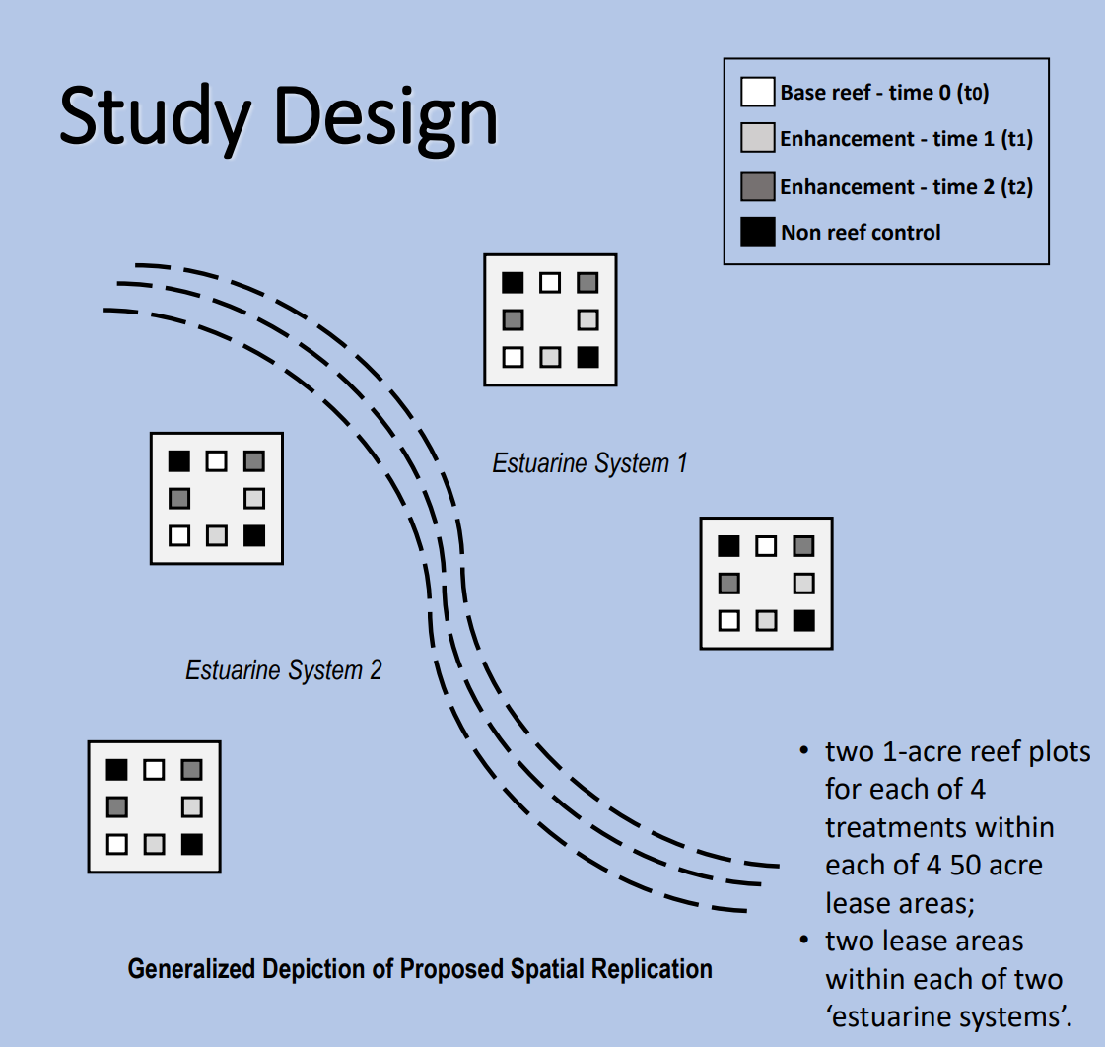

Figure 2. Example of lease area UEPW, including layout and configuration of plots as well as base and treatment applications. Relative spatial positions and plot number designations will remain the same across all four lease areas. All plots except plots 1 and 8 are slated to receive the base reef application specified in this bid.

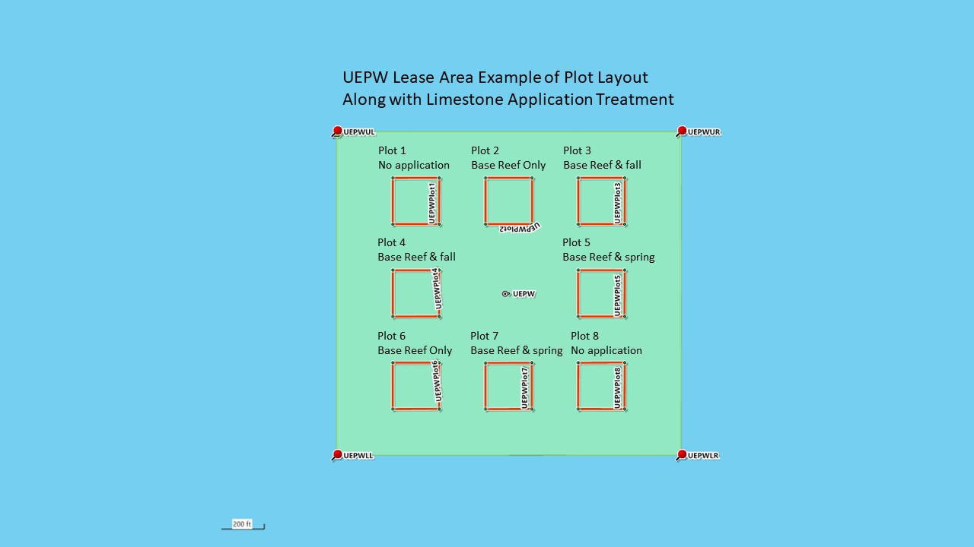

2.4 CUSTOMER SUPPORT

The vendor should be willing to work with personnel of The University of Southern Mississippi to resolve any technical issues associated with deployment of the material within acceptable tolerances. It is preferred that the vendor can provide technical service through remote access and/or on‐site technical support.

2.5 SAFETY

Prescribed and appropriate safety procedures should be followed while fulfilling the contract.
Emergency stop procedures should be established.

2.6 WARRANTY

Bidder warrants that the work performed shall be free from defects in materials used, accuracy and areal tolerance of the substrate applications. Defective or inaccurate completion of the work shall be rectified to the mutual satisfaction of the and workmanship under normal use and service with obligation to repair or replace any parts, which are proven defective, within one year from delivery.

2.7 BONDS AND SURETIY

Each bid shall be accompanied by a Certified Check on a solvent bank or a Bidder’s Bond issued by a Surety Company licensed to operate in the State of Mississippi, in the amount of five percent (5%) of the total bid price, payable to the University of Southern Mississippi as bid security. Bidders shall also submit a current financial statement, if requested by the University. The successful bidder will be required to furnish a performance and payment bond in the amount of one hundred percent (100%) of the contract amount. Both bonds shall be signed or countersigned by a Mississippi Resident Agent.

2.8 DELIVERY

Vendor should quote the lead time required for obtaining the materials and conducting the work for the quoted contract. All required materials for the entire quoted project should be acquired as a one-time purchase. Quoted prices should be F.O.B. Destination Freight Allowed.

3.0 Points of Contact

For questions, contact Millissa Stork at: Millissa.Stork@usm.edu or (228) 818-8001

4.0 Submission Instructions to Bidders

One (1) signed original and two (2) copies of the sealed bid response. USM reserves the right to request an electronic copy of the exact bid response prior to review of the bid), subject to the conditions made a part hereof, will be received before 2:00 PM CDT on Friday, August 11, 2023,
in the USM/Gulf Coast Research Lab Halstead Campus Receiving Office, as indicated in the General Terms, Conditions, and Instructions to Bidders described herein. It is the responsibility of the respondent to ensure that the proposal package arrives in the Procurement Office.

Each bid must be submitted in a sealed envelope bearing on the outside the name “Bid # 24-01
University of Southern Mississippi - Lease Area Oyster Reef Plot Creation,” the name of the Vendor, and the opening date specified on the coversheet.

For US mail, FedEx, UPS, or other express couriers the proposal should be addressed as follows:

USM/ Gulf Coast Research Lab
Attn: Millissa Stork
703 East Beach Drive
Ocean Springs, MS 39564
Bid #24-01

Hand‐carried responses should be brought to:

USM/ Gulf Coast Research Lab
Halstead Campus Receiving Office
Attn: Millissa Stork
703 East Beach Drive
Oceanography Building, Room 148
Ocean Springs, MS 39564
Bid #24-01

As an alternative to traditional sealed proposals in envelopes, the University of Southern Mississippi can receive electronic bid responses. While this option is available, it is not required, and we ask that all potential respondents keep in mind that with any electronic system there could be delays or glitches with the submission process; therefore, the University highly encourages traditional sealed responses that are either mailed or submitted in person. Additionally, the University will not be responsible for issues with attempted submissions of bids using the electronic method.

Please note that emailed bids will not be accepted.

Should a vendor choose to submit their response electronically, please follow the instructions below using the following website:

https://www.ms.gov/dfa/contract_bid_search/Home/Sell

On this site you will find helpful links to procurement opportunities, as well as a link to supplier registration. If not already registered in this system, potential bidders will first need to click on
‘Supplier Registration’ and follow the steps outlined (a one‐time process). Once registered, suppliers can return to the original website and click on ‘Procurement Opportunities’ where they can either search by keyword for the bid they desire to respond to or leave the search box blank and click ‘Search’ for a listing of all current bids and proposals for the various State of Mississippi offices.

When submitting an electronic bid, the bid must be submitted in “pdf” format and shall contain the same information and forms as required for the paper bids. Electronic bids must be secured with a bid bond. When submitting a bid electronically, the authorized signature shall be an electronic signature or handwritten in blue-ink signature. In the event that an electronically submitted bid has a corrupted attachment, the bid will be considered null and void.

Appendix A provisions are hereby expressly incorporated into any contract between USM and the awarded Contractor, and the Contractor agrees to comply with all applicable provisions of Appendix A during performance of such contract.

Any bid may be withdrawn prior to the scheduled time for the opening of bids or authorized postponement thereof. Any bid received after the time and date specified will not be considered.

The University of Southern Mississippi reserves the right to accept or reject any or all bids and to waive any formalities.

The University of Southern Mississippi reserves the right to accept or reject optional line items included in the bid response.

Vendors are responsible for examining all specifications, terms, conditions, and instructions of this request. Failure to do so will be at Vendor’s risk.

To ensure all interested bidders receive any addenda that may be issued, proposers must email their intent to propose using the Intent to Bid link on the USM Bid Calendar under Bid 24-01 prior to the deadline to submit:

https://www.usm.edu/procurement‐contract‐services/current‐bids‐and‐sole‐source‐notices.php

Appendix A

The parties acknowledge that any contract subsequent to this solicitation is subject to the provisions of 2 C.F.R. § 200 et seq., Uniform Administrative Requirements, Cost Principles, and Audit Requirements for Federal Awards, as well as additional requirements of the U.S. Department of Commerce. Notwithstanding anything contained in this solicitation, the awarded Contractor agrees to comply with all applicable provisions of 2 C.F.R. § 200 et seq., as amended. These provisions are hereby expressly incorporated into the Contract between USM and the Contractor.

Authority to Participate in this Agreement. The Contractor certifies that (a) it is either a 1) state agency, 2) a validly organized business that is authorized to do business in the state of Mississippi, 3) a non-governmental organization, or 4) political subdivision of the state of Mississippi with valid authority to enter into this agreement and (b) entry into and performance under this agreement is not restricted or prohibited by any loan, security, financing, contractual, or other agreement of any kind; and (c) notwithstanding any other provision of this Agreement to the contrary, that there are no existing legal proceedings, either voluntary or otherwise, which may adversely affect its ability to perform its obligations under this agreement.

Equitable Remedies. The parties agree that irreparable damage would occur if any provision of this Agreement were not performed in accordance with the terms hereof and that the parties shall be entitled to equitable relief, including injunctive relief or specific performance of the terms hereof, in addition to any other remedy to which they are entitled at law or in equity.

Termination for Cause or Convenience. USM, by written notice to the Contractor may terminate this Agreement for convenience or cause, in whole or in part, when the interests of USM so require. In the event of termination, the Contractor will not incur any new obligations for the terminated portion of the Contract after the Contractor has received notification of termination. If the Contract is terminated before performance is completed, the Contractor shall be paid only for that work satisfactorily performed for which costs can be substantiated. Such payment, however, may not exceed an amount that is the same percentage of the Agreement price as the amount of work satisfactorily completed is a percentage of the total work called for by the Contract. All work in progress shall become the property of USM and shall be turned over promptly by the Contractor.

Equal Employment Opportunity. Contractor agrees to comply with the Equal Opportunity Clause provided under 41 CFR 60-1.4(a) (Government Contracts) and 41 CFR 60-1.4(b) (Federal Assisted Construction Contracts), in accordance with Executive Order 11246, "Equal Employment Opportunity" (30 FR 12319, 12935, 3 CFR Part, 1964-1965 Comp., p. 339), as amended by Executive Order 11375, "Amending Executive Order 11246 Relating to Equal Employment Opportunity," and implementing regulations at 41 CFR part 60, "Office of Federal Contract Compliance Programs, Equal Employment Opportunity, Department of Labor." Contractor further agrees to include this provision, including the Equal Opportunity Clause or a reference thereto, in any subcontracts it enters into pursuant to the Contract.
Clean Air Act (42 U.S.C. 740l-7671q.) and the Federal Water Pollution Control Act (33 U.S.C. 1.25 1-1 387), as amended. All parties agree to comply with all applicable standards, orders, or regulations issued pursuant to the Clean Air Act (42 U.S.C. 7401-7671q.) and the Federal Water Pollution Control Act as amended (33 U.S.C. 1251-1387). All parties shall report violations to the Federal awarding agency and the Regional Office of the Environmental Protection Agency (EPA).

Suspension and Debarment. Contractor shall comply with the Office of Management and Budget (OMB) Guidelines to Agencies on Governmentwide Debarment and Suspension (Non-procurement) in 2 CFR Part 180, as adopted by the U.S. Department of Treasury at 31 CFR Part 19. Contractor represents that neither it, nor any of its principals has been debarred, suspended, or otherwise determined ineligible to participate in federal assistance awards or contracts. Subrecipient further agrees that it will notify USM immediately if it or any of its principals is placed on the list of parties excluded from federal procurement or non-procurement programs available at https://sam.gov/.

Federal Restrictions on Lobbying. Contractor shall comply with the restrictions on lobbying in 31 CFR Part 21. Pursuant to this regulation. Contractor may not use any federal funds to pay any person to influence or attempt to influence an officer or employee of any agency, a Member of Congress, an officer or employee of Congress, or an employee of a Member of Congress in connection with any of the following covered federal actions: the awarding of any federal contract, the making of any federal grant, the making of any federal loan, the entering into of any cooperative agreement, and the extension, continuation, renewal, amendment, or modification of any federal contract, grant, loan, or cooperative agreement. Contractor shall certify in writing that Subrecipient has not made, and will not make, any payment prohibited by these requirements using the form provided in Exhibit A (Lobbying Certifications).

Ban on Foreign Telecommunications. Contractor acknowledges that grant funds shall not be used to purchase equipment, services or systems that uses, "covered telecommunications" equipment or services as a substantial or essential component of any system, or as critical technology as part of any system. Covered Telecommunications" means: purchases from Huawei Technologies Company or ZTE Corporation (or any subsidiary or affiliate of such entities. Video surveillance and telecommunications equipment produced by Hytera Communication Corporation, Hangzhou Hikvision Digital Technology Company, or Dahua Technology Company (or any subsidiary or affiliate of such entities).

Travel. Contractor acknowledges that USM will reimburse the Contractor for reasonable travel expenses incurred in accordance with 2 C.P.R. 200.475, if applicable.

Access to Records. The U. S. Army Engineer Research And Development Center (ERDC), USM, the State or any duly authorized representatives shall have the right of timely and unrestricted access to any of the Contractor's books, documents, papers, and other records, including electronic records, which are maintained or produced as a result of the agreement for the purpose of making audits, investigations, examinations, excerpts, transcripts, and copies of such documents. This right also includes timely and reasonable access to the Contractor's personnel for the purpose of interview and discussion related to such documents. This right of access shall continue as long as records are required to be retained.

Record Retention and Right to Audit. The Contractor shall maintain and retain books, documents, papers, financial records, and other records, including electronic records, which are maintained or produced as a result of the agreement. These records must be retained for a minimum of three (3) years after final payment under the agreement is made. These records shall be made available during the term of the agreement and the subsequent three-year period for examination, transcription, and audit by the ERDC, USM, the State or any duly authorized representatives. If any litigation, claim, investigation, or audit relating to this Agreement or an activity funded under the Agreement is started before the expiration of the three (3) year period, the records must be retained until all litigation, claims, investigations, or audit findings involving the records have been resolved and final action taken.

Domestic Preferences for Procurements.
(a) As appropriate and to the extent consistent with law, the non-Federal entity should, to the greatest extent practicable under a Federal award, provide a preference for the purchase, acquisition, or use of goods, products, or materials produced in the United States (including but not limited to iron, aluminum, steel, cement, and other manufactured products). The requirements of this section must be included in all subawards including all contracts and purchase orders for work or products under this award.
(b) For purposes of this section:
(1) “Produced in the United States” means, for iron and steel products, that all manufacturing processes, from the initial melting stage through the application of coatings, occurred in the United States.
(2) “Manufactured products” means items and construction materials composed in whole or in part of non-ferrous metals such as aluminum; plastics and polymer-based products such as polyvinyl chloride pipe; aggregates such as concrete; glass, including optical fiber; and lumber.

Procurement of Recovered Materials. A non-Federal entity that is a state agency or agency of a political subdivision of a state and its contractors must comply with section 6002 of the Solid Waste Disposal Act, as amended by the Resource Conservation and Recovery Act. The requirements of Section 6002 include procuring only items designated in guidelines of the Environmental Protection Agency (EPA) at 40 CFR part 247 that contain the highest percentage of recovered materials practicable, consistent with maintaining a satisfactory level of competition, where the purchase price of the item exceeds $10,000 or the value of the quantity acquired during the preceding fiscal year exceeded $10,000; procuring solid waste management services in a manner that maximizes energy and resource recovery; and establishing an affirmative procurement program for procurement of recovered materials identified in the EPA guidelines.

