

**Mississippi Department of Marine Resources**

|  |  |
| --- | --- |
| **SOLICITATION:** | Request for Quote Formal (RFQF) |
|  | Reverse Auction |
| **SOLICITATION NUMBER:** | 3140001420 |
| **DESCRIPTION:** | Furnish and Deploy Oyster Shell |
| **ISSUE DATE:** | Wednesday, May 23, 2018, 10:00 AM CST |
| **BID CLOSING LOCATION:** | Mississippi Department of Marine Resources  1141 Bayview Avenue  Biloxi, Mississippi 39530 |
| **BID COORDINATOR:** | Rick Kinnard  (228) 523-4147  procurement@dmr.ms.gov |
| **CLOSING DATE AND TIME:** | June 11, 2018, 2:00 PM CST |

#### SECTION I GENERAL CONDITIONS – REVERSE AUCTIONS

**ALL BIDS SUBMITTED SHALL BE IN COMPLIANCE WITH ALL CONDITIONS SET FORTH HEREIN. THE BID PROCEDURES FOLLOWED BY THIS OFFICE WILL BE IN ACCORDANCE WITH THESE CONDITIONS. THEREFORE, ALL BIDDERS ARE URGED TO READ AND UNDERSTAND THESE CONDITIONS PRIOR TO SUBMITTING A BID.**

#### DEFINITIONS

The use of the word “agency” in any Bid Invitation solicitation or specification shall be intended to mean state agencies only. The words “governing authority” when used shall be intended as meaning city, county or other local entities.

#### PREPARATION OF BIDS

* 1. Bids and/or Quotes may be submitted through the State of Mississippi’s e-procurement system (MAGIC) or in person to the Mississippi Department of Marine Resources, Procurement Department (“MDMR”). Paper bids are allowed. All prices and notations must be printed in ink or typewritten. No erasures permitted. Errors may be crossed out and corrections printed in ink or typewritten adjacent and must be initialed, in ink, by the person signing bid.
  2. To submit bids electronically, bidders must ensure they are registered in the MAGIC system and have received a login, password, and supplier number and that all technical requirements have been met.
  3. If a bidder is unwilling or unable to participate through MAGIC, an MDMR representative can enter the Vendor’s bid(s) manually (i.e. Surrogate bidding).
  4. Bidders participating in person by surrogate bidding must so indicate in their response to the initial Request for Quote-Formal (RFQF).
  5. Failure to examine any drawings, specifications, and instructions will be at bidder's risk.
  6. Price each item separately. Unit prices shall be shown. Bid prices must be net.
  7. It is understood that reference to available specifications shall be sufficient to make the terms of such specifications binding on the bidder.
  8. Bidders must furnish all information requested in the bid specifications. Further, when required, each bidder must submit for bid evaluation cuts, sketches, descriptive literature and technical specifications covering the product offered. Reference to literature submitted with a previous bid or on file with MDMR will not satisfy this provision.
  9. Samples of items, when requested, must be furnished free of expense, and if not destroyed in testing will, upon request, be returned at the bidder's expense. Request for the return of samples must be made within ten (10) days following opening bids. Each individual sample must be labeled with bidder's name, manufacturer's brand name and number, State of Mississippi commodity number, bid number and item reference.
  10. Time of performance. The number of calendar days in which delivery will be made after receipt of order shall be indicated in the bid specifications.

#### BID SUBMISSION

* 1. When submitting a bid electronically, the authorized signature may be typed or be an electronic signature.
  2. Bids and modifications or corrections received after the closing time specified will not be considered.
  3. When submitting the response to the RFQF in MAGIC, bidder must ensure all questions have been answered within the RFQF and all proposed items in the bid have a response.
  4. Bidders submitting paper responses should submit responses to the MDMR by the response deadline. The bid package must be sealed and must contain the following:
* Specifications Checklist (Attachment A)
* Bid Cover Sheet (Attachment B)
* Bid Form (Attachment C)
* Bidder Checklist (Attachment D)

#### ACCEPTANCE OF BIDS

MDMR reserves the right to reject any and all bids, to waive any informality in bids and unless otherwise specified by the bidders, to accept any items on the bid. The State reserves the right to modify or cancel in whole or in part its Invitation for Bids.

If a bidder fails to state the time within which a submitted bid will expire, it is understood and agreed that the MDMR shall have 60 days to accept.

#### ERROR IN BID

If a vendor is participating in a Live Auction, the vendor can notify MDMR in the event of an erroneous bid via the chat message feature. Erroneous bids, where the mistake is apparent to MDMR, may be deleted during the live auction.

#### SPECIAL DISCOUNT PERIOD

Time in connection with a special discount offered will be computed from date of delivery at destination or from the date correct invoices are received, if the latter date is later than the date of delivery. Cash discounts will not be considered in the award process.

#### AWARD

* 1. Contracts and purchases will be made or entered into with the lowest responsible bidder meeting specifications, except as otherwise specified in the bid specifications. Where more than one item is specified in the specifications, MDMR reserves the right to determine the low bidder either on the basis of the individual item(s) or on the basis of all items included in its Invitation for Bids, or as expressly provided in MDMR’s Invitation for Bids.
  2. Unless the bidder specified otherwise in the bid, MDMR may accept any item or group of items of any kind.
  3. A written purchase order or contract award furnished to the successful bidder within the time of acceptance specified in the Invitation for Bid results in a binding contract without further action by either party. The contract shall consist solely of these General Conditions, the Instructions and Special Conditions, the successful bidder’s bid, and the written purchase order or contract award. The contract shall not be assignable in whole or in part without the written consent of MDMR.
  4. Suppliers should be advised that no award will automatically result from a reverse auction, and that the purchasing entity will review the results of the auction and make a determination in a timely manner.

#### INSPECTION

Final inspection and acceptance or rejection may be made at delivery destination, but all materials and workmanship shall be subject to inspection and test at all times and places, and when practicable. During manufacture, the right is reserved to reject articles which contain defective material and workmanship.

Rejected material shall be removed by and at the expense of the contractor promptly after notification or rejection. Final inspection and acceptance or rejection of the materials or supplies shall be made as promptly as practicable, but failure to inspect and accept or reject materials or supplies shall not impose liability on the State or any subdivision thereof for such materials or supplies as are not in accordance with the specification. In the event necessity requires the use of materials or supplies not conforming to the specification, payment therefore may be made at a proper reduction in price.

#### TAXES

The State is exempt from federal excise taxes and state and local sales or use taxes and bidders must quote prices which do not include such taxes. Exemption certificates will be furnished upon request. Contractors making improvements to, additions to or repair work on real property on behalf of the State are liable for any applicable sales or use tax on purchase of tangible personal property for use in connection with the contracts. Contractors are likewise liable for any applicable use tax on tangible personal property furnished to them by the State for use in connection with their contracts.

#### GIFTS, REBATE, GRATUITIES

* 1. Acceptance of gifts from bidders is prohibited. No officer or employee of the MDMR, nor any head of any state department, institution or agency, nor any employee of any state department, institution or agency charged with responsibility of initiating requisitions, shall accept or receive, directly or indirectly, from any person, firm or corporation to whom any contract for the purchase of materials, supplies, or equipment for the State of Mississippi may be awarded, by rebate, gifts, or otherwise, any money or

anything of value whatsoever, or any promise, obligation or contract for future rewards or compensation.

* 1. Bidding by state employees is prohibited. It is unlawful for any state official or employee to bid on, or sell, or offer for sale, any merchandise equipment or material, or similar commodity to the State during the tenure of his or her office or employment, or for the period prescribed by law thereafter, or to have any interest in the selling of the same to the State.

#### BID INFORMATION

Bid information and documents may be examined pursuant to the Mississippi Public Records Act of 1983, MS Code 25-61-1 et seq.

#### PRECEDENCE

Bids shall be made and the contract shall be entered into in accordance with the General Conditions as hereinafter amended and modified. Should a conflict exist between the General Conditions and the Instructions and Special Conditions, the Instructions and Special Conditions shall take precedence.

#### COMPETITION

There are no federal or state laws that prohibit bidders from submitting a bid lower than a price or bid given to the U.S. Government. Bidders may bid lower than U.S. Government contract price without any liability as the State is exempt from the provisions of the Robinson-Patman Act and other related laws. In addition, the U.S. Government has no provisions in any of its purchasing arrangements with bidders whereby a lower price to the State must automatically be given to the U.S. Government.

#### WAIVER

MDMR reserves the right to waive any General Condition, Special Condition, or minor specification deviation when considered to be in the best interest of the State.

#### CANCELLATION

Any contract or item award may be canceled with or without cause by the State with the giving of 30 days written notice of intent to cancel. Cause for the State to cancel may include, but is not limited to, cost exceeding current market prices for comparable purchases; request for increase in prices during the period of the contract; or failure to perform to contract conditions. The Contractor will be required to honor all purchase orders that were prepared and dated prior to the date of expiration or cancellation if received by the Contractor within a period of 30 days following the date of expiration or cancellation. Cancellation by the State does not relieve the Contractor of any liability arising out of a default or nonperformance. If a contract is canceled by the State due to a Contractor’s request for increase in prices or failure to perform, that Contractor will be disqualified from bidding for a period of 24 months. The Contractor may cancel a contract for cause with the giving of a 30-day written notice of intent to cancel. Cause for the Contractor to cancel may include, but is not limited to, the item(s) being discontinued and/or unavailable from the manufacturer.

#### SUBSTITUTIONS DURING CONTRACT

During the term of a contract, if adequate documentation is provided that supports the claim that the contract item(s) are not available, items which meet the minimum specifications may be substituted if approved by MDMR and the substitutions are deemed to be in the best interest of the State.

#### APPLICATION

It is understood and agreed by the bidder that any contract entered into as a result of this Invitation for Bids is established for use by state agencies and all purchases made by these agencies for products included under the provisions of the contract shall be purchased from the bidder receiving the award unless exempt by special authorization from the MDMR.

Under the provisions of Section 31-7-7 Mississippi Code of 1972, Annotated, the prices offered herein shall be extended to the governing authorities. However, the governing authorities, by provisions of Section 31-7-12 Mississippi Code, may purchase products covered by state contracts from any source offering an identical product at a price that does not exceed the state contract price.

Employees of the MDMR have acted exclusively as agents of the State for the award, consummation, and administration of the contract and are not liable for any performance or nonperformance by the state agencies that utilize the contract.

#### ADDENDA

Addenda modifying plans and/or specifications may be issued if time permits. No addendum will be issued within a period of two (2) working days prior to the time and date set for the bid opening. Should it become necessary to issue an addendum within the two (2) day period prior to the bid opening, the bid date will be reset to a date not less than five (5) working days after the date of the addendum, giving bidders ample time to comply with the addendum. When replying to a bid request on which an addendum has been issued, and the specifications require acknowledgement, the bid shall indicate that provisions of the addendum have been noted and that the bid is being offered in compliance therewith. Failure to make this statement may result in the bid being rejected as not being in accordance with the revised specifications or plans.

#### NONRESPONSIVE BIDS

Nonresponsive bids will not be considered. A non-responsive bid is considered to be a bid that does not comply with the minimum provisions of the specification. Any bidder found to repeatedly offer alternated products that are not compliant with specifications in an attempt to obtain a contract on the basis of pricing only will be disqualified from bidding for a period of 24 months.

#### SPECIFICATION CLARIFICATION

It shall be incumbent upon all bidders to understand the provisions of the specifications and to obtain clarification prior to the time and date set for the live auction or bid opening. Such clarification will be answered only in response to a written request submitted in the specified amount of time set by the MDMR. The MDMR reserves the right to specify a time frame in which clarification request shall be made.

#### PRE-QUALIFICATION PROCESS

* 1. The purpose of the RFQF is to advertise the competitive procurement for solicitation of formal quotes from potential bidders to participate in the Reverse Auction. The MDMR will be responsible for defining product categories, adding bidders, and publishing all bid related documents to the procurement portal. Once the responses have been received and the Opening Date has been reached, the MDMR will review the submissions to qualify bidders and determine a starting price for reverse auction items.
  2. The Invitation for Bids/RFQF shall be advertised in accordance with Section 3.106.05.4 of the Mississippi Procurement Manual. The MDMR shall advertise once each week for two (2) consecutive weeks in accordance with Section 31-7-13(c)(i)(1) of the Miss. Code Ann. Responses to the RFQF will be due no earlier than the 8th working day after the last day of advertisement.
  3. The initial response to the Invitation for Bids shall include a proposed product, including specifications and/or samples, for the purchasing entity to evaluate and determine responsiveness to requirements. Responses to the RFQF will be reviewed by the MDMR for responsiveness to specifications. Once a supplier’s product is determined to be responsive, the supplier may participate in the reverse auction. Price quotes received will be evaluated in conjunction with other market research to determine the starting price for the Auction.
  4. The MDMR will accept bidder responses in MAGIC who have qualified meeting RFx specifications. Bidders not meeting specifications will not be allowed to participate in the Auction.
  5. Once qualified, the MDMR will notify the vendor of Qualification and the date of the Live Auction via email. After receiving the confirmation email, bidders should review/ensure technical requirements for MAGIC have been met or confirm participation in person.
  6. It is requested that bids be submitted on the basis of statewide distribution. Contractors must maintain adequate distribution capabilities and adequate stock of all items to insure prompt delivery.

#### FIRM BID PRICE

Prices accepted from bidder submissions shall be firm for the term of the contract except that the State shall receive the benefit of any price decrease in excess of five (5) percent. The contractor must provide written price reduction information within ten (10) days of its effective date.

#### CONTRACT EXTENSION

23.1 Automatic contract renewals or extensions are not allowed. Contracts must be extended or renewed with the proper documents signed or approved by the MDMR.

23.2 The MDMR reserves the right to extend the term of a contract, when necessary, to continue a source of supply whenever new or replacement contracts are not completed prior to the expiration date. Such extensions are dependent upon agreement of the Contractor and shall not exceed three (3) months.

#### 24. SUSPENSION AND DEBARMENT

By submitting a bid, the bidder is certifying that neither the bidder nor any potential subcontractors are debarred or suspended or are otherwise excluded from or ineligible for participation in federal assistance programs.

#### 25. ASSIGNMENT

The Contractor shall not assign or subcontract in whole or in part, its right or obligations under this agreement without prior written consent of the MDMR.

#### INDEMNIFICATION

Contractor shall indemnify, defend, save and hold harmless, protect, and exonerate the State of Mississippi, its Commissioners, Board Members, officers, employees, agents, and representatives from and against all claims, demands, liabilities, suits, actions, damages, losses, and costs of every kind and nature whatsoever, including, without limitation, court costs, investigative fees and expenses, and attorneys’ fees, arising out of or caused by Contractor’s and/or its partners, principals, agents, employees, and/or subcontractors in the performance of or failure to perform this Agreement. In the State’s sole discretion, Contractor may be allowed to control the defense of any such claim, suit, etc. In the event Contractor defends said claim, suit, etc., Contractor shall use legal counsel acceptable to the State; Contractor shall be solely liable for all reasonable costs and/or expenses associated with such defense and the State shall be entitled to participate in said defense. Contractor shall not settle any claim, suit, etc., without the State’s concurrence, which the State shall not unreasonably withhold.

#### LIVE AUCTION

* 1. Notification of Auction Start date and time will be sent via email to qualifying bidders. If a bidder is unwilling or unable to participate through MAGIC, a representative from the MDMR can enter the Vendor’s bid(s) manually (i.e. Surrogate Bidding). **If a bidder elects to participate via Surrogate Bidding, the bidder must be physically present at the public bidding location, with the means to submit written bids for each offer made and signed by an authorized agent of the Vendor**. A Bid Form will be provided to the Vendor at the start of the auction. This form will not be returned to the bidder but will become a part of the Bid Documentation for Evaluation by the MDMR.
  2. The Auction time may be extended at the discretion of the MDMR. Examples of reasons to extend an auction include, but are not limited to, technical difficulties experienced by the MDMR or bidder, the need to pause the Auction, or bids placed within the last few moments of bidding.
  3. Communication with bidders participating electronically during the Auction may be done via the Live Chat Feature. The MDMR has the ability to send messages to particular bidders or broadcast to all bidders. Bidders can ONLY communicate with the MDMR and no other bidders.
  4. Bidders may be removed from a Live Auction for improper conduct, including but not limited to profanity, threats, consistently entering erroneous or extremely low bids, or other disruptive behavior.

1. **THE TIMING OF THE AUCTION (RA REQUIREMENT).**

The Invitation for Bids shall be advertised in accordance with Section 3.106.05.4 of the Mississippi Procurement Manual, and the deadline to receive initial responses by suppliers shall be due no earlier than the 8th working day after the last day of advertisement. After such deadline has passed, the submissions shall be taken under advisement for prequalification. The reverse auction should occur only after the purchasing agent has had sufficient time to prequalify the suppliers. Such anticipated time shall be included in the Invitation for Bids Packet; however, the purchasing agent should reserve the right to extend the auction date if necessary to complete prequalification.

1. **QUOTES (RA REQUIREMENT)**

Responding suppliers must provide a quote with the initial response. Quotes are utilized by the purchasing agent to determine market pricing and set the auction parameters (e.g., Start Price).

#### FORCE MAJEURE

If the MDMR is closed for any reason, including but not limited to: acts of God, strikes, lockouts, riots, acts of war, epidemics, governmental regulations superimposed after the fact, fire, earthquakes, floods, or other natural disasters (the “Force Majeure Events”), which closure prevents the opening of bids at the advertised date and time, all bids received shall be publicly opened and read aloud on the next business day that the agency shall be open and at the previously advertised time. The new date and time of the bid opening, as determined in accordance with this paragraph, shall not be advertised, and all bidders, upon submission of a bid proposal, shall be deemed to have knowledge of and shall have agreed to the provisions of this paragraph. Bids shall be received by the agency until the new date and time of the bid opening as set forth herein. The MDMR shall not be held responsible for the receipt of any bids for which the delivery was attempted and failed due to the closure of the MDMR as a result of a Force Majeure Event. Each bidder shall be required to ensure the delivery and receipt of its bid by the MDMR prior to the new date and time of the live auction or bid opening.

#### SECTION II

#### INSTRUCTIONS AND SPECIAL CONDITIONS

#### PURPOSE

The Mississippi Department of Marine Resources (MDMR) manages the coastal resources for the State of Mississippi through the authority of the Commission on Marine Resources. We are dedicated to enhancing, protecting and conserving the marine interests of Mississippi for present and future generations. We manage all marine life, public trust wetlands, adjacent uplands and waterfront areas for the long-term recreational, educational, commercial, and economic benefit of everyone.

MDMR is seeking bids for furnishing and deploying of oyster shell cultch material (sometimes referred to herein as “cultch”) The deployment of oyster shell cultch is for the enhancement of oyster beds in the Western Mississippi Sound and Biloxi Bay. The scope of work to be performed and the deliverables required under the contract are also set forth herein.

#### 2. SCOPE OF SERVICES

The Contractor will be responsible for furnishing and deploying cultch by barge to the Western Mississippi Sound and Biloxi Bay. Bids should include the unit price per cubic yard of cultch, total cubic yards of cultch and overall price (unit price per cubic yard multiplied by total cubic yards) which will include deployment. The price of this project will not exceed $200,000.00.

The scope of work for the contract will include, but is not limited to, the following:

* The Contractor will plant cultch in specified areas which will be designated by MDMR personnel in advance of the day of the cultch deployment. The contractor will give the MDMR Project Manager at least twenty-four (24) hour notice of cultch deployment.
* Type of approved cultch material is oyster shell only.
* Cultch will be clean and free of any hazardous substances or excessive dust.
* The Contractor will guarantee that all cultch is clean and no more than 5% of the cultch material, by volume, may consist of fragments, pieces, fines, or shells smaller than ¾” to 1 ½” (three-fourths inch to one and one-half inch) in diameter. The MDMR reserves the right to have its representatives inspect all cultch material at the loading site before cultch material is accepted and each barge-load will be monitored at the deployment site. All small particles in excess of the allowed 5%, or otherwise outside of the specifications listed above, will be deducted from the total project cost.
* Cultch material will be transported to deployment areas on deck barges that are loaded to conform to the depth of the water at the deployment site. Tugboats and barges (loaded) will not draw more than five (5) feet of water. The deployment will be performed utilizing a grid pattern to accomplish a uniform distribution of the cultch material. To ensure proper maneuverability, the tugboat used to distribute the cultch material will not push or pull more than two (2) loaded barges at one time during deployment. MDMR employees will be onsite to monitor compliance with the terms of the contract. This will include, among other aspects, the even distribution of cultch material during the deployment at locations specified by the MDMR. The Contractor understands that this project consists of multiple deployment sites and irregular shapes ranging from 5 acres to 75 acres.
* The Contractor is responsible for ensuring that the minimal clearances are met.
* The MDMR will measure cultch material on board the barges prior to deployment and will calculate the total cubic yards of material on each barge (See Attachment E).
* Cultch material will be washed overboard using a minimum of three (3) high-pressure water hoses having not less than 90 psi. pressure on a 1.25-inch nozzle or greater. This high-pressure jet of water is directed against the cultch in a manner to spray it in a thin, even layer for a distance of 20 to 50 feet from the barge. Throughout the operation, the barge will be maneuvered over the deployment location in a fashion so that cultch will cover the entire area to the needed density as determined by authorized MDMR personnel.
* At no time, will the spray barge and tug pass over previously deployed areas unless authorized to do so by MDMR personnel.
* The barge deploying the cultch material must maintain a speed no less than one (1) knot per hour while actively deploying cultch material.
* Hopper barges must stage in a deep-water area and not over public oyster reefs. At no time will the hopper barges be allowed to pass over or anchor over existing public oyster reefs.
* The diagrams found in Attachments E, F and G illustrate the procedure and necessary equipment for deployment. The Contractor must have equipment and personnel capable of unloading two hundred and fifty (250) cubic yards of suitable cultch material within one (1) hour upon arrival at the site and have sufficient equipment and crew capable of handling a minimum of one thousand two hundred and fifty (1250) cubic yards per day. The use of multiple pumps and spray nozzles will increase the rate of unloading proportionately. Multiple pumps, spray nozzles and hoses, three or more in number, will unload a two hundred and fifty (250) cubic yard barge in approximately one (1) hour or less. This system is highly recommended.
* The Contractor must understand and agree that the deadlines in this agreement are essential to the successful planting of the cultch and must be done at a time when oyster spat is present in order to yield the best results, therefore, the Contractor agrees to adhere to the specified timeline.
* The Contractor will move and deploy cultch material between **August 7, 2018 and September 14, 2018, with actual deployment to begin no later than August 28, 2018.**
* The Contractor agrees to commence delivery within the timeframe as stated above in this RFQF and to continue delivery without delay, unless otherwise notified by the MDMR personnel monitoring this project, or upon successful deployment of the contractual amount of cultch material.
* All deployment activities must be conducted during daylight hours Monday through Friday. No deployments may be made on weekends, or during state holidays.
* In the event that weather or other environmental conditions are deemed unsuitable for deployment by the MDMR, the MDMR reserves the right to either cancel or postpone the deployment. There will be **no** deployment activity during a Small Craft Advisory or greater.
* The Contractor must retrieve any and all debris expelled during deployment. If debris is present, the Contractor must provide vessel and personnel to achieve debris collection. The debris collection vessel must be capable of communicating with the captain in charge of the deployment barge. All personnel must wear a United States Coast Guard approved personal flotation device while on deck during deployment and while retrieving any debris.
* All equipment used on this project by the Contractor must be in compliance with Occupational Safety and Health Administration (OSHA) and United States Coast Guard requirements. The successful bidder may be required to provide MDMR with documents evidencing this compliance.
* Before a contract is signed, the successful bidder will be required to designate the exact equipment that will be used in the performance of the work and MDMR personnel may inspect the equipment which may be accepted or rejected because it is not considered to be satisfactory for the purpose of this project. The inspection will be conducted at a date and time mutually agreed upon between the successful bidder and the MDMR representative. Failure to comply with this requirement may result in rejection of the bid.
* The contractor will also provide a functioning United States Coast Guard approved marine sanitation device (MSD) on either the pump barge or the tug boat.

#### DELIVERABLES

The deliverables are to include:

* Furnishing and deploying of oyster shell;
* Deployment of cultch between **August 7, 2018 and September 14, 2018, with actual deployment to begin no later than August 28, 2018; and,**
* **Project completion date: September 14, 2018.**

#### MINIMUM REQUIRED QUALIFICATIONS

**The minimum qualifications for bidding include:**

* Bidders must have prior experience furnishing and deploying cultch material. Bidders must submit at least one prior project of comparable scope they have successfully completed which demonstrates the required experience, including a description of the work performed and one (1) reference (customer for the project) with contact name, phone number, and email address. Bidders may submit more than one project but, are not required to do so. (See Attachment A); and,
* By submitting a bid, the bidder certifies that it is not currently debarred from submitting bids for contracts issued by any political subdivision, agency of the State of Mississippi, or any other state, and that it is not an agent of a person or entity that is currently so debarred.
* Bidders are required to be electronically registered in Mississippi’s Accountability System for Government Information and Collaboration (MAGIC) before submitting their bid. Instructions for registering in MAGIC can be found below and in Section II-B MAGIC Reverse Auction Bidders Instruction Guide.

**The minimum qualifications for contracting include:**

* Vendors which are domestic corporations, limited liability companies, or limited partnerships must be in good standing with the Mississippi Secretary of State.
* Vendors which are foreign corporations, limited liability companies, or limited partnerships may be required to register with the Mississippi Secretary of State to transact business in Mississippi. *See* Miss. Code Ann § 79-4-15.01.

#### BASIS FOR AWARD

The contract will be awarded to the responsive, responsible bidder who supplies the maximum amount of oyster shells to be deployed to the planting site(s) selected by the MDMR at the lowest price per cubic yard, not to exceed a total contract price of $200,000.00.

#### AMENDMENTS TO THIS RFQF

Should an amendment or amendments to this RFQF be issued by MDMR, it will be posted on the MDMR website [www.dmr.ms.gov](http://www.dmr.ms.gov) and on the Mississippi Contract Procurement Opportunity Search Board (Procurement Portal) website <https://www.ms.gov/dfa/contract_bid_search/Bid> in a manner that all bidders will be able to view. **Furthermore, bidders must acknowledge receipt of any amendment to this RFQF by signing and returning the amendment with the bid submission, by identifying the amendment number and date in the space provided for this purpose on the Bid Form-**Attachment C **or by letter.** The acknowledgment must be received by the MDMR by the time and at the place specified for receipt of Bids. It is the bidder’s sole responsibility to monitor the website for amendments to the RFQF.

#### QUESTIONS/REQUESTS FOR CLARIFICATION

All questions and requests for clarification must be submitted by email to: [procurement@dmr.ms.gov](mailto:procurement@dmr.ms.gov)

All questions/requests for clarification must be received no later than **May 31,** **2018 at 10:00 a.m. CST.**

All questions/requests for clarification and the answers thereto will be published on the MDMR website, <http://dmr.ms.gov> and the MAGIC Portal <http://www.mmrs.state.ms.us/vendors/index.shtml> in a manner that all bidders will be able to view by **June 1,** **2018 at 4:00 p.m. CST.**

The MDMR will not be bound by any verbal or written information that is not specified within this RFQF unless formally noticed and issued by the contact person.

#### INSURANCE REQUIREMENTS

In order to enter into a contract, you must meet minimum insurance protection requirements. You must provide evidence of your policies **within ten (10) calendar days of a fully executed contract**.

All insurance policies must be issued by companies licensed or holding a Certificate of Authority from the Mississippi Department of Insurance. All liability insurance policies must provide coverage to the MDMR as an additional insured.

You must hold the following insurance throughout the term of the contract:

|  |  |
| --- | --- |
| **Coverage Type** | **Amount** |
| **Workers’ Compensation (as required by Mississippi law)** | |
| Accident (Per Occurrence) | $100,000 |
| Disease-Policy Limit | $500,000 |
| Disease-Per Employee | $100,000 |
| **General Liability** | |
| Aggregate | $1,000,000 |
| Personal Injury/Bodily Injury and Property Damage (Per Occurrence) | $500,000 |
| Fire Damage (Per Fire) | $50,000 |
| Medical Expense (Per Person) | $5,000 |

## BOND REQUIREMENTS

**You must provide certain bonds within ten (10) calendar days of a fully executed contract.** All bonds must be corporate surety bonds issued by a surety company authorized to do business in Mississippi. MDMR must be named as exclusive beneficiary. This project requires the following bonds:

**Performance Bond.** You must provide a performance bond for 100 percent of the bid. The bond helps guarantee timely and complete performance of the project.

* **Alternative Surety**. A certified check for cash escrow deposit in the face amount of the contract such as a personal bond, property bond, or a bank or savings and loan association letter of credit may be tendered in lieu of a payment bond subject to approval by the MDMR attorney.

**Payment Bond.** You must provide a payment bond for 100 percent of the bid. The bond guarantees payment of all workers and subcontractors working on this project.

## RFQF SUBMISSION INSTRUCTIONS

You are required to electronically register in Mississippi’s Accountability System for Government Information and Collaboration (MAGIC) and you may submit your bid electronically through MAGIC, or you may submit your bid by paper submission via mail or hand delivery to MDMR as outlined below:

**Vendor Electronic Registration in MAGIC:**

* It shall be the responsibility of each bidder to ensure that its vendor profile is current in the MAGIC system. The website to register as a vendor with the State of Mississippi is: <http://www.mmrs.state.ms.us/vendors/index.shtml>.
* For online learning instructions on submitting your bid electronically, select “Supplier Training” from the link listed above. Select the LOG820 Supplier Self-Service Course link and then click “Launch Course.”
* If you have problems getting on the website, please contact the Mash Helpdesk at (601) 359-1343 or mash@dfa.ms.gov. You must receive a User ID and Password to access the MAGIC portal. **This process could take up to 72 hours to complete.**

**MAGIC Submission and Technical Requirements**

* The bid submission must be submitted in MAGIC no later than **2:00 PM CST, June 11, 2018.**
* Timely submission of the bid is the responsibility of the bidder. Bids received after the specified time will be rejected and the unopened bid will be made a part of the procurement file. **It is suggested that you allow 72 hours before the due date and time for submission of the bid in MAGIC, especially if you are a first-time user.**
* Bidders are responsible for ensuring that Technical Requirements are met before participating in the Reverse Auction. The Technical Requirements can be accessed at the following link**:** <http://www.dfa.ms.gov/dfa-offices/mmrs/mmrs-applications/magic-technical/>
* Bidders participating in person by surrogate bidding must so indicate in their initial response to the Request for Quote-Formal (RFQF).
* For step by step instructions a MAGIC Reverse Auction Bidders Guide has been provided in Section II-B.

**RFQF Paper Submission Requirements**

* **The bid submission must be signed and submitted in a sealed envelope.** It must be submitted to MDMR Procurement Department, 6th Floor, at 1141 Bayview Avenue, Biloxi MS 39530 no later than **2:00 PM CST, June 11, 2018.**
* Timely submission is the responsibility of the bidder. Submissions received after the specified time will be rejected and the unopened bid will be made a part of the procurement file.
* All prices and notations must be printed in ink or typewritten. No erasures permitted. Errors may be crossed out and corrections printed in ink or typewritten adjacent and must be initialed, in ink, by the person signing bid.
* The time and date of receipt will be indicated on the envelope or package by the MDMR staff.
* Bidders are responsible for ensuring that Technical Requirements are met before participating in the Reverse Auction. The Technical Requirements can be accessed at the following link**:** <http://www.dfa.ms.gov/dfa-offices/mmrs/mmrs-applications/magic-technical/>
* Bidders participating in person by surrogate bidding must so indicate in their initial response to the Request for Quote-Formal (RFQF).
* Submissions via facsimile (faxes) or email will not be accepted. It is suggested that if a submission is mailed to MDMR, it should be posted in certified mail with a return receipt requested. MDMR will not be responsible for mail delays or lost mail.
* All Bids submitted by hand delivery or mail will become the property of the MDMR.
* Bids should be mailed, or hand delivered and must be labeled as follows:

**“Furnish & Deploy Oyster Shell”**

RFx No. 3140001420

Smart No. 1450-18-R-RFQF-00007

Opening Date: 2:00 PM CST, June 11, 2018

Attention MDMR Procurement Department 6th Floor

1141 Bayview Avenue Biloxi MS 39530

**SEALED BID – DO NOT OPEN**

The **deadline** for receiving Bids is **June 11,** **2018 at 2:00 p.m.** Late submissions will not be accepted.

## LIVE AUCTION NOTIFICATION

**All qualifying bidders will be notified of the Reverse Auction Start date and time via email. The** Reverse Auction will be held at MDMR, 1141 Bayview Avenue Biloxi, MS. 39530. MDMR reserves the right to extend the auction date if necessary to complete prequalification.

If a qualified bidder elects to participate via Surrogate Bidding, the bidder must be physically present at the MDMR during the Reverse Auction, with the means to submit written bids for each offer made and signed by an authorized agent of the vendor/bidder. A Bid Form will be provided to the bidder at the start of the auction. This form will not be returned to the bidder but will become a part of the Bid Documentation for Evaluation by the MDMR.

##### TIMELINE

|  |  |
| --- | --- |
| Start Date   * First Date of Advertisement: * Second Date of Advertisement | May 23, 2018  May 30, 2018 |
| Questions Submission Deadline  Answers Posted | May 31, 2018 10:00 AM CST  June 1, 2018 4:00 PM CST |
| **Bidder Submission Deadline Date and Time** | **June 11, 2018, 2:00 PM CST** |
| Opening Date and Time | June 11, 2018, 2:00 PM CST |
| Email sent to Qualified Bidders of Auction Start Date/Time | June 14, 2018 |
| Tentative Reverse Auction Start Date/Time | June 18, 2018, 2:00 PM – 4:00 PM CST |
| Bid Evaluations | June 19, 2018 |
| Contract Intent to Award | June 20, 2018 |
| Contract Approval | Unexecuted contract will require additional approval from DFA before it is awarded. |

#### TERM OF CONTRACT

The start date for the contract is the date the contract is signed by the selected bidder and the Executive Director of the MDMR. The end date is one year, or 365 days, from the start date. The contract may be extended subject to the availability of funds and at the sole discretion of the MDMR with the agreement of the Contractor. Any contract renewal or extension shall be under the same pricing, terms, and conditions as in the original contract, and shall be agreed to, in writing, by the MDMR and the Contractor.

#### REQUIREMENTS FOR BIDDING

All Bids must include the following:

* Specifications Checklist-Attachment A completed and signed
* Bid Cover Sheet-Attachment B completed and signed
* Bid Form-Attachment C completed and signed
* Bidder Checklist-Attachment D completed and signed

Use the bid form-Attachment C to identify your best price. **You must identify your company’s name on each page of the bid form and each of the attachments. Complete all of the blanks and sign the form.**

You ***must*** use the bid form-Attachment C. Submissions without a bid form will be rejected as nonresponsive. Do not amend or add to the bid form, and do not alter the terms of the contract. We may reject modified bid forms as nonresponsive on a case-by-case basis.

You are responsible for the costs of preparing your bid. We do not accept liability for such expenses.

Any bidder claiming that its bid contains information exempt from the Mississippi Public Records Act (Miss. Code Ann. § 25-61-1, *et seq*.), shall segregateand mark the information as confidential and provide the specific statutory authority for the exemption. Requests to review proprietary information will be handled in accordance with the Mississippi Public Records Act.

#### CONDITIONS OF SOLICITATION

When you submit a bid, then you promise that you will accept an award if offered. You also certify that you have not communicated with any other bidder or competitor regarding your bid or the price, your intention to submit a bid, or the factors you used to calculate the bid price. You can read more about your certifications on the Bid Form, Attachment C.

The MDMR reserves the right to reject any and/or all bids and waive any minor informality.

#### BID PROTESTS

If you are an actual bidder, offeror or contractor and feel aggrieved by this RFQF or the outcome, then you may file a protest with the Executive Director of the MDMR with a copy to the State Chief Procurement Officer. The protest must be in writing and explain the specific reasons that you are protesting. The protest must be filed within seven days after you know, or should have known, of the facts giving rise to your protest. Late protests will not be considered. *See* Section 6.101 of the Mississippi Procurement Manual available online at<http://www.dfa.ms.gov/media/4002/chapter6.pdf>.

#### NOTIFICATION OF INTENT TO AWARD

Notification will be sent to all bidders by mail and email of the selection of the successful bidder. We will also post the selection of the successful bidder on our website at [www.dmr.ms.gov](http://www.dmr.ms.gov). Work is expected to begin within 15 calendar days of receipt of a fully executed contract.

#### GOVERNING LAW

This solicitation and any resulting contract shall be governed in all respects by the laws of the State of Mississippi, excluding its conflict of laws provisions, and any litigation with respect thereto shall be brought in the courts of Biloxi, Harrison County, Mississippi.

#### RELATIONSHIP OF PARTIES

It is expressly understood and agreed that if MDMR enters into a contract with a bidder, it does so based on the purchase of a commodity or commodities and not based on an employer-employee relationship or a joint venture relationship.

#### CONTRACT ADMINISTRATION

The contract awarded, if any, subsequent to this solicitation shall be administered by the MDMR. All invoices submitted by the Contractor for goods received or services performed pursuant to the contract shall be submitted as follows:

**By Mail**: Mississippi Department of Marine Resources, Procurement Department

1141 Bayview Avenue Biloxi, Mississippi 39530

**By Email**: [Procurement@dmr.ms.gov](mailto:Procurement@dmr.ms.gov)

The MDMR will provide timely payment in accordance with Section 31-7-301, *et seq.* of the Mississippi Code Annotated, which generally provides for payment by the MDMR within forty-five (45) days of receipt of an approved invoice. The Contractor understands and agrees that MDMR is exempt from the payment of taxes.

#### COMPENSATION FOR GOODS AND SERVICES

* **Payment.** The MDMR will pay Contractor upon satisfactory completion of the Scope of Work and Deliverables.
* **Invoice.** Contractor must submit a detailed invoice upon completion of the Scope of Work and Deliverables. In order to process payment, the Invoice must include the following information and supporting documentation:

1. Contract number;
2. Purchase Order Number;
3. Date(s) of deployment; and,
4. A certification signed by the Contractor that all employees working on the project, all material suppliers, and all sub-contractors, if any, have been paid in full by the Contractor.

* **Payment Processing.** The MDMR makes payments within 45 days of receiving an approved invoice. Payment will not be made for work performed before the execution or after expiration of this contract.

#### EQUAL OPPORTUNITY STATEMENT

MDMR will select the bidder for award without regard to political affiliation, race, color, handicap, genetic information, religion, national origin, sex, religious creed, age, or disability.

#### ATTACHMENTS

The attachments to this RFQF are made a part of this RFQF as if copied herein in words and figures and include:

Attachment A – Specifications Checklist

Attachment B – Bid Cover Sheet

Attachment C – Bid Form

Attachment D – Bidder Checklist

Attachment E – Barge Measurement Method

Attachment F – Procedure and Equipment 1

Attachment G– Procedure and Equipment 2

**SECTION II-A**

**CONTRACT CLAUSES**

THE FOLLOWING ARE THE CLAUSES THAT WILL BE INCLUDED IN ANY CONTRACT ARISING FROM THIS RFQF. BY SUBMITTING A BID, YOU AGREE TO BE BOUND BY THESE CLAUSES.

#### Payment

**Payment Processing**. The MDMR makes payments within 45 days of receiving an approved invoice. Payment will not be made for services performed before the execution or after expiration of this contract.

**How Payments Are Made**. The MDMR makes payments electronically through the MAGIC Accounting System. Payments are deposited into the Contractor’s chosen bank account. The MDMR may require the Contractor to electronically submit invoices and supporting documentation. The Contractor understands that the MDMR is exempt from paying taxes.

#### Certifications

The Contractor certifies the following:

**Representation Regarding Gratuities**. The Contractor has not violated, is not violating, and promises that it will not violate the prohibition against gratuities set forth in Section 9.105 of the Mississippi Procurement Manual.

**Representation Regarding Contingent Fees**. The Contractor represents that it has not retained a person to solicit or secure a state contract upon an agreement or understanding for compensation, except as disclosed in Contractor’s bid or proposal.

#### Employees and Subcontracts

**Independent Contractor Status**. The Contractor is an independent contractor for MDMR, not an employee, agent, or partner.

**Discrimination Prohibited**. The MDMR is an equal opportunity employer and maintains a policy which prohibits unlawful discrimination based on race, color, creed, sex, age, national origin, physical handicap, disability, genetic information or any other consideration made unlawful by federal, state, or local laws. The Contractor agrees to strictly adhere to this policy in its employment practices and provision of services.

**E-Verify Program**. The Contractor will ensure its compliance with the Mississippi Employment Protection Act, Miss. Code Ann. §§ 71-11-3. For anyone hired to perform work in Mississippi, the Contractor must register and participate in the E-Verify Program operated by the United States Department of Homeland Security. The Contractor agrees to maintain records of compliance and to provide a copy of verification to the MDMR on request. The Contractor further represents and warrants that any person assigned to perform services related to this contract meets the employment eligibility requirements of all immigration laws of the State of Mississippi. The Contractor understands that any breach of these warranties may subject it to the following:

a) termination of this Agreement and ineligibility for any state or public contract in Mississippi for up to three years, with notice of the termination being made public, or

b) the loss of any license, permit, certification or other document granted to Contractor by an agency, department or government entity for the right to do business in Mississippi for up to one year, or

c) both. In the event of termination, Contractor is also liable for any additional costs incurred by the state due to contract cancellation or loss of license or permit.

#### Access to Records

The Contractor agrees that the MDMR, or any of its duly authorized representatives, at any time during the term of this contract, has access to, and the right to audit or examine any pertinent documents, paper, and records, related to charge and performance under this contract. The Contractor agrees to refund to the MDMR any overpayments disclosed by an audit. Records must be kept for a period of three years after final payment, unless the MDMR authorizes earlier disposal. However, if any litigation, claim, negotiation, audit or other action involving the records has been started before the expiration of the three-year period, the records must be retained until completion of the action and resolution of all issues which arise from it.

#### Termination

The MDMR may terminate the contract for any of the following reasons:

A. for default;

B. for convenience;

C. for insufficient funds; or

D. by mutual agreement.

**Termination for Default**. If the MDMR determines that the Contractor has breached any provision of this contract, or it appears that the project deadlines will not be met, the MDMR may notify the Contractor in writing of the delay or nonperformance. The writing must provide a time period for cure. If the Contractor does not cure in the time specified, then the MDMR may terminate all or part of the contract. The MDMR may then procure similar supplies or services from another vendor. The Contractor must continue performance of the contract to the extent it is not terminated and is liable for MDMR’s excess costs to procure similar goods or services.

**Termination for Convenience**. The MDMR may, when the interests of the state so require, terminate this contract in whole or in part, for the convenience of the state.

**Termination for Insufficient Funds**. The MDMR’s obligations under this contract are conditioned on the appropriation of funds by the state or federal government. If the anticipated funds are ever insufficient or there is a material alteration in the funded program, then the MDMR may terminate this agreement with 10 day’s written notice to the Contractor. If the MDMR terminates the contract under this subsection, then it does so without any damage, penalty, cost, or expense.

**Mutual Termination**. Upon agreement of both parties, the contract can be terminated immediately.

**Force Majeure**. Each party is excused from performance of any period and to the extent that it is prevented from performing any obligation or service, in whole or in part, as a result of causes beyond the reasonable control and without the fault or negligence of the party or its contractors. Force majeure events include acts of God, strikes, lockouts, riots, acts of war, epidemics, governmental regulations superimposed after the fact, fire, earthquakes, floods, or other natural disasters. When such a cause arises, the Contractor must notify the MDMR immediately in writing of the cause of its inability to perform; how it affects its performance, and the anticipated duration of the inability to perform. Delays in delivery or in meeting completion dates due to force majeure events automatically extend such dates for a period equal to the duration of the delay caused by such events, unless the MDMR determines it to be in its best interest to terminate the contract.

**In Case of Termination**. On the date of termination, the Contractor incurs no further obligations regarding the terminated portion of the work. The MDMR will pay for completed services at the contract price. The MDMR may withhold such sums as the MDMR considers necessary to protect the state against loss because of outstanding liens or claims of former lien holders and to reimburse the MDMR for the excess costs incurred in procuring similar goods and services.

On termination, the Contractor must do all of the following:

1. Terminate outstanding orders and subcontracts as they relate to the terminated work.

2. Settle the liabilities and claims arising out of the termination of subcontracts and orders connected with the terminated work.

3. Take timely, reasonable, and necessary action to protect and preserve property in its possession in which the state has an interest.

4. Assign the Contractor’s rights, titles, and interest under terminated orders or subcontracts to the state, if requested by the MDMR.

5. If the termination is just for a portion of the work, then complete the non-terminated work duties.

#### Stop Work Order

**Order to Stop Work.**

The MDMR may require the Contractor to stop all work or any part of the work called for by this contract. The order must be identified as a “stop work order” and cite this section of the contract. The written stop work order must not exceed 90 days, unless the parties agree to a longer period. The MDMR may issue the order at any time and without notice to any surety.

The Contractor must comply with the stop work order and take all reasonable steps to minimize costs allocable to the order. Before the stop work order expires, the MDMR may either:

a) cancel the stop work order; or

b) terminate the work covered by the order. If MDMR elects to terminate for default, it does not need to issue a new notice and may terminate immediately.

**Cancellation or Expiration of the Order:**

If a stop work order expires or is cancelled, the Contractor may resume work. An appropriate adjustment may be made in the delivery schedule and price if:

1. the stop work order results in an increase in the time or cost required for performance of this contract;

2. the Contractor asserts a claim for an adjustment within 30 days after the end of the period of work stoppage. The MDMR may waive this time requirement if it decides that the facts justify such an action; and,

3. the modifications are put in writing and signed by the parties.

#### Confidentiality

**Confidentiality**. The Contractor must not use or disclose any confidential information. However, nothing in this section precludes the Contractor from disclosing or using confidential information, if:

a) The confidential information is available to the public or in the public domain at the time of such disclosure or use, without breach of this Agreement;

b) Disclosure of the confidential information is required to be made by any law, regulation, governmental authority, or court; or,

c) The confidential information was received by the Contractor after termination of the service period from a third party that had a lawful right to disclose it to the Contractor.

d) Contractor must not disclose or discuss the contents of any personnel file except to MDMR personnel that are authorized to receive and review such information.

**Transparency**. This contract, including all attachments, is under the Mississippi Public Records Act of 1983 (Miss. Code Ann. §§ 25-61-1 et seq. and § 79-23-1) and the Mississippi Accountability and Transparency Act of 2008 (Miss. Code Ann. §§ 27-104-151 et seq.). Unless exempted by a court-issued protective order, a copy of this contract will be posted to the Department of Finance and Administration’s website for public access at [www.transparency.mississippi.gov](http://www.transparency.mississippi.gov). Information identified by the Contractor as trade secrets, or other proprietary information, including confidential vendor information or any other information which is required to be kept confidential by state or federal law or outside the applicable freedom of information statues, will be redacted. In the event the MDMR receives a public records request for documents containing information identified by the Contractor as trade secrets or proprietary information, the MDMR will notify the Contractor who will be given a reasonable time to obtain a court order protecting the information. See Mississippi Code Annotated § 25-61-9(1).

**Trade Secrets, Commercial and Financial Information**. It is expressly understood that Mississippi law requires that the provisions of this contract which contain the commodities purchased or the personal or professional services provided, the price to be paid, and the term of the contract shall not be deemed to be a trade secret or confidential commercial or financial information and shall be available for examination, copying, or reproduction.

Liability and Indemnification

Liability and Indemnity. The Contractor assumes all liability for work to be performed and for breach of any of the terms of this Agreement. The Contractor agrees to indemnify, hold harmless and defend the State of Mississippi, MDMR and any and all of its affiliates, directors, officers, agents or employees from and against all loss, injury, damage and legal liability including attorneys’ fees and other costs of defense, arising out of any breach of confidentiality, negligent act, error or omission of Contractor, its employees or representatives. Contractor assumes all liability for workers’ compensation and employers’ liability coverage for its own employees. Contractor is responsible for and holds MDMR harmless from loss of or damage to Contractor’s or Contractor’s tools and equipment and rented items which are used or intended for use in performing work, and for any consequential, special or indirect damages, or loss of anticipated profits sustained by Contractor or its independent contractors. Contractor must comply with all applicable laws and government regulations, including OSHA and comparable state requirements.

**Attorneys’ Fees and Expenses**. Subject to other terms and conditions of this contract, in the event the Contractor defaults in any obligations under this contract, the Contractor must pay to the MDMR all costs and expenses (including, without limitation, investigative fees, court costs, and attorneys’ fees) incurred by the MDMR in enforcing this contract or otherwise reasonably related thereto. Contractor agrees that under no circumstances is the MDMR or the State of Mississippi obligated to pay any attorneys’ fees or costs of legal action to the Contractor.

#### Miscellaneous

**Severability**. Each provision of this Agreement must be interpreted in a way that is valid under applicable law. If any provision is held invalid, the rest of the Agreement remains in full effect.

**Entire Agreement**. This Agreement and its attachments are the entire understanding between the parties.

**Changes**. The parties can amend this Agreement only by a written document signed by both parties.

**No Delegation (Subcontracting)**. The Contractor acknowledges that it was selected by the MDMR to perform the work based upon the Contractor’s special skills and expertise. The Contractor must not delegate its duties under this Agreement in whole or in part without the prior written consent of the MDMR. The MDMR may, in its sole discretion, approve, approve with conditions, or deny consent without reason. Any attempted delegation or transfer of its obligations without consent is null and void. No approval by the MDMR of any subcontract is consent to increase the maximum price of this contract.

**Applicable Law**. This Agreement is governed and interpreted by Mississippi law, excluding its conflict of laws provisions. Any lawsuit arising directly or indirectly out of this Agreement must be litigated in the state courts of Mississippi. The Agreement is further governed by the Mississippi Procurement Manual, a copy of which is available online at <http://www.dfa.ms.gov/dfa-offices/purchasing-travel-and-fleet-management/purchasing-and-travel/procurement-manual/>

#### SECTION II-B

#### INSTRUCTIONS AND SPECIAL CONDITIONS

The following section provides a DFA MAGIC Reverse Auction Bidders Training Guide. It includes detailed instructions on how to access the reverse auction event, including how to gain access to the system utilized and what technical requirements may be involved. However, no supplier may be prohibited from participating in person by paper through surrogate bidding.

#### MAGIC Reverse Auction Bidders Training Guide

The MAGIC Reverse Auction Bidders Training Guide provides instructions for vendors to participate in Reverse Auctions. Vendors have the ability to submit bids electronically and view real time bid ranking. The identity of participating bidders will not be displayed to other bidders throughout the online auction process. However, bidders will be able to see the current best bid.

##### Contents

**Technical Requirements** 26

**Login Procedure** 26

**View Available Reverse Auctions** 27

**Search for Auction(s)** 27

**Display Auction Details** 28

**Display Line Items** 30

**Display Notes and Attachments** 32

**Participating in a Live Auction** 32

**Live Auction Cockpit** 33

**Chat and System Messages** 35

**Pausing and/or Resuming an Auction** 36

## Technical Requirements

Bidders are responsible for ensuring technical requirements are met. It is suggested that you allow at least 72 hours before the due date and time for submission of the bid in MAGIC, especially if you are a first-time user. Technical Requirements can be accessed at the following link: <http://www.dfa.ms.gov/dfa-offices/mmrs/mmrs-applications/magic-technical/>

**Acceptable Internet Browser(s)**

* Microsoft Internet Explorer (IE) version 11
* Google Chrome versions 49 and above (will need to download and install a Chrome

Extension called “IE Tab Extension”)

**Unsupported Internet Browser(s)**

* Microsoft Internet Explorer (IE) version 10 or below
* Microsoft Edge
* Google Chrome
* Safari
* Firefox

**Note: Pop-up blocker must be turned off.**

**Java**

* Reverse Auction requires Java version 6.30 or higher. Java can be downloaded from following Web site-<https://www.java.com/en/download/>

## Login Procedure

Vendors must be registered in MAGIC in order to receive a User ID and password to log in. Vendors who are new to MAGIC may visit the [Vendor Information page o](http://www.dfa.ms.gov/dfa-offices/mmrs/mississippi-suppliers-vendors/)n DFA’s Web Site, or register online, [Vendor Registration.](https://sus.magic.ms.gov/sap/bc/webdynpro/sapsrm/wda_e_suco_sreg?sap-client=100)

To Log into MAGIC, open the following URL: [https://portal.magic.ms.gov/irj/portal.](https://portal.magic.ms.gov/irj/portal) Enter User ID and Password. The password is case sensitive.

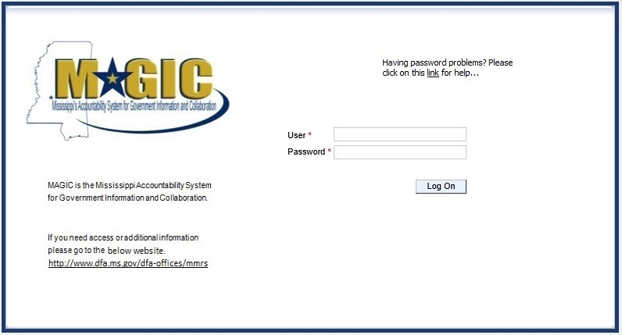

## View Available Reverse Auctions

### Search for Auction(s)

Listed below are the steps to search for a bid response.

1. **Bidders must first respond to the RFx (RFQF) to be able to participate in the Reverse Auction.** Instructions for creating a response to an RFx are available here, [RFx Response -Supplier Self Service.](http://uperform.magic.ms.gov/gm/folder-1.11.7512?originalContext=1.11.8507)

The RFx (RFQF)– Bid Specifications will provide details for qualifying criteria. Only bidders qualified through the RFx (RFQF) will be invited to participate in Reverse Auctions.

1. To search for auctions, click on the **Suppliers Self-Service** tab.
2. Select **RFx and Auctions** in the navigation menu on the left of the screen.
3. Select the **Published** link on the eAuctions line of the Active Queries section.

Note: If the search fields are not visible, click the  button to expand the search criteria.

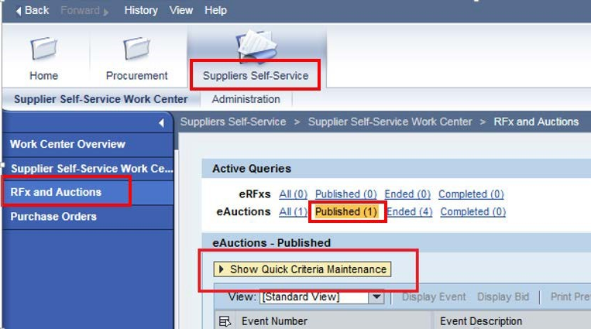

1. Enter the search criteria. To find all available bid opportunities, skip to step (f).

* 1. Select **All** or **Published** to search for available Events (eAuctions).

* 1. Enter the appropriate *Quick Criteria Maintenance* fields: **Event Number** (Auction number) or complete any optional relevant search criteria.

* 1. Click on **Apply** to view all Auctions based on your search criteria.

* 1. To generate an updated search using the same selection criteria, click **Refresh**

or skip to step (7).

1. Click **Apply** to find available bid opportunities.

1. In the results list, click on the **Event Number** to open the Auction details in a separate window.

(Pop-up blocker must be turned off.)

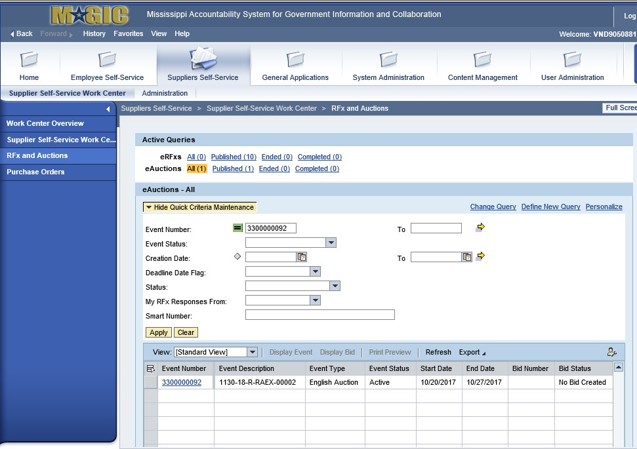

### Display Auction Details

Listed below are the steps view the auction details and information regarding the auction.

1.) The Auction Details screen will be displayed. It is important to review the details prior to the Auction begin time. Bidding will not be available prior to the Auction Start Date/Time.

The table below list the fields and a brief description of the information available on the Auction Parameters sub-tab of the Auction Information tab.

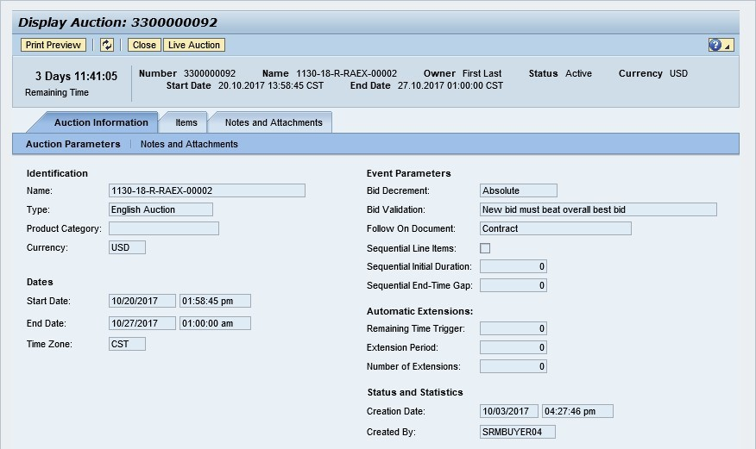

|  |  |  |
| --- | --- | --- |
| **Section** | **Field Name** | **Description** |
| Identification | Name | Smart Number with details related to the RFx |
| Type | English Auction is the standard for State of Mississippi |
| Product Category | The 5-digit NIGP code (optional) |
| Currency | US Dollar (USD) |
| Dates | Start Date | Begin Date and Time for the Live Auction |
| End Date | Date and Time of Live Auction completion |
| Time Zone | Central Standard Time (CST) |
| Event  Parameters | Bid Decrement | The amount/percentage by which the next bid must decrease relevant to the current lowest bid. |
| Bid Validation | Logic used to determine if the bid is valid. |
| Follow On Document | Contract or Purchase Order |
| Sequential Line Items | Enables sequential line item functionality to stagger end times. |
| Sequential Initial Duration | The amount of time in between each line item end time. |
| Sequential End-Time Gap | The time between item end times. |
| Automatic | Remaining Time Trigger | The time period before the end of the auction where an |

|  |  |  |
| --- | --- | --- |
| Extensions |  | extension can be triggered due to bid activity. |
| Extension Period | Number of minutes, for which the auction will be extended if a bidder submits an offer within the Remaining Time Trigger period. |
| Number of Extensions | The number of times an auction can be extended by bid activity within the Remaining Time Trigger. |
| Status and Statistics | Creation Date | The date and time the auction was created. |
| Created By | The User ID of the Agency Buyer who created the auction. |

### Display Line Items

Listed below is information regarding the line items associated with the auction.

1. Click the **Items** tab to view the line items.

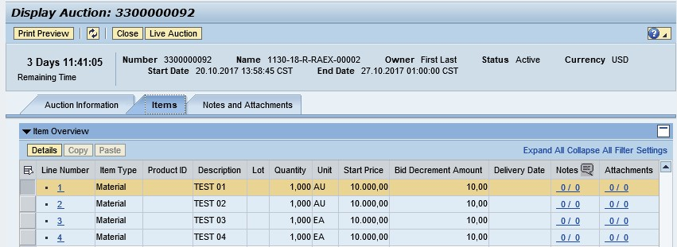

If the items are in **Lots**, the main items will be listed with individual lot items below.

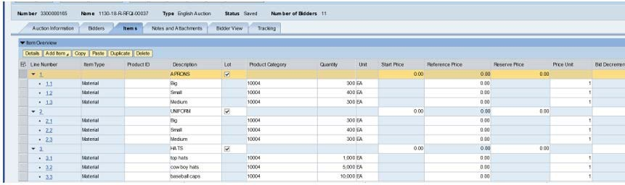

1. To view additional details for a line item, select the desired line and click the  button.



1. 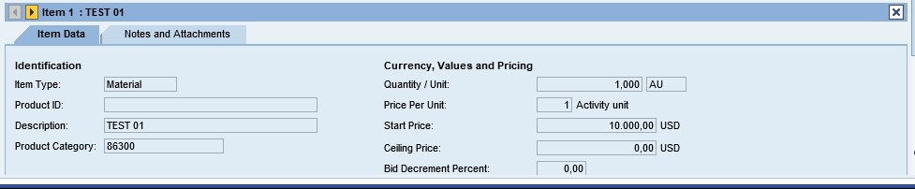The details for the line item will be displayed.

The table below list the fields and a brief description of the information available for each line item.

|  |  |  |
| --- | --- | --- |
| **Section** | **Field Name** | **Description** |
| Identification | Item Name | Type of item (Material) |
| Product ID | 11-digit material number |
| Description | Detailed description of the item |
| Product Category | The 5-digit NIGP code |
| Currency,  Values, and  Pricing | Quantity /Unit | The number of items / the Unit of Measure (i.e. EA for each) |
| Price Per Unit | The individual price based on the Unit of Measure indicated. |
| Start Price | Starting bid price of the item (Bids higher than the start price will not be accepted.) |
| Ceiling Price | Ceiling Price is not used. |
| Bid Decrement Percent | Bid decrement amount if percentage option is selected. |
| Bid Decrement | Bid decrement amount if dollar amount option is selected. |

### Display Notes and Attachments

Click the **Notes and Attachments** tab to view supporting documents and/or notes associated with the auction.

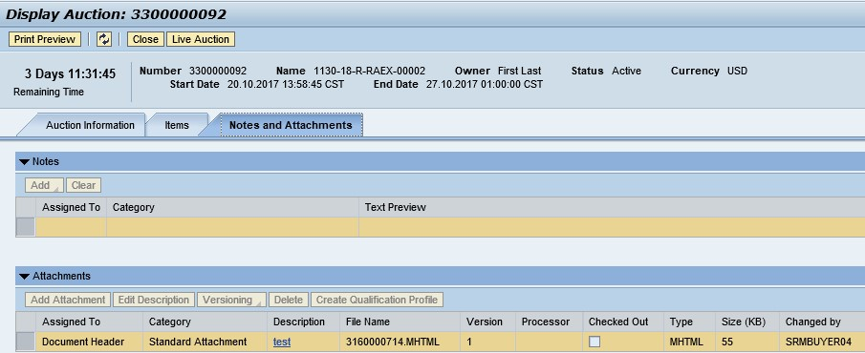

# Participating in a Live Auction

After completing the steps above to find a desired auction, the steps below can be used to participate in the Live Auction process.

1. With the Auction displayed, click the **Live Auction** button.

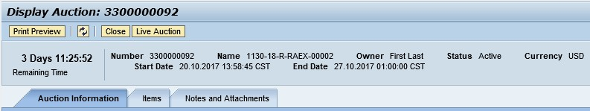

1. A pop-up window will appear containing Terms and Conditions to participate in the Live Auction. Review all terms and conditions. If you agree, click **Accept**. If you click **Decline** you will not be allowed to participate in the Live Auction.

If the agency did not establish Terms and Conditions this screen will not be displayed.

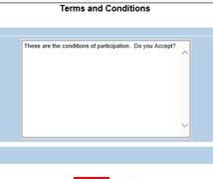

1. If any pop-ups appear asking for a confirmation to run the JAVA application, click **Run**.

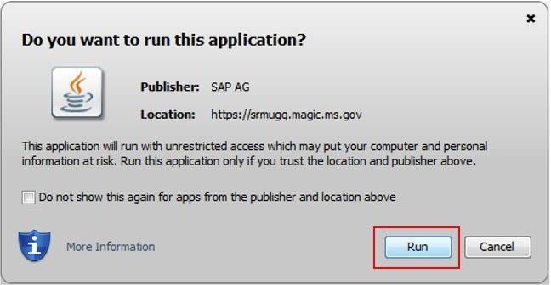

1. The Live Auction bidding screen will be displayed. If you receive any error messages, please ask your company’s system administrator to verify your computer’s technical requirements.

### Live Auction Cockpit

The Live Auction Cockpit will be displayed when the JAVA application has run.

Listed below is information regarding key items for the Live Auction Cockpit. The steps for submitting a response are located on the next page.

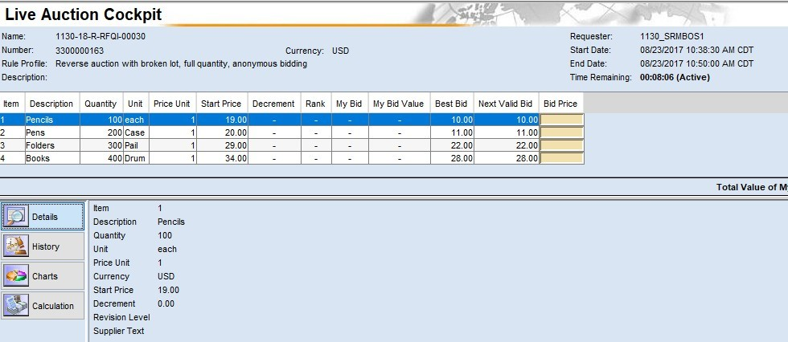

|  |  |
| --- | --- |
| **Field Name** | **Description** |
| Start Date | Date and Time the Live Auction starts |
| End Date | Date and Time the Live Auction ends |
| Time Remaining | The time remaining for the Live Auction |
| Description | Line item description |
| Quantity | Line item quantity |
| Unit | Line item unit |
| Price Unit | Line item price per unit |
| Start Price | The initial price for the line item. |
| Best Bid | The lowest bid that has been submitted, to date, for that line item. This field will be blank until the first bid has been submitted. |
| Next Valid Bid | The next price that is allowed to be bid for that line item. It is determined by subtracting the decrement amount from the best bid amount. |
| Bid Price | Your bid for the item. Your bid should be equal or less than the next valid bid field.    For instructions on how to enter your bid price, see the next page. |

**Submitting a Bid Response**

The steps below must be completed for each separate line item you wish to bid on.

1. Click desired line item.

1. Enter the price in the **Bid Price** field(s) for the items you wish to bid on.

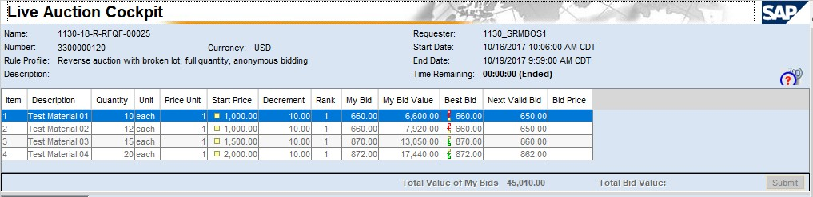

1. Click the **Submit** button. The submit button may be submitted after each line item price is entered or after you enter the price for all line items you wish to bid on.

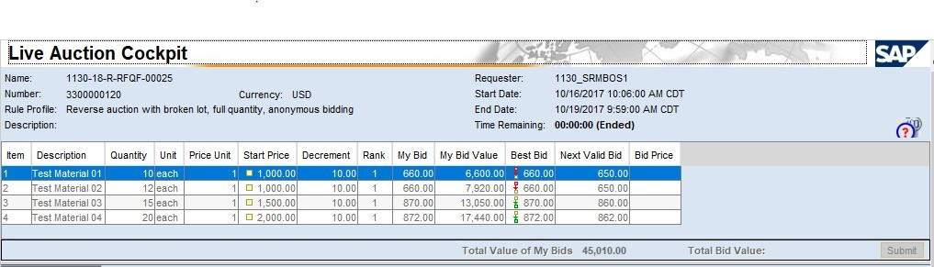

1. A confirmation pop-up window will be displayed. The bid value (by line item) will be display

the total of the Unit Price times the Quantity for that item. If the bid amount(s) are correct, click **Yes**. If the bid amount(s) are incorrect, click **No** and repeat the steps above to enter the correct bid amounts.

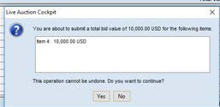

1. A confirmation of a successful bid submission will be displayed in the Chat Window.

Note: Erroneous bids may be deleted by the agency during the live auction.

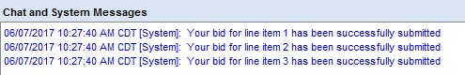

1. Repeat steps 1 – 5 for each desired line item.

### Chat and System Messages

The Chat and System Messages area is used for viewing chat messages from an agency buyer and information messages automatically generated by MAGIC.

Below are helpful hints in using the chat feature:

|  |  |
| --- | --- |
| **A bidder CAN:** | Send a message to an agency buyer.  Type the message in the message box and click **Send**. |
| See broadcast messages from the agency buyer to ALL bidders. |
| See messages regarding the status of the auction (e.g. paused, resumed, or extended) |
| **A bidder CANNOT:** | Send a message to other bidders of the auction. |
| See messages sent to an agency by other bidders. |
| See messages sent to other bidders from the agency buyer. |

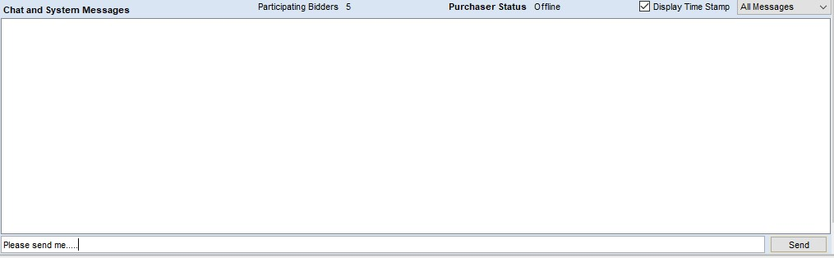

### 

### Pausing and/or Resuming an Auction

If necessary, the agency buyer can pause the Live Auction bidding. In such cases, the auction status will be changed from “Active” to “Paused”. A system alert will appear on the screen.

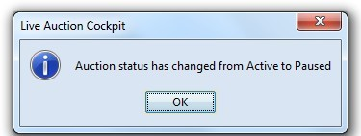

**The countdown clock will not stop running while the auction is paused. The time remaining and end date / time are not affected or extended automatically.**

When the agency buyer resumes the auction the auction status will be changed from “Paused” to “Active”. A system alert will appear on the screen.

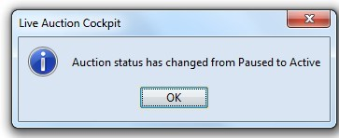

Once the auction has ended, a notification will display.

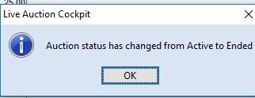

###### SECTION III-SPECIFICATIONS

#### ATTACHMENT A-SPECIFICATIONS CHECKLIST

###### The specifications set forth herein as “Section III” represent the minimum standard of oyster shell cultch needs of the MDMR. The bidder may propose options above and beyond these specifications that best suit MDMR’s interests as determined by the agency. The bidder agrees to complete the scope of services and all deliverables by September 14, 2018, unless additional time is approved in writing by the MDMR. Failure to do so may result in cancellation of award. If cancellation of award occurs, a new award will be made to the next lowest bidder meeting required specifications.

###### Bidders must furnish all information requested in the bid specifications. Further, when required, each bidder must submit for bid evaluation cuts, sketches, descriptive literature, samples and technical specifications covering the product offered. Reference to literature submitted with a previous bid or on file with MDMR will not satisfy this provision.

1. Respond “Yes” or “No” to indicate compliance to the specifications for each listed criterion and add comments as needed. Submit completed specifications checklist with bid package.

**Company Name: _______________________________________________________**



____________________________________________ ____________________

Signature Date

_________________________________________ ____________________________ Printed Name Title

#### ATTACHMENT B - BID COVER SHEET

The Mississippi Department of Marine Resources, on behalf of the State of Mississippi, is accepting bids for the furnishing and deploying of approved oyster cultch material.

Bids must be submitted by **2:00 p.m. CST on June 11, 2018**

**Name of Company:** ___________________________________________________________

**Quoted by:** __________________________________________________________________

**Signature:** ___________________________________________________________________

**Address: _____________________________________________________________________**

**City/State/Zip: _____________________________________________**

**Telephone:** ________________________________________________

**Fax Number:** ______________________________________________

**Email Address:** _____________________________________________

Name and phone number of company representative to be contacted by MDMR:

________________________________________________________________

In addition to providing the above contact information, please answer the following questions regarding your company:

What year was your company started? ________________________________________

Please provide the physical location and mailing address of your company’s home office, principal place of business, and place of incorporation.

________________________________________________________________________

________________________________________________________________________

________________________________________________________________________

________________________________________________________________________

**Company Name: _______________________________________________________**

Is your company currently for sale or involved in any transaction to expand or to become acquired by another business entity? If yes, please discuss the impact both in organizational and directional terms.

________________________________________________________________________

________________________________________________________________________

________________________________________________________________________

________________________________________________________________________

________________________________________________________________________

**Prior Project(s) of Comparable Complexity**

List prior experience furnishing and deploying cultch material using the methods described in this RFQF, including a description of the project, location, time-period for completion of the project, the actual completion date, and the reference (customer) for the project who may be contacted by MDMR. You must list a minimum of one project, but you may list more. You may use a supplemental sheet to describe the projects, if necessary.

Please provide current contact information as MDMR must be able to contact this reference. You may provide more than one reference, however, MDMR will only call the reference (Company Contact) listed below.

**Project Reference:**

Company Name: ________________________________________________________

Company Contact Name: __________________________________________________

Company Contact’s Title: __________________________________________________

Telephone: _______________________________

Email: _______________________________________________

Date Completed: ___________________________

Description of Scope: ­­­­___________­­___________________________________________

________________________________________________________________________

Location: _______________________________________________________________

Timeframe for Completion: _______________________________

**Company Name: _______________________________________________________**

If a bidder elects to participate via Surrogate Bidding, the bidder must be physically present at the public bidding location, with the means to submit written bids for each offer made and signed by an authorized agent of the Vendor. A Bid Form will be provided to the Vendor at the start of the auction. This form will not be returned to the bidder but will become a part of the Bid Documentation for Evaluation by the MDMR. Reverse Auction will be held at MDMR, 1141 Bayview Avenue, Biloxi, MS. 39530.

Bidders participating in person by surrogate bidding must so indicate in their initial response to the Request for Quote-Formal (RFQF).

Does your company intend to participate in person by surrogate bidding?

□ Yes □ No

#### ATTACHMENT C - BID FORM

**Company Name: _______________________________________________________**

Unit price per cubic yard $ ____________________________

Total cubic yards of oyster cultch _______________________

Bid price $__________________ (Total of (A) multiplied by (B))

By signing below, you certify that you have authority to bind the company, and further acknowledge and certify on behalf of the company:

1. That you thoroughly read and understand the Request for Quotes and its attachments.
2. That the pricing includes ALL associated costs with no additional or hidden fees.
3. That you meet all requirements and acknowledge all the certifications contained in the RFQF.
4. That you agree to all provisions of the RFQF, including the contract clauses in Section II-A.
5. That you will deliver the goods and perform the services required at the prices quoted above.
6. That, to the best of your knowledge and belief, the cost or pricing data submitted is accurate, complete, and current as of the submission date.
7. **NON-DEBARMENT.** By submitting a bid, you are certifying that you are not currently debarred from bidding by the State, any political subdivision of the State (towns, cities, counties, agencies, etc.), any other state, or the federal government. You also certify that you are not submitting a bid as an agent of someone so debarred.
8. **INDEPENDENT PRICE DETERMINATION.** You certify that you have not communicated with any other bidder or competitor regarding your bid or the price, your intention to submit a bid, or the factors you used to calculate the bid price.
9. **CONTINGENT FEES.** Have you retained a person to solicit or secure a state contract upon an agreement or understanding for compensation?

* Yes
* No

If yes, please explain:

_____________________________________________________________________

_____________________________________________________________________

**Company Name: _____________________________________________________________**

1. **GRATUITIES.** You represent that you have not violated, are not violating, and promise not to violate the prohibition against gratuities set forth in Section 9.105 of the Mississippi Procurement Manual available online at <http://www.dfa.ms.gov/dfa-offices/purchasing-travel-and-fleet-management/purchasing-and-travel/procurement-manual/>.
2. **ACKNOWLEDGMENT OF AMENDMENTS.** You acknowledge all amendments to this RFQF. Please list the amendments acknowledged by the amendment number and date:

__________________________________________________________________________________________________________________________________________________________________________________________________________________________________________

_______________________________________________ _____________________

Signature Date

___________________________________________ _____________________________

Printed Name Title

#### ATTACHMENT D – BIDDER CHECKLIST

|  |  |
| --- | --- |
|  | Initials |
| Prior Project(s) with Reference(s) Submitted |  |
| Registered with MAGIC |  |
| Technical Requirements met for Reverse Auction (unless planning to participate by Surrogate Bidding) |  |
| Amendments to RFQF acknowledged, if any |  |
| Attachment A, Attachment B, Attachment C and Attachment D signed |  |

Company Name: **_________________________________________________________**

Signed: _________________________________________________________________

Printed Name: ___________________________________________________________

Date: ___________________________________________

#### ATTACHMENT E

## Barge Measurement Method

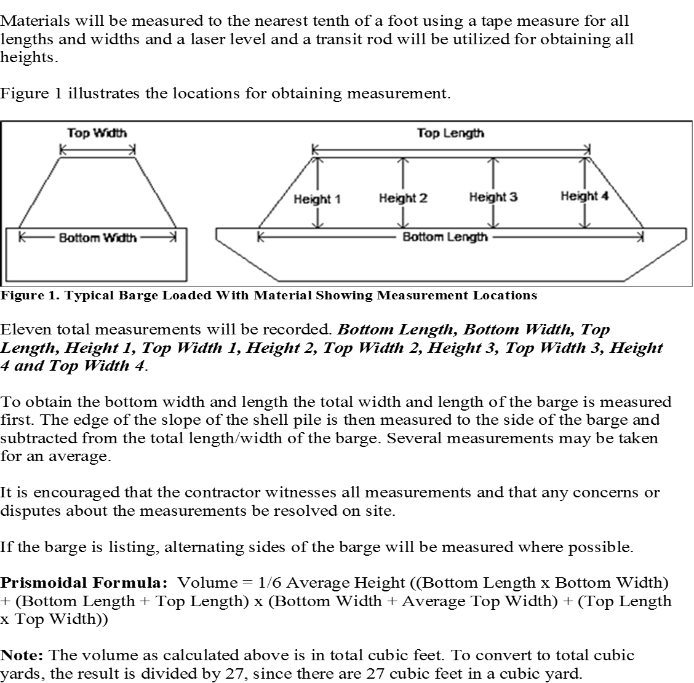

#### ATTACHMENT F

## Procedure and Equipment 1

#### ATTACHMENT G

## Procedure and Equipment 2

