Invitation: Sealed bids, subject to the conditions included in this Invitation for Bid (IFB), will be received in the Office of Category Management and Procurement at the University of Mississippi Medical Center (UMMC). All bids must be received in the Office of Category Management and Procurement on or before the bid opening time and date listed herein. Delivery of bids must be during normal working hours, 8:00 a.m. to 4:30 p.m. CST, except on weekends and holidays when no delivery is possible.
Advanced Interdisciplinary Patient Simulators, as further described in the Specifications section of Bid No. 7064, needed to assist UMMC in daily operations.

NOTE: Bid No. 7064 CONTAINS MANDATORY REQUIREMENTS TO WHICH NO EXCEPTION MAY BE TAKEN.

Invitation for Bid Number 7064
Opening Date: March XX, 2024 at 2:00PM CST
Advanced Interdisciplinary Patient Simulators
RFx: XXXX

Bidders shall submit their bids either electronically or in a sealed envelope. Sealed bids should include the bid number on the face of the envelope as well as the bidder’s name and address.

The following address should be used for submitting your bid:
The University of Mississippi Medical Center
Office of Category Management and Procurement
Jackson Medical Mall, Suite 1164
350 West Woodrow Wilson
Jackson, MS 39216

For electronic submission, the Bidder should go to: https://www.ms.gov/dfa/contract_bid_search

Online learning instructions on how to submit your quote electronically can be obtained by logging onto the Mississippi Management and Reporting System website at www.mmrs.state.ms.us/vendors/index.html, next, click on “Supplier Training”, and last, select the LOG820 Supplier Self Service Course link and then “launch Course”.

If you are having problems submitting your quote electronically, please contact the MAGIC Support Center at (601) 359-1343 or email at mash@dfa.ms.gov

SPECIAL INSTRUCTIONS:

IFB PREPARATION:
The information provided within this IFB is intended to assist Bidders in the preparation of a proper response. It is designed to provide interested Bidders with sufficient basic information to submit proposals meeting minimum requirements; it is not intended to limit a proposal’s content, or to exclude any relevant or essential information or data thereof. Bidders are permitted (and encouraged) to expand upon specifications to evidence service capability under any agreement.

The Office of Category Management and Procurement of UMMC is the issuing office for this document and all subsequent addenda relating thereto. The reference number for this transaction is Bid No. 7064. This number MUST be referenced on all Bids, correspondence, and documentation relating to this IFB.

The Bidder will absorb all costs incurred in the preparation of a bid.

Bidders are responsible for examining and following all specifications, terms, conditions, and instructions in the IFB. Failure to do so will be at the Bidder’s risk. Bidders may request in writing an interpretation or correction of any inconsistency or error within the invitation, which would be evident to any reasonably prudent Bidder. All such questions, in order to be considered, must be sent via email to John Shows at jashows@umc.edu and Kendra Carter at kcarter2@umc.edu at least (5) business days prior to the IFB closing date. Questions should be directed in writing or by email only; phone calls will not be accepted. Any unauthorized contact shall not be used as a basis for responding to this IFB and may result in the disqualification of the Bidder’s submittal.

Bidders are hereby informed that only the written interpretation or correction so given by the authorized UMMC representative, as noted above, shall be binding and prospective and that no other agent, or employee of UMMC is authorized to provide information concerning, or to explain or interpret the IFB, unless otherwise notified. Such interpretations or corrections, as well as any additional provisions that UMMC may decide to include, will be issued in writing as an addendum to the IFB documents and binding on all prospective Bidders. UMMC will make addenda available to all known prospective Bidders.

IFB RESPONSE OUTLINE
Bids must be written, concise, and in the format prescribed by this IFB. Pertinent supplemental information should be referenced and included as attachments. All proposals must be organized and tabbed to comply with the following sections, failure of which may be cause for rejection of Bid:

Proposal Form
The attached proposal form must be completed with Bidder’s proposed Bid and contact information, as well as any and all relevant information

Distribution
At UMMC’s discretion, Bidders may be required, as appropriate, to provide their product(s) through UMMC’s designated partner. Contact information for the designated distribution partner will be provided as appropriate.

Price List
Pricing Information to be submitted shall include the following:
- Brand: the brand name of the products being proposed
- Model Number: the model number of the product(s) being proposed
- Description: a brief, unique description of the product(s)
- Contract Purchase Price: the maximum price to be paid by state agencies and governing authorities during the term of the contract
- Discount: the percentage discount or range of discounts, off of the published price list, being offered for the products listed
- Unit of Measure: the amount or quantity in which the commodity will be received and for which the price is based (i.e. box, case, etc.)
- Global Trade Item Numbers (GS1 GTIN preferred), or another approved FDA UDI, if applicable
- United Nations Standard Products and Services Codes (UNSPSC), if applicable

Additional Information to be Included
In addition to answering each specification within this IFB, the Bidder must include complete product and service information, including product pictorials and technical and/or descriptive literature, relative to any product and/or service offered with the Bid. Information submitted must be sufficiently detailed to substantiate that the products and/or services offered meet or exceed specifications.

CONFIDENTIAL AND/OR PROPRIETARY INFORMATION
Bidders should mark any and all pages of the proposal considered to be proprietary information which may remain confidential in accordance with Miss. Code Ann. §§ 25-61-9 and 79-23-1 (1972, as amended). Each page of the proposal that the Bidders considers trade secrets or confidential commercial or financial information should be on a different color paper than non-confidential pages and can be marked in the upper right-hand corner with the word “CONFIDENTIAL”. Failure to clearly identify trade secrets or confidential commercial or financial information will result in that information being released subject to a public records request.
UMMC is a public agency of the State of Mississippi and is subject to the Mississippi Public Records Act, Miss. Code Ann. § 25-61-1, et seq. If a public records request is made for any information provided to UMMC regarding this IFB, UMMC shall promptly notify Bidders of such request. UMMC shall not be liable to Bidders for disclosures of information required by court order or required by law. UMMC also is subject to the provision of the Mississippi Accountability and Transparency Act of 2008, Miss Code Ann. § 27-104-151, et seq., and is required to provide public access to its financial information and expenditures through the Institutions of Higher Learning Accountability and Transparency website.

SCOPE OF WORK
The University of Mississippi Medical Center is seeking one (1) vendor to provide multiple patient simulators that can assist students with realistic training in a variety of general patient care exercises, such as ostomy management, oral hygiene, catheter and injection training, breast palpation and airway management, obstetric training of birth management with both manual and automatic delivery modes and neonatal training.
Bidder’s proposal should include a detailed discussion addressing specifications as listed below. If the response to a specification is simply “acknowledge,” Bidder should also provide evidence or examples from previous implementations of a similar nature. Bidder’s proposal must address in each response to specifications regarding system requirements and/or functionality whether the proposed system meets the specification in its existing released version or if the particular feature is under development for the proposed system.
Specifications marked “MANDATORY” are minimum requirements. Bidder may not take exception to these specifications. Failure to comply with mandatory requirements will result in invalidation of Bidder’s proposal.
The specifications listed below are not exhaustive and any additional specification of the Bidder’s product and services should be included in its proposal.
- SPECIFICATIONS

- System Components—Advanced Patient Simulator
  - Bidder’s proposal shall provide a detailed discussion regarding their simulator technical specifications and abilities related to an advanced patient simulator, but not limited to the following:
1.1.1 Bidder’s system must have the ability to provide simulated learning experiences such as airway management, spontaneous breathing, cardiac, and vascular real-time performance feedback and movement such as seizure activity, interactive eyes, and positioning of multipurpose patient simulator specifically designed to simulate lifelike cases across a broad range of clinical areas including Emergency Department (ED), and Operating Room (OR). (MANDATORY)
1.1.2 Bidder’s system must provide a preloaded tablet PC with the control software for the simulator to receive wireless commands. (MANDATORY)
1.1.3 Bidder’s system must provide a virtual patient monitor option on an “all-in-one” PC either through software license or the PC itself. (MANDATORY)

BASIS OF AWARD
The award of the Bid will be determined based on a two-step evaluation process as follows:
STEP 1 – VALIDATION
The first step will be to determine if the Bid is responsive and Bidder is responsible. To be responsive, the proposal must properly address all specifications and information needed to facilitate proper evaluation, including completion of the proposal form. Bids that are found not to adhere to the specifications will invalidated and rejected for evaluation.
STEP II – EVALUATION
The award of the Bid will be determined based on the lowest and best cost of the validated Bids as stipulated on the proposal from. Cost shall be determined as the total cost of the products requested at the quantity requested herein.

AWARD OF BID
The IFB will be awarded to the Bidder whose Bid, based upon the evaluation criteria listed in the scope of work of this request, is determined to be the most advantageous to UMMC and has been approved by the Mississippi Department of Finance and Administration (DFA). UMMC will issue a Notice of Intent to Award once the Bids have been evaluated.

INSTITUTIONAL OVERVIEW
UMMC is the state’s only academic health science center. The 164-acre campus located in Jackson, Mississippi, includes seven health science schools: Medicine, Dentistry, Health Related Professions, Population Health, Pharmacy, and Graduate Studies. The campus houses a large research center, a general acute care teaching hospital, and three specialty teaching hospitals. UMMC is the only Level I trauma center in the State of Mississippi and has a leading role in state wide emergency and disaster preparedness efforts.
UMMC conducts business in an ethical manner and in accordance with state purchasing laws. Therefore, please indicate clearly what you, as a Bidder, propose in response to this request and how it will benefit UMMC.

GENERAL INFORMATION

CONTRACTS
As an agency of the State, there are standard terms and conditions to which all Bidders must agree.
In addition, if the scope of work for this IFB involves the use of health information of UMMC patients, the Bidder must also sign and enter into a business associate agreement with UMMC, which can be found at https://www.umc.edu/Contracts/Resources-Forms.html.
The awarded Bidder may be asked to complete a vendor information packet. This information is necessary for the Bidder’s information to be uploaded into UMMC’s financial/business systems.
All proposals shall remain firm until the proposal has been rejected or, in the case of acceptance, until the Parties can negotiate the contract through their internal approval systems. UMMC reserves the right to reject and all proposals submitted. A contract will be awarded to the Bidder whose proposal, based upon the evaluation criteria listed in the specifications of this request, is deemed to be in the best interest of UMMC.
UMMC is governed by the Mississippi Board of Trustees of state Institutions of Higher Learning (IHL) and is subject to it approval for particular contracts. All contractual issues MUST be successfully negotiated with UMMC within a reasonable time from the selected Bidder’s notice of award. This initial period of negotiation does not include the time necessary for obtaining approval from IHL when applicable. The contract must be based upon the proposed contract provided in and considered during the evaluation of the proposal. Failure of the Bidder to negotiate a contract within this timeframe may constitute grounds for UMMC to withdraw its award and wither begin negotiations with any other ranked Bidder of purse other options, whichever is in the best interest of UMMC as an Institution of Higher Learning of the State of Mississippi.
In submitting a proposal, each Bidder acknowledges its understanding and acceptance of the procedures, terms and conditions contained herein, as well as of all attached documents including UMMC’s Standard Terms and Conditions. Any contract that is entered into as a result of this process will be based on the contents of this Invitation for Bid. Therefore, the contents of this IFB and your responses to it both now and during negotiations will be considered an integral part of the final contract.
A contract is not deemed final until it has been signed the Vice Chancellor of UMMC. All contracts are valid only if signed the Vice Chancellor of UMMC, and Vendors will be required to sign contracts before the Vice Chancellor of UMMC. All contracts are subject to availability of funds of UMMC are contingent upon receipt by the winning Vendor of a purchase order from UMMC.
The initial contract shall be in effect for one year. The contract may be terminated by either party prior to the expiration of one year with or without cause.

RIGHTS RESERVED BY UMMC

Right to remove Vendor’s employees – UMMC shall have authority to require a Contractor to remove, from the site, any employee of the Contractor who shall be deemed incompetent or detrimental to the best interests of the work of UMMC.

Right to conduct background checks/secure access – All individuals who work at any UMMC facility must have a background check in accordance with Mississippi state law. Therefore, UMMC reserves the right to required vendors whose employees will work at any UMMC facility to provide each such employee’s nine (9) digit social security number. The social security number will be used to conduct the background checks. The last four digits of the social security number will also be used to provide secure access to UMMC networks, should the scope of work to be performed by the vendor require such access.
In addition, UMMC reserves the right to require vendors, whose employees will be not be physically working at any UMMC facility but who will have access to our networks to provide the last four digits of each employee’s nine (9) digit social security number in order for UMMC to provide secure access into its network.

Right to award in whole or in part – UMMC reserves the right to award the Bid in whole or in part, whichever is deemed to be in the best interest of UMMC as an agency of the State of Mississippi. This IFB does not commit UMMC to contract for any requirements detailed in this document.

Right to reject any and all offers – UMMC reserves the right to reject any or all offers and to waive informalities in the proposal received. UMMC may deem proposals which meet any of the following criteria as nonresponsive and therefore disqualify the proposal/Bidder from consideration:
- Failure to follow specifications and instructions contained in the IFB;
- Failure to meet the announced requirements of UMMC in some material respect;
- Submission of a response that alters or limits terms contained in the IFB; or
- Submission of a response that UMMC deems to be unreasonable in terms, cost, etc.

Right to disclose Proposal Form – UMMC reserves the right to disclose the Bidder’s Bid Proposal From in response to a Public Records Request.

Right to share Award amount and successful Bidder’s name – UMMC reserves the right to disclose the winning amount and successful Bidder’s name to all responding Bidder’s.

Right to withdraw Award – UMMC reserves the right to withdraw any Award resulting from the IFB if, it its sole discretion, it would in UMMC’s best interest.

  - REQUIRED TERMS AND CONDITIONS
Any contract entered into between UMMC and bidder will include terms and conditions. Those terms and conditions will be negotiated until mutually beneficial. An example of the UMMC Standard Terms and Conditions can be found in Attachment A.

  - ATTACHMENTS
The attachments to this Invitation for Bid are made a part of this Invitation for Bid as if copied herein in words and figures. Attachment B must be completed and returned with the proposal.

USE OF SUBCONTRACTORS
No subcontractor shall be used without the prior written consent of UMMC.

REGISTRATION WITH VENDORMATE AND MAGIC
At the time the contract is awarded, the selected Bidder becomes a vendor of UMMC. All vendors are required to register with the UMMC vendor credentialing system, GHX VendorMate, which requires a fee for registration at the expense of the vendor. GHX Vendor Mate registration can be completed on line at https://registersupplier.ghx.com/reg/network/vendor.
Vendors will be expected to register with the Department of Finance and Administration (DFA) for purchases for all State agencies. Registration can be completed online at
http://www.dfa.ms.gov

COMMUNICATIONS WITH THE STATE
From the issue date of this IFB until a Bidder is selected for award and such selection is announced, neither Bidders nor their representatives may communicate either orally or in writing regarding this IFB with any statewide elected official, state officer or employee member of the legislature or exception as noted herein. This directive is meant to ensure fair an unbiased selection of a Bidder. To ensure equal treatment of each responding Bidder, all questions regarding this IFB must be submitted in writing to the contact persons listed in Section 1 of this IFB.

By signing below, the Bidder Representative certifies that he/she has authority to bind the company, and further acknowledges on behalf of the company:
- That he/she has thoroughly read and understands this Invitation for Bid, 7064, Patient Simulators, and the attachments herein;

- That the Bidder meets all requirements and acknowledges all certifications contained in this Invitation for Bid, 7064, and the attachments herein;

- That the Bidder agrees to all provisions of this Invitation for Bid, 7064 and attachments herein;

- That the Bidder has, or will secure, at its own expense, applicable personnel who shall be qualified to perform the duties required to be performed under this Invitation for Bid.

Printed Name: ____________________________________________________________________

Signature/Date: ____________________________________________________________________

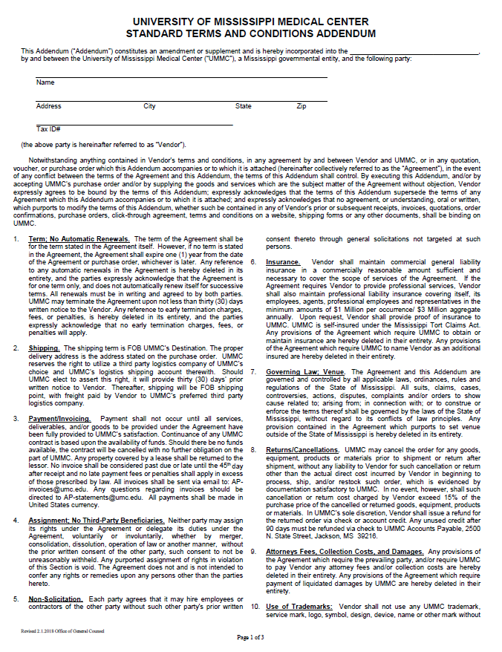
ATTACHMENT A
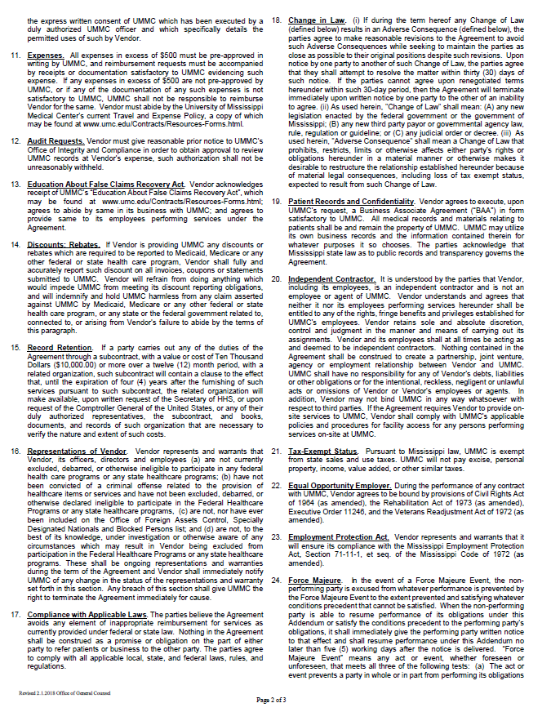
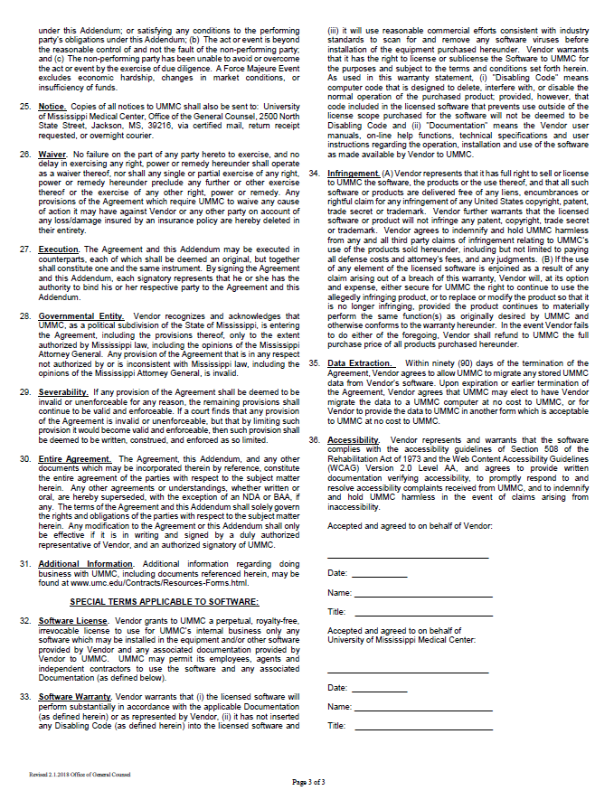

ATTACHMENT B
BID# 7064 PROPOSAL FORM

Date:

Proposal From:
(Bidder)
Office of Category Management and Procurement
Jackson Medical Mall, Suite 1164
350 West Woodrow Wilson
Jackson, Mississippi 39216-4505

RE: University of Mississippi Medical Center
Patient Simulators
IFB # 7064

Having carefully examined the Bid Documents and all addenda, I, the undersigned, propose to furnish all products, materials, and services required by the Bid Documents in accordance with the conditions of said Bid Documents for the sums set forth below:
BASE BID: $__________________________________________
Certification of Authority to Sell:
The Bidder is certified with Mississippi Secretary of State Office and is authorized to sell, deliver items or perform services within the state of Mississippi (yes/no answer required)
____ Yes
____ No
Provide Mississippi Business Identification Number: ________________
I (We) agree to hold our bid open for acceptance for one year from the date of bid opening. I (We) agree that this Proposal Form may be disclosed in full in response to a public records request. I(We) agree that if I(we) are the winning Bidder, the Base Bid above and our name shall be disclosed to all responding Bidders in the Notice of Award.
I (We) attest that I (we) are either a manufacturer or an authorized distributor/reseller of the commodities and/or equipment for which UMMC is seeking bids. If I (we) are a distributor/reseller, I (we) have included documentation with this bid proposal documenting that I (we) are an authorized distributor/reseller of said commodities/equipment.

Our Corporation is chartered under the laws of the State of , and the names, titles and business addresses of the principal officers are as follows:

Name Title

Address

Name Title

Address

(TO BE FILLED IN IF A PARTNERSHIP)

Our Partnership is composed of the following individuals:

Name Title

Address

Name Title

Address

Please provide directions for sending notice of acceptance of the bid (mail, email, delivery, etc.).

EMAIL: ___________________________________________________

TITLE: ____________________________________________________

SIGNATURE: ______________________________________________

