Mississippi Department of Marine Resources

SOLICITATION: | Invitation for Bids (IFB)
SOLICITATION NUMBER: | 3160003622
DESCRIPTION: | Rehabilitation and Land Restoration of the Clower Thornton Nature Area
ISSUE DATE: | May 18, 2020
BID CLOSING LOCATION: | Mississippi Department of Marine Resources  1141 Bayview Avenue  Biloxi, Mississippi 39530
BID COORDINATOR: | Rick Kinnard  (228) 523-4147  procurement@dmr.ms.gov
CLOSING DATE AND TIME: | June 18, 2020 2:00 PM CST
- INTRODUCTION
The Clower-Thornton Nature Area is an approximate 17.5-acre remnant patch of southern mixed hardwood forest within the urban setting of Gulfport, Mississippi. This site is owned by the City of Gulfport and is managed by the Gulfport Parks and Recreation Department. This renowned birding site is listed on the Audubon Mississippi Coastal Birding Trail and has a well-maintained hiking trail along Coffee Creek that is located on the western side of the property.
Coffee Creek flows through the entirety of the property from north to south and ultimately drains into the Mississippi Sound to the south of the park. After many years of neglect, the property has become overgrown and infested with invasive and/or nuisance native vegetation. The topography of the property is largely defined by the waterways that run through the area including Coffee Creek and small tributaries that vary in size. The largest tributary comes into Coffee Creek from the east in the northern part of the property. Elevation ranges from 1.5 ft to 23 ft.
An ecological assessment and inventory of the property was recently completed by Cypress Environment and Infrastructure. Their assessment (Attachment A) will form a part of this proposal request and ensuing contract. It identified Chinese tallow Triadica sebifera), Chinese privet (Ligustrum sinense), camphor tree (Cinnamomum camphora), Japanese climbing fern (Lygodium japonicum), Japanese honeysuckle (Lonicera japonica), alligatorweed (Alternanthera philoxeroides), taro (Colocasia esculenta), and canna lily (Canna sp.) as the primary harmful invasive species.
The contractor will also remove existing debris within the project boundary and properly dispose of all materials as work progresses. Debris includes but is not limited to the following:
Encampments and trash that exist on the property;
Remnants of the old baseball field (backstop, light poles, etc.) located in the Pine Forest, and;
Two existing wooden walkways that must be removed from the property – one located in the area defined in the central portion of the area defined as “Bottomland Forest”. This structure spans the edge of the “Live oak Forest” to within 15-feet of the creek. The other walkway is located within the northeast corner of the “Bottomland Forest” – this one will be rebuilt in its original location per drawing and specifications in Attachment B.
The MDMR is requesting services to fulfill the scope and deliverables listed within this solicitation. The intent of a contract resultant from this solicitation is to secure chemical, mechanical and manual applications and techniques during a period of time when environmental conditions and target species phenology are most favorable to ensure elimination and/or control of designated non-native invasive vegetation and tree removal. As well as the removal of listed debris and reconstruction of stated boardwalk.
- PURPOSE
The MDMR is issuing an Invitation for Bids (IFB) to establish a contract with an individual, entity, or firm to rehabilitate and restore this +/- 17-acre parcel known as the Clower-Thornton Nature Area.
Treatment methods will include mechanical mulching of the of the dense understory, removal of all larger invasive and non-native trees and shrubs, chemical herbicide treatment of non-native species, manual clearing of nuisance species, selective clearing and limbing up of remaining trees and shrubs, bush hogging, planting of native vegetation, along with any necessary erosion control measures that may be needed. This project is envisioned to last for three years with the majority of the heavy clearing work, debris removal, and construction activities occurring in Year 1 followed by regularly scheduled maintenance visits to mechanically and chemically treat new growth for the remaining two years.

All Offeror’s must submit bid to include, at a minimum, the following:
- Method(s) of treatment and removal of the identified and targeted species specified in the Cypress report for the entire +/-17 acres, including herbicides and/or mechanical techniques that will be used to achieve control/reduction of existing infestations of invasive species and overgrown areas;
- Site logistics plan indicating equipment laydown and staging areas, transportation methods, construction matting of wet areas, removal and disposal of non-mulched materials and access points to complete the work.;
- Timing and anticipated scheduling of work to be performed;
- Coordination and timing of the removal of debris and reconstruction of the wooden walkway;
- Emergency spill plan;
- Biosecurity plan to prevent the introduction and spread of invasive species; and,
- An acceptable weather conditions plan.
A contract may be awarded to the individual, entity, or firm, determined to be the most advantageous to the MDMR and the State of Mississippi. The scope of work to be performed and the deliverables required under the contract are set forth herein.

- CONTACT PERSON AND QUESTIONS/REQUESTS FOR CLARIFICATION
All questions and requests for clarification must be submitted by email to: Rick Kinnard at procurement@dmr.ms.gov. Contact with anyone other than the Procurement Staff regarding this IFB may result in Bidder disqualification.
All questions/requests for clarification must be received no later than June 1, 2020 at 10:00 a.m. CST.
All questions/requests for clarification and the answers thereto will be published on the MDMR website at dmr.ms.gov and the MAGIC Portal at ms.gov/dfa/contract_bid_search/Bid for all Bidders to view by June 2, 2020 at 4:00 p.m. CST.
MDMR has entered into a services contract with Covington Civil and Environmental to perform all engineering, field observation, and project management on its behalf for the life of this project. The primary contact for Covington can be reached at bob.gist@ccellc.us.

- TIMELINE

Start Date  - First Date of Advertisement:  - Second Date of Advertisement | May 19 , 2020  May 26, 2020
Questions Submission Deadline  Answers Posted | June 1, 2020 10:00 AM CST  June 2, 2020 4:00 PM CST
Pre Bid Meeting (Contact Information Below) | May 27,2020 10:00am
Bid Submission/Bid Opening Deadline | June 18, 2020, 2:00 PM CST
Bid Evaluations | June 19, 2020
Contract Intent to Award | June 22, 2020
Contract Approval | Unexecuted contract will require additional approval from DFA before it is awarded.

- SCOPE OF SERVICES
The scope of work for the contract will include, but is not limited to, the following:
- The Cypress Ecological Assessment report dated 2/3/2020 (Attachment A) shall be used as the basis for determining the quantity and type of invasive species that will be required to be treated and removed from the entire project area.
- The steep slope located just west of the creek on the western edge of the property will require brush cutter, weed eater and chemical treatment to be performed at the direction of the engineer and shall be considered work to be accomplished under the base bid.
- The area delineated as the pine forest will require what is normally called a “residential thinning” and when complete will result in an approximate density of 30 – 40 remaining trees to be established between the contractor and the engineer. This work is in addition to invasive removal and shall be considered work to be accomplished under the bid.
- No mechanical equipment will be allowed within the Coffee Creek waterway. All in water work will be confined to chemically treating the alligator weed with the suggested chemicals.
- Contractor will be allowed to bring in a portable mulcher for in-place mulching if desired. Mulch piles will be required to be evenly spread upon completion. All trees and vegetation not mulched, including previously fallen timber, will be required to be removed from site.
- All felled trees will be required to be cut no more than 1” above the surrounding ground surfaces and stumps must immediately be chemically treated with the suggested chemicals.
- All equipment used by the contractor must be suited for the activity being performed and shall not cause any larger footprint than necessary. Wide track low impact machines are expected in all wet areas - if they are even accessible. Long lasting and detrimental impacts to the bottomlands by equipment will not be allowed.
- Equipment access to the western most asphalt walking trail within the park will be off limits. Site access must be obtained from the east and north sides of the project area. Any damage caused by the contractor to existing asphalt walkways or lawn areas must be repaired to the satisfaction of the engineer at the completion of the project.
- An all-inclusive allowance has been established on the bid form for potential future plantings and park amenities as needed to compliment this restoration effort. Plant selections and planting areas, along with amenities, will be established by the engineer.
- Contractor is to remove existing debris within the project boundary and properly dispose of all materials as work progresses. Debris includes but is not limited to the following:
  - Encampments and trash that exist on the property;
  - Remnants of the old baseball field (backstop, light poles, etc.) located in the Pine Forest, and;
  - Two existing wooden walkways that must be removed from the property – one located in the area in the central portion of the area defined as “Bottomland Forest”. This structure spans the edge of the “Live oak Forest” to within 15-feet of the creek. The other walkway is located within the northeast corner of the “Bottomland Forest”.
- Contractor will reconstruct a boardwalk located within the northeast corner of the “Bottomland Forest” – this will be rebuilt in its original location as shown in the drawing and construction specifications in Attachment B.

3 Year Treatment Process:
- Year 1 – Mechanical and chemical treatment of all invasive species listed on Table 1 – Management Unit Description Summary Table – in the Cypress assessment (Attachment A) will be required. All tree and shrub species smaller than 4” diameter breast height(“dbh”) encountered during mechanical mulching operations will be mulched whether they are considered invasive or not. Once mechanical mulching operations are underway selective clearing for all trees larger than 4” dbh will be as directed by the engineer. The treatment shall result in a minimum rate of 95% of original infestation treated per parcel (*treated, not controlled). Contractor will remove debris as stated and reconstruct a boardwalk located within the northeast corner of the “Bottomland Forest” – this will be rebuilt in its original location as shown in the drawing and construction specification in Attachment B. Engineer’s personnel reserve the right to accompany the field crew on any workday to observe treatment methods, confirm the quality of work and to photograph the activities.
- Year 2 – Bush hog all upland and hand-clear bottomland areas in the spring and fall time frames. Perform chemical treatments and brush cutter work on a monthly maintenance cycle beginning March 15 thru October 15 in year 2.
- Year 3 – Bush hog uplands and hand-clear bottomland areas once in the early summer in all areas showing unmanageable growth. Continue chemical treatments on a every other month cycle beginning March 15 thru October 15.
Special Provisions:
- The Contractor shall furnish all necessary labor, equipment, supplies, permits, licenses, certifications, supervision, transportation, and incidentals to perform all chemical and/or mechanical applications necessary under the terms of a contract.
- The Contractor will perform all treatments in accordance with the US Environmental Protection Agency regulations to maximize effectiveness of treatments while minimizing effects on surrounding habitat and non-target species.
- The Contractor will strictly adhere to all herbicide label application, precautionary and safety statements, and shall be liable for damage due to an herbicide spill or contamination.
- All equipment including, but not limited to, vehicles, trailers, ATV’s, and chippers must be cleaned with a pressure washer to reduce the spread of exotic vegetation prior to initiating work activities on public lands. Decontamination protocols include spraying down all equipment surfaces, including the undercarriage and tires, to ensure that mud, sand, dirt, muck and vegetative debris and any other debris are not transported from the previous treatment site. All hand-held equipment such as chain saws, loppers, etc. used for treatment activities must be wiped down and cleaned so that they are free of debris.
- All equipment used shall be in good repair and operating condition at all times and be in compliance with all federal, state, and local regulations. All equipment shall meet all safety standards as established for that piece of equipment. All equipment shall be operated and maintained in accordance with the manufacturer’s recommendations. All equipment shall be equipped with all appropriate safety guards, as specified by the manufacturer. The Engineer reserves the right to request replacement of equipment or personnel if deemed to be unsafe or operating in an unsafe manner.
- The Contractor shall be responsible for any repairs, replacements, or restoration to original condition on all property damaged as a result of any activity by the Contractor, to the satisfaction of the MDMR. This includes, but is not limited to, soil grade disturbance resulting from heavy equipment, damaged pavement surfaces, turf areas, man-made structures, and the like.
- The Contractor shall be responsible for immediate work stoppage and clean-up operation in the event of any spill of herbicide, petroleum product or other hazardous material. The Contractor shall report any such incident to the Engineer immediately.
Trees and debris must be prevented from falling into Coffee Creek, or onto walking paths, roads, and adjacent private properties. If this occurs, work must cease until the tree or debris is immediately removed from the adjacent property, road or canals or any such area where it is not desirable. No tree should be treated and left standing if it is possible it could fall into a waterbody, road, or adjacent property at a later date.

- DELIVERABLES
The deliverables are to include:
- Within fifteen (15) calendar days of a fully executed contract, the Contractor must meet with Engineer and MDMR staff to discuss the project and determine the most advantageous time to begin work.
- Contractor must notify Engineer’s personnel each day prior to beginning work on any treatment area. Notifications must include the site location(s), name and phone number for the field supervisor and the estimated arrival and departure time for each site. Notifications must be sent either the day before, or on the same day of work, as long as notifications are sent before work commences. Engineer’s personnel must also be notified in the event work is cancelled due to weather or any other circumstances. Failure to comply with these notification requirements may result in early termination of the contract.
- The Contractor will submit monthly progress reports by the 25th of each month. Reports should include a GIS map showing the size and location of the treated area(s), as well as a daily log of herbicide application and/or mechanical treatment by site and species. All progress reports must be submitted to Covington Civil and Environmental at bob.gist@ccellc.us. Failure to submit reports to the Engineer will result in a delay of payment.
- Within 1,095 days from the date of a fully executed contract, the project must be completed.
- MINIMUM REQUIRED QUALIFICATIONS
The minimum qualifications for bidding include:
- Certifications – Bidderr’s site manager(s) and/or supervisor(s) who will be assigned to work on the project must possess and maintain a valid Mississippi Commercial Pesticide Applicator Certificate. A copy of the Mississippi Commercial Pesticide Applicator Certificate for each such site manager and/or supervisor must be submitted with the proposal. For more information concerning the Mississippi Commercial Pesticide Applicator Certificate contact:
Mississippi Bureau of Plant Industry
P.O. Box 5207, Mississippi State, MS 39762
Telephone: 662-325-3390
- Experience – Bidder must have completed a minimum of two (2) projects of comparable scope, size and complexity to the Scope of Work herein. These projects must have been within the past five (5) years and demonstrate a successful history of invasive plant eradication and construction experience, unless the Bidder intends to subcontract the construction portion of the contract. In the event of a sub-contractor being used for the construction portion of the contract, the sub contracted vendor must have the necessary experience and successful history of construction projects of comparable scope, size and complexity in the Southeastern United States. Bidder must provide the project name, location, date, client contact, species targeted, summary of methods used and approximate area of project.

- BASIS FOR AWARD
The MDMR will award the bid to the lowest responsive, responsible bidder who meets all required specifications, subject to approval by the Public Procurement Review Board, if necessary. The MDMR reserves the right to reject any and/or all bids and waive minor informalities which do not affect quality, quantity, price or delivery.
- INSURANCE REQUIREMENTS
In order to enter into a contract, you must meet minimum insurance protection requirements. You must provide evidence of your policies within ten (10) calendar days of a fully executed contract.
All insurance policies must be issued by companies licensed or holding a Certificate of Authority from the Mississippi Department of Insurance. All liability insurance policies must provide coverage to the MDMR as an additional insured.

You must hold the following insurance throughout the term of the contract:
Coverage Type | Amount
Workers’ Compensation (as required by Mississippi law)
Accident (Per Occurrence) | $100,000
Disease-Policy Limit | $500,000
Disease-Per Employee | $100,000
General Liability
Aggregate | $1,000,000
Personal Injury/Bodily Injury and Property Damage (Per Occurrence) | $500,000
Fire Damage (Per Fire) | $50,000
Medical Expense (Per Person) | $5,000

- BOND REQUIREMENTS
You must provide certain bonds within ten (10) calendar days of a fully executed contract. All bonds must be corporate surety bonds issued by a surety company authorized to do business in Mississippi. MDMR must be named as exclusive beneficiary. This project requires the following bonds:
Performance Bond. You must provide a performance bond for 100 percent of the bid. The bond helps guarantee timely and complete performance of the project.
- Alternative Surety. A certified check for cash escrow deposit in the face amount of the contract such as a personal bond, property bond, or a bank or savings and loan association letter of credit may be tendered in lieu of a performance bond subject to approval by the MDMR attorney.
Payment Bond. You must provide a payment bond for 100 percent of the bid. The bond guarantees payment of all workers, subcontractors, and material suppliers for this project.
- BID SUBMISSION INSTRUCTIONS
You are required to electronically register in Mississippi’s Accountability System for Government Information and Collaboration (MAGIC), and you may submit your bid electronically through MAGIC, or you may submit your bid by paper submission via mail or hand delivery to MDMR as outlined below:
Vendor Electronic Registration in MAGIC:
- It shall be the responsibility of each bidder to ensure that its vendor profile is current in the MAGIC system. The website to register as a vendor with the State of Mississippi is: http://www.dfa.ms.gov/dfa-offices/mmrs/mississippi-suppliers-vendors/ .
- For online learning instructions on submitting your bid electronically, select “Supplier Training” from the link listed above. Select the LOG820 Supplier Self-Service Course link and then click “Launch Course.”
- If you have problems getting on the website, please contact the Mash Helpdesk at (601) 359-1343 or mash@dfa.ms.gov. You must receive a User ID and Password to access the MAGIC portal. This process could take up to 72 hours to complete.
MAGIC Submission and Technical Requirements
- The bid submission must be submitted in MAGIC no later than 2:00 PM CST, June 18, 2020.
- Timely submission of the bid is the responsibility of the bidder. Bids received after the specified time will be rejected and the unopened bid will be made a part of the procurement file. It is suggested that you allow 72 hours before the due date and time for submission of the bid in MAGIC, especially if you are a first-time user.
Paper Bid Submission Requirements
- The bid submission must be signed and submitted in a sealed envelope. It must be submitted to MDMR Procurement Department, 6th Floor, at 1141 Bayview Avenue, Biloxi MS 39530 no later than 2:00 PM CST, June 18, 2020.
- Timely submission is the responsibility of the bidder. Submissions received after the specified time will be rejected and the unopened bid will be made a part of the procurement file.
- The time and date of receipt will be indicated on the envelope or package by the MDMR staff.
- All prices and notations must be printed in ink or typewritten. No erasures permitted. Errors may be crossed out and corrections printed in ink or typewritten adjacent and must be initialed, in ink, by the person signing bid.
- Submissions via facsimile (faxes) or email will not be accepted. It is suggested that if a submission is mailed to MDMR, it should be posted in certified mail with a return receipt requested. MDMR will not be responsible for mail delays or lost mail.
- All Bids submitted by hand delivery or mail will become the property of the MDMR.
- Bids should be mailed, or hand delivered and must be labeled as follows:

Rehabilitation and Land Restoration of the Clower Thornton Nature Area

RFx No. 3160003622
Smart No. 1450-20-R-IFBD-00006
Opening Date: 2:00 PM CST, June 18, 2020
Attention MDMR Procurement Department 6th Floor
1141 Bayview Avenue Biloxi MS 39530
SEALED BID – DO NOT OPEN
The deadline for receiving Bids is June 18, 2020 at 2:00 p.m.
Late submissions will not be accepted.
- AMENDMENTS TO THIS IFB
Should an amendment or amendments to this IFB be issued by MDMR, it will be posted on the MDMR website dmr.ms.gov and on the Mississippi Contract Procurement Opportunity Search Board (Procurement Portal) website ms.gov/dfa/contract_bid_search/Bid in a manner that all bidders will be able to view. Furthermore, bidders must acknowledge receipt of any amendment to this IFB by signing and returning the amendment with the bid submission, or by identifying the amendment number and date in the space provided for this purpose on the Bid Form-Attachment D, or by letter. The acknowledgment must be received by the MDMR by the time and at the place specified for receipt of Bids. It is the bidder’s sole responsibility to monitor the website for amendments to the IFB.
- QUESTIONS/REQUESTS FOR CLARIFICATION
All questions and requests for clarification must be submitted by email to: procurement@dmr.ms.gov. All questions/requests for clarification must be received no later than June 1, 2020 at 10:00 a.m. CST.
All questions/requests for clarification and the answers thereto will be published on the MDMR website, dmr.ms.gov, and the MAGIC Portal http://www.dfa.ms.gov/dfa-offices/mmrs/mississippi-suppliers-vendors/ in a manner that all bidders will be able to view by June 2, 2020 at 4:00 p.m. CST.
A Pre-Bid Meeting will be held at 10:00 a.m., May 27, 2020, online utilizing GoTo Meeting and can be accessed here, or by phone at +1 (872) 240-3412; access code: 633-708-797. The purpose of the pre-submittal conference is to allow potential offerors an opportunity to present questions to staff and obtain clarification of the procurement requirements.

The MDMR will not be bound by any verbal or written information that is not specified within this IFB unless formally noticed and issued by the contact person.

- TERM OF CONTRACT
The start date for the contract is the date the contract is signed by the selected bidder and the Executive Director of the MDMR. The end date is 1,095 days from the start date. The contract may be extended subject to the availability of funds and at the sole discretion of the MDMR with the agreement of the Contractor. Any contract renewal or extension shall be under the same pricing, terms, and conditions as in the original contract, and shall be agreed to, in writing, by the MDMR and the Contractor.

- REQUIRED DOCUMENTS FOR BIDDING
All bids must include the following:
- Attachment C—Bid Cover Form completed and signed;
- Attachment D—Bid Form completed and signed; and,
- Attachment G—Bidder’s Checklist completed and signed.
Use the bid form to identify your best price. You must identify your company’s name on each page of the bid form, and each of the attachments. Complete all of the blanks and sign the form.
You must use the bid form. Submissions without a bid form will be rejected as nonresponsive. Do not amend or add to the bid form. We may reject modified bid forms as nonresponsive on a case-by-case basis.
You are responsible for the costs of preparing your bid. We do not accept liability for such expenses.
Any bidder claiming that its bid contains information exempt from the Mississippi Public Records Act (Miss. Code Ann. § 25-61-1, et seq.), shall segregate and mark the information as confidential and provide the specific statutory authority for the exemption. The bidder must submit all attachments. Requests to review proprietary information will be handled in accordance with the Mississippi Public Records Act.
- CONDITIONS OF SOLICITATION
When you submit a bid, then you promise that you will accept an award if offered. You also certify that you have not communicated with any other bidder or competitor regarding your bid or the price, your intention to submit a bid, or the factors you used to calculate the bid price. You can read more about your certifications on the Bid Form, Attachment D.
The MDMR reserves the right to reject any and/or all bids and waive any minor informality.

BID PROTESTS
When all Proposals have been read and recorded, should a Bidder wish to protest, the Bidder should rise and announce to all present the protest. All protest, after being made verbally, must be made in writing to the Bureau no later than twenty-four (24) hours following the bid opening. The letter of protest should be addressed to the Bureau of Building, Grounds and Real Property Management's
Director. It should identify the Project, include what is being protested, why it is being protested, and be signed by the individual who is protesting. Protestors may be required to appear at the next PPRB meeting and personally present their protest. The Bureau is under no obligation to consider any protest received after twenty-four (24) hours. This includes a protest made by anyone regardless of whether they attended the bid opening. (B.O.B. Manual Section 600.51)

POST AWARD VENDOR DEBRIEFING
The vendor may request a post-award debriefing, in writing, by U. S. mail or electronic submission. The request must be made within three (3) business days of notification of the contract award. A debriefing is a meeting and not a hearing. Therefore, legal representation is not required. Should the vendor prefer to have legal representation present, the vendor must notify the MDMR and identify the attorney. The MDMR shall be allowed to schedule and/or suspend and reschedule the debriefing at a time when a representative from the Office of the Mississippi Attorney General can be present.

NOTIFICATION OF INTENT TO AWARD
Notification will be sent to all bidders by mail and/or email of the selection of the successful bidder. We will also post the selection of the successful bidder on our website at www.dmr.ms.gov. Work is expected to begin within 15 calendar days of receipt of a fully executed contract.
- GOVERNING LAW
This solicitation and any resulting contract shall be governed in all respects by the laws of the State of Mississippi, excluding its conflict of laws provisions, and any litigation with respect thereto shall be brought in the courts of Biloxi, Harrison County, Mississippi.
- RELATIONSHIP OF PARTIES
It is expressly understood and agreed that if MDMR enters into a contract with a bidder, it does so based on the purchase of commodities or services and not based on an employer-employee relationship or a joint venture relationship.
- CONTRACT ADMINISTRATION
The contract awarded, if any, subsequent to this solicitation shall be administered by the MDMR. All invoices submitted by the Contractor for goods received or services provided pursuant to the contract shall be submitted as follows:
By Mail: Mississippi Department of Marine Resources, Procurement Department, 1141 Bayview Avenue, Biloxi, Mississippi 39530
By Email: Procurement@dmr.ms.gov
The MDMR will provide timely payment in accordance with Section 31-7-301, et seq. of the Mississippi Code Annotated, which generally provides for payment by the MDMR within forty-five (45) days of receipt of an approved invoice. The Contractor understands and agrees that MDMR is exempt from the payment of taxes.
- COMPENSATION FOR GOODS AND SERVICES
- Payment. The MDMR will pay Contractor upon satisfactory completion of the Scope of Services and Deliverables.
- Invoice. Contractor may submit detailed invoices incrementally, either monthly but no less than quarterly. In order to process payment, the invoices must include the following information and supporting documentation:
- Contract number;
- Purchase Order Number;
- Detailed itemization of the work performed during the period invoiced; and,
- Date(s) when work being invoiced was completed.
- Payment Processing. The MDMR makes payments within 45 days of receiving an approved invoice. Payment will not be made for work performed before the execution or after expiration of the contract.
- EQUAL OPPORTUNITY STATEMENT
MDMR will select the successful bidder without regard to political affiliation, race, color, handicap, genetic information, religion, national origin, sex, religious creed, age, or disability.

- ATTACHMENTS
The attachments to this IFB are made a part of this IFB as if copied herein in words and figures and include:
- Attachment A — Cypress Ecological Assessment
- Attachment B — Boardwalk Drawing & Construction Specifications
- Attachment C — Bid Cover Form
- Attachment D — Bid Form
- Attachment E — Contract Clauses
- Attachment F — Reference Score Sheet
- Attachment G— Bidders Checklist
- Attachment H—Photo and Location of the Clower Thornton Property

Attachment A
Cypress Ecological Assessment
Clower-Thornton Park Ecological Assessment

Submitted to:
Covington Civil and Environmental

April 15, 2020

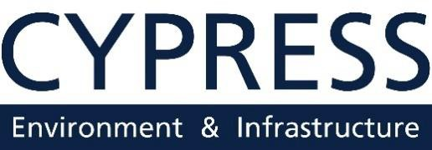

Purpose
The purpose of this ecological assessment is to provide a description of the native habitats, invasive species, and vegetation community restoration opportunities at Clower-Thornton Park in Gulfport, MS. This ecological assessment is focused on invasive plant species.

Site Information
Clower-Thornton Park is located in Gulfport, Mississippi, on East Railroad Street. Figure 1 shows the mapped location of Clower-Thornton Park. The +/-17-acre park and associated trails comprise several forest types and are detailed in the Management Unit Descriptions section. A paved trail, named the Clower-Thornton Nature Trail, is located on the perimeter of the entire park and additional unimproved trails are present throughout the park interior. A perennial stream named Coffee Creek runs along the west side of the park and flows south to the Mississippi Sound. An unnamed small stream flows east-west through the north portion of the bottomland forest and connects to Coffee Creek.
The adjacent land use predominantly consists of single-family residence.

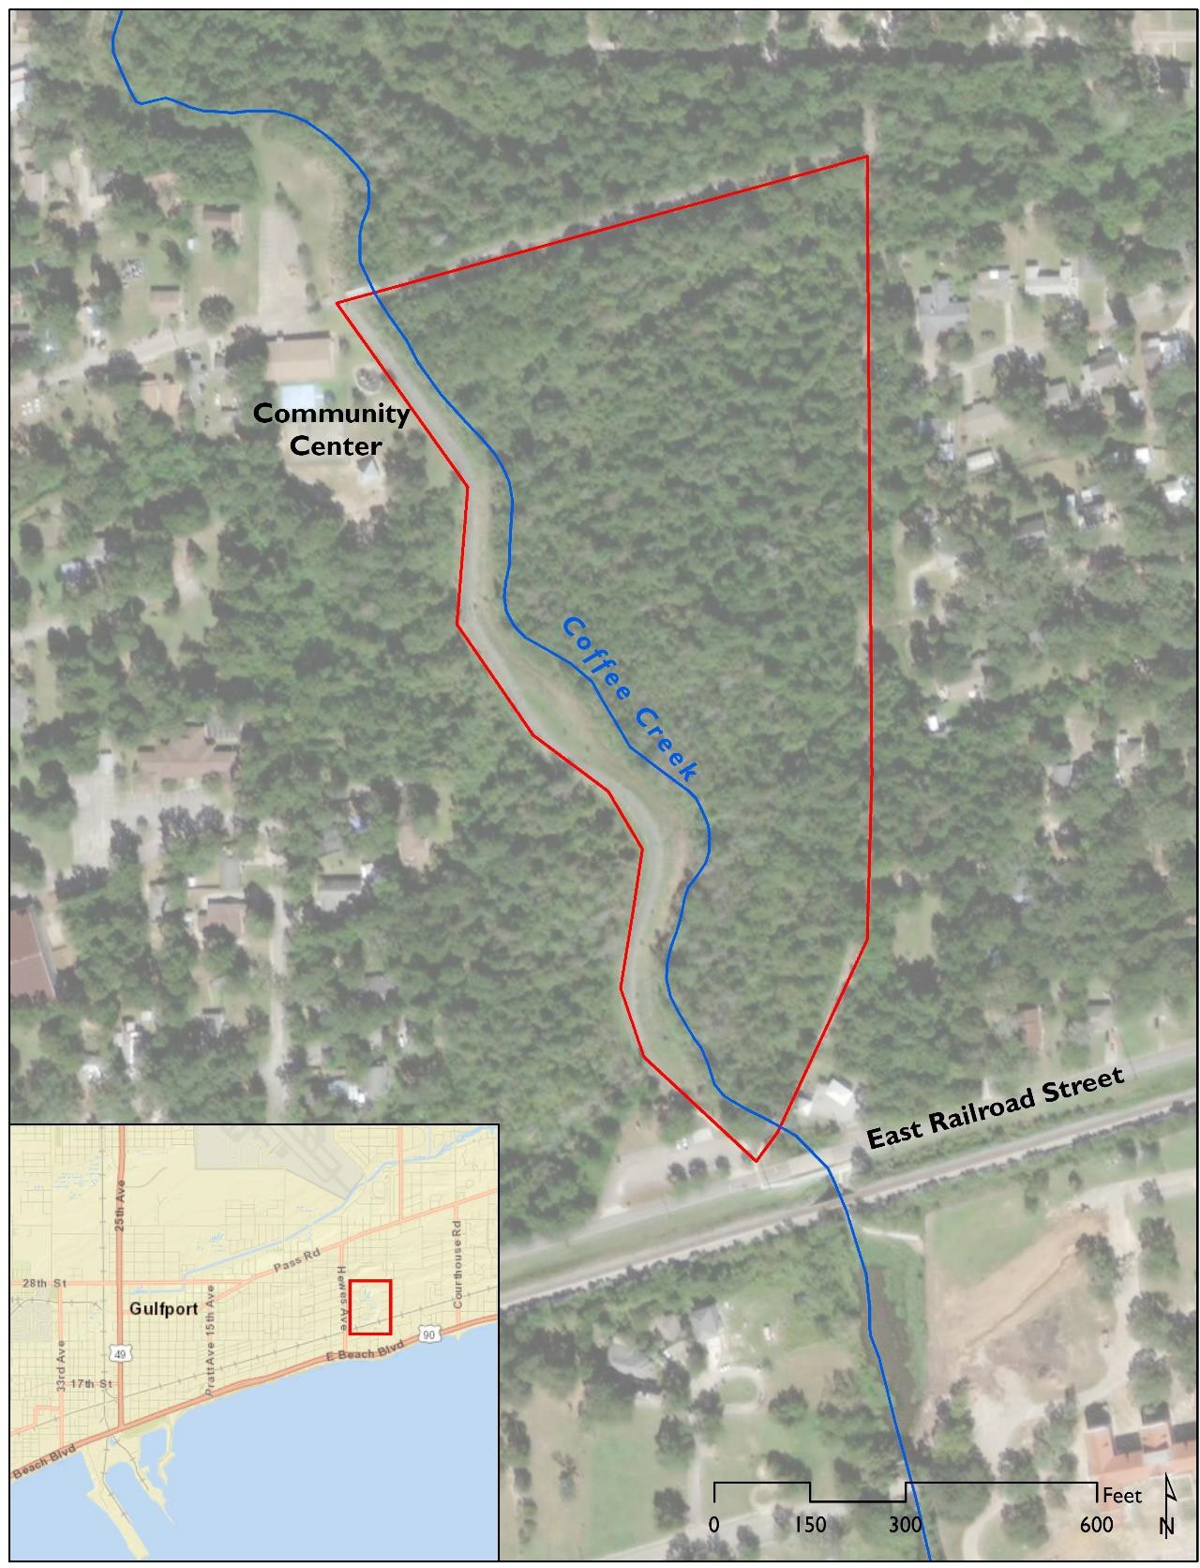
Figure 1: Clower-Thornton Park Location and Vicinity Map

Overview
An onsite field assessment was conducted on January 14, 2020. The +/-17-acre site was characterized based on native habitat type, invasive plant species, and potential restoration opportunities. Eight management units were characterized onsite and are mapped in Figure 2. These management units include a magnolia forest, pine forest, live oak forest, bottomland forest, bottomland forest with a dense infestation of invasive species, stream and associated streambank, artificial mound, and trail berm.
Invasive tree, vine, and herbaceous species listed below are present throughout the site. The majority of invasive species onsite are trees and shrubs. Invasive vine species were noted as isolated occurrences and invasive herbaceous species were only present within the stream.
- Triadica sebifera (Chinese tallow tree)
- Cinnamomum camphora (camphor tree)
- Ligustrum sinense (Chinese privet)
- Lygodium japonicum (Japanese climbing fern)
- Lonicera japonica (Japanese honeysuckle)
- Alternanthera philoxeroides (alligatorweed)
- Colocasia esculenta (taro)
- Canna sp. (canna lily)
Invasive tree and shrub species were categorized into three size classes to inform treatment methods. The size classes include small (0-4” diameter at breast height (dbh)), medium (4-8” dbh) and large (8”+ dbh). The most prevalent invasive species onsite include Triadica sebifera, Cinnamomum camphora, and Ligustrum sinense. Triadica sebifera is present throughout the site and is more prevalent within the bottomland forest, usually as clusters of medium and large size trees. Large Triadica sebifera are present along the streambank of Coffee Creek. Cinnamomum camphora is present in all size classes across the higher elevation areas onsite including the streambank of Coffee Creek. Ligustrum sinense is present throughout the site as small shrubs with a high density population in the bottomland forest in the northwest corner of the site.
Restoration opportunities are based on size class and densities for each invasive species and the specific habitat and site conditions present.

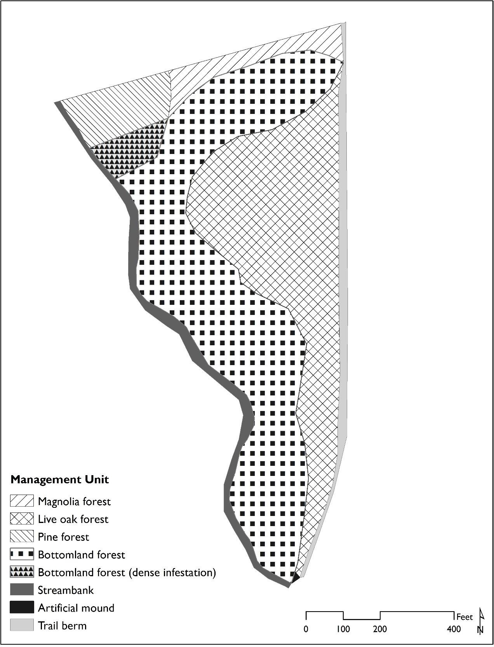

Figure 2. Clower-Thornton Park Management Units

Management Unit Descriptions
A description of the native habitat types, invasive species, recommended treatment, management unit considerations, and recommendations for tree and shrub preservation is provided below for each management unit. These findings are summarized in Table 1.

Streambank and Stream
A 1,598-foot segment of the Coffee Creek is adjacent to the western park boundary. An estimated 0.76 acres of streambank run along the western park boundary. The streambank varies between 15 to 30 feet wide and has a steep slope along Coffee Creek.

Native Habitat Type
The streambank is densely vegetated. The native species include Magnolia grandiflora, Quercus lyrata, Quercus nigra, Ilex vomitoria, and Rhus copallinum.

Invasive Species
Invasive species include large and medium Cinnamomum camphora and Triadica sebifera and small Ligustrum sinense. Discrete occurrences of vine invasive species include Lonicera japonica and Lygodium japonicum. Alternanthera philoxeroides and Colocasia esculenta are present within the Coffee Creek channel.

Treatment
Mechanical
Treatment will require a crew equipped with chainsaws, brushcutters, and weedeaters.
Chemical
Broadleaf herbicide approved for use within aquatic habitats, such as Triclopyr 4, can be used to treat cut stumps and control Alternanthera philoxeroides and Colocasia esculenta within the channel of Coffee Creek.

Management Considerations
The stream position, streambank slope, and wet soil conditions within the adjacent bottomland forest are factors that limit access and pose a challenge for mechanical equipment. A less steep segment of the streambank is located near the middle of the site where the stream channel widens. A large culvert connects a stream west of the park to Coffee Creek. This stream contains Alternanthera philoxeroides and Lemna minor.

Preserved Native Trees and Shrubs
Native tree species that warrant consideration for preservation along the streambank include medium to large size class individuals of the following species:
  - Quercus nigra
  - Magnolia grandiflora
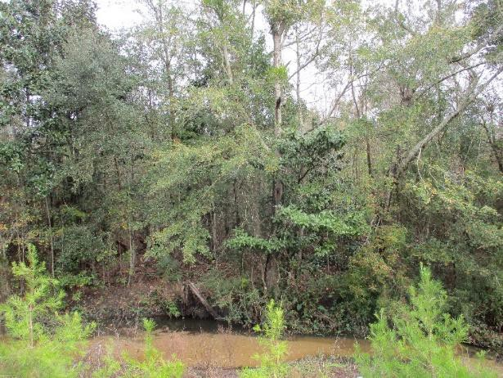  Coffee Creek and adjacent streambank | 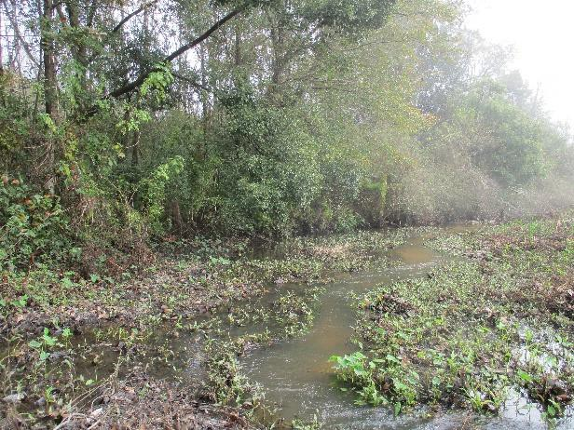  Alternanthera philoxeroides present in Coffee Creek

Magnolia Forest
An estimated 0.65 acres of magnolia forest are located in the northeast portion of the site. A damaged boardwalk with pilings is present and will require removal/replacement.

Native Habitat Type
This unit is dominated by native Magnolia grandiflora, Carya aquatica, Prunus caroliniana, Serenoa repens, and
Vaccinium elliottii.

Invasive Species
Invasive species include small Ligustrum sinense individuals clustered near the damaged boardwalk and
Canna sp. individuals along the southern edge of the unit.
Treatment
Mechanical
A small skid steer with a mulching attachment can be used to remove invasive species and decrease the density of native shrubs throughout this unit.
Chemical
A crew outfitted with backpack sprayers can use Triclopyr or a similar broadleaf herbicide for treatment.

Management Considerations
The damaged boardwalk throughout the magnolia forest poses an obstacle for mechanical equipment. Coordination for removal and replacement will be critical to allow access and equipment movement in this area. Mechanical equipment should avoid the small stream that runs east-west along the southern edge of the magnolia forest.

Preserved Native Trees and Shrubs
Native tree and shrub species that warrant consideration for preservation within the magnolia forest include medium to large size class individuals of the following species:
- Magnolia grandiflora
- Quercus nigra
- Carya aquatica
- Serenoa repens

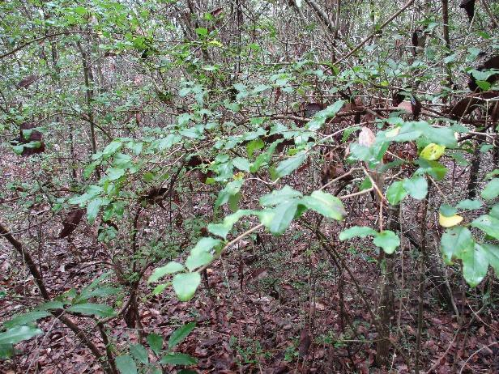  Ligustrum sinense trees near boardwalk | 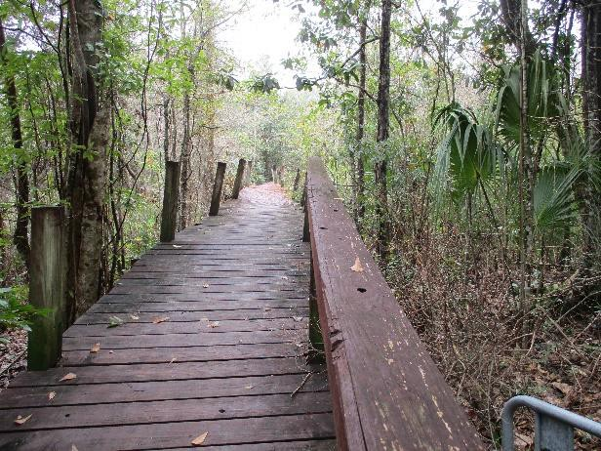  Damaged boardwalk

Pine Forest
An estimated 0.83 acres of pine forest are located in the northwest corner of the site.

Native Habitat Type
This unit is dominated by native Pinus elliottii with an open understory.

Invasive Species
Invasive species include small Cinnamomum camphora and isolated occurrences of Lygodium japonicum.

Treatment
Mechanical
Mechanical equipment such as a small skid steer with a mulching attachment can be used to remove invasive species throughout this unit.
Chemical
A crew outfitted with backpack sprayers can use Triclopyr or a similar broadleaf herbicide for treatment.

Management Considerations
A high fence and utility poles associated with the previously constructed baseball field are present within this unit.

Preserved Native Trees and Shrubs
Native tree species that warrant consideration for preservation within the pine forest include medium to large size class individuals of the following species:
- Pinus elliottii

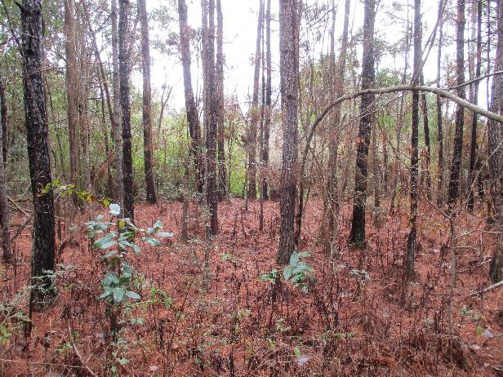  Open understory of pine forest | 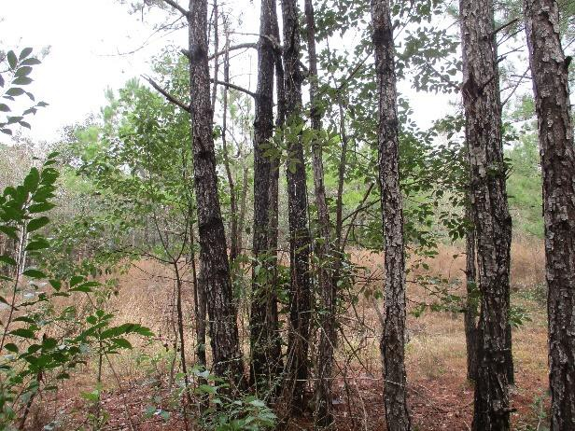  Small Cinnamomum camphora trees

Live Oak Forest
An estimated 5.23 acres of live oak forest are located in the east portion of the site. There are several unimproved trails within this unit. An old damaged boardwalk is located near the center of this unit that will need to be removed.

Native Habitat Type
The live oak forest is dominated by native Magnolia grandiflora, Quercus virginiana, Quercus nigra, Pinus palustris, Ilex vomitoria, Prunus caroliniana, Serenoa repens, Rubus sp., and Smilax spp.

Invasive Species
Invasive species include Ligustrum sinense in varying densities with extremely dense areas limiting line of sight. There are small and medium Triadica sebifera and Cinnamomum camphora trees throughout the live oak forest.

Treatment
Mechanical
Mechanical equipment such as a small skid steer with a mulching attachment can be used to remove invasive species and native Ilex vomitoria, which is very dense in the understory of this unit.
Chemical
A cut stump treatment with Triclopyr or a similar broadleaf herbicide post mowing/mulching can be used for control.

Management Considerations
The damaged boardwalk throughout the live oak forest poses an obstacle for mechanical equipment.

Preserved Native Trees and Shrubs
Native tree and shrub species that warrant consideration for preservation within the live oak forest include medium to large size class individuals of the following species:
- Quercus virginiana
- Quercus nigra
- Magnolia grandiflora
- Serenoa repens

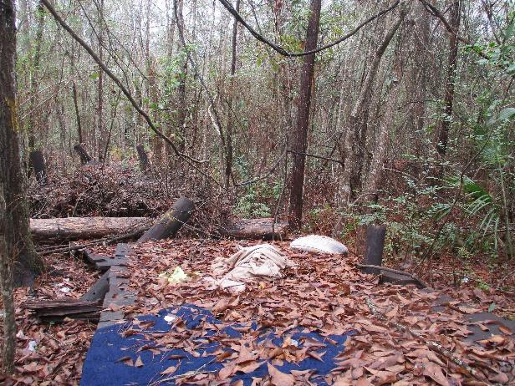  Damaged boardwalk | 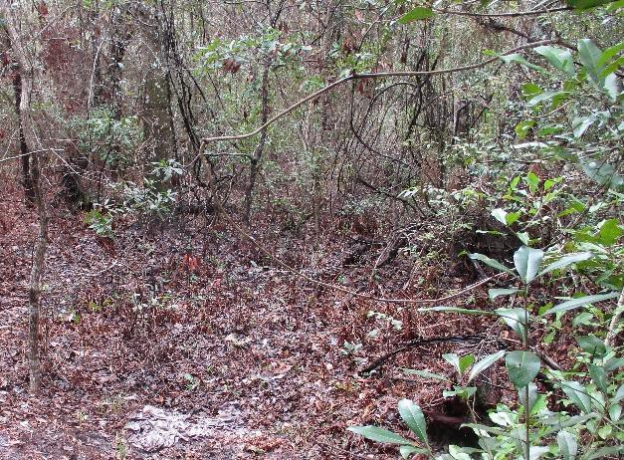  Limited line of sight

Bottomland Forest
An estimated 6.95 acres of bottomland forest are located in the west interior of the site. Surface water was observed in wetter areas in the southern portion and sporadically along the interior of the bottomland forest. A small stream runs east-west and connects with Coffee Creek within the north portion of this unit.

Native Habitat Type
The bottomland forest is dominated by native Magnolia virginiana, Quercus nigra, Taxodium distichum, Nyssa biflora, Ilex vomitoria, Ilex opaca, and Woodwardia areolata.

Invasive Species
Invasive species include medium to large Triadica sebifera trees throughout this unit with high densities at the southern end. Small Ligustrum sinense trees are present throughout this unit with some high-density clusters. Lygodium japonicum and Lonicera japonica are present sporadically.

Treatment
Mechanical
Large individual trees will require removal using hand crews equipped with chainsaws.
Chemical
Herbicide treatment should be applied to cut stumps, small size class invasive species, and vines throughout the unit. Triclopyr or a similar broadleaf herbicide can be used for control.

Management Considerations
Standing water within the bottomland forest limits access and poses as a challenge for mechanical equipment. Mechanical equipment should not be permitted in areas with standing water. Colocasia esculenta is present in the east-west stream just outside the park boundary and is connected to the stream onsite by a box culvert.

Preserved Native Trees and Shrubs
Native tree species that warrant consideration for preservation within the bottomland forest include medium to large size class individuals of the following species:
- Taxodium distichum
- Quercus nigra
- Nyssa biflora

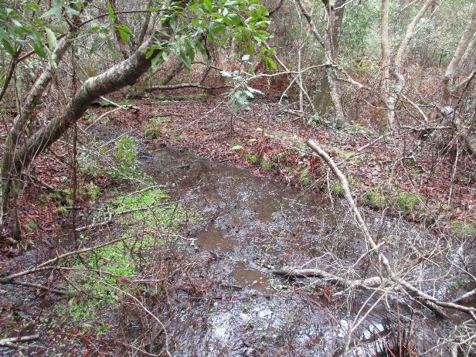  Standing water in some wetter areas | 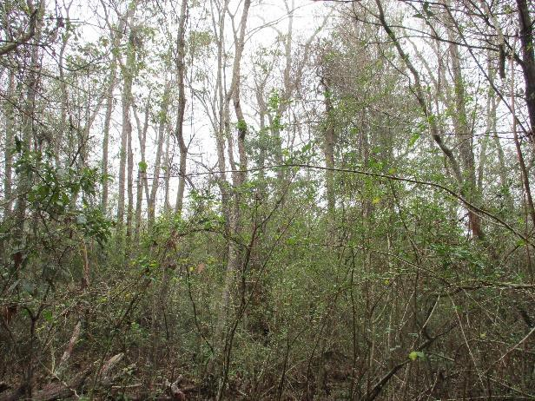  Triadica sebifera trees

Bottomland Forest (Dense Infestation)
An estimated 0.39 acres of bottomland forest are densely infested in the northwest area of the site. A small stream runs along the southern edge of the dense infestation.

Native Habitat Type
The bottomland forest is dominated by native Magnolia virginiana, Quercus nigra, Taxodium distichum, Nyssa biflora, Ilex vomitoria, Ilex opaca, and Woodwardia areolata.

Invasive Species
Invasive species include a high-density stand of small Ligustrum sinense in the understory and small, medium, and large Triadica sebifera trees in the subcanopy and canopy. Isolated occurrences of small Cinnamomum camphora and the invasive vine, Lygodium japonicum, are present.

Treatment
Mechanical
Mechanical equipment such as a small skid steer with a mulching attachment can be used to remove small and medium size invasive trees. Hand crews equipped with chainsaws may be necessary for large Triadica sebifera trees.
Chemical
A cut stump treatment with Triclopyr or a similar broadleaf herbicide post mowing/mulching can be used for control.

Management Considerations
Standing water within the bottomland forest limits access and poses as a challenge for mechanical equipment. Mechanical equipment should avoid the small stream that runs east-west along the southern edge of the dense infestation.

Preserved Native Trees and Shrubs
Native tree species that warrant consideration for preservation within the bottomland forest include medium to large size class individuals of the following species:
- Taxodium distichum
- Quercus nigra
- Nyssa biflora

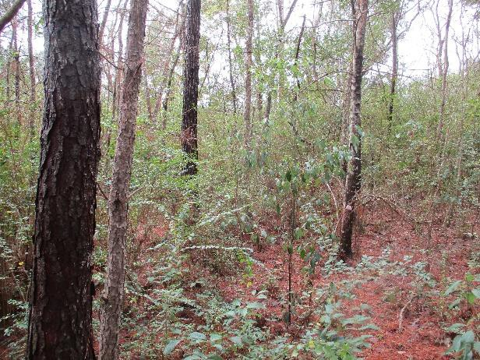  High density of Ligustrum sinense | 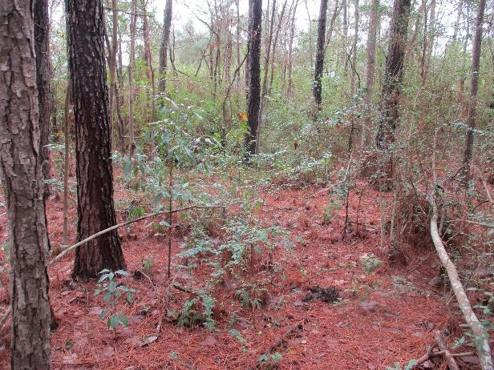  Potential access through pine forest

Trail Berm
Along the eastern boundary of the site is a 1,506-foot paved trail. A berm covering approximately 0.62 acres runs along the paved trail. A 100-foot segment of the berm is distinctly steep at the south end of the site.

Native Habitat Type
The trail berm runs adjacent to the live oak forest for a majority of its length.

Invasive Species
The berm is dominated by small invasive Ligustrum sinense. There are small and medium Triadica sebifera
trees towards the north portion of the trail.

Treatment
Mechanical
Mechanical equipment such as a heavy duty brush mower or mulching equipment can be used to control Ligustrum sinense directly adjacent to the paved trail. Medium to large trees and vegetation will remain in place on the east side of the paved trail to act as a buffer for the residential community that is in close proximity.
Chemical
A cut stump treatment with Triclopyr or a similar broadleaf herbicide post mowing/mulching can be used for control.

Management Considerations
Mechanical equipment should circumvent steep slope segments of the berm.

Preserved Native Trees and Shrubs
Native tree species that warrant consideration for preservation within the trail berm unit include medium to large size class individuals of the following species:
- Quercus virginiana
- Quercus nigra
- Magnolia grandiflora
- Serenoa repens

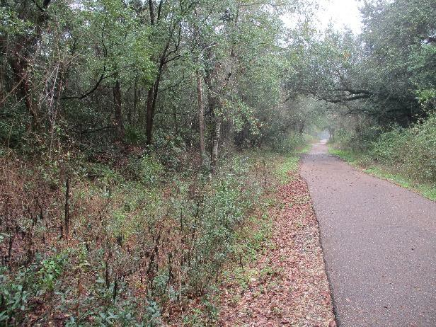  Trail and adjacent berm looking north | 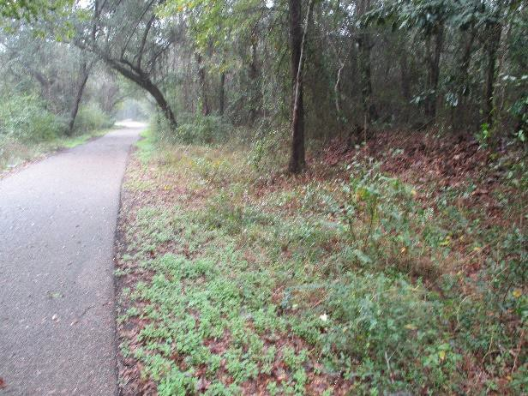  Trail and adjacent berm looking south

Artificial Mound
A small artificial mound covering approximately 0.01 acres is located at the southern end of the site. The mound has steep slopes on all sides.

Native Habitat Type
The artificial mound is at the southern end of the bottomland forest.

Invasive Species
Invasive species present include large Cinnamomum camphora and Triadica sebifera trees.

Treatment
Mechanical
Large individual trees can be removed using hand crews equipped with chainsaws.
Chemical
A cut stump treatment with Triclopyr or a similar broadleaf herbicide post tree removal can be used for control.

Management Considerations
The steep slope of the mound may be a site limitation to mechanical equipment.

Preserved Native Trees and Shrubs
Native tree species that warrant consideration for preservation within the artificial mound unit include medium to large size class individuals of the following species:
- Quercus nigra

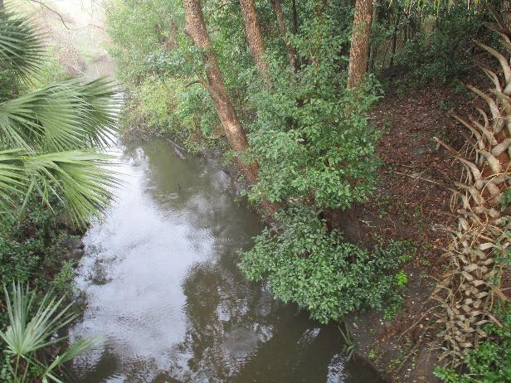  Artificial mound is to the right | 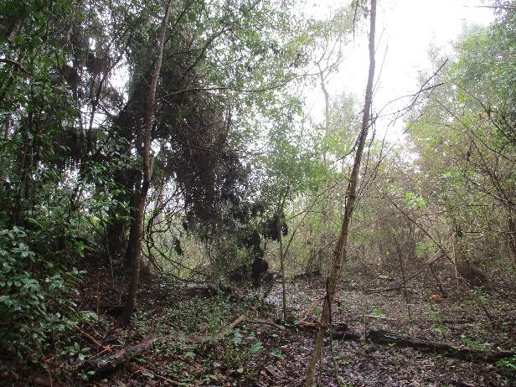  Toe slope of the mound to the left

Table 1. Management Unit Description Summary Table
Management Unit | Area (acres) | Invasive Species | Size Class | Density (stems/acre) | Treatment | Management Considerations | Access
Streambank/ Stream | 0.76 | Triadica sebifera Cinnamomum camphora Sesbania punicea Ligustrum sinense Lonicera japonica  Alternanthera philoxeroides* Colocasia esculenta* | Small | 60 | Chainsaw/hand crew; Mechanical equipment assist with removal of felled trees; Cut stump herbicide treatment | Steep slopes adjacent to Coffee Creek; Wet soil conditions | No direct access; Trail access from north or east boundary
 |  |  | Medium | 140
 |  |  | Large | 190
Magnolia forest | 0.65 | Ligustrum sinense Canna sp. | Small | 80 | Mechanized skid steer with a mulching attachment: Cut stump herbicide treatment | Damaged boardwalk obstacle for equipment; Stream along southern edge | Trail access along the north boundary
Pine forest | 0.83 | Cinnamomum camphora Lygodium japonicum | Small | 25 | Mechanized skid steer with a mulching attachment: Cut stump herbicide treatment | Open understory | Trail access along the north boundary
Live oak forest | 5.23 | Ligustrum sinense Triadica sebifera Cinnamomum camphora | Small | 25 | Mechanized skid steer with a mulching attachment; Cut stump herbicide treatment | Damaged boardwalk obstacle for equipment; Dense native understory | Trail along east boundary; Unimproved trails throughout
 |  |  | Medium | 240
 |  |  | Large | 60
Bottomland forest | 6.95 | Ligustrum sinense Triadica sebifera Lygodium japonicum | Small | 60 | Chainsaw/hand crew; Cut stump herbicide treatment | Wet soil conditions and unstable ground; Small stream along northern edge | Hike in from closest trail
 |  |  | Medium | 240
 |  |  | Large | 60
Bottomland forest (dense infestation) | 0.39 | Ligustrum sinense Triadica sebifera Cinnamomum camphora Lygodium japonicum | Small | 620 | Mechanized skid steer with a mulching attachment; Chainsaw/hand crew;  Cut stump herbicide  treatment | Wet soil conditions and unstable ground; Stream along southern edge | Hike in from trail along north boundary and through pine forest
 |  |  | Medium | 150
 |  |  | Large | 10
Trail berm | 0.62 | Ligustrum sinense Triadica sebifera Cinnamomum camphora | Small | 150 | Mechanized brush mowing/ mulching equipment; Cut stump herbicide treatment | Berm runs along trail edge and is steep on south end of site | Trail along east boundary
Artificial mound | 0.01 | Triadica sebifera Cinnamomum camphora | Large | <5 indv. | Chainsaw/hand crew; Cut stump herbicide treatment | Steep slopes; Unlikely to be accessible with heavy equipment | Bridge and boardwalk along south boundary
*Alternanthera philoxeroides and Colocasia esculenta cover a majority of Coffee Creek. Treat with herbicide approved for aquatic use.

Attachment B

Boardwalk Drawing & Construction Specifications
PILING & TIMBER FRAMING FOR PEDESTRIAN BOARDWALK
PART 1 GENERAL
- SCOPE OF WORK
A. This work shall consist of the installation of all piling, timber framing, including caps, stringers, decking, railing, connectors, and wood accessories, as detailed on the plans and/or in these specifications.
B. The Contractor shall furnish all labor, equipment, tools, transportation, and supplies required to install the Boardwalk structures in accordance with the plans, specifications, and terms of the contract.
2. QUALITY ASSURANCE
A. Use adequate numbers of skilled workmen who are thoroughly trained and experienced in the necessary crafts and who are completely familiar with the specified requirements and the methods needed for proper performance of the work of this Section.
B. The finished Boardwalk shall be straight, true, and pleasing to the eye.
3. SUBMITTALS
A. Submit certification from the treating plant stating that the chemicals and process used, net amount of salts retained and the moisture content after drying following treatment are in conformance with applicable standards.
B. Submit certifications indicating compliance with piling size and treatment.
PART 2 PRODUCTS
- TIMBER AND DIMENSION LUMBER
A. All timber and dimension lumber shall be Southern Pine, medium grained or better, shall be well manufactured, and shall conform in all respects to applicable requirements of the Standard Specifications for Structural Timber, Lumber and Piling. Timber and lumber shall be furnished in the sizes shown on the plans or as directed. All treated wood shall be full size, S2E, or better. Structural timber and lumber shall be No. 2 stress-rated or better, graded according to American Lumber Standards.
B. All decking shall be Lumberock composite materials (or equal as determined by the engineer) that contain no wood fibers in its production.
2. GRADE STAMPS
A. Identify framing lumber by the grade stamp of agency certified by National Forest Products Association, or such other grade stamp as is approved in advance by the Architect.
3. WOOD TREATMENT
A. Comply with applicable standards for the American Wood Preservers Association (AWWPA) and the American Preservers Bureau (AWPB). Each piece shall bear the quality mark of an independent agency or inspection service certified by these organizations to inspect treated materials.
B. Preservative Treatment:
- Pressure treat boards and dimension lumber with waterborne preservative according to AWPA. All timber and piling shall receive a CCA preservative treatment (water borne salts) with a minimum net retention of 2.50 pcf.
- After treatment, redry boards, dimension lumber, timber, and pilings to 19 percent maximum moisture content.
4. FASTENERS
- General: Provide fasteners of size and type indicated on the drawings. There will be no nails allowed as a permanent connection. All connections shall either be bolted with hot dipped galvanized bolts, nuts, and washers or 316 stainless screws.
- For composite wood decking, use #10 x 2.75” color matching heads - 316 stainless steel screws.
- For all Boardwalk railings use 316 stainless screws – sized according for its intended use.
- Lag Screws: ASME B18.2.1.
- Carbon-Steel Bolts: ASTM A 307 with ASTM A 563 hex nuts and, where indicated, flat washers all hot-dip zinc coated.
5. CONNECTORS
A. All connectors shall be hot-dip galvanized in conformance with ASTM-153.
B. All bolts facing the occupied portion of structures, such as railings, etc., shall be fin neck timber bolts with dome heads, 3/4-inch diameter, unless otherwise noted on the plans.
C. All other bolts shall be 3/4-inch diameter, grade Z, hex head, low carbon bolts, in accordance with ASTM-A307.
D. Ogee washers shall be utilized throughout.

PART 3 EXECUTION
- CONSTRUCTION REQUIREMENTS
A. Treated timber shall be carefully handled without sudden dropping, breaking of outer fibers, bruising, or penetrating the surface with tools. Cant hooks, peaveys, spikes, or hooks shall not be used.
B. All cuts in treated timbers, and all abrasions, after having been carefully trimmed, shall be covered with two (2) applications of a preservative solution.
C. Holes for matching bolts shall be bored with a bit the same diameter as the bolt.
D. A washer shall be used under all bolt heads and nuts which would otherwise come in contact with wood.
E. The nuts of all bolts shall be effectively locked after having been tightened.
F. All lumber and timber shall be accurately cut and framed to a close fit in such a manner that the joints will have even bearing over the entire surfaces.
G. Workmanship shall be good throughout. All framing shall be true and exact.
H. 2" x 6" Lumberock composite decking (or equal as determined by the engineer) shall be fastened at each stringer with a minimum of two screws per location driven flush.
I. Spacing between deck boards shall be no less than ¼” inch at the time of construction.

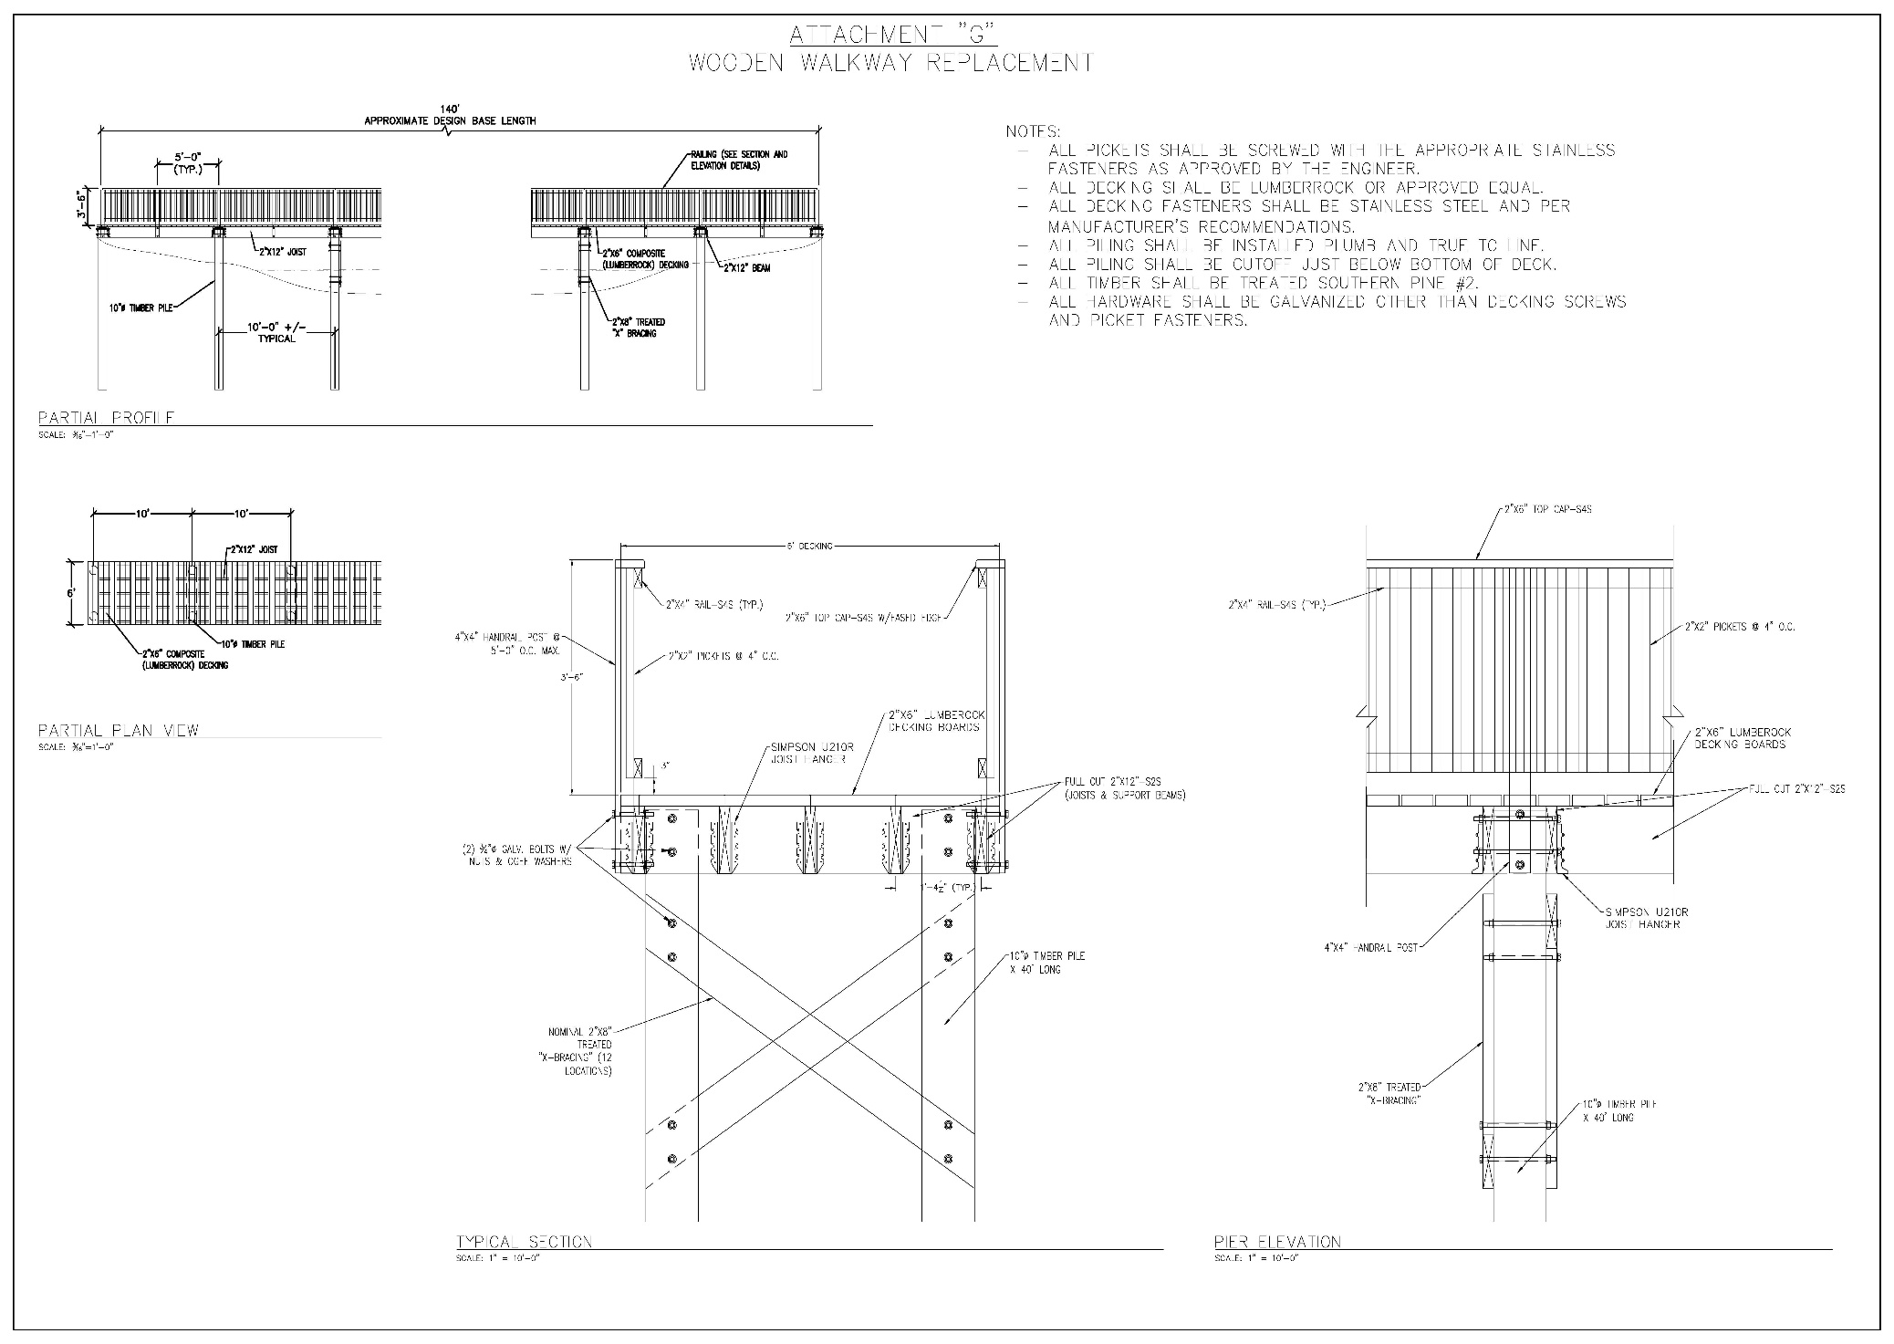

Attachment C-Bid Cover Form
The Mississippi Department of Marine Resources is accepting bids for Rehabilitation and Land Restoration of the Clower Thornton Nature Area.
Bids must be submitted by 2:00 p.m. CST on xxxxxxx, 2020.
Company Name: ______________________________________________________
Quoted by: __________________________________________________________
Signature: __________________________________________________________
Address: ____________________________________________________________
City/State/Zip: _______________________________________________________
Telephone: _________________________________________
Email Address: ________________________________________________________
Name, title and phone number of company representative to be contacted by MDMR:
_____________________________________________________________________________________
In addition to providing the above contact information, please answer the following questions regarding your company:
What year was your company started? _____________________________________________________
Please provide the physical location and mailing address of your company’s home office, principal place of business, and place of incorporation.
__________________________________________________________________________________
__________________________________________________________________________________
Is your company currently for sale or involved in any transaction to expand or to become acquired by another business entity? If yes, please discuss the impact both in organizational and directional terms.
_________________________________________________________________________________
_________________________________________________________________________________
_________________________________________________________________________________
Company Name: _________________________________________________________________
Professional References:
Please list two (2) professional references familiar with the vendor’s abilities using the methods described in this IFB.
Please provide current contact information as MDMR must be able to contact these references.
Professional Reference:
Customer Name and Title: ______________________________________________________
Telephone: ___________________________________________________
Email: _______________________________________________________
Professional Reference:
Customer Name and Title: ______________________________________________________
Telephone: ___________________________________________________
Email: _______________________________________________________

Attachment D-Bid Form

REhabilitation and Land Restoration of the Clower Thornton Nature Area

The Bidder proposes and agrees, if this Bid is accepted, to enter into a Contract with Mississippi Department of Marine Resources (hereinafter called “MDMR” ) in the form included in the Invitation for Bids to perform all Work as specified or indicated in the Contract Documents for the prices and within the times indicated in this Bid and in accordance with the other terms and conditions of the Contract Documents.

  - BIDDER’S ACKNOWLEDGEMENTS

Bidder accepts all of the terms and conditions of the Invitation for Bids, including without limitation those dealing with the disposition of Bid security. This Bid will remain subject to acceptance for ninety (90) days after the Bid opening or for such longer period of time that Bidder may agree to in writing upon request of MDMR.

  - BIDDER’S REPRESENTATIONS

In submitting this Bid, Bidder represents that:

  - Bidder has examined and carefully studied the Contract Documents, including the Invitation for Bids, and the following addenda, receipt of which is hereby acknowledged:

Addendum No. Addendum Date

_____________ ______________
_____________ ______________
_____________ ______________

  - Bidder has reviewed the requirements to bid this Project and become familiar with and is satisfied as to the general, local, and site conditions that may affect cost, progress, and performance of the Work.
  - Bidder is familiar with and is satisfied as to all laws and regulations that may affect cost, progress, and performance of the Work.
  - Bidder has considered the information known to Bidder; information commonly known to contractors doing business in the locality of the work site; information and observations obtained from visits to the work site; the Invitation for Bids; and the site-related reports and drawings identified in the Invitation for Bids with respect to the effect of such information, observations, and documents on (1) the cost, progress, and performance of the Work; (2) the means, methods, techniques, sequences, and procedures of construction to be employed by Bidder, including applying the specific means, methods, techniques, sequences, and procedures of construction expressly required by the Contract Documents; and (3) the Bidder’s safety precautions and programs.
  - Based on the information and observations referred to above, Bidder does not consider that further examinations, investigations, explorations, tests, studies, or data are necessary for the determination of this Bid for performance of the Work at the price(s) bid and within the times required and in accordance with the other terms and conditions of the Contract Documents.
  - Bidder is aware of the general nature of work to be performed at the site that relates to the Work as indicated in the Contract Documents.
  - Bidder has given MDMR written notice of all conflicts, errors, ambiguities, or discrepancies that Bidder has discovered in the Contract Documents, (including, but not limited to, the Drawings and Specifications), and the written resolution thereof by MDMR is acceptable to Bidder.
  - The Invitation for Bids is generally sufficient to indicate and convey understanding of all terms and conditions for the performance of the Work for which this Bid is submitted.

  - BID FORM INSTRUCTIONS

All blank spaces for the bid prices must be filled in ink or typewritten, and this Bid Form must be fully completed and executed when submitted.

Base Bid – Schedule of Prices
Item No. | Description of Bid Item | Unit of Measure | Bid Amount ($)
1 | Year 1 – Invasives Removal | LS
 | Written Total:
2 | Year 2 – Invasives  Maintenance/ Removal | LS
 | Written Total:
3 | Year 3 – Invasives  Maintenance/ Remal | LS
 | Written Total:
4 | Construction of Boardwalk | LS
 | Written Total:
 |  | Total Base Bid ($)

 | Unit Price Bid Items
BIDDER TO PROVIDE UNIT PRICES FOR THE FOLLOWING CREWS THAT WILL BE DIRECTED BY THE ENGINEER AND PAID IN ADDITION TO THE BASE BID ABOVE FOR CLEARING AND THINNING OF VEGETATION NOT LISTED IN THE CYPRESS REPORT OR THE SCOPE OF WORK:
CHAINSAW/POLESAW CREW - 4 MAN MINIMUM TO INCLUDE ALL NECESSARY TOOLS, LABOR AND EQUIPMENT TO SELECTIVELY CLEAR, LIMB UP TREES AND VEGETATION AND REMOVE FELLED TREES IF NOT MULCHED - ALL AT ENGINEERS DIRECTION.
BRUSHCUTTER/WEEDEATER CREW - 4 MAN MINIMUM TO INCLUDE ALL NECESSARY TOOLS, LABOR AND EQUIPMENT TO SELECTIVELY REMOVE UNDERBRUSH AND VEGETATION - ALL AT ENGINEERS DIRECTION.
 | Description of Bid Item | Unit of Measure | Unit Price  Bid Amount ($)
 | Chainsaw / Polesaw Crew | DAY
 | Brushcutter / Weedeater Crew | DAY
 | Allowances  (to be added by change order if necessary) | Unit of Measure | Amount
 | Future Planting | 1 | $20,000.00
 | Park Amenities | 1 | $10,000.00
Total Aggregate Numerical Amount of Bid for Rehabilitation and Land Restoration of the Clower Thornton Nature Area
Construction $

Written Total Amount of Bid

***SIGNATURE STATEMENT'**
BIDDER ACKNOLWEDGES THAT HE/SHE HAS CHECKED ALL ITEMS IN THIS PROPOSAL FOR ACCURACY AND CERTIFIES THAT THE FIGURES THEREIN CONSTITUTE THEIR OFFICIAL BID.

BIDDER'S
SIGNATURE:
(Printed Name/Title)

By submitting a proposal for this project, you certify the following:
- That you have thoroughly read and understand the IFB and Attachments, and that you agree to all provisions of the IFB and Attachments including, but not limited to, the clauses contained in Attachment E which will be included in any contract resulting from this IFB;
- If submitting a proposal on behalf of a company, that you have authority to bind the company;
- That you will perform the services and provide the deliverables required at the price quoted above;
- That, to the best of your knowledge and belief, the price quoted is based upon cost or pricing data which is accurate, complete, and current as of the submission date;
- That you and/or your company are not currently debarred from contracting with the state, any political subdivision of the state, any other state, the federal government, or any political subdivision of the federal government; and,
- That the price submitted in response to this solicitation has been arrived at independently and that you have not communicated with any other vendor or competitor regarding your pricing offer, or the factors you used to calculate the price.

Attachment E-Contract Clauses
Any contract entered into pursuant to this Invitation for Bids will contain these clauses and may contain other clauses. Any reference to “he”, “his” or “himself” also includes “she”, “her” or “herself.”

APPLICABLE LAW
The contract shall be governed by and construed in accordance with the laws of the State of Mississippi, excluding its conflicts of laws provisions, and any litigation with respect thereto shall be brought in the state courts of Harrison County, Mississippi. Contractor shall comply with applicable federal, state, and local laws and regulations.

APPROVAL CLAUSE
It is understood that if this contract requires approval by the Bureau of Buildings (BOB) and/or the Public Procurement Review Board (PPRB) and this contract is not approved by the BOB and/or PPRB it is void and no payment shall be made hereunder.

AVAILABILITY OF FUNDS
It is expressly understood and agreed that the obligation of the MDMR to proceed under this agreement is conditioned upon the appropriation of funds by the Mississippi State Legislature and the receipt of state and/or federal funds. If the funds anticipated for the continuing fulfillment of the agreement are, at any time, not forthcoming or insufficient, either through the failure of the federal government to provide funds or of the State of Mississippi to appropriate funds or the discontinuance or material alteration of the program under which funds were provided or if funds are not otherwise available to the MDMR, the MDMR shall have the right upon ten (10) working days’ notice to Contractor, to terminate this agreement without damage, penalty, cost or expenses to the MDMR of any kind whatsoever. The effective date of termination shall be as specified in the notice of termination.
REPRESENTATION REGARDING GRATUITIES: Contractor represents that it has not violated, is not violating, and promises that it will not violate the prohibition against gratuities as provided under State law.
The Bidder, Offeror or Contractor represents that it has not violated, is not violating, and promises that he will not violate the prohibition against gratuities set forth in Section 6-204 (Gratuities) of the Mississippi Public Procurement Review Board Office of Personal Service Contract Review Rules and Regulations.
REPRESENTATION REGARDING CONTINGENT FEES: The Contractor represents that it has not retained a person to solicit or secure a State contract upon an agreement or understanding for a commission, percentage, brokerage, or contingent fee, except as disclosed in Contractor's bid or proposal.

PROCUREMENT REGULATIONS
The Contract shall be governed by the applicable provisions of the Public Procurement Review Board regulations.
The contract shall be governed by the applicable provisions of the Mississippi Public Procurement Review Board Office of Personal Service Contract Review Rules and Regulations, a copy of which is available at 501 North West Street, Suite 701E, Jackson, Mississippi 39201 for inspection, or downloadable at http://www.DFA.ms.gov.

COMPLIANCE WITH LAWS
Contractor understands that the MDMR is an equal opportunity employer and, therefore, maintains a policy which prohibits unlawful discrimination based on race, color, creed, sex, age, national origin, physical handicap, disability, genetic information, or any other consideration made unlawful by federal, state, or local laws. All such discrimination is unlawful and Contractor agrees during the term of the agreement that Contractor will strictly adhere to this policy in his employment practices and provision of services. Contractor shall comply with, and all activities under this agreement shall be subject to, all applicable federal, State of Mississippi, and local laws and regulations, as now existing and as may be amended or modified.

TRADE SECRETS, COMMERCIAL AND FINANCIAL INFORMATION
It is expressly understood that Mississippi law requires that the provisions of this contract which contain the commodities purchased or the personal or professional services provided, the price to be paid, and the term of the contract shall not be deemed to be a trade secret or confidential commercial or financial information and shall be available for examination, copying, or reproduction.

TRANSPARENCY

This contract, including any accompanying exhibits, attachments, and appendices, is subject to the "Mississippi Public Records Act of 1983," and its exceptions. See Mississippi Code Annotated §§ 25-61-1 et seq. and Mississippi Code Annotated § 79-23-1. In addition, this contract is subject to the provisions of the Mississippi Accountability and Transparency Act of 2008. Mississippi Code Annotated §§ 27-104-151 et seq. Unless exempted from disclosure due to a court-issued protective order, a copy of this executed contract is required to be posted to the Department of Finance and Administration's independent agency contract website for public access at http://www.transparency.mississippi.gov. Information identified by Contractor as trade secrets, or other proprietary information, including confidential vendor information or any other information which is required confidential by state or federal law or outside the applicable freedom of information statutes, will be redacted.

STOP WORK ORDER
- Order to Stop Work: The Chief Procurement Officer, may, by written order to Contractor at any time, and without notice to any surety, require Contractor to stop all or any part of the work called for by this contract. This order shall be for a specified period not exceeding 90 days after the order is delivered to Contractor, unless the parties agree to any further period. Any such order shall be identified specifically as a stop work order issued pursuant to this clause. Upon receipt of such an order, Contractor shall forthwith comply with its terms and take all reasonable steps to minimize the occurrence of costs allocable to the work covered by the order during the period of work stoppage. Before the stop work order expires, or within any further period to which the parties shall have agreed, the Chief Procurement Officer shall either:
  - cancel the stop work order; or,
  - terminate the work covered by such order as provided in the Termination for Default clause or the Termination for Convenience clause of this contract.
- Cancellation or Expiration of the Order: If a stop work order issued under this clause is canceled at any time during the period specified in the order, or if the period of the order or any extension thereof expires, Contractor shall have the right to resume work. An appropriate adjustment shall be made in the delivery schedule or Contractor price, or both, and the contract shall be modified in writing accordingly, if:
  - the stop work order results in an increase in the time required for, or in Contractor's cost properly allocable to, the performance of any part of this contract; and,
  - Contractor asserts a claim for such an adjustment within 30 days after the end of the period of work stoppage; provided that, if the Chief Procurement Officer decides that the facts justify such action, any such claim asserted may be received and acted upon at any time prior to final payment under this contract.
- Termination of Stopped Work: If a stop work order is not canceled and the work covered by such order is terminated for default or convenience, the reasonable costs resulting from the stop work order shall be allowed by adjustment or otherwise.
- Adjustments of Price: Any adjustment in contract price made pursuant to this clause shall be determined in accordance with the Price Adjustment clause of this contract.
E-PAYMENT
Contractor agrees to accept all payments in United States currency via the State of Mississippi's electronic payment and remittance vehicle. The agency agrees to make payment in accordance with Mississippi law on "Timely Payments for Purchases by Public Bodies," which generally provides for payment of undisputed amounts by the agency within forty-five (45) days of receipt of invoice. Mississippi Code Annotated§ 31-7-301 et seq.

PAYMODE
Payments by state agencies using the State’s accounting system shall be made and remittance information provided electronically as directed by the State. These payments shall be deposited into the bank account of the Contractor’s choice. The State may, at its sole discretion, require the Contractor to electronically submit invoices and supporting documentation at any time during the term of the Agreement. Contractor understands and agrees that the State is exempt from the payment of taxes. All payments shall be in United States currency.

E-VERIFICATION

If applicable, Contractor represents and warrants that it will ensure its compliance with the Mississippi Employment Protection Act of 2008 and will register and participate in the status verification system for all newly hired employees. Mississippi Code Annotated §§ 71-11-1 et seq. The term "employee" as used herein means any person that is hired to perform work within the State of Mississippi. As used herein, "status verification system" means the Illegal Immigration Reform and Immigration Responsibility Act of 1996 that is operated by the United States Department of Homeland Security, also known as the E-Verify Program, or any other successor electronic verification system replacing the E-Verify Program. Contractor agrees to maintain records of such compliance. Upon request of the State and after approval of the Social Security Administration or Department of Homeland Security when required, Contractor agrees to provide a copy of each such verification. Contractor further represents and warrants that any person assigned to perform services hereafter meets the employment eligibility requirements of all immigration laws. The breach of this agreement may subject Contractor to the following:

(1) termination of this contract for services and ineligibility for any state or public contract in Mississippi for up to three (3) years with notice of such cancellation/termination being made public;

the loss of any license, permit, certification or other document granted to Contractor by an agency, department or governmental entity for the right to do business in Mississippi for up to one (I) year; or,

both. In the event of such cancellation/termination, Contractor would also be liable for any additional costs incurred by the State due to Contract cancellation or loss of license or permit to do business in the State.

TERMINATION FOR CONVENIENCE
- Termination. The Agency Head or designee may, when the interest of the State so require, terminate this contract in whole or in part, for the convenience of the State. The Agency Head or designee shall give written notice of the termination to Contractor specifying the part of the contract terminated and when termination becomes effective.
- Contractor’s Obligations. Contractor shall incur no further obligations in connection with the terminated work and on the date set in the notice of termination Contractor will stop work to the extent specified. Contractor shall also terminate outstanding orders and subcontracts as they relate to the terminated work. Contractor shall settle the liabilities and claims arising out of the termination of subcontracts and orders connected with the terminated work. The Agency Head or designee may direct Contractor to assign Contractor’s right, title, and interest under terminated orders or subcontracts to the State. Contractor must still complete the work not terminated by the notice of termination and may incur obligations as are necessary to do so.

TERMINATION FOR DEFAULT
- Default. If Contractor refuses or fails to perform any of the provisions of this contract with such diligence as will ensure its completion within the time specified in this contract or any extension thereof, or otherwise fails to timely satisfy the contract provisions, or commits any other substantial breach of this contract, the Agency Head or designee may notify Contractor in writing of the delay or nonperformance and if not cured in ten (10) days or any longer time specified in writing by the Agency Head or designee, such officer may terminate Contractor’s right to proceed with the contract or such part of the contract as to which there has been delay or a failure to properly perform. In the event of termination in whole or in part, the Agency Head or designed may procure similar supplies or services in a manner and upon terms deemed appropriate by the Agency Head or designee. Contractor shall continue performance of the contract to the extent it is not terminated and shall be liable for excess costs incurred in procuring similar goods or services.
- Contractor’s Duties. Notwithstanding termination of the contract and subject to any directions from the Chief Procurement Officer, Contractor shall take timely, reasonable, and necessary action to protect and preserve property in the possession of Contractor in which the State has an interest.
- Compensation. Payment for completed services delivered and accepted by the State shall be at the contract price. The State may withhold from amounts due Contractor such sums as the Agency Head or designee deems to be necessary to protect the State against loss because of outstanding liens or claims of former lien holders and to reimburse the State for the excess costs incurred in procuring similar goods and services.
- Excuse for Nonperformance or Delayed Performance. Except with respect to defaults of subcontractors, Contractor shall not be in default by reason of any failure in performance of this contract in accordance with its terms (including any failure by Contractor to make progress in the prosecution of the work hereunder which endangers such performance) if Contractor has notified the Agency Head or designee within 15 days after the cause of the delay and the failure arises out of causes such as: acts of God; acts of the public enemy; acts of the State and any other governmental entity in its sovereign or contractual capacity; fires; floods; epidemics; quarantine restrictions; strikes or other labor disputes; freight embargoes; or unusually severe weather. If the failure to perform is caused by the failure of a subcontractor to perform or to make progress, and if such failure arises out of causes similar to those set forth above, Contractor shall not be deemed to be in default, unless the services to be furnished by the subcontractor were reasonably obtainable from other sources in sufficient time to permit Contractor to meet the contract requirements. Upon request of Contractor, the Agency Head or designee shall ascertain the facts and extent of such failure, and, if such officer determines that any failure to perform was occasioned by any one or more of the excusable causes, and that, but for the excusable cause, Contractor’s progress and performance would have met the terms of the contract, the delivery schedule shall be revised accordingly, subject to the rights of the State under the clause entitled (in fixed-price contracts, “Termination for Convenience,” in cost-reimbursement contracts, “Termination”). (As used in this paragraph of this clause, the term “subcontractor” means subcontractor at any tier.)
- Erroneous Termination for Default. If after notice of termination of Contractor’s right to proceed under the provisions of this clause, it is determined for any reason that the contract was not in default under the provisions of this clause, or that the delay was excusable under the provisions of paragraph (4) (Excuse for Nonperformance or Delayed Performance) of this clause, the rights and obligations of the parties shall, if the contract contains a clause providing for termination for convenience of the State, be the same as if the notice of termination had been issued pursuant to such clause.
- Additional Rights and Remedies. The rights and remedies provided in this clause are in addition to any other rights and remedies provided by law or under this contract.

TERMINATION UPON BANKRUPTCY
This contract may be terminated in whole or in part by the MDMR upon written notice to Contractor, if Contractor should become the subject of bankruptcy or receivership proceedings, whether voluntary or involuntary, or upon the execution by Contractor of an assignment for the benefit of its creditors. In the event such termination, Contractor shall be entitled to recover just and equitable compensation for satisfactory work performed under this contract, but in no case shall said compensation exceed the total contract price.

ADDITIONAL TERMS AND CLAUSES

ATTORNEYS' FEES AND EXPENSES
Subject to other terms and conditions of this agreement, in the event the Contractor defaults in any obligations under this agreement, the Contractor shall pay to the MDMR all costs and expenses (including, without limitation, investigative fees, court costs, and attorneys' fees) incurred by the MDMR in enforcing this agreement or otherwise reasonably related thereto. Contractor agrees that under no circumstances shall the MDMR be obligated to pay any attorneys' fees or costs of legal action to the Contractor.

INDEMNIFICATION
To the fullest extent allowed by law, the Contractor shall indemnify, defend, save and hold harmless, protect, and exonerate the MDMR, its commissioners, board members, officers, employees, agents, and representatives, and the State of Mississippi from and against all claims, demands, liabilities, suits, actions, damages, losses, and costs of every kind and nature whatsoever, including, without limitation, court costs, investigative fees and expenses, and attorney's fees arising out of or caused by the Contractor and/or its partners, principals, agents, employees and/or subcontractors in the performance of or failure to perform this agreement. In the State's sole discretion, the Contractor may be allowed to control the defense of any such claim, suit, etc. In the event the Contractor defends said claim, suit, etc., the Contractor shall use legal counsel acceptable to the State; the Contractor shall be solely responsible for all costs and/or expenses associated with such defense, and the MDMR shall be entitled to participate in said defense. The Contractor shall not settle any claim, suit, etc. without the State's concurrence, which the State shall not unreasonably withhold.

CONTRACTOR PERSONNEL
MDMR shall, throughout the life of the contract, have the right of reasonable rejection and approval of staff or subcontractors assigned to the work under the contract by the Contractor. If the MDMR reasonably rejects staff or subcontractor, the Contractor must provide replacement staff or subcontractors satisfactory to the MDMR in a timely manner and at no additional cost to the MDMR. The day-to-day supervision and control of the Contractor's employees and subcontractors is the sole responsibility of the Contractor.

CHANGE IN SCOPE OF WORK

The MDMR may order changes in the work consisting of additions, deletions, or other revisions within the general scope of the contract. No claims may be made by Contractor that the scope of the project or of Contractor’s services has been changed, requiring changes to the amount of compensation to Contractor or other adjustments to the contract, unless such changes or adjustments have been made by written amendment to the contract signed by the MDMR and Contractor.

If Contractor believes that any particular work is not within the scope of the project, is a material change, or will otherwise require more compensation to Contractor, Contractor must immediately notify the MDMR in writing of this belief. If the MDMR believes that the particular work is within the scope of the contract as written, Contractor will be ordered to and shall continue with the work as changed and at the cost stated for the work within the contract.

FAILURE TO ENFORCE
Failure by the MDMR at any time to enforce the provisions of the contract shall not be construed as a waiver of any such provisions. Such failure to enforce shall not affect the validity of the contract or any part thereof or the right of the MDMR to enforce any provision at any time in accordance with its terms.

INDEPENDENT CONTRACTOR STATUS

Contractor shall, at all times, be regarded as and shall be legally considered an independent contractor and shall at no time act as an agent for the State. Nothing contained herein shall be deemed or construed by the State, Contractor, or any third party as creating the relationship of principal and agent, master and servant, partners, joint ventures, employer and employee, or any similar such relationship between the State and Contractor. Neither the method of computation of fees or other charges, nor any other provision contained herein, nor any acts of the State or Contractor hereunder creates or shall be deemed to create a relationship other than the independent relationship of the State and Contractor. Contractor’s personnel shall not be deemed in any way, directly or indirectly, expressly or by implication, to be employees of the State. Neither Contractor nor its employees shall, under any circumstances, be considered servants, agents, or employees of the MDMR, and the MDMR shall be at no time legally responsible for any negligence or other wrongdoing by Contractor, its servants, agents, or employees. The MDMR shall not withhold from the contract payments to Contractor any federal or state unemployment taxes, federal or state income taxes, Social Security tax, or any other amounts for benefits to Contractor. Further, the MDMR shall not provide to Contractor any insurance coverage or other benefits, including Worker’s Compensation, normally provided by the State for its employees.

NOTICES
All notices required or permitted to be given under this agreement must be is writing and personally delivered or sent by certified United States mail, postage prepaid, return receipt requested, to the party to whom the notice should be given at the address set forth below. Notice shall be deemed given when actually received or when refused. The parties agree to promptly notify each other in writing of any change of address.
For the Contractor: name, title, Contractor, address
For the MDMR: name, title, agency, address

RECORD RETENTION AND ACCESS TO RECORDS
Provided the Contractor is given reasonable advance written notice and such inspection is made during normal business hours of the Contractor, the MDMR or any of its duly authorized representatives, shall have unimpeded, prompt access to any of the Contractor's books, documents, papers, and/or records which are maintained or produced as a result of the project for the purpose of making audits, examination, excerpts, and transcriptions. All records related to this Contract shall be retained by the Contractor for three (3) years after final payment is made under this Contract and all pending matters are closed; However, if any audit, litigation or other action arising out of or related in any way to this project is commenced before the end of the three (3) year period, the records shall be retained for one (1) year after all issues arising out of the action are finally resolved or until the end of the three (3) year period, whichever is later.

RECOVERY OF MONEY
Whenever, under the contract, any sum of money shall be recoverable from or payable by the Contractor to the MDMR, the same amount may be deducted from any sum due to the Contractor under the contract or under any other contract between the Contractor and the MDMR. The rights of the MDMR are in addition and without prejudice to any other right the MDMR may have to claim the amount of any loss or damage suffered by the MDMR on account of the acts or omissions of the Contractor.

THIRD PARTY ACTION NOTIFICATION
Contractor shall give the MDMR prompt notice in writing of any action or suit filed, and prompt notice of any claim made against Contractor by any entity that may result in litigation related in any way to this Contract.

UNSATISFACTORY WORK
If, at any time during the contract term, the service performed or work done by the Contractor is considered by the MDMR to create a condition that threatens the health, safety, or welfare of the citizens and/or employees of the State of Mississippi, the Contractor shall, on being notified by the MDMR, immediately correct such deficient service or work. In the event the Contractor fails, after notice, to correct the deficient service or work immediately, the MDMR shall have the right to order the correction of the deficiency by separate contract or with its own resources at the expense of the Contractor.

WAIVER
No delay or omission by either party to this agreement in exercising any right, power, or remedy hereunder or otherwise afforded by the contract, at law, or in equity shall constitute an acquiescence therein, impair any other right, power or remedy hereunder or otherwise afforded by any means, or operate as a waiver of such right, power, or remedy. No waiver by either party to this agreement shall be valid unless set forth in writing by the party making said waiver. No waiver or modification to any term or condition of this agreement will void, waive, or change any other term or condition. No waiver by one party to this agreement of a default by the other party will imply, be construed as or require waiver of future or other defaults.

FORCE MAJEURE
Each party shall be excused from performance for any period and to the extent that it is prevented from performing any obligation or service, in whole or in part, as a result of causes beyond the reasonable control and without the fault or negligence of such party and/or its subcontractors. Such acts shall include without limitation acts of God, strikes, lockouts, riots, acts of war, epidemics, governmental regulations superimposed after the fact, fire, earthquakes, floods, or other natural disasters (“force majeure events”). When such a cause arises, Contractor shall notify the State immediately in writing of the cause of its inability to perform, how it affects its performance, and the anticipated duration of the inability to perform. Delays in delivery or in meeting completion dates due to force majeure events shall automatically extend such dates for a period equal to the duration of the delay caused by such events, unless the State determines it to be in its best interest to terminate the agreement.

Attachment F
Reference Score Sheet
To Be Completed by MDMR Staff Only

Bidder Name: _______________________________________________________________
Reference Name: ____________________________________________________________
Person Spoken To: ___________________________________________________________

Score: _____________________________________________
Was the Bidder easy to work with in the scheduling and provision of the services rendered? | Yes | No
Were you satisfied with the services provided? If no, please explain. | Yes | No
Was the Bidder responsive to your needs? | Yes | No
Would you recommend the Bidder to others for future projects? | Yes | No

The References will be scored as either “Pass” or “Fail.” The Bidder is responsible for providing relevant references. Each “yes” is one point; each “no” is zero points. Bidder must have a combined minimum score of “7” from two references to be considered responsible and for Bidder’s bid to be considered.
Called By: ____________________________________________________________________
Signature: ____________________________________________________________________
Title:_________________________________________________________________________
Date and Time: ________________________________________________________________
Notes: _______________________________________________________________________
______________________________________________________________________________
______________________________________________________________________________

Attachment G- Bidder’s Checklist

Two (2) Professional References.
Registered with MAGIC.
Amendments to IFB acknowledged, if any.
Attachment C, Attachment D and Attachment G, completed and signed.

Printed Name: _________________________________________________________________

Signature: ____________________________________________________________________

Date: __________________________________________

