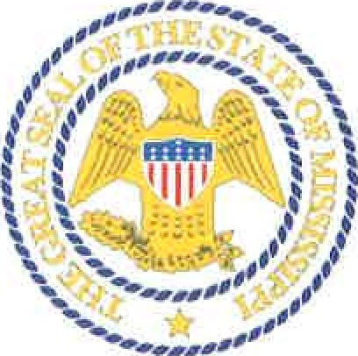
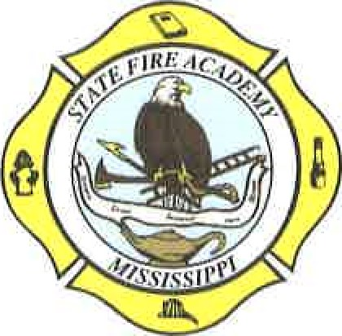
STATE FIRE ACADEMY
Division of the Mississippi Insurance Department
#1 FIRE ACADEMY U.S.A.

JACKSON, MISSISSIPPI 39208-9600

Phone: (601) 932-2444
Terry Wages Mike Chaney
Executive Director Insurance Commissioner

LEGAL NOTICE

Request for Quotes - Formal

Sealed bids will be received by the State Fire Academy, until 2:00 P.M. on Monday, December 16, 2019, through Mississippi’s Accountability System for Government Information and Collaboration (MAGIC) or hand delivered to our office at #1 Fire Academy, USA, Jackson, MS 39208, and opened immediately thereafter, for the purpose of contracting the following:

Aircraft Rescue and Fire Fighting (ARFF) Vehicle.
RFX #3140002070

Detailed specifications may be obtained by contacting Laura Mayo, Staff Officer, at (601)932-2444 or lmayo@msfa.ms.gov. The State Fire Academy reserves the right to reject any and/or all bids, to waive any informalities, and to call for new bids if necessary.

By: Terry Wages, Executive Director.
Run Dates: November 27, 2019
December 4, 2019

