Mississippi State University
Notice of Proposed Sole Source Purchase

223-108
Mississippi State University anticipates purchasing the item(s) listed below as a sole source purchase. Anyone objecting to this purchase shall follow the procedures outlined below.

Commodity or commodities to be purchased (make, model, description):

*Make, model, and quantity denoted in bold.
FANUC
Stand-Alone CERT Robots
(4x) 1.7.14 Stand-alone CRX-5iA Collaborative Robot for Material Handling
Stand-alone Start-Up Accessory Pkg
(4x) 1.7.17 EOAT (Collaborative gripper, connection cable & Standard fingers)
CRX Robot cart
(2x) CRX-CART-ST-00 Modular Cart for FANUC CRX Robot
(2x) CRX-MBPED24 Swivellink® CRX Mobile Base, 24” Pedestal
Project Based Learning
CRX-CART-DTD Fixed grip pattern template, 12 locations, 3 x 4 grid pattern, 140mm grid spacing, with 6 pieces of 3” foam dice cubes
FANUC 2D iRVision
(3x) 1.8.4 CRX 2D IRVision
CERT Instructor Training
1.10.1 CERT Instructor Only Program MH
1.10.3 FANUC COLLABORATIVE CERT Program
ARC-CERT FANUC ARC CERT
APT WELD CERT CART – Certified Robotic Welding Trainer
CART10S-350 FANUC CRX10iA on base modular cart. Cobot has a reach of 1,249mm (49.1”) and a payload of 10kg. System features Miller Auto-continuum 350 with Miller Wire Feeder
SCLFRR Side Cart Left Front or Right Rear, work surface 34” W x 54” Deep with 16mm Holes
SCRFLR Side Cart Right Front or Left Rear, work surface 34” W x 54” Deep with 16mm Holes
WELDPPE Personal Protective Equipment Kit (per student)
TORCH 15’ Bernard Manual weld torch kit with ground clamp
88001197 Magnetic workholding kit
CRAW10KIT Certification material kit to perform (10) AWS CRAW tests
200402000 APTARC50 CERT Instructor & Student Guide Curriculum
DW1025 Shallow drawer, 2-1/2” deep, narrow location E
DW1040 Medium drawer, 4” deep, narrow locations E
DW2025 Shallow drawer, 2-1/2” deep, wide locations B, D
DW2040 Medium drawer, 4” deep, wide locations, B, D
WS1826 Tabletop temporary weld screen
Description:
FANUC
The CRX-5iA Collaborative Robot, with a 5kg payload and 994mm reach, is designed for manufacturers with little to no robotic experience. The CRX series offers a FANUC programming interface with simple drag-and-drop technology on a touchscreen pendant. The ease of programming paired with FANUC’s world-renowned technology, proven reliability, and sensitive contact detection allows the CRX-5iA to work safely alongside people in a variety of industrial and manufacturing jobs. The CRX Series of Cobots are 8 Years Zero Maintenance with the proven industrial reliability FANUC customers expect.
The FANUC America Corporation (hereinafter FANUC) Certified Education Training program (CRX-5iA Collaborative Robots), is an exclusive offer for Mississippi State University. The CERT training platform and instructor certification training provide students and instructors with curriculum and instructional guides. FANUC America, together with NOCTI developed the industry recognized national certification programs which include two levels of FANUC Certified Robot Operator (FCR-O1 & FCR-O2) and two levels of FANUC Certified Technician (FCR-T1 & FCR-T2) indicates an operator level of skills and knowledge. These certification programs are focused on the core Operator and Technician level skills needed for student and adult education programs.
APT WELD CERT CART
The following package provided by APT Manufacturing Solutions includes a fenceless cart with FANUC CRX 10iA collaborative robot that can be used for demonstrating welded construction. It includes a fully integrated collapsible mobile cart design that firs through standard 36” door as well as tinted sides to protect classroom (helmet required for viewing). It qualifies for the FANUC educational CERT program, integrates with FANUC and Miller equipment, and ships with project-based learning.

Explanation of the need to be fulfilled by this item(s), how is it unique from all other options, and why it is the only one that can meet the specific needs of the department:

Employee recruitment and retention is one of the largest issues for manufacturing employers in Mississippi and surrounding states. Retaining and educating workers for skilled technical positions, such as those that require special training to work alongside collaborative robots – or cobots, which are designed to physically interact with human workers in a shared workspace – is becoming more of a problem, since those positions require a specific level of skill and training that is difficult to find in our six-county target region (Clay, Kemper, Lauderdale, Lowndes, Noxubee, Oktibbeha). By providing new technology and training centers for existing industrial and manufacturing companies located in Mississippi, Mississippi State University (MSU) and The Communiversity at East Mississippi Community College (EMCC) can improve the career paths of many while making Mississippi a manufacturing technology leader in the southeast and creating a stronger economy.

The FANUC collaborative robots, CERT training, and CERT robotic welding trainer fill this training need by providing a complete instrumentation and education package. The FANUC CERT program is unique in that the equipment included is production-ready (i.e. can be immediately integrated for use in a real manufacturing setting). Other existing solutions on the market do not fit our desired need, as they provide a simplified version of the co-bot that is used for educational purposes only. Our industry partners have specifically requested co-bot training that can directly translate to real-world manufacturing settings.
FANUC already provides a complete training curriculum that the Communiversity is seeking to adapt to their mechatronics certificate program (Figure 1), in addition to individual special topics workshops tailored to local industry partners. This adapted curriculum has already been Further, FANUC collaborative robots are the most used co-bot brand in industry in the state of Mississippi (~80%) and will consequently be in highest demand for training. Since EMCC is creating these certifications for local industry, the technologies used must fit realistic use cases. The educational/training packages are integral for these purchases as that will be the primary use for the machines proposed, and other solutions on the market do not match this level of detail in terms of curriculum that translate to real-world scenarios. Choosing a brand besides FANUC would lead to significant setbacks in development of the proposed mechatronics curriculum incorporated around this equipment, as MSU and the Communiversity would instead have to start from scratch with developing co-bot educational materials.
The FANUC CERT program is being sold through SIVAD, which is the exclusive FANUC Education Authorized Reseller for the state of Mississippi and can only be sold to educational institutions. This specific combination of equipment and training curriculum cannot be purchased elsewhere in the state of Mississippi.

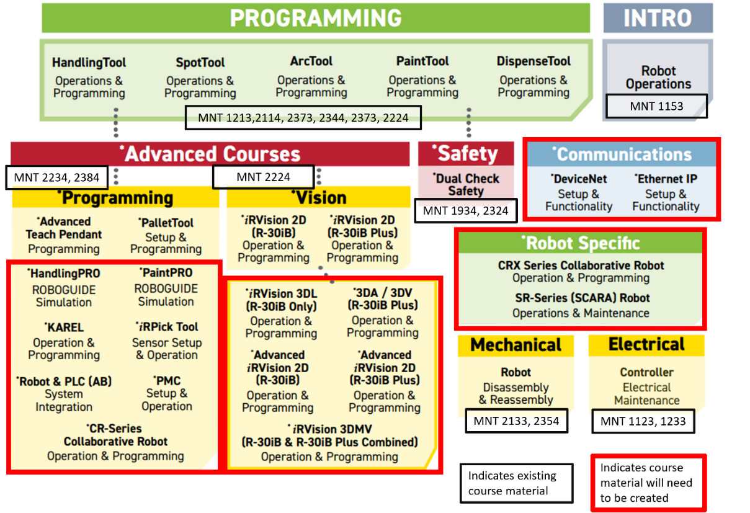
Figure 1: Anticipated modified Mechatronics Engineering Technology course Curriculum at The Communiversity with injection of cobot as inspired by Fanuc robot training model (https://www.fanucamerica.com/support/training/robot/course-descriptions); both existing and new content are identified.

Name of company/individual selling the item and why that source is the only possible source that can provide the required item(s):
Company Name:
Sivad, Inc.
Sole Source Details:
The FANUC America Corporation (hereinafter FANUC) Certified Education Training program (CRX-5iA Collaborative Robots) is an exclusive offer for Mississippi State University. The CERT training platform and instructor certification training provide students and instructors with curriculum and instructional guides. FANUC CERT program can only be purchased from SIVAD Inc. and is only offered to educational institutions. The sale price offered is significantly discounted from the price that would be offered to a commercial or industrial customer. FANUC offers U.S. based manufacturing that includes robots, CNC, simulation software, and product development. The FANUC CERT program and educational products are being provided by SIVAD, an exclusive FANUC Education Authorized Reseller for the state of Mississippi.
The APT Manufacturing Solutions (APT) FANUC CRX robot cart with project based learning is an exclusive offer for Mississippi State University. Sivad, Inc. is the sole provider of equipment from FANUC American & APT in the state of Mississippi.

Estimated cost of item(s) and an explanation why the amount to be expended is considered reasonable:

An official quote of $308,597 has been provided by the supplier for the FANUC Cobots + CERT Training and the APT WELD CERT CART + CERT Curriculum. This amount is considered reasonable due to the need of economic development in the state of Mississippi and surrounding states. The holistic approach to cobot purchasing through the supplier-provided comprehensive training concepts, required hardware, programming insights, and simulation software offers a great value. The cost savings on the time to develop curriculum and more quickly introduce training programs allows for expedited realized economic impacts to the state of Mississippi.

Explanation of the efforts taken by the department to determine this is the only source and the efforts used to obtain the best possible price:
A sole source document was provided (attached) by the manufacturer of the stating that Sivad Inc. is an exclusive FANUC Education Authorized Reseller for the state of Mississippi. Alongside the recommendations from an advisory board of industry experts.
Any person or entity that objects and proposes that the commodity listed is not sole source and can be provided by another person or entity shall submit a written notice to:
Don Buffum, CPPO
Director of Procurement & Contracts
dbuffum@procurement.msstate.edu
Subject Line must read “Sole Source Objection”
The notice shall contain a detailed explanation of why the commodity is not a sole source procurement. Appropriate documentation shall also be submitted if applicable.
If after a review of the submitted notice and documents, MSU determines that the commodity in the proposed sole source request can be provided by another person or entity, then MSU will withdraw the sole source request publication from the procurement portal website and submit the procurement of the commodity to an advertised competitive bid or selection process.
If MSU determines after review that there is only one (1) source for the required commodity, then MSU will appeal to the Public Procurement Review Board. MSU will have the burden of proving that the commodity is only provided by one (1) source.

.

