MISSISSIPPI DEPARTMENT of WILDLIFE, FISHERIES, AND PARKS
Sam Polles, Ph.D., Executive Director
1505 Eastover Drive
Jackson, Mississippi 39211
(601) 432-2400

SOLICITATION: | Request for Quotes Formal (RFQF)
SOLICITATION NUMBER: | RFX #3140001752
DESCRIPTION: | Nine (9) 2019 Ford F-150 Extended Cab Trucks
ISSUE DATE: | March 11, 2019
BID CLOSING LOCATION: | Mississippi Department of Wildlife, Fisheries, and Parks  1505 Eastover Drive  Jackson, Mississippi 39211
BID COORDINATOR: | Marilyn Watkins  Telephone: 601.432.2195  Fax: 601.432.2102  Email: Marilyn.Watkins@wfp.ms.gov
OPENING DATE AND TIME: | March 29, 2019, 2:00 PM CST

SECTION I
GENERAL CONDITIONS – REVERSE AUCTIONS
ALL BIDS SUBMITTED SHALL BE IN COMPLIANCE WITH ALL CONDITIONS SET FORTH HEREIN. THE BID PROCEDURES FOLLOWED BY THIS OFFICE WILL BE IN ACCORDANCE WITH THESE CONDITIONS. THEREFORE, ALL BIDDERS ARE URGED TO READ AND UNDERSTAND THESE CONDITIONS PRIOR TO SUBMITTING A BID.

Definitions
The use of the word “agency” in any Bid Invitation solicitation or specification shall be intended to mean state agencies only. The words “governing authority” when used shall be intended as meaning city, county or other local entities.

Preparation of Bids
  - Bids and/or Quotes may be submitted through the State of Mississippi’s e-procurement system (MAGIC), via email, or in person to the Mississippi Department of Wildlife, Fisheries, and Parks, Purchasing Department (“MDWFP”). Paper bids are allowed. All prices and notations must be printed in ink or typewritten. No erasures permitted. Errors may be crossed out and corrections printed in ink or typewritten adjacent and must be initialed, in ink, by the person signing bid.
  - To submit bids electronically, bidders must ensure they are registered in the MAGIC system and have received a login, password, and supplier number and that all technical requirements have been met.
  - If a bidder is unwilling or unable to participate through MAGIC, an MDWFP representative can enter the Vendor’s bid(s) manually (i.e. Surrogate bidding).
  - Bidders participating in person by surrogate bidding must so indicate in their response to the initial Request for Quote-Formal (RFQF).
  - Failure to examine any drawings, specifications, and instructions will be at bidder's risk.
  - Price each item separately. Unit prices shall be shown. Bid prices must be net.
  - It is understood that reference to available specifications shall be sufficient to make the terms of such specifications binding on the bidder.
  - Bidders must furnish all information requested in the bid specifications. Further, when required, each bidder must submit for bid evaluation cuts, sketches, descriptive literature and technical specifications covering the product offered. Reference to literature submitted with a previous bid or on file with MDWFP will not satisfy this provision.
  - Samples of items, when requested, must be furnished free of expense, and if not destroyed in testing will, upon request, be returned at the bidder's expense. Request for the return of samples must be made within ten (10) days following opening bids. Each individual sample must be labeled with bidder's name, manufacturer's brand name and number, State of Mississippi commodity number, bid number and item reference.
  - Time of performance. The number of calendar days in which delivery will be made after receipt of order shall be indicated in the bid specifications.

Bid Submission
  - When submitting a bid electronically, the authorized signature may be typed or be an electronic signature.
  - Bids and modifications or corrections received after the closing time specified will not be considered.
  - When submitting the response to the RFQF in MAGIC, bidder must ensure all questions have been answered within the RFQF and all proposed items in the bid have a response.
  - Bidders submitting paper responses should submit responses to the MDWFP by the response deadline. The bid package must be sealed and must contain the following:
      - Bid Cover Sheet (Attachment A)
      - Bid Form (Attachment B)
      - Execution of Bid (Attachment C)
      - Specifications Checklist (Attachment D)

Acceptance of Bids
MDWFP reserves the right to reject any and all bids, to waive any informality in bids and unless otherwise specified by the bidders, to accept any items on the bid. The MDWFP reserves the right to modify or cancel in whole or in part its Invitation for Bids.

If a bidder fails to state the time within which a submitted bid will expire, it is understood and agreed that the MDWFP shall have 60 days to accept.

Error in Bid
If a vendor is participating in a Live Auction, the vendor can notify MDWFP in the event of an erroneous bid via the chat message feature. Erroneous bids, where the mistake is apparent to MDWFP, may be deleted during the live auction.

Special Discount Period
Time in connection with a special discount offered will be computed from date of delivery at destination or from the date correct invoices are received, if the latter date is later than the date of delivery. Cash discounts will not be considered in the award process.

Award
  - Contracts and purchases will be made or entered into with the lowest responsible bidder meeting specifications, except as otherwise specified in the bid specifications. Where more than one item is specified in the specifications, MDWFP reserves the right to determine the low bidder either on the basis of the individual item(s) or on the basis of all items included in its Invitation for Bids, or as expressly provided in MDWFP’s Invitation for Bids.
  - Unless the bidder specified otherwise in the bid, MDWFP may accept any item or group of items of any kind.
  - A written purchase order or contract award furnished to the successful bidder within the time of acceptance specified in the Invitation for Bid results in a binding contract without further action by either party. The contract shall consist solely of these General Conditions, the Instructions and Special Conditions, the successful bidder’s bid, and the written purchase order or contract award. The contract shall not be assignable in whole or in part without the written consent of MDWFP.

Inspection
Final inspection and acceptance or rejection may be made at delivery destination, but all materials and workmanship shall be subject to inspection and test at all times and places, and when practicable. During manufacture, the right is reserved to reject articles which contain defective material and workmanship. Rejected material shall be removed by and at the expense of the contractor promptly after notification or rejection. Final inspection and acceptance or rejection of the materials or supplies shall be made as promptly as practicable, but failure to inspect and accept or reject materials or supplies shall not impose liability on the MDWFP or any subdivision thereof for such materials or supplies as are not in accordance with the specification. In the event necessity requires the use of materials or supplies not conforming to the specification, payment therefore may be made at a proper reduction in price.

Taxes
The MDWFP is exempt from federal excise taxes and state and local sales or use taxes and bidders must quote prices which do not include such taxes. Exemption certificates will be furnished upon request. Contractors making improvements to, additions to or repair work on real property on behalf of the MDWFP are liable for any applicable sales or use tax on purchase of tangible personal property for use in connection with the contracts. Contractors are likewise liable for any applicable use tax on tangible personal property furnished to them by the MDWFP for use in connection with their contracts.

Gifts, Rebate, Gratuities
  - Acceptance of gifts from bidders is prohibited. No officer or employee of the MDWFP, nor any head of any state department, institution or agency, nor any employee of any state department, institution or agency charged with responsibility of initiating requisitions, shall accept or receive, directly or indirectly, from any person, firm or corporation to whom any contract for the purchase of materials, supplies, or equipment for the State of Mississippi may be awarded, by rebate, gifts, or otherwise, any money or anything of value whatsoever, or any promise, obligation or contract for future rewards or compensation.
  - Bidding by state employees is prohibited. It is unlawful for any state official or employee to bid on, or sell, or offer for sale, any merchandise equipment or material, or similar commodity to the State during the tenure of his or her office or employment, or for the period prescribed by law thereafter, or to have any interest in the selling of the same to the State.

Bid Information
Bid information and documents may be examined pursuant to the Mississippi Public Records Act of 1983, MS Code 25-61-1 et seq.

Precedence
Bids shall be made and the contract shall be entered into in accordance with the General Conditions as hereinafter amended and modified. Should a conflict exist between the General Conditions and the Instructions and Special Conditions, the Instructions and Special Conditions shall take precedence.

Competition
There are no federal or state laws that prohibit bidders from submitting a bid lower than a price or bid given to the U.S. Government. Bidders may bid lower than U.S. Government contract price without any liability, as the State is exempt from the provisions of the Robinson-Patman Act and other related laws. In addition, the U.S. Government has no provisions in any of its purchasing arrangements with bidders whereby a lower price to the State must automatically be given to the U.S. Government.

Waiver
MDWFP reserves the right to waive any General Condition, Special Condition, or minor specification deviation when considered to be in the best interest of the State.

Cancellation
Any contract or item award may be canceled with or without cause by the MDWFP with the giving of 30 days written notice of intent to cancel. Cause for the MDWFP to cancel may include, but is not limited to, cost exceeding current market prices for comparable purchases; request for increase in prices during the period of the contract; or failure to perform to contract conditions. The Contractor will be required to honor all purchase orders that were prepared and dated prior to the date of expiration or cancellation if received by the Contractor within a period of 30 days following the date of expiration or cancellation. Cancellation by the MDWFP does not relieve the Contractor of any liability arising out of a default or nonperformance. If a contract is canceled by the MDWFP due to a Contractor’s request for increase in prices or failure to perform, that Contractor will be disqualified from bidding for a period of 24 months. The Contractor may cancel a contract for cause with the giving of a 30-day written notice of intent to cancel. Cause for the Contractor to cancel may include, but is not limited to the item(s) being discontinued and/or unavailable from the manufacturer.

Substitutions during Contract
During the term of a contract, if adequate documentation is provided that supports the claim that the contract item(s) are not available, items which meet the minimum specifications may be substituted if approved by MDWFP and the substitutions are deemed to be in the best interest of the State.

Application
It is understood and agreed by the bidder that any contract entered into as a result of this Invitation for Bids is established for use by state agencies and all purchases made by these agencies for products included under the provisions of the contract shall be purchased from the bidder receiving the award unless exempt by special authorization from the MDWFP.

Under the provisions of Section 31-7-7 Mississippi Code of 1972, Annotated, the prices offered herein shall be extended to the governing authorities. However, the governing authorities, by provisions of Section 31-7-12 Mississippi Code, may purchase products covered by state contracts from any source offering an identical product at a price that does not exceed the state contract price.

Employees of the MDWFP have acted exclusively as agents of the State for the award, consummation, and administration of the contract and are not liable for any performance or nonperformance by the state agencies that utilize the contract.

Addenda
Addenda modifying plans and/or specifications may be issued if time permits. No addendum will be issued within a period of two (2) working days prior to the time and date set for the bid opening. Should it become necessary to issue an addendum within the two (2) day period prior to the bid opening, the bid date will be reset to a date not less than five (5) working days after the date of the addendum, giving bidders ample time to comply with the addendum. When replying to a bid request on which an addendum has been issued, and the specifications require acknowledgement, the bid shall indicate that provisions of the addendum have been noted and that the bid is being offered in compliance therewith. Failure to make this statement may result in the bid being rejected as not being in accordance with the revised specifications or plans.

Nonresponsive Bids
Nonresponsive bids will not be considered. A non-responsive bid is considered to be a bid that does not comply with the minimum provisions of the specification. Any bidder found to repeatedly offer alternated products that are not compliant with specifications in an attempt to obtain a contract on the basis of pricing only will be disqualified from bidding for a period of 24 months.

Specification Clarification
It shall be incumbent upon all bidders to understand the provisions of the specifications and to obtain clarification prior to the time and date set for the live auction or bid opening. Such clarification will be answered only in response to a written request submitted in the specified amount of time set by the MDWFP. The MDWFP reserves the right to specify a time frame in which clarification request shall be made.

Pre-Qualification Process
  - The purpose of the RFQF is to advertise the competitive procurement for solicitation of formal quotes from potential bidders to participate in the Reverse Auction. The MDWFP will be responsible for defining product categories, adding bidders, and publishing all bid related documents to the procurement portal. Once the responses have been received and the Opening Date has been reached, the MDWFP will review the submissions to qualify bidders and determine a starting price for reverse auction items.
  - The Invitation for Bids/RFQF shall be advertised in accordance with Section 3.106.05.4 of the Mississippi Procurement Manual. The MDWFP shall advertise once each week for two (2) consecutive weeks in accordance with Section 31-7-13(c)(i)(1) of the Miss. Code Ann. Responses to the RFQF will be due no earlier than the 8th working day after the last day of advertisement.
  - Responses to the RFQF will be reviewed by the MDWFP for responsiveness to specifications. Price quotes received will be evaluated in conjunction with other market research to determine the starting price for the Auction.
  - The MDWFP will accept bidder responses in MAGIC who have qualified meeting RFx specifications. Bidders not meeting specifications will not be allowed to participate in the Auction.
  - Once qualified, the MDWFP will notify the vendor of Qualification and the date of the Live Auction via email. After receiving the confirmation email, bidders should review/ensure technical requirements for MAGIC have been met or confirm participation in person.
  - It is requested that bids be submitted on the basis of statewide distribution. Contractors must maintain adequate distribution capabilities and adequate stock of all items to insure prompt delivery.

Firm Bid Price
Prices accepted from bidder submissions shall be firm for the term of the contract except that the State shall receive the benefit of any price decrease in excess of five (5) percent. The contractor must provide written price reduction information within ten (10) days of its effective date.

Contract Extension
  - Automatic contract renewals or extensions are not allowed. Contracts must be extended or renewed with the proper documents signed or approved by the MDWFP.
  - The MDWFP reserves the right to extend the term of a contract, when necessary, to continue a source of supply whenever new or replacement contracts are not completed prior to the expiration date. Such extensions are dependent upon the agreement of the Vendor and shall not exceed three (3) months.

Suspension and Debarment
By submitting a bid, the bidder is certifying that neither the bidder nor any potential subcontractors are debarred or suspended or are otherwise excluded from or ineligible for participation in federal assistance programs.

Assignment
The Vendor shall not assign or subcontract in whole or in part, its right or obligations under this agreement without prior written consent of the MDWFP.

Indemnification
Vendor shall indemnify, defend, save and hold harmless, protect, and exonerate the MDWFP, its Commissioners, Board Members, officers, employees, agents, and representatives from and against all claims, demands, liabilities, suits, actions, damages, losses, and costs of every kind and nature whatsoever, including, without limitation, court costs, investigative fees and expenses, and attorneys’ fees, arising out of or caused by Vendor’s and/or its partners, principals, agents, employees, and/or subcontractors in the performance of or failure to perform this Agreement. In the MDWFP’s sole discretion, Vendor may be allowed to control the defense of any such claim, suit, etc. In the event Vendor defends said claim, suit, etc., Vendor shall use legal counsel acceptable to the MDWFP; Vendor shall be solely liable for all reasonable costs and/or expenses associated with such defense and the MDWFP shall be entitled to participate in said defense. Vendor shall not settle any claim, suit, etc., without the MDWFP’s concurrence, which the MDWFP shall not unreasonably withhold.

Live Auction
  - Notification of Auction Start date and time will be sent via email to qualifying bidders. If a bidder is unwilling or unable to participate through MAGIC, a representative from the MDWFP can enter the Vendor’s bid(s) manually (i.e. Surrogate Bidding). If a bidder elects to participate via Surrogate Bidding, the bidder must be physically present at the public bidding location, with the means to submit written bids for each offer made and signed by an authorized agent of the Vendor. A Bid Form will be provided to the Vendor at the start of the auction. This form will not be returned to the bidder but will become a part of the Bid Documentation for Evaluation by the MDWFP.
  - The Auction time may be extended at the discretion of the MDWFP. Examples of reasons to extend an auction include, but are not limited to, technical difficulties experienced by the MDWFP or bidder, the need to pause the Auction, or bids placed within the last few moments of bidding.
  - Communication with bidders participating electronically during the Auction may be done via the Live Chat Feature. The MDWFP has the ability to send messages to particular bidders or broadcast to all bidders. Bidders can ONLY communicate with the MDWFP and not other bidders.
  - Bidders may be removed from a Live Auction for improper conduct, including but not limited to profanity, threats, consistently entering erroneous or extremely low bids, or other disruptive behavior.

Force Majeure
If the MDWFP is closed for any reason, including but not limited to: acts of God, strikes, lockouts, riots, acts of war, epidemics, governmental regulations superimposed after the fact, fire, earthquakes, floods, or other natural disasters (the “Force Majeure Events”), which closure prevents the opening of bids at the advertised date and time, all bids received shall be publicly opened and read aloud on the next business day that the agency shall be open and at the previously advertised time. The new date and time of the bid opening, as determined in accordance with this paragraph, shall not be advertised, and all bidders, upon submission of a bid proposal, shall be deemed to have knowledge of and shall have agreed to the provisions of this paragraph. Bids shall be received by the agency until the new date and time of the bid opening as set forth herein. The MDWFP shall not be held responsible for the receipt of any bids for which the delivery was attempted and failed due to the closure of the MDWFP as a result of a Force Majeure Event. Each bidder shall be required to ensure the delivery and receipt of its bid by the MDWFP prior to the new date and time of the live auction or bid opening.

SECTION II
INSTRUCTIONS AND SPECIAL CONDITIONS
- Purpose
The Mississippi Department of Wildlife, Fisheries, and Parks requests sealed bids for the purchase and delivery of Nine (9) 2019 Ford F-150 Extended Cab Trucks. It is understood that any contract resulting from RFX #3140001752 requires approval by the Office of Purchasing, Travel and Fleet Management (OPTFM). If any contract resulting from RFX #3140001752 is not approved by the OPTFM, it is void and no payment shall be made.

- Scope Of Services
The specifications set forth herein as “Section III” represent a minimum of required equipment and operational needs of the MDWFP. The bidder may propose options above and beyond these specifications that best suit MDWFP’s interests as determined by the agency. The bidder agrees to begin delivery within 90 days of award. Failure to do so may result in cancellation of award. If cancellation of award occurs, a new award will be made to the next lowest bidder meeting required specifications. Please respond “Yes” or “No” to indicate compliance to the specifications for each listed criterion and add comments as needed.

- Bid Acceptance Period
Bids may be submitted through the State of Mississippi’s e-procurement system (MAGIC) or in person to the Mississippi Department of Wildlife, Fisheries, and Parks, Purchasing Department (“MDWFP”).

The bid cover sheet, bid form, execution of bid form, and completed specifications checklist, shall be signed and submitted in a sealed envelope or package to the Mississippi Department of Wildlife, Fisheries, and Parks, 1505 Eastover Drive, Jackson, MS 39211, no later than the time and date specified for receipt of bids. Timely submission of the bid forms is the responsibility of the bidder. Bids received after the specified time shall be rejected and returned to the bidder unopened. The envelope or package shall be marked with the bid opening date and time, and the number of the invitation for bid. The time and date of receipt shall be indicated on the envelope or package by Support Services. Each page of the bid form and all attachments shall be identified with the name of the bidder. Failure to submit a bid on the bid form provided shall be considered just cause for rejection of the bid. Modifications or additions to any portion of the procurement document may be cause for rejection of the bid. The MDWFP reserves the right to decide, on a case-by-case basis, whether to reject a bid with modifications or additions as non-responsive. As a precondition to bid acceptance, the MDWFP may request the bidder to withdraw or modify those portions of the bid deemed non-responsive that do not affect quality, quantity, price, or delivery of the service.

3.1 Timeline

Start Date  - First Date of Advertisement:  - Second Date of Advertisement | Monday, March 11, 2019  Monday, March 18, 2019
Bidder Submission Deadline Date and Time | Friday, March 29, 2019, 2:00 PM CST
Opening Date and Time | Friday, March 29, 2019, 2:00 PM CST
Email sent to Qualified Bidders of Auction Start Date/Time | Wednesday, April 3, 2019,
Tentative Reverse Auction Start Date/Time | April 11, 2019, 3:00 PM – 3:30 PM CST
Bid Evaluations | Friday, April 12, 2019
Contract Intent to Award | Tuesday, April 16, 2019
Contract Approval | Unexecuted contract will require additional approval from DFA/OPTFM before it is awarded.

3.2. Late Submissions
A bid received at the place designated in the solicitation for receipt of bids after the exact time specified for receipt will not be considered unless it is the only bid received, or it is received before award is made and was sent by registered or certified mail not later than the fifth (5th) calendar day before the date specified for receipt of bids. It must be determined by the MDWFP that the late receipt was due solely to mishandling by the MDWFP after receipt at the specified address. The only acceptable evidence to establish the date of mailing of a late bid is the U.S. Postal Service postmark on the wrapper or on the original receipt from the U.S. Postal Service. If the postmark does not show a legible date, the contents of the envelope or package shall be processed as if mailed late. “Postmark” means a printed, stamped, or otherwise placed impression, exclusive of a postage meter impression, that is readily identifiable without further action as having been supplied and affixed by the U.S. Postal Service on the date of mailing. Bidders should request postal clerks to place a hand cancellation postmark (often called a bull’s eye) on both the receipt and the envelope or wrapper. The only acceptable evidence to establish the time of receipt at the office identified for bid opening is the time and date stamp of that office on the bid wrapper or other documentary evidence of receipt used by that office.

Expenses Incurred In Preparing Bid
The MDWFP accepts no responsibility for any expense incurred by the bidder in the preparation and presentation of a bid. Such expenses shall be borne exclusively by the bidder.

Bid Form
All pricing must be submitted on the bid form (Attachment B). Failure to complete and/or sign the bid form may result in the bidder being determined nonresponsive.

Bidder Certification
The bidder agrees that submission of a signed bid form is certification that the bidder will accept an award made to it as a result of the submission.

Registration with Mississippi Secretary Of State
By submitting a bid, the bidder certifies that it is registered to do business in the State of Mississippi as prescribed by the Mississippi Secretary of State or, if not already registered, that it will do so within seven (7) business days of being offered an award. Sole proprietors are not required to register with the Mississippi Secretary of State.

MDWFP Contract

Awarded vendor will be required to enter into an MDWFP contract. The contract outlines the terms and conditions that are required by State Law. A copy of the contract is attached as Attachment F. The contract does not need to be completed as part of the bid response. MDWFP will work with the awarded vendor on the contract execution.

Additional Information
Questions about the contract or technical portions of the procurement document must be submitted in writing to Marilyn Watkins at 1505 Eastover Dr., Jackson, MS 39211, marilyn.watkins@wfp.ms.gov or (601) 432-2195. Bidders are cautioned that any statements made by contact persons that cause a material change to any portion of the bid document shall not be relied upon unless subsequently ratified by a formal written amendment to the bid document.

SECTION II – A
INSTRUCTIONS AND SPECIAL CONDITIONS
The following section provides a DFA MAGIC Reverse Auction Bidders Training Guide. It includes detailed instructions on how to access the reverse auction event, including how to gain access to the system utilized and what technical requirements may be involved. However, no supplier may be prohibited from participating in person by paper through surrogate bidding.
The DFA MAGIC Reverse Auction Bidders Training Guide is attached as Attachment E.
The guide and additional information can be found on the DFA Mississippi Suppliers (Vendors) webpage.

SECTION III
SPECIFICATIONS
- Bidders must furnish all information requested in the bid specifications. Further, when required, each bidder must submit for bid evaluation cuts, sketches, descriptive literature and technical specifications covering the product offered. Reference to literature submitted with a previous bid or on file with MDWFP will not satisfy this provision.
- The specifications set forth herein as “Section III” represent a minimum of required equipment and operational needs of the Mississippi Department of Wildlife, Fisheries, and Parks. The bidder may propose options above and beyond these specifications that best suit MDWFP’s interests as determined by the agency.
- The bidder agrees to begin delivery within 90 days of award. Failure to do so may result in cancellation of award. If cancellation of award occurs, new award will be made to the next lowest bidder meeting required specifications.
- Respond “Yes” or “No” to indicate compliance to the specifications for each listed criterion and add comments as needed. Submit completed specifications checklist with bid package.
- The specifications checklist can be found as Attachment D.

MS Department of Wildlife, Fisheries, and Parks  1505 Eastover Drive, Jackson, MS 39211-6374 | BID COVER SHEET  Attachment A
RFX #3140001752

The MDWFP is seeking to receive bids for RFX #3140001752, which is for the purchase of: Nine (9) 2019 Ford F-150 Extended Cab Trucks. Bids are to be submitted online in MAGIC or by paper submission, on or before March 29, 2019 at 2:00 PM CST.

PLEASE MARK YOUR ENVELOPE:

RFX #3140001752
Opening Date: March 29, 2019, 2:00 PM CST
Mississippi Department of Wildlife, Fisheries, and Parks
ATTN: Marilyn Watkins
1505 Eastover Drive
Jackson, MS 39211

SEALED BID – DO NOT OPEN

Company Name: ________________________________________________________________________

Quoted by: ________________________________________________________________________

Signature: ________________________________________________________________________

Address: ________________________________________________________________________
(Street/P.O. Box)
________________________________________________________________________
(City) (State) (Zip Code)

Company Representative: _____________________________________________________________________

Telephone Number: ______________________________ Fax Number: ____________________________

Email Address: ______________________________________________________________________________

MS Department of Wildlife, Fisheries, and Parks  1505 Eastover Drive, Jackson, MS 39211-6374 | BID FORM  Attachment B
RFX #3140001752

Company | Company Representative | Telephone

The pricing quoted must be inclusive of, but not limited to the following:
  - All required equipment and materials
  - All required insurance
  - All required overhead
  - All required profit
  - All required transportation
  - All required labor
  - All required business and professional licenses, permits, fees, etc. (if any)
  - Any and all other costs associated with performing the services

The pricing must include ALL associated costs with no additional or hidden fees.

Brief description of Commodities To be purchased:
Qty. | Description | Unit Price | Line total
 |  | Total price

By signing below, the Company Representative certifies that he/she has authority to bind the company, and further acknowledges on behalf of the company:

- That he/she has thoroughly read and understands this Request for Quotes Formal – RFX #3140001752 and the attachments herein;

- That the company meets all requirements and acknowledges all certifications contained in this Request for Quotes Formal – RFX #3140001752, and the attachments herein;

- That the company agrees to all provisions of this Request for Quotes Formal – RFX #3140001752, and the attachments herein;

- That the company will perform, without delay, the services required at the prices quoted in this Attachment B; and

- That, to the best of its knowledge and belief, the cost or pricing data submitted is accurate, complete, and current as of the submission date.

- That the company has, or will secure, at its own expense, applicable personnel who shall be qualified to perform the duties required to be performed under this Invitation for Bids.

Printed Name: ________________________________________________________________________

Signature/Date: ________________________________________________________________________

MS Department of Wildlife, Fisheries, and Parks  1505 Eastover Drive, Jackson, MS 39211-6374 | Execution of Bid  Attachment C

RFX #3140001752
brief description: Nine (9) 2019 Ford F-150 Extended Cab Trucks
EXECUTION OF BID MUST BE SIGNED IN INK
In compliance with this request for bid and subject to all the conditions and specifications listed herein, the undersigned offers and agrees to furnish any or all of the items upon which prices are quoted, at the price set opposite each item.
Bidder Information:
Company Name: ____________________________________________________________________
Address: ____________________________________________________________________
(Street/P.O. Box)
____________________________________________________________________
(City) (State) (Zip Code)
Telephone Number: ____________________________ Fax Number: ____________________________
Email Address: ____________________________________________________________________
Authorized Signature: ___________________________________________________________________
*(Member of Business/Corporation or Person Authorized to Sign on Behalf of Business)
Printed Name: ___________________________________________________________________________
Title: ___________________________________________________________________________
Date: ___________________________________________________________________________

Acknowledgment of Amendments: (if applicable)
Amendment No. 1 __________________________________
Amendment No. 2 __________________________________
Amendment No. 3 __________________________________

*Signature of bidder must be in ink

Printed Name/Title: ____________________________________________________________________
Signature/Date: _______________________________________________________________________

MS Department of Wildlife, Fisheries, and Parks  1505 Eastover Drive, Jackson, MS 39211-6374 | SPECIFICATIONS SHEET  Attachment D
RFX #3140001752
Mississippi Department of Wildlife, Fisheries, and Parks
Minimum Specifications for Nine (9) 2019 Ford F-150 Extended Cab Trucks
(Must meet or exceed the following minimum specifictions and requirements)
VEHICLE CONFIGURATION
Compliance |  | Specification description | Bidder comment  (required if “no”)
Yes | No | Engine – 5.0 V-8 and Larger
Yes | No | Electronic Engine System
Yes | No | Extended Cab
Yes | No | Short Wheel Base
Yes | No | Half Ton
Yes | No | Aluminum Cylinder Head
Yes | No | 4 X 4 Drive System
Yes | No | Electronic Automatic Transmission
Yes | No | Power 4-Wheel Anti-Lock Brakes
Yes | No | Independent Double – Wishbone Front Suspension
Yes | No | Leaf Spring/Solid Axle Rear Suspension
Yes | No | 17 inch All Terrain Tires
Yes | No | 23 Gallon or Larger Fuel Capacity
Yes | No | 2,000 Lbs and up Payload
Yes | No | 6,000 Lbs and up Towing Capacity
Yes | No | Exterior color – Dark Forest Green, Gem Green or Exact Match (must provide color sample)
Yes | No | Interior-color – Grey
Yes | No | Air Conditioning
Yes | No | Driver and Passenger Air Bags
Yes | No | Trailer Towing with 4 Pin Harness
Yes | No | Cloth Headliner
Yes | No | Power Windows/Locks/Tilt/Cruise
Yes | No | Vinyl Seats and Flooring
Yes | No | Rear Step Bumper
Yes | No | AM/FM Radio
DELIVERY
Yes | No | Delivery Time: 90 days from date of order
Yes | No | Delivery Location: 2148 Riverside Drive, Jackson, MS 39202
Additional Comments:

Printed Name/Title: ____________________________________________________________________
Signature/Date: _______________________________________________________________________

MS Department of Wildlife, Fisheries, and Parks  1505 Eastover Drive, Jackson, MS 39211-6374 | MAGIC REVERSE AUCTION BIDDERS TRAINING GUIDE  Attachment E
RFX #3140001752

MAGIC Reverse Auction Bidders Training Guide

The MAGIC Reverse Auction Bidders Training Guide provides instructions for vendors to participate in Reverse Auctions. Vendors have the ability to submit bids electronically and view real time bid ranking. The identity of participating bidders will not be displayed to other bidders throughout the online auction process. However, bidders will be able to see the current best bid.

Contents
Technical Requirements 21
Login Procedure 21
View Available Reverse Auctions 22
Search for Auction(s) 22
Display Auction Details 24
Display Line Items 25
Display Notes and Attachments 27
Participating in a Live Auction 27
Live Auction Cockpit 28
Chat and System Messages 30
Pausing and/or Resuming an Auction 31

Technical Requirements
Bidders are responsible for ensuring technical requirements are met.
Acceptable Internet Browser(s)
- Microsoft Internet Explorer (IE) version 11
- Google Chrome versions 49 and above (will need to download and install a Chrome Extension called “IE Tab Extension”)

Unsupported Internet Browser(s)
- Microsoft Internet Explorer (IE) version 10 or below
- Microsoft Edge
- Google Chrome
- Safari
- Firefox
Note: Pop-up blocker must be turned off.
Java
- Reverse Auction requires Java version 6.30 or higher. Java can be downloaded from the following Web site.
https://www.java.com/en/download/

Login Procedure
Vendors must be registered in MAGIC in order to receive a User ID and password to log in. Vendors who are new to MAGIC may visit the Vendor Information page on DFA’s Web Site, or register online, Vendor Registration.

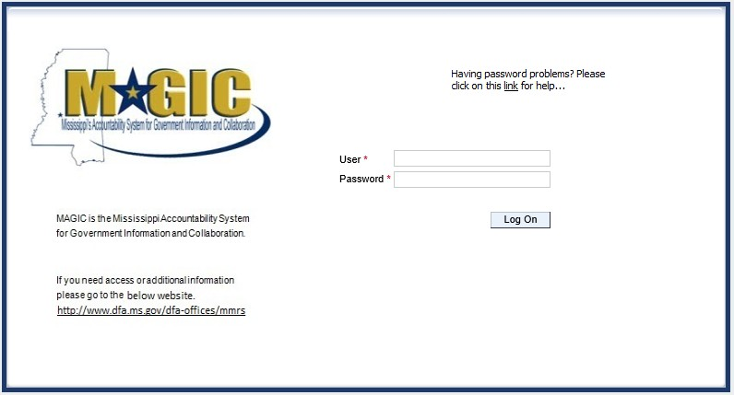
To Log into MAGIC, open the following URL: https://portal.magic.ms.gov/irj/portal. Enter User ID and Password. The password is case sensitive.

View Available Reverse Auctions

Search for Auction(s)
Listed below are the steps to search for a bid response.

1.) Bidders must first respond to the RFx (RFQF) to be able to participate in the Reverse Auction. Instructions for creating a response to an RFx are available here, RFx Response -Supplier Self Service.
The RFx (RFQF) – Bid Specifications will provide details for qualifying criteria. Only bidders qualified through the RFx (RFQF) will be invited to participate in Reverse Auctions.

2.) To search for auctions, click on the Suppliers Self-Service tab.
3.) Select RFx and Auctions in the navigation menu on the left of the screen.
4.) Select the Published link on the eAuctions line of the Active Queries section.
Note: If the search fields are not visible, click the button to expand the search criteria.

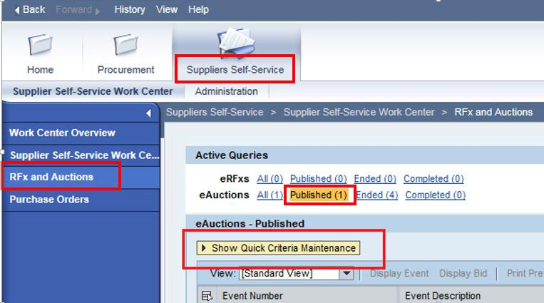

5.) Enter the search criteria. To find all available bid opportunities, skip to step (f).

- Select All or Published to search for available Events (eAuctions).

- Enter the appropriate Quick Criteria Maintenance fields: Event Number (Auction number) or complete any optional relevant search criteria.

- Click on Apply to view all Auctions based on your search criteria.

- To generate an updated search using the same selection criteria, click Refresh
or skip to step (7).

6.) Click Apply to find available bid opportunities.

7.) In the results list, click on the Event Number to open the Auction details in a separate window. (Pop-up blocker must be turned off.)

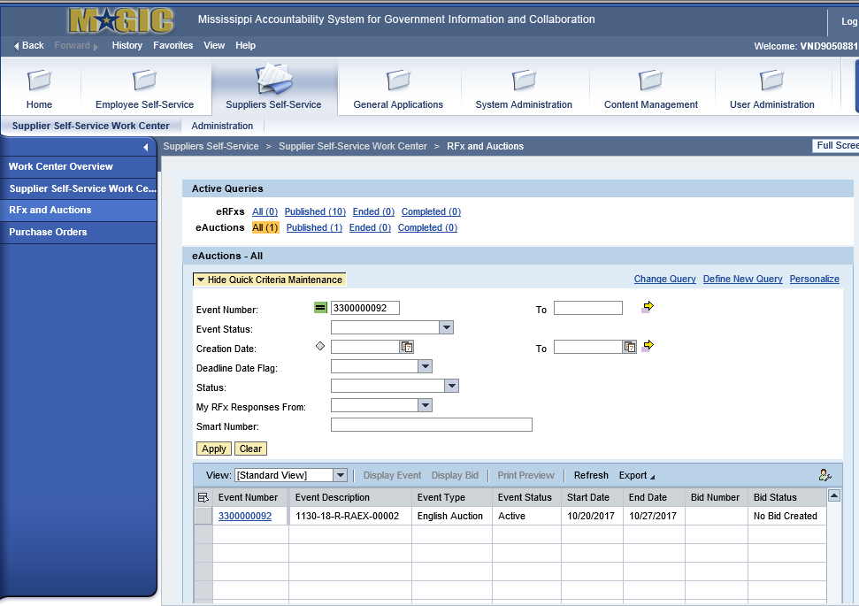

Display Auction Details
Listed below are the steps view the auction details and information regarding the auction.
1.) The Auction Details screen will be displayed. It is important to review the details prior
to the Auction begin time. Bidding will not be available prior to the Auction Start Date / Time.
The table below list the fields and a brief description of the information available on the Auction Parameters sub-tab of the Auction Information tab.
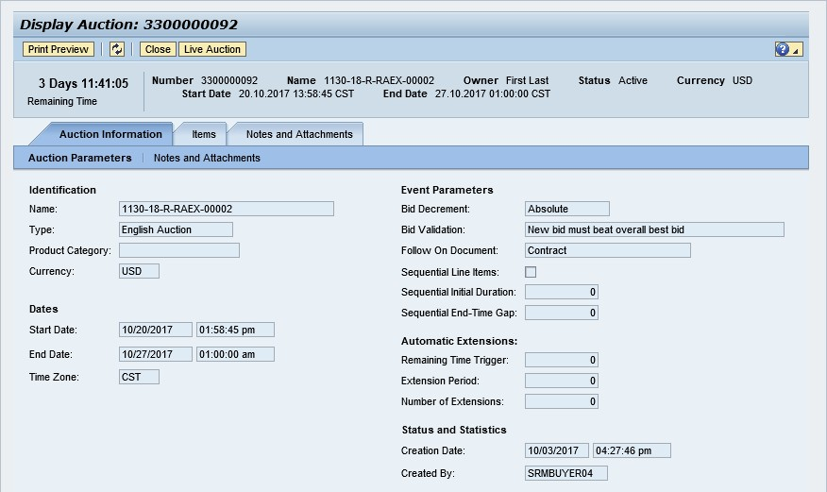

Section | Field Name | Description
Identification | Name | Smart Number with details related to the RFx
 | Type | English Auction is the standard for State of Mississippi
 | Product Category | The 5 digit NIGP code (optional)
 | Currency | US Dollar (USD)
Dates | Start Date | Begin Date and Time for the Live Auction
 | End Date | Date and Time of Live Auction completion
 | Time Zone | Central Standard Time (CST)
Event Parameters | Bid Decrement | The amount/percentage by which the next bid must decrease relevant to the current lowest bid.
 | Bid Validation | Logic used to determine if the bid is valid.
 | Follow On Document | Contract or Purchase Order
 | Sequential Line Items | Enables sequential line item functionality to stagger end times.
 | Sequential Initial Duration | The amount of time in between each line item end time.
 | Sequential End-Time Gap | The time between item end times.
Automatic | Remaining Time Trigger | The time period before the end of the auction where an

Extensions |  | extension can be triggered due to bid activity.
 | Extension Period | Number of minutes, for which the auction will be extended if a bidder submits an offer within the Remaining Time Trigger period.
 | Number of Extensions | The number of times an auction can be extended by bid activity within the Remaining Time Trigger.
Status and  Statistics | Creation Date | The date and time the auction was created.
 | Created By | The User ID of the Agency Buyer who created the auction.

Display Line Items
Listed below is information regarding the line items associated with the auction.
1.) Click the Items tab to view the line items.
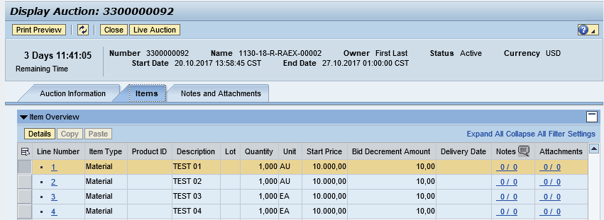
If the items are in Lots, the main items will be listed with individual lot items below.
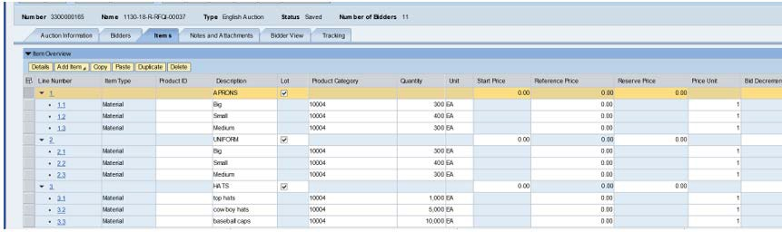

2.) To view additional details for a line item, select the desired line and click the button.

3.) The details for the line item will be displayed.
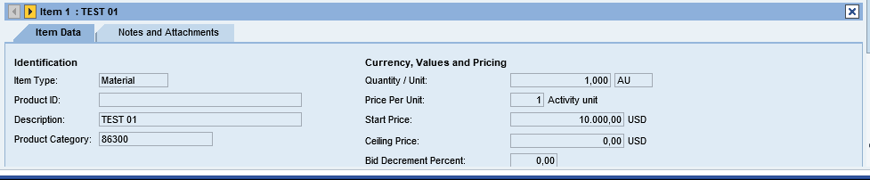

The table below list the fields and a brief description of the information available for each line item.

Section | Field Name | Description
Identification | Item Name | Type of item (Material)
 | Product ID | 11 digit material number
 | Description | Detailed description of the item
 | Product Category | The 5 digit NIGP code
Currency, Values, and Pricing | Quantity /Unit | The number of items / the Unit of Measure (i.e. EA for each)
 | Price Per Unit | The individual price based on the Unit of Measure indicated.
 | Start Price | Starting bid price of the item (Bids higher than the start price will not be accepted.)
 | Ceiling Price | Ceiling Price is not used.
 | Bid Decrement Percent | Bid decrement amount if percentage option is selected.
 | Bid Decrement | Bid decrement amount if dollar amount option is selected.

Display Notes and Attachments
Click the Notes and Attachments tab to view supporting documents and/or notes associated with the auction.
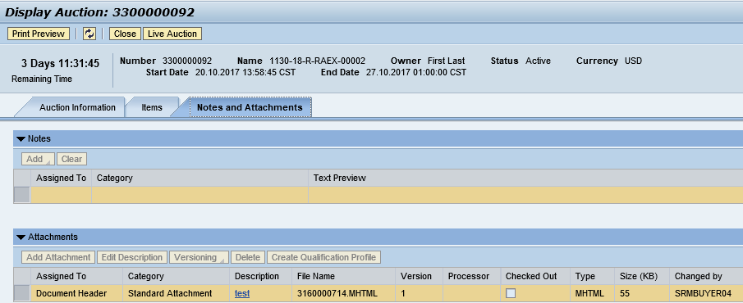

Participating in a Live Auction
After completing the steps above to find a desired auction, the steps below can be used to participate in the Live Auction process.
1.) With the Auction displayed, click the Live Auction button.
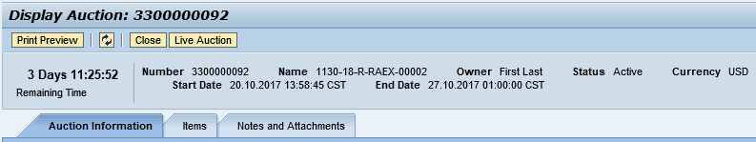
2.) A pop-up window will appear containing Terms and Conditions to participate in the Live Auction. Review all terms and conditions. If you agree, click Accept. If you click Decline you will not be allowed to participate in the Live Auction.
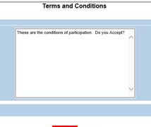
If the agency did not establish Terms and Conditions this screen will not be displayed.

3.) If any pop-ups appear asking for a confirmation to run the JAVA application, click Run.
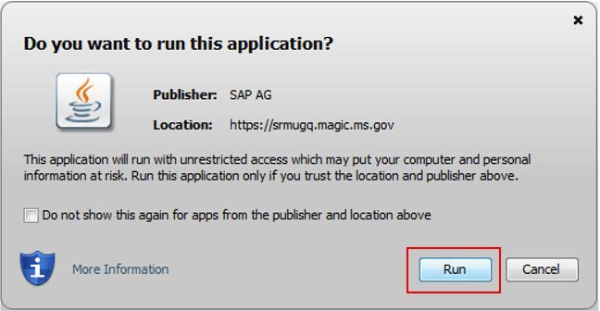

4.) The Live Auction bidding screen will be displayed. If you receive any error messages, please ask your company’s system administrator to verify your computer’s technical requirements.

Live Auction Cockpit
The Live Auction Cockpit will be displayed when the JAVA application has run.
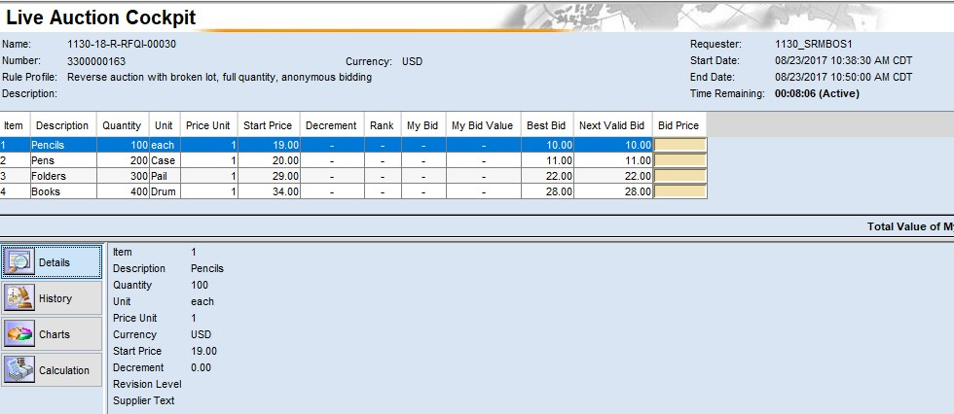
Listed below is information regarding key items for the Live Auction Cockpit. The steps for submitting a response are located on the next page.

Field Name | Description
Start Date | Date and Time the Live Auction starts
End Date | Date and Time the Live Auction ends
Time Remaining | The time remaining for the Live Auction
Description | Line item description
Quantity | Line item quantity
Unit | Line item unit
Price Unit | Line item price per unit
Start Price | The initial price for the line item.
Best Bid | The lowest bid that has been submitted, to date, for that line item. This field will be blank until the first bid has been submitted.
Next Valid Bid | The next price that is allowed to be bid for that line item. It is determined by subtracting the decrement amount from the best bid  amount.
Bid Price | Your bid for the item. Your bid should be equal or less than the next valid bid field.  For instructions on how to enter your bid price, see the next page.

Submitting a Bid Response
The steps below must be completed for each separate line item you wish to bid on.
- Click desired line item.
- Enter the price in the Bid Price field(s) for the items you wish to bid on.
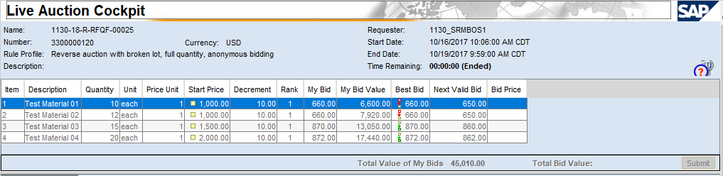

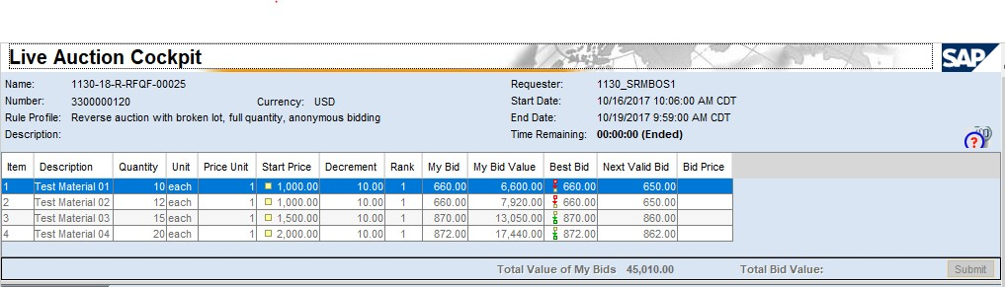
- Click the Submit button. The submit button may be submitted after each line item price is entered or after you enter the price for all line items you wish to bid on.
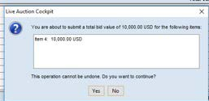
- A confirmation pop-up window will be displayed. The bid value (by line item) will be display the total of the Unit Price times the Quantity for that item. If the bid amount(s) are correct, click Yes. If the bid amount(s) are incorrect, click No and repeat the steps above to enter the correct bid amounts.

5.) A confirmation of a successful bid submission will be displayed in the Chat Window. Note: Erroneous bids may be deleted by the agency during the live auction.
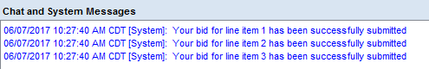
6.) Repeat steps 1 – 5 for each desired line item.

Chat and System Messages
The Chat and System Messages area is used for viewing chat messages from an agency buyer and information messages automatically generated by MAGIC. Below are helpful hints in using the chat feature:

A bidder CAN: | Send a message to an agency buyer.  Type the message in the message box and click Send.
 | See broadcast messages from the agency buyer to ALL bidders.
 | See messages regarding the status of the auction (e.g. paused, resumed, or extended)
A bidder CANNOT: | Send a message to other bidders of the auction.
 | See messages sent to an agency by other bidders.
 | See messages sent to other bidders from the agency buyer.
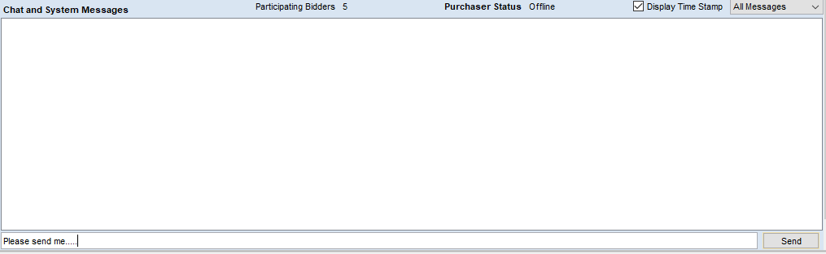
Pausing and/or Resuming an Auction
If necessary, the agency buyer can pause the Live Auction bidding. In such cases, the auction status will be changed from “Active” to “Paused”. A system alert will appear on the screen.
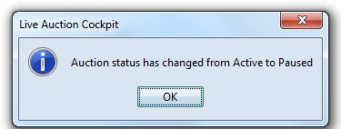

The countdown clock will not stop running while the auction is paused. The time remaining and end date / time are not affected or extended automatically.
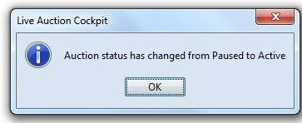
When the agency buyer resumes the auction the auction status will be changed from “Paused” to “Active”. A system alert will appear on the screen.
Once the auction has ended, a notification will display.

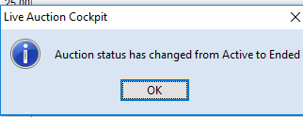

MS Department of Wildlife, Fisheries, and Parks  1505 Eastover Drive, Jackson, MS 39211-6374 | Commodities Contract  Attachment F
RFX #3140001752

State of Mississippi
Department OF Wildlife, Fisheries, and Parks
&
vENDOR

- Parties. This contract is made and entered into by and between the Mississippi Department of Wildlife, Fisheries, and Parks (MDWFP) and Vendor.

- Purpose. MDWFP hereby agrees to purchase the following items from Vendor, as set forth in Paragraph 3, "Description of Commodities,” below.

- Description of Commodities. Vendor shall transfer and deliver to MDWFP, and the MDWFP shall, subject to the conditions set forth herein, take delivery and accept the following commodities: (Describe commodities, quantity and quality and purpose of commodities if available).

- Contract Term. (May be entered into for a period of time)

- Consideration and Method of Payment. (Insert payment amount, schedule of payments, etc….)

- Applicable Law. This contract shall be governed by and construed in accordance with the laws of the State of Mississippi, excluding its conflict of laws, provisions, and any litigation with respect thereto shall be brought in the courts of the State. Vendor shall comply with applicable federal, state and local laws and regulations.

- Approval Clause. It is understood that if this contract requires approval by the Public Procurement Review Board and/or the Mississippi Department of Finance and Administration Office of Personal Service Contract Review and this contract is not approved by the PPRB and/or OPSCR, it is void and no payment shall be made hereunder.

- Compliance with Laws. Vendor understands that the MDWFP is an equal opportunity employer and therefore, maintains a policy which prohibits unlawful discrimination based on race, color, creed, sex, age, national origin, physical handicap, disability, genetic information, or any other consideration made unlawful by federal, state, or local laws. All such discrimination is unlawful and Vendor agrees during the term of the agreement that Vendor will strictly adhere to this policy in its employment practices and provision of services. Vendor shall comply with, and all activities under this agreement shall be subject to, all applicable federal, state of Mississippi, and local laws and regulations, as now existing and as may be amended or modified.

- Debarment. By submitting a bid, the bidder certifies that it is not currently debarred from submitting bids for contracts issued by any political subdivision or agency of the State of Mississippi or Federal government and that it is not an agent of a person or entity that is currently debarred from submitting bids for contracts issued by any political subdivision or agency of the State of Mississippi.

- Failure to Deliver. In the event of failure of Vendor to deliver goods in accordance with the contract terms and conditions, the MDWFP, after due oral or written notice, may procure the goods from other sources and hold Vendor responsible for any resulting additional purchase and administrative costs. This remedy shall be in addition to any other remedies that the MDWFP may have.

- Force Majeure. Each party shall be excused from performance for any period and to the extent that it is prevented from performing any obligation or service, in whole or in part, as a result of causes beyond the reasonable control and without the fault or negligence of such party and/or its subcontractors. Such acts shall include without limitation acts of God, strikes, lockouts, riots, acts of war, epidemics, governmental regulations superimposed after the fact, fire, earthquakes, floods, or other natural disasters (“force majeure events”). When such a cause arises, Vendor shall notify the State immediately in writing of the cause of its inability to perform, how it affects its performance, and the anticipated duration of the inability to perform. Delays in delivery or in meeting completion dates due to force majeure events shall automatically extend such dates for a period equal to the duration of the delay caused by such events, unless the State determines it to be in its best interest to terminate the agreement.

- Modification or Renegotiation. This agreement may be modified only by written agreement signed by the parties hereto. The parties agree to renegotiate the agreement if federal and/or state revisions of any applicable laws or regulations make changes in this agreement necessary.

- Notices. All notices required or permitted to be given under this agreement must be in writing and personally delivered or sent by certified United States mail, postage prepaid, return receipt requested, to the party to whom the notice should be given at the address set forth below. Notice shall be deemed given when actually received or when refused. The parties agree to promptly notify each other in writing of any change of address.

For the MDWFP: | For Vendor:
Sam Polles, Ph.D., Executive Director | [Name, Title]
Mississippi Department of Wildlife, Fisheries, and Parks | [Vendor Name]
1505 Eastover Drive | [Address]
Jackson, Mississippi 39211 | [City, State, Zip]

- Paymode. Payments by state agencies using the State’s accounting system shall be made and remittance information provided electronically as directed by the State. These payments shall be deposited into the bank account of Vendor’s choice. The State may, at its sole discretion, require Vendor to electronically submit invoices and supporting documentation at any time during the term of this Agreement. Vendor understands and agrees that the State is exempt from the payment of taxes. All payments shall be in United States currency.
- Procurement Regulations. The contract shall be governed by the applicable provisions of the Mississippi Procurement Manual, a copy of which is available at 501 N. West St., 701 Woolfolk Building, Suite A, Jackson, MS or downloadable at www.dfa.ms.gov.

- Representation Regarding Contingent Fees. Vendor represents that it has not retained a person to solicit or secure a state contract upon an agreement or understanding for a commission, percentage, brokerage, or contingent fee, except as disclosed in Vendor’s bid.

- Termination for Convenience.
- Termination. The MDWFP Head or designee may, when the interests of the State so require, terminate this contract in whole or in part, for the convenience of the State. The MDWFP Executive Director or designee shall give written notice of the termination to Vendor specifying the part of the contract terminated and when termination becomes effective.
- Vendor's Obligations. Vendor shall incur no further obligations in connection with the terminated work and on the date set in the notice of termination Vendor will stop work to the extent specified. Vendor shall also terminate outstanding orders and subcontracts as they relate to the terminated work. Vendor shall settle the liabilities and claims arising out of the termination of subcontracts and orders connected with the terminated work. The MDWFP Executive Director or designee may direct Vendor to assign Vendor’s right, title, and interest under terminated orders or subcontracts to the State. Vendor must still complete the work not terminated by the notice of termination and may incur obligations as are necessary to do so.

- Termination for Default.
- Default. If Vendor refuses or fails to perform any of the provisions of this contract with such diligence as will ensure its completion within the time specified in this contract or any extension thereof, or otherwise fails to timely satisfy the contract provisions, or commits any other substantial breach of this contract, the MDWFP Executive Director or designee may notify Vendor in writing of the delay or nonperformance and if not cured in ten (10) days or any longer time specified in writing by the MDWFP Executive Director or designee, such officer may terminate Vendor’s right to proceed with the contract or such part of the contract as to which there has been delay or a failure to properly perform. In the event of termination in whole or in part, the MDWFP Executive Director or designee may procure similar supplies or services in a manner and upon terms deemed appropriate by the MDWFP Executive Director or designee. Vendor shall continue performance of the contract to the extent it is not terminated and shall be liable for excess costs incurred in procuring similar goods or services.
- Vendor's Duties. Notwithstanding termination of the contract and subject to any directions from the procurement officer, Vendor shall take timely, reasonable, and necessary action to protect and preserve property in the possession of Vendor in which the State has an interest.
- Compensation. Payment for completed services delivered and accepted by the State shall be at the contract price. The State may withhold from amounts due Vendor such sums as the MDWFP Executive Director or designee deems to be necessary to protect the State against loss because of outstanding liens or claims of former lien holders and to reimburse the State for the excess costs incurred in procuring similar goods and services.
- Excuse for Nonperformance or Delayed Performance. Except with respect to defaults of subcontractors, Vendor shall not be in default by reason of any failure in performance of this contract in accordance with its terms (including any failure by Vendor to make progress in the prosecution of the work hereunder which endangers such performance) if Vendor has notified the MDWFP Executive Director or designee within fifteen (15) days after the cause of the delay and the failure arises out of causes such as: acts of God; acts of the public enemy; acts of the State and any other governmental entity in its sovereign or contractual capacity; fires; floods; epidemics; quarantine restrictions; strikes or other labor disputes; freight embargoes; or unusually severe weather. If the failure to perform is caused by the failure of a subcontractor to perform or to make progress, and if such failure arises out of causes similar to those set forth above, Vendor shall not be deemed to be in default, unless the services to be furnished by the subcontractor were reasonably obtainable from other sources in sufficient time to permit Vendor to meet the contract requirements. Upon request of Vendor, the MDWFP Executive Director or designee shall ascertain the facts and extent of such failure, and, if such officer determines that any failure to perform was occasioned by any one or more of the excusable causes, and that, but for the excusable cause, Vendor’s progress and performance would have met the terms of the contract, the delivery schedule shall be revised accordingly, subject to the rights of the State under the clause entitled in fixed-price contracts, “Termination for Convenience”. (As used in this Paragraph of this clause, the term “subcontractor” means subcontractor at any tier).
- Erroneous Termination for Default. If, after notice of termination of Vendor’s right to proceed under the provisions of this clause, it is determined for any reason that the contract was not in default under the provisions of this clause, or that the delay was excusable under the provisions of Paragraph (4) (Excuse for Nonperformance or Delayed Performance) of this clause, the rights and obligations of the parties shall, if the contract contains a clause providing for termination for convenience of the State, be the same as if the notice of termination had been issued pursuant to such clause.
- Additional Rights and Remedies. The rights and remedies provided in this clause are in addition to any other rights and remedies provided by law or under this contract.

- Termination upon Bankruptcy. This contract may be terminated in whole or in part by MDWFP upon written notice to Vendor, if Vendor should become the subject of bankruptcy or receivership proceedings, whether voluntary or involuntary, or upon the execution by Vendor of an assignment for the benefit of its creditors. In the event of such termination, Vendor shall be entitled to recover just and equitable compensation for satisfactory work performed under this contract, but in no case shall said compensation exceed the total contract price.

- Transparency. This contract, including any accompanying exhibits, attachments, and appendices, is subject to the “Mississippi Public Records Act of 1983,” and its exceptions. See Mississippi Code Annotated §§ 25-61-1 et seq. and Mississippi Code Annotated § 79- 23-1. In addition, this contract is subject to the provisions of the Mississippi Accountability and Transparency Act of 2008. Mississippi Code Annotated §§ 27-104-151 et seq. Unless exempted from disclosure due to a court-issued protective order, a copy of this executed contract is required to be posted to the Department of Finance and Administration’s independent agency contract website for public access at http://www.transparency.mississippi.gov. Information identified by Vendor as trade secrets, or other proprietary information, including confidential vendor information or any other information which is required confidential by state or federal law or outside the applicable freedom of information statutes, will be redacted.

IN WITNESS WHEREOF, this contract has been entered into and executed by the parties hereto in duplicate originals.

This ________ day of ___________________, 20___.

Mississippi Department of Wildlife, Fisheries, and Parks

By: _______________________________
Sam Polles, Ph.D., Executive Director

Courtesy Motors

By: ___________________________
Vendor Name, Title

