SOLICITATION: Request for Quote Formal (RFQF) Reverse Auction

SOLICITATION: RFX #3140003765

DESCRIPTION: Two (2) Ford Transit 350 HR DRW Van Vans

ISSUE DATE: February 20, 2024

RFQF CLOSING LOCATION: Mississippi Veteran Affairs

660 North Street
Jackson, MS 39202

RFQF COORDINATOR: Edward Williams.

Telephone: 601-576-4862 Email: ewilliams@msva.ms.gov

CLOSING DATE AND TIME: March 15, 2024 4:00 PM CT

SECTION I
GENERAL CONDITIONS – REVERSE AUCTIONS
ALL BIDS SUBMITTED SHALL BE IN COMPLIANCE WITH ALL CONDITIONS SET FORTH HEREIN. THE BID PROCEDURES FOLLOWED BY THIS OFFICE WILL BE IN ACCORDANCE WITH THESE CONDITIONS. THEREFORE, ALL BIDDERS ARE URGED TO READ AND UNDERSTAND THESE CONDITIONS PRIOR TO SUBMITTING A BID.

Definitions
The use of the word “agency” in any Bid Invitation solicitation or specification shall be intended to mean state agencies only. The words “governing authority” when used shall be intended as meaning city, county or other local entities.

Preparation of Bids
  - Bids and/or Quotes may be submitted through the State of Mississippi’s e- procurement system (MAGIC), via email, or in person to the Mississippi Veteran Affairs, Purchasing Department (“MSVA”). Paper bids are allowed. All prices and notations must be printed in ink or typewritten. No erasures permitted. Errors may be crossed out and corrections printed in ink or typewritten adjacent and must be initialed, in ink, by the person signing bid.
  - To submit bids electronically, bidders must ensure they are registered in the MAGIC system and have received a login, password, and supplier number and that all technical requirements have been met.
  - If a bidder is unwilling or unable to participate through MAGIC, an MSVA representative can enter the Vendor’s bid(s) manually (i.e. Surrogate bidding).
  - Bidders participating in person by surrogate bidding must so indicate in their response to the initial Request for Quote-Formal (RFQF).
  - Failure to examine any drawings, specifications, and instructions will be at bidder's risk.
  - Price each item separately. Unit prices shall be shown. Bid prices must be net.
  - It is understood that reference to available specifications shall be sufficient to make the terms of such specifications binding on the bidder.
  - Bidders must furnish all information requested in the bid specifications. Further, when required, each bidder must submit for bid evaluation cuts, sketches, descriptive literature and technical specifications covering the product offered. Reference to literature submitted with a previous bid or on file with MSVA will not satisfy this provision.
  - Samples of items, when requested, must be furnished free of expense, and if not destroyed in testing will, upon request, be returned at the bidder's expense. Request for the return of samples must be made within ten (10) days following opening bids. Each individual sample must be labeled with bidder's name, manufacturer's brand name and number, State of Mississippi commodity number, bid number and item reference.
  - Time of performance. The number of calendar days in which delivery will be made after receipt of order shall be indicated in the bid specifications.

Bid Submission
  - When submitting a bid electronically, the authorized signature may be typed or be an electronic signature.
  - Bids and modifications or corrections received after the closing time specified will not be considered.
  - When submitting the response to the RFQF in MAGIC, bidder must ensure all questions have been answered within the RFQF and all proposed items in the bid have a response.
  - Bidders submitting paper responses should submit responses to the MSVA by the response deadline. The bid package must be sealed and must contain the following:
    - Bid Cover Sheet (Attachment A)
    - Bid Form (Attachment B)
    - Execution of Bid (Attachment C)
    - Completed specifications checklist

Acceptance of Bids
MSVA reserves the right to reject any and all bids, to waive any informality in bids and unless otherwise specified by the bidders, to accept any items on the bid. The MSVA reserves the right to modify or cancel in whole or in part its Invitation for Bids.

If a bidder fails to state the time within which a submitted bid will expire, it is understood and agreed that the MSVA shall have 60 days to accept.

Error in Bid
If a vendor is participating in a Live Auction, the vendor can notify MSVA in the event of an erroneous bid via the chat message feature. Erroneous bids, where the mistake is apparent to MSVA, may be deleted during the live auction.

Special Discount Period
Time in connection with a special discount offered will be computed from date of delivery at destination or from the date correct invoices are received, if the latter date is later than the date of delivery. Cash discounts will not be considered in the award process.

Award
  - Contracts and purchases will be made or entered into with the lowest responsible bidder meeting specifications, except as otherwise specified in the bid specifications. Where more than one item is specified in the specifications, MSVA reserves the right to determine the low bidder either on the basis of the individual item(s) or on the basis of all items included in its Invitation for Bids, or as expressly provided in MSVA’s Invitation for Bids.
  - Unless the bidder specified otherwise in the bid, MSVA may accept any item or group of items of any kind.
  - A written purchase order or contract award furnished to the successful bidder within the time of acceptance specified in the Invitation for Bid results in a binding contract without further action by either party. The contract shall consist solely of these General Conditions, the Instructions and Special Conditions, the successful bidder’s bid, and the written purchase order or contract award. The contract shall

not be assignable in whole or in part without the written consent of MSVA.

  - Suppliers should be advised that no award will automatically result from a reverse auction, and that the purchasing entity will review the results of the auction and make a determination in a timely manner.

Inspection
Final inspection and acceptance or rejection may be made at delivery destination, but all materials and workmanship shall be subject to inspection and test at all times and places, and when practicable. During manufacture, the right is reserved to reject articles which contain defective material and workmanship.

Rejected material shall be removed by and at the expense of the contractor promptly after notification or rejection. Final inspection and acceptance or rejection of the materials or supplies shall be made as promptly as practicable, but failure to inspect and accept or reject materials or supplies shall not impose liability on the MSVA or any subdivision thereof for such materials or supplies as are not in accordance with the specification. In the event necessity requires the use of materials or supplies not conforming to the specification, payment therefore may be made at a proper reduction in price.

Taxes
The MSVA is exempt from federal excise taxes and state and local sales or use taxes and bidders must quote prices which do not include such taxes. Exemption certificates will be furnished upon request. Contractors making improvements to, additions to or repair work on real property on behalf of the MSVA are liable for any applicable sales or use tax on purchase of tangible personal property for use in connection with the contracts. Contractors are likewise liable for any applicable use tax on tangible personal property furnished to them by the MSVA for use in connection with their contracts.

Gifts, Rebate, Gratuities
  - Acceptance of gifts from bidders is prohibited. No officer or employee of the MSVA, nor any head of any state department, institution or agency, nor any employee of any state department, institution or agency charged with responsibility of initiating requisitions, shall accept or receive, directly or indirectly, from any person, firm or corporation to whom any contract for the purchase of materials, supplies, or equipment for the State of Mississippi may be awarded, by rebate, gifts, or otherwise, any money or anything of value whatsoever, or any promise, obligation or contract for future rewards or compensation.
  - Bidding by state employees is prohibited. It is unlawful for any state official or employee to bid on, or sell, or offer for sale, any merchandise equipment or material, or similar commodity to the State during the tenure of his or her office or employment, or for the period prescribed by law thereafter, or to have any interest in the selling of the same to the State.

Bid Information

Bid information and documents may be examined pursuant to the Mississippi Public Records Act of 1983, MS Code 25-61-1 et seq.

Precedence
Bids shall be made and the contract shall be entered into in accordance with the General Conditions as hereinafter amended and modified. Should a conflict exist between the General Conditions and the Instructions and Special Conditions, the Instructions and Special Conditions shall take precedence.

Competition
There are no federal or state laws that prohibit bidders from submitting a bid lower than a price or bid given to the U.S. Government. Bidders may bid lower than U.S. Government contract price without any liability as the State is exempt from the provisions of the Robinson-Patman Act and other related laws. In addition, the U.S. Government has no provisions in any of its purchasing arrangements with bidders whereby a lower price to the State must automatically be given to the U.S. Government.

Waiver
MSVA reserves the right to waive any General Condition, Special Condition, or minor specification deviation when considered to be in the best interest of the State.

Cancellation
Any contract or item award may be canceled with or without cause by the MSVA with the giving of 30 days written notice of intent to cancel. Cause for the MSVA to cancel may include, but is not limited to, cost exceeding current market prices for comparable purchases; request for increase in prices during the period of the contract; or failure to perform to contract conditions. The Contractor will be required to honor all purchase orders that were prepared and dated prior to the date of expiration or cancellation if received by the Contractor within a period of 30 days following the date of expiration or cancellation. Cancellation by the MSVA does not relieve the Contractor of any liability arising out of a default or nonperformance. If a contract is canceled by the MSVA due to a Contractor’s request for increase in prices or failure to perform, that Contractor will be disqualified from bidding for a period of 24 months. The Contractor may cancel a contract for cause with the giving of a 30-day written notice of intent to cancel. Cause for the Contractor to cancel may include, but is not limited to the item(s) being discontinued and/or unavailable from the manufacturer.

Substitutions during Contract
During the term of a contract, if adequate documentation is provided that supports the claim that the contract item(s) are not available, items which meet the minimum specifications may be substituted if approved by MSVA and the substitutions are deemed to be in the best interest of the State.

Application
It is understood and agreed by the bidder that any contract entered into as a result of this Invitation for Bids is established for use by state agencies and all purchases made by these agencies for products included under the provisions of the contract shall be purchased from the bidder receiving the award unless exempt by special authorization from the

MSVA.

Under the provisions of Section 31-7-7 Mississippi Code of 1972, Annotated, the prices offered herein shall be extended to the governing authorities. However, the governing authorities, by provisions of Section 31-7-12 Mississippi Code, may purchase products covered by state contracts from any source offering an identical product at a price that does not exceed the state contract price.

Employees of the MSVA have acted exclusively as agents of the State for the award, consummation, and administration of the contract and are not liable for any performance or nonperformance by the state agencies that utilize the contract.

Addenda
Addenda modifying plans and/or specifications may be issued if time permits. No addendum will be issued within a period of two (2) working days prior to the time and date set for the bid opening. Should it become necessary to issue an addendum within the two
(2) day period prior to the bid opening, the bid date will be reset to a date not less than five (5) working days after the date of the addendum, giving bidders ample time to comply with the addendum. When replying to a bid request on which an addendum has been issued, and the specifications require acknowledgement, the bid shall indicate that provisions of the addendum have been noted and that the bid is being offered in compliance therewith. Failure to make this statement may result in the bid being rejected as not being in accordance with the revised specifications or plans.

Nonresponsive Bids
Nonresponsive bids will not be considered. A non-responsive bid is considered to be a bid that does not comply with the minimum provisions of the specification. Any bidder found to repeatedly offer alternated products that are not compliant with specifications in an attempt to obtain a contract on the basis of pricing only will be disqualified from bidding for a period of 24 months.

Specification Clarification
It shall be incumbent upon all bidders to understand the provisions of the specifications and to obtain clarification prior to the time and date set for the live auction or bid opening. Such clarification will be answered only in response to a written request submitted in the specified amount of time set by the MSVA. The MSVA reserves the right to specify a time frame in which clarification request shall be made.

Pre-Qualification Process
  - The purpose of the RFQF is to advertise the competitive procurement for solicitation of formal quotes from potential bidders to participate in the Reverse Auction. The MSVA will be responsible for defining product categories, adding bidders, and publishing all bid related documents to the procurement portal. Once the responses have been received and the Opening Date has been reached, the MSVA will review the submissions to qualify bidders and determine a starting price for reverse auction items.

  - The Invitation for Bids/RFQF shall be advertised in accordance with Section

3.106.05.4 of the Mississippi Procurement Manual. The MSVA shall advertise once each week for two (2) consecutive weeks in accordance with Section 31-7-13(c)(i)(1) of the Miss. Code Ann. Responses to the RFQF will be due no earlier than the 8th working day after the last day of advertisement.
  - The initial response to the Invitation for Bids shall include a proposed product, including specifications and/or samples, for the purchasing entity to evaluate and determine responsiveness to requirements. Responses to the RFQF will be reviewed by the MSVA for responsiveness to specifications. Once a supplier’s product is determined to be responsive, the supplier may participate in the reverse auction. Price quotes received will be evaluated in conjunction with other market research to determine the starting price for the Auction.
  - The MSVA will accept bidder responses in MAGIC who have qualified meeting RFx specifications. Bidders not meeting specifications will not be allowed to participate in the Auction.
  - Once qualified, the MSVA will notify the vendor of Qualification and the date of the Live Auction via email. After receiving the confirmation email, bidders should review/ensure technical requirements for MAGIC have been met or confirm participation in person.
  - It is requested that bids be submitted on the basis of statewide distribution. Contractors must maintain adequate distribution capabilities and adequate stock of all items to insure prompt delivery.

Firm Bid Price
Prices accepted from bidder submissions shall be firm for the term of the contract except that the State shall receive the benefit of any price decrease in excess of five (5) percent. The contractor must provide written price reduction information within ten (10) days of its effective date.

Contract Extension
  - Automatic contract renewals or extensions are not allowed. Contracts must be extended or renewed with the proper documents signed or approved by the MSVA.
  - The MSVA reserves the right to extend the term of a contract, when necessary, to continue a source of supply whenever new or replacement contracts are not completed prior to the expiration date. Such extensions are dependent upon the agreement of the Contractor and shall not exceed three (3) months.

Suspension and Debarment
By submitting a bid, the bidder is certifying that neither the bidder nor any potential subcontractors are debarred or suspended or are otherwise excluded from or ineligible for participation in federal assistance programs.

Assignment
The Contractor shall not assign or subcontract in whole or in part, its right or obligations under this agreement without prior written consent of the MSVA.

Indemnification

Contractor shall indemnify, defend, save and hold harmless, protect, and exonerate the MSVA, its Commissioners, Board Members, officers, employees, agents, and representatives from and against all claims, demands, liabilities, suits, actions, damages, losses, and costs of every kind and nature whatsoever, including, without limitation, court costs, investigative fees and expenses, and attorneys’ fees, arising out of or caused by Contractor’s and/or its partners, principals, agents, employees, and/or subcontractors in the performance of or failure to perform this Agreement. In the MSVA’s sole discretion, Contractor may be allowed to control the defense of any such claim, suit, etc. In the event Contractor defends said claim, suit, etc., Contractor shall use legal counsel acceptable to the MSVA; Contractor shall be solely liable for all reasonable costs and/or expenses associated with such defense and the MSVA shall be entitled to participate in said defense. Contractor shall not settle any claim, suit, etc., without the MSVA’s concurrence, which the MSVA shall not unreasonably withhold.

Live Auction
  - Notification of Auction Start date and time will be sent via email to qualifying bidders. If a bidder is unwilling or unable to participate through MAGIC, a representative from the MSVA can enter the Vendor’s bid(s) manually (i.e. Surrogate Bidding). If a bidder elects to participate via Surrogate Bidding, the bidder must be physically present at the public bidding location, with the means to submit written bids for each offer made and signed by an authorized agent of the Vendor. A Bid Form will be provided to the Vendor at the start of the auction. This form will not be returned to the bidder but will become a part of the Bid Documentation for Evaluation by the MSVA.
  - The Auction time may be extended at the discretion of the MSVA. Examples of reasons to extend an auction include, but are not limited to, technical difficulties experienced by the MSVA or bidder, the need to pause the Auction, or bids placed within the last few moments of bidding.
  - Communication with bidders participating electronically during the Auction may be done via the Live Chat Feature. The MSVA has the ability to send messages to particular bidders or broadcast to all bidders. Bidders can ONLY communicate with the MSVA and not other bidders.
  - Bidders may be removed from a Live Auction for improper conduct, including but not limited to profanity, threats, consistently entering erroneous or extremely low bids, or other disruptive behavior.

- The Timing of the Auction (RA Requirement). The Invitation For Bids Shall Be Advertised In accordance with Section 3.106.05.4 herein, and the deadline to receive initial responses by suppliers shall be due no earlier than the 8th working day after the last day of advertisement. After such deadline has passed, the submissions shall be taken under advisement for prequalification. The reverse auction should occur only after the purchasing agent has had sufficient time to prequalify the suppliers. Such anticipated time shall be included in the Invitation for Bids Packet; however, the purchasing agent should reserve the right to extend the auction date if necessary to complete prequalification.

- Quotes (RA Requirement) - Responding suppliers must provide a quote with the initial

response. Quotes are utilized by the purchasing agent to determine market pricing and set the auction parameters (e.g., Start Price).

Force Majeure
If the MSVA is closed for any reason, including but not limited to: acts of God, strikes, lockouts, riots, acts of war, epidemics, governmental regulations superimposed after the fact, fire, earthquakes, floods, or other natural disasters (the “Force Majeure Events”), which closure prevents the opening of bids at the advertised date and time, all bids received shall be publicly opened and read aloud on the next business day that the agency shall be open and at the previously advertised time. The new date and time of the bid opening, as determined in accordance with this paragraph, shall not be advertised, and all bidders, upon submission of a bid proposal, shall be deemed to have knowledge of and shall have agreed to the provisions of this paragraph. Bids shall be received by the agency until the new date and time of the bid opening as set forth herein. The MSVA shall not be held responsible for the receipt of any bids for which the delivery was attempted and failed due to the closure of the MSVA as a result of a Force Majeure Event. Each bidder shall be required to ensure the delivery and receipt of its bid by the MSVA prior to the new date and time of the live auction or bid opening.

Purpose
SECTION II
INSTRUCTIONS AND SPECIAL CONDITIONS

The Mississippi Veteran Affairs requests sealed bids for One (1) Ford Transit 350 HR DRW Van. It is understood that any contract resulting from RFX #3140003765 requires approval by the Office of Purchasing, Travel and Fleet Management (OPTFM). If any contract resulting from RFX #3140003765 is not approved by the OPTFM, it is void and no payment shall be made.

Scope of Services
The specifications set forth herein as “Section III” represent a minimum of required equipment and operational needs of the Mississippi Veteran Affairs. The bidder may propose options above and beyond these specifications that best suit MSVA’s interests as determined by the agency. The bidder agrees to begin delivery within 30 days of award. Failure to do so may result in cancellation of award. If cancellation of award occurs, a new award will be made to the next lowest bidder meeting required specifications. Please respond “Yes” or “No” to indicate compliance to the specifications for each listed criterion and add comments as needed.

Bid Acceptance Period
The bid cover sheet, the bid form, and the execution of bid form, shall be signed and submitted in a sealed envelope or package to the Mississippi Veteran Affairs, 660 North Street, Jackson, MS 39202, no later than the time and date specified for receipt of bids. Timely submission of the bid forms is the responsibility of the bidder. Bids received after the specified time shall be rejected and returned to the bidder unopened. The envelope or package shall be marked with the bid opening date and time, and the number of the invitation for bid. The time and date of receipt shall be indicated on the envelope or package by Support Services. Each page of the bid form and all attachments shall be identified with the name of the bidder. Failure to submit a bid on the bid form provided shall be considered just cause for rejection of the bid. Modifications or additions to any portion of the procurement document may be cause for rejection of the bid. The MSVA reserves the right to decide, on a case-by-case basis, whether to reject a bid with modifications or additions as non-responsive. As a precondition to bid acceptance, the MSVA may request the bidder to withdraw or modify those portions of the bid deemed non-responsive that do not affect quality, quantity, price, or delivery of the service.

Timeline

Start Date | February 20, 2024
First Date of Advertisement: | February 20, 2024
Second Date of Advertisement | February 27, 2024
Bidder Submission Deadline Date and Time | March 15, 2024, 4:00 p.m. CT
Opening Date and Time | March 15, 2024, 4:00 p.m. CT
Email sent to Qualified Bidders of Auction Start  Date/Time | March 20, 2024
Tentative Reverse Auction Start Date/Time | March 27, 2024, 3:30-4:00 p.m.
Bid Evaluations | March 27 – 29, 2024
Contract Intent to Award | April 2, 2024
Contract Approval | Unexecuted contract will require additional  approval from DFA before it is awarded.

3.2. Late Submissions
A bid received at the place designated in the solicitation for receipt of bids after the exact time specified for receipt will not be considered unless it is the only bid received, or it is received before award is made and was sent by registered or certified mail not later than the fifth (5th) calendar day before the date specified for receipt of bids. It must be determined by the MSVA that the late receipt was due solely to mishandling by the MSVA after receipt at the specified address. The only acceptable evidence to establish the date of mailing of a late bid is the U.S. Postal Service postmark on the wrapper or on the original receipt from the U.S. Postal Service. If the postmark does not show a legible date, the contents of the envelope or package shall be processed as if mailed late. “Postmark” means
a printed, stamped, or otherwise placed impression, exclusive of a postage meter impression, that is readily identifiable without further action as having been supplied and affixed by the U.S. Postal Service on the date of mailing. Bidders should request postal clerks to place a hand cancellation postmark (often called a bull’s eye) on both the receipt and the envelope or wrapper. The only acceptable evidence to establish the time of receipt at the office identified for bid opening is the time and date stamp of that office on the bid wrapper or other documentary evidence of receipt used by that office.

Expenses Incurred In Preparing Bid
The MSVA accepts no responsibility for any expense incurred by the bidder in the preparation and presentation of a bid. Such expenses shall be borne exclusively by the bidder.

Bid Form
All pricing must be submitted on the bid form (Attachment B). Failure to complete and/or sign the bid form may result in the bidder being determined nonresponsive.

5.1.1 Bidder Certification
The bidder agrees that submission of a signed bid form is certification that the bidder will accept an award made to it as a result of the submission.

Registration with Mississippi Secretary Of State
By submitting a bid, the bidder certifies that it is registered to do business in the State of Mississippi as prescribed by the Mississippi Secretary of State or, if not already registered, that it will do so within seven (7) business days of being offered an award. Sole proprietors are not required to register with the Mississippi Secretary of State.

Additional Information
Questions and requests for clarification must be submitted in writing to Edward Williams at ewilliams@msva.ms.gov. Bidders are cautioned that any statements made by contact persons that cause a material change to any portion of the bid document shall not be relied upon unless subsequently ratified by a formal written amendment to the bid document.

- Applicable Law. This contract shall be governed by and construed in accordance with the laws of the State of Mississippi, excluding its conflict of laws provisions, and any litigation with respect thereto shall be brought in the courts of the State. Contractor shall comply with applicable federal, state and local laws and regulations.

- Availability of Funds. It is expressly understood that the obligation of the MSVA to proceed under this agreement is conditioned upon the appropriation of funds by the Mississippi State Legislature and the receipt of state and/or federal funds. If the funds anticipated for the continuing fulfillment of the agreement are, at any time, not forthcoming or insufficient, either through the failure of the federal government to provide funds or of the State of Mississippi, to appropriate funds or the discontinuance or material alteration of the program under which funds were provided or if funds are not otherwise available to the MSVA, the MSVA shall have the right upon ten (10) working days notice to the Independent Contractor, to terminate this agreement without damage, penalty, cost or expenses to the MSVA of any kind whatsoever. The effective date of termination shall be as specified in the notice of termination.

- Compliance with Laws. Contractor understands that the MSVA is an equal opportunity employer and therefore, maintains a policy which prohibits unlawful discrimination based on race, color, creed, sex, age, national origin, physical handicap, disability, genetic information, or any other consideration made unlawful by federal, state, or local laws. All such discrimination is unlawful and contractor agrees during the term of the agreement that contractor will strictly adhere to this policy in its employment practices and provision of services. Contractor shall comply with, and all activities under this agreement shall be subject to, all applicable federal, state of Mississippi, and local laws and regulations, as now existing and as may be amended or modified.

- E-Payment. Contractor agrees to accept all payments in United States currency via the State of Mississippi’s electronic payment and remittance vehicle. The agency agrees to make payment in accordance with Mississippi law on “Timely Payments for Purchases by Public Bodies,” Mississippi Code Annotated § 31-7-301, et seq., which generally provides for payment of undisputed amounts by the agency within forty-five (45) days of receipt of invoice. Mississippi Code Annotated § 31-7-301 et seq..

- E-Verification. If applicable, Contractor represents and warrants that it will ensure its compliance with the Mississippi Employment Protection Act of 2008, and will register and participate in the status verification system for all newly hired employees. Mississippi Code Annotated §§ 71-11-1 et seq. The term “employee” as used herein means any person that is hired to perform work within the State of Mississippi. As used herein, “status verification system” means the Illegal Immigration Reform and Immigration Responsibility Act of 1996 that is operated by the United States Department of Homeland Security, also known as the E-Verify Program, or any other successor electronic verification system replacing the E-Verify Program. Contractor agrees to maintain records of such compliance. Upon request of the State and after approval of the Social Security Administration or Department of Homeland Security when required, Contractor agrees to provide a copy of each such verification. Contractor further represents and warrants that any person assigned to perform services hereafter meets the employment eligibility requirements of all immigration laws. The breach of this agreement may subject Contractor to the following:
- termination of this contract for services and ineligibility for any state or public
contract in Mississippi for up to three (3) years with notice of such cancellation/termination being made public; or
- the loss of any license, permit, certification or other document granted to Contractor by an agency, department or governmental entity for the right to do business in Mississippi for up to one (1) year; or,
- both. In the event of such cancellation/termination, Contractor would also be liable for any additional costs incurred by the State due to contract cancellation or loss of license or permit to do business in the State.

In the event of such cancellation/termination, Contractor would also be liable for any additional costs incurred by the State due to contract cancellation or loss of license or permit to do business in the State.

- Force Majeure. Each party shall be excused from performance for any period and to the extent that it is prevented from performing any obligation or service, in whole or in part, as a result of causes beyond the reasonable control and without the fault or negligence of such party and/or its subcontractors. Such acts shall include without limitation acts of God, strikes, lockouts, riots, acts of war, epidemics, governmental regulations superimposed after the fact, fire, earthquakes, floods, or other natural disasters (“force majeure events”). When such a cause arises, Contractor shall notify the State immediately in writing of the cause of its inability to perform, how it affects its performance, and the anticipated duration of the inability to perform. Delays in delivery or in meeting completion dates due to force majeure events shall automatically extend such dates for a period equal to the duration of the delay caused by such events, unless the State determines it to be in its best interest to terminate the agreement.

- Independent Contractor Status. Contractor shall, at all times, be regarded as and shall be legally considered an independent contractor and shall at no time act as an agent
or employee of MSVA. Nothing contained herein shall be deemed or construed by MSVA, Contractor, or any third party as creating the relationship of principal and agent, master and servant, partners, joint ventures, employer and employee, or any similar such relationship between the MSVA and Contractor. Neither the method of computation of fees or other charges, nor any other provision contained herein, nor
any acts of the MSVA or Contractor hereunder creates, or shall be deemed to create

a relationship other than the independent relationship of the MSVA and Contractor. Contractor’s personnel shall not be deemed in any way, directly or indirectly, expressly or by implication, to be employees of the State. Neither Contractor nor its employees shall, under any circumstances, be considered servants, agents, or employees of the MSVA, and the MSVA shall be at no time legally responsible for any negligence or other wrongdoing by Contractor, its servants, agents, or employees. The MSVA shall not withhold from the contract payments to Contractor any federal or state unemployment taxes, federal or state income taxes, Social Security tax, or any other amounts for benefits to Contractor. Further, the MSVA shall not provide to Contractor any insurance coverage or other benefits, including Worker’s Compensation, normally provided by the State for its employees. All of the
Contractor’s activities will be at its own risk and Contractor is hereby given notice of its responsibility for arrangement to guard against physical, financial, and other risks as appropriate. Contractor shall observe and abide by all applicable laws and regulations including, but not limited to, those of MSVA relative to conduct on its premises.

- Modification or Renegotiation. This agreement may be modified only by written agreement signed by the parties hereto. The parties agree to renegotiate the agreement if federal and/or state revisions of any applicable laws or regulations make changes in this agreement necessary.

- Notices. All notices required or permitted to be given under this agreement must be in writing and personally delivered or sent by certified United States mail, postage prepaid, return receipt requested, to the party to whom the notice should be given at the address set forth below. Notice shall be deemed given when actually received or when refused. The parties agree to promptly notify each other in writing of any change of address.

For MVSA: | For Contractor:
Mark Smith, Executive Director
660 North Street
Jackson, MS 39202

- Paymode. Payments by state agencies using the State’s accounting system shall be made and remittance information provided electronically as directed by the State. These payments shall be deposited into the bank account of Contractor’s choice. The State may, at its sole discretion, require Contractor to electronically submit invoices and supporting documentation at any time during the term of this Agreement. Contractor understands and agrees that the State is exempt from the payment of taxes. All payments shall be in United States currency.

- Representation Regarding Contingent Fees. Contractor represents that it has not retained a person to solicit or secure a state contract upon an agreement or understanding for a commission, percentage, brokerage, or contingent fee, except as disclosed in Contractor’s bid or proposal.

Termination for Convenience.
- Termination. The MSVA Head or designee may, when the interests of the State so require, terminate this contract in whole or in part, for the convenience of the State. The MSVA Executive Director or designee shall give written notice of the termination to contractor specifying the part of the contract terminated and when termination becomes effective.
- Contractor's Obligations. The contractor shall incur no further obligations in connection with the terminated work and on the date set in the notice of termination the contractor will stop work to the extent specified. The contractor shall also terminate outstanding orders and subcontracts as they relate to the terminated work. The contractor shall settle the liabilities and claims arising out of the termination of subcontracts and orders connected with the terminated work. The MSVA Executive Director or designee may direct the contractor to assign the contractor’s right, title, and interest under terminated orders or subcontracts to the State. The contractor must still complete the work not terminated by the notice of termination and may incur obligations as are necessary to do so.

Termination for Default.
- Default. If Contractor refuses or fails to perform any of the provisions of this contract with such diligence as will ensure its completion within the time specified in this contract or any extension thereof, or otherwise fails to timely satisfy the contract provisions, or commits any other substantial breach of this contract, the MSVA Executive Director or designee may notify Contractor in writing of the delay or nonperformance and if not cured in ten (10) days or any longer time specified in writing by the MSVA Executive Director or designee, such officer may terminate Contractor’s right to proceed with the contract or such part of the contract as to which there has been delay or a failure to properly perform. In the event of termination in whole or in part, the MSVA Executive Director or designee may procure similar supplies or services in a manner and upon terms deemed appropriate by the MSVA Executive Director or designee. Contractor shall continue performance of the contract to the extent it is not terminated and shall be liable for excess costs incurred in procuring similar goods or services.
- Contractor's Duties. Notwithstanding termination of the contract and subject to any directions from the procurement officer, Contractor shall take timely, reasonable, and
necessary action to protect and preserve property in the possession of Contractor in which the State has an interest.
- Compensation. Payment for completed services delivered and accepted by the State shall be at the contract price. The State may withhold from amounts due Contractor such sums as the MSVA Executive Director or designee deems to be necessary to protect the State against loss because of outstanding liens or claims of former lien holders and to reimburse the State for the excess costs incurred in procuring similar goods and services.

- Excuse for Nonperformance or Delayed Performance. Except with respect to defaults of subcontractors, Contractor shall not be in default by reason of any failure in performance of this contract in accordance with its terms (including any failure by Contractor to make progress in the prosecution of the work hereunder which endangers such performance) if Contractor has notified the MSVA Executive Director or designee within fifteen (15) days after the cause of the delay and the failure arises out of causes such as: acts of God; acts of the public enemy; acts of the

State and any other governmental entity in its sovereign or contractual capacity; fires; floods; epidemics; quarantine restrictions; strikes or other labor disputes; freight embargoes; or unusually severe weather. If the failure to perform is caused by the failure of a subcontractor to perform or to make progress, and if such failure arises out of causes similar to those set forth above, Contractor shall not be deemed to be in default, unless the services to be furnished by the subcontractor were reasonably obtainable from other sources in sufficient time to permit Contractor to meet the contract requirements. Upon request of Contractor, the MSVA Executive Director or designee shall ascertain the facts and extent of such failure, and, if such officer determines that any failure to perform was occasioned by any one or more of the excusable causes, and that, but for the excusable cause, Contractor’s progress and performance would have met the terms of the contract, the delivery schedule shall be revised accordingly, subject to the rights of the State under the clause entitled in fixed- price contracts, “Termination for Convenience”. (As used in this Paragraph of this clause, the term “subcontractor” means subcontractor at any tier).
- Erroneous Termination for Default. If, after notice of termination of Contractor’s right
to proceed under the provisions of this clause, it is determined for any reason that the contract was not in default under the provisions of this clause, or that the delay was excusable under the provisions of Paragraph (4) (Excuse for Nonperformance or Delayed Performance) of this clause, the rights and obligations of the parties shall, if the contract contains a clause providing for termination for convenience of the State, be the same as if the notice of termination had been issued pursuant to such clause.
- Additional Rights and Remedies. The rights and remedies provided in this clause are in addition to any other rights and remedies provided by law or under this contract.

- Termination upon Bankruptcy. This contract may be terminated in whole or in part by MSVA upon written notice to Contractor, if Contractor should become the subject of bankruptcy or receivership proceedings, whether voluntary or involuntary, or upon the execution by Contractor of an assignment for the benefit of its creditors. In the event of such termination, Contractor shall be entitled to recover just and equitable compensation for satisfactory work performed under this contract, but in no case shall said compensation exceed the total contract price.

- Trade Secrets, Commercial and Financial Information. It is expressly understood that Mississippi law requires that the provisions of this contract which contain the commodities purchased or the personal or professional services provided, the price to be paid, and the term of the contract shall not be deemed to be a trade secret or confidential commercial or financial information and shall be available for examination, copying, or reproduction.

- Transparency. This contract, including any accompanying exhibits, attachments, and appendices, is subject to the “Mississippi Public Records Act of 1983,” and its exceptions. See Mississippi Code Annotated §§ 25-61-1 et seq. and Mississippi Code Annotated § 79- 23-1. In addition, this contract is subject to the provisions of the Mississippi Accountability and Transparency Act of 2008. Mississippi Code Annotated §§ 27-104-151 et seq. Unless exempted from disclosure due to a court-issued protective order, a copy of this executed contract is required to be posted to the Department of Finance and Administration’s independent agency contract website for public access at http://www.transparency.mississippi.gov. Information identified by Contractor as trade

secrets, or other proprietary information, including confidential vendor information or any other information which is required confidential by state or federal law or outside the applicable freedom of information statutes, will be redacted.

- Protest of Award
Any actual or prospective bidder or contractor who is aggrieved in connection with this solicitation or the outcome of the Invitation for Bids may file a protest with the RFQF Coordinator, Edward Williams. All protests must be in writing, dated, signed by the bidder or an individual authorized to sign contracts on behalf of the protesting bidder, and contain a statement of the reason(s) for protest, citing the law(s), rule(s) or regulation(s), and/or procedure(s) on which the protest is based.

Protests shall be made in writing and shall be filed in duplicate within seven (7) days after the protestor knows or should have known of the facts giving rise thereto. A protest is considered filed when received by the Chief Procurement Officer or the head of a purchasing agency. Protests filed after the seven (7) day period shall not be considered.

SECTION II – A INSTRUCTIONS AND SPECIAL CONDITIONS

The following section provides a DFA MAGIC Reverse Auction Bidders Training Guide. It includes detailed instructions on how to access the reverse auction event, including how to gain access to the system utilized and what technical requirements may be involved. However, no supplier may be prohibited from participating in person by paper through surrogate bidding.

MAGIC Reverse Auction Bidders Training Guide

The MAGIC Reverse Auction Bidders Training Guide provides instructions for vendors to participate in Reverse Auctions. Vendors have the ability to submit bids electronically and view real time bid ranking. The identity of participating bidders will not be displayed to other bidders throughout the online auction process. However, bidders will be able to see the current best bid.

Contents

Technical Requirements 19
Login Procedure 19
View Available Reverse Auctions 20
Search for Auction(s) 20
Display Auction Details 22
Display Line Items 23
Display Notes and Attachments 25
Participating in a Live Auction 25
Live Auction Cockpit 26
Chat and System Messages 29
Pausing and/or Resuming an Auction 30

Technical Requirements

MAGIC Reverse Auction Bidders Instruction Guide

Bidders are responsible for ensuring technical requirements are met.

Acceptable Internet Browser(s)
- Microsoft Internet Explorer (IE) version 11
- Google Chrome versions 49 and above (will need to download and install a Chrome Extension called “IE Tab Extension”)

Unsupported Internet Browser(s)
- Microsoft Internet Explorer (IE) version 10 or below
- Microsoft Edge
- Google Chrome
- Safari
- Firefox
Note: Pop-up blocker must be turned off. Java
- Reverse Auction requires Java version 6.30 or higher. Java can be downloaded from following Web site.
https://www.java.com/en/download/

Login Procedure

Vendors must be registered in MAGIC in order to receive a User ID and password to log in. Vendors who are new to MAGIC may visit the Vendor Information page on DFA’s Web Site, or register online, Vendor Registration.

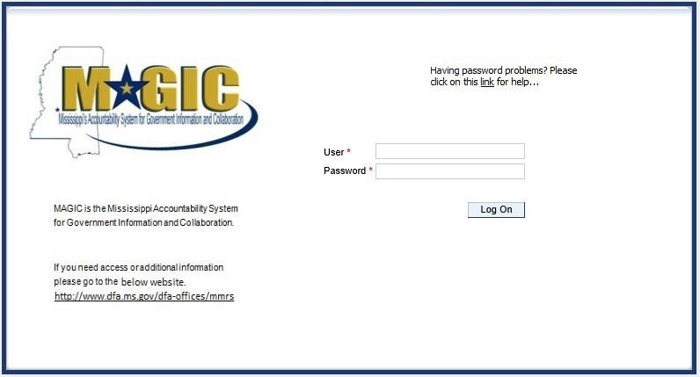
To Log into MAGIC, open the following URL: https://portal.magic.ms.gov/irj/portal. Enter User ID and Password. The password is case sensitive.

MAGIC Reverse Auction Bidders Instruction Guide

View Available Reverse Auctions

Search for Auction(s)
Listed below are the steps to search for a bid response.

- Bidders must first respond to the RFx (RFQF) to be able to participate in the Reverse Auction.
Instructions for creating a response to an RFx are available here, RFx Response -Supplier Self Service.
The RFx (RFQF)– Bid Specifications will provide details for qualifying criteria. Only bidders qualified through the RFx (RFQF) will be invited to participate in Reverse Auctions.

- To search for auctions, click on the Suppliers Self-Service tab.
- Select RFx and Auctions in the navigation menu on the left of the screen.

- Select the Published link on the eAuctions line of the Active Queriessection.

Note: If the search fields are not visible, click the button to expand the search criteria.

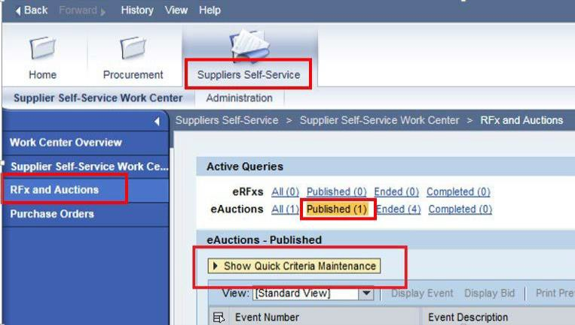

MAGIC Reverse Auction Bidders Instruction Guide

- Enter the search criteria. To find all available bid opportunities, skip to step (f).

  - Select All or Published to search for available Events (eAuctions).

  - Enter the appropriate Quick Criteria Maintenance fields: Event Number (Auction number) or complete any optional relevant search criteria.

  - Click on Apply to view all Auctions based on your search criteria.

  - To generate an updated search using the same selection criteria, click Refresh
or skip to step (7).

- Click Apply to find available bid opportunities.

- In the results list, click on the Event Number to open the Auction details in a separate window. (Pop-up blocker must be turned off.)

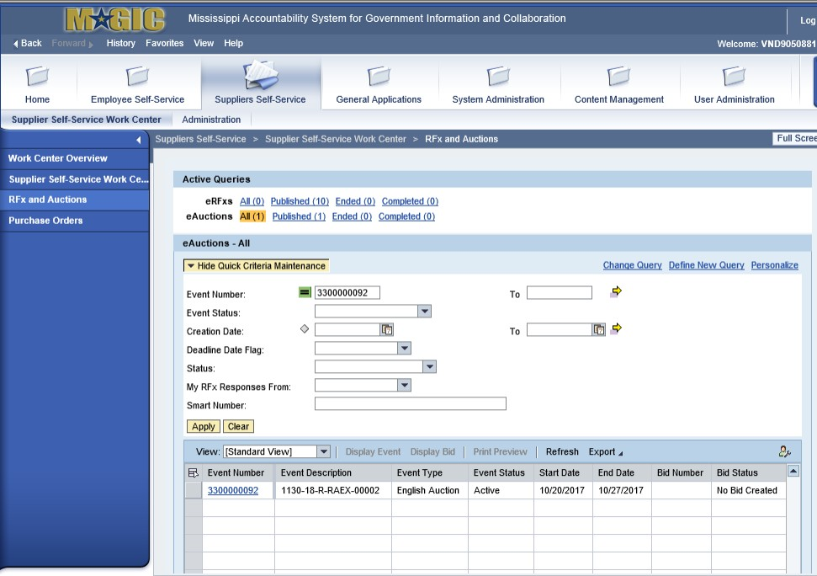

Display Auction Details
MAGIC Reverse Auction Bidders Instruction Guide

Listed below are the steps view the auction details and information regarding the auction.

1.) The Auction Details screen will be displayed. It is important to review the details prior
to the Auction begin time. Bidding will not be available prior to the Auction Start Date / Time.
The table below list the fields and a brief description of the information available on the Auction Parameters sub-tab of the Auction Information tab.
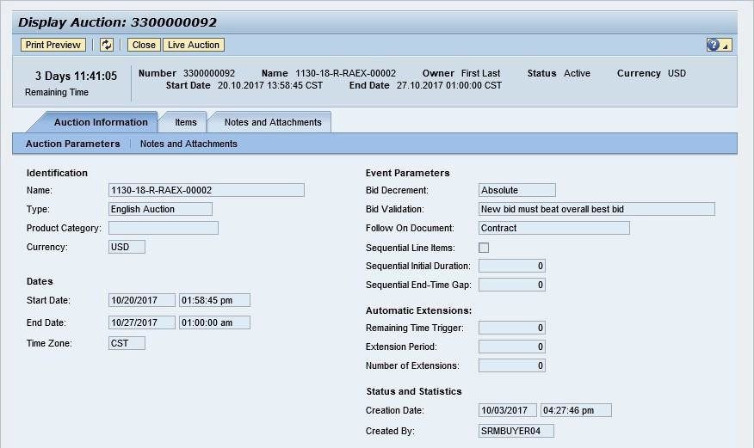

Section | Field Name | Description
Identification | Name | Smart Number with details related to the RFx
 | Type | English Auction is the standard for State of Mississippi
 | Product Category | The 5 digit NIGP code (optional)
 | Currency | US Dollar (USD)
Dates | Start Date | Begin Date and Time for the Live Auction
 | End Date | Date and Time of Live Auction completion
 | Time Zone | Central Standard Time (CST)
Event Parameters | Bid Decrement | The amount/percentage by which the next bid must decrease  relevant to the current lowest bid.
 | Bid Validation | Logic used to determine if the bid is valid.
 | Follow On Document | Contract or Purchase Order
 | Sequential Line Items | Enables sequential line item functionality to stagger end  times.
 | Sequential Initial Duration | The amount of time in between each line item end time.
 | Sequential End-Time Gap | The time between item end times.
Automatic | Remaining Time Trigger | The time period before the end of the auction where an

MAGIC Reverse Auction Bidders Instruction Guide

Extensions |  | extension can be triggered due to bid activity.
 | Extension Period | Number of minutes, for which the auction will be extended if a bidder submits an offer within the Remaining Time Trigger  period.
 | Number of Extensions | The number of times an auction can be extended by bid  activity within the Remaining Time Trigger.
Status and Statistics | Creation Date | The date and time the auction was created.
 | Created By | The User ID of the Agency Buyer who created the auction.

Display Line Items
Listed below is information regarding the line items associated with the auction.

- Click the Items tab to view the line items.
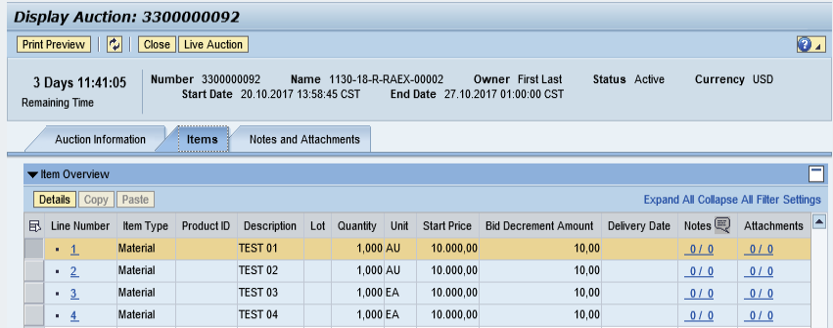

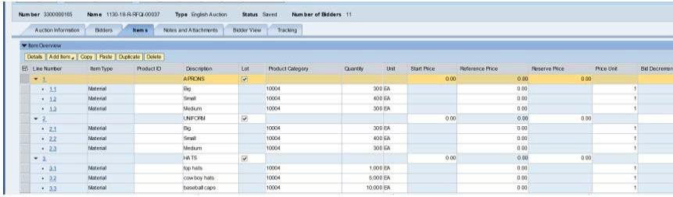
If the items are in Lots, the main items will be listed with individual lot items below.

- To view additional details for a line item, select the desired line and click the button.

MAGIC Reverse Auction Bidders Instruction Guide

- The details for the line item will be displayed.
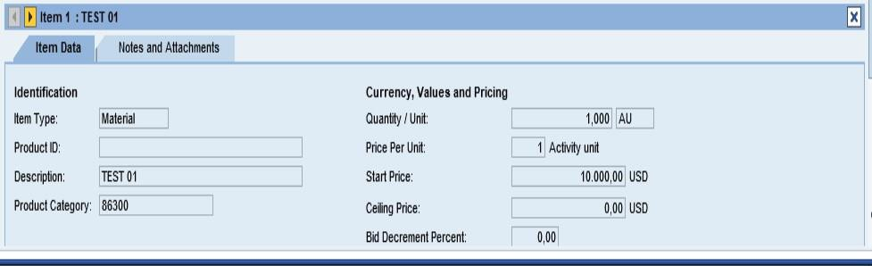

The table below list the fields and a brief description of the information available for each line item.

Section | Field Name | Description
Identification | Item Name | Type of item (Material)
 | Product ID | 11 digit material number
 | Description | Detailed description of the item
 | Product Category | The 5 digit NIGP code
Currency, Values, and Pricing | Quantity /Unit | The number of items / the Unit of Measure (i.e. EA for  each)
 | Price Per Unit | The individual price based on the Unit of Measure  indicated.
 | Start Price | Starting bid price of the item (Bids higher than the start  price will not be accepted.)
 | Ceiling Price | Ceiling Price is not used.
 | Bid Decrement Percent | Bid decrement amount if percentage option is selected.
 | Bid Decrement | Bid decrement amount if dollar amount option is  selected.

MAGIC Reverse Auction Bidders Instruction Guide

Display Notes and Attachments
Click the Notes and Attachments tab to view supporting documents and/or notes associated with the auction.
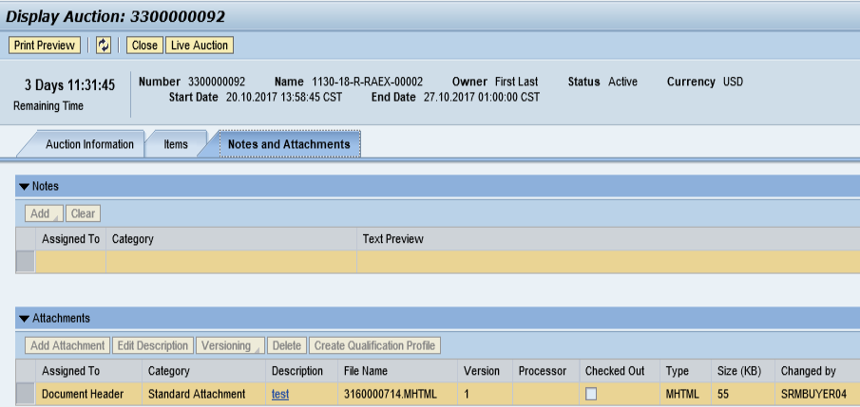

Participating in a Live Auction
After completing the steps above to find a desired auction, the steps below can be used to participate in the Live Auction process.
  - With the Auction displayed, click the Live Auction button.
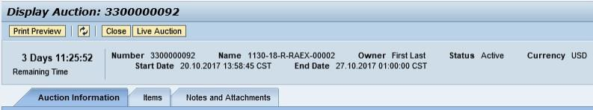
  - A pop-up window will appear containing Terms and Conditions to participate in the Live Auction.
Review all terms and conditions. If you agree, click Accept. If you click Decline you will not be allowed to participate in the Live Auction.
If the agency did not establish Terms and Conditions this screen will not be displayed.
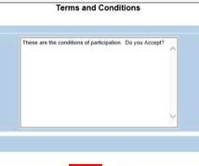

MAGIC Reverse Auction Bidders Instruction Guide

  - If any pop-ups appear asking for a confirmation to run the JAVA application, click Run.

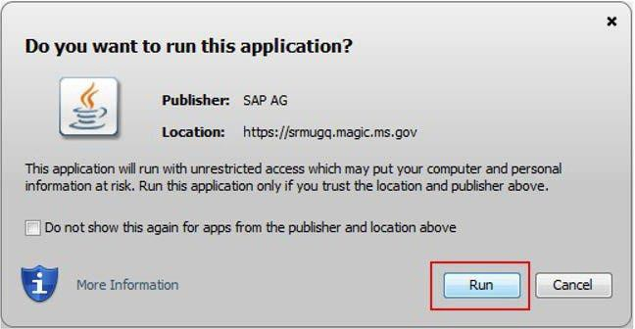

  - The Live Auction bidding screen will be displayed. If you receive any error messages, please ask your
company’s system administrator to verify your computer’s technical requirements.

Live Auction Cockpit
The Live Auction Cockpit will be displayed when the JAVA application has run.

Listed below is information regarding key items for the Live Auction Cockpit. The steps for submitting a response are located on the next page.

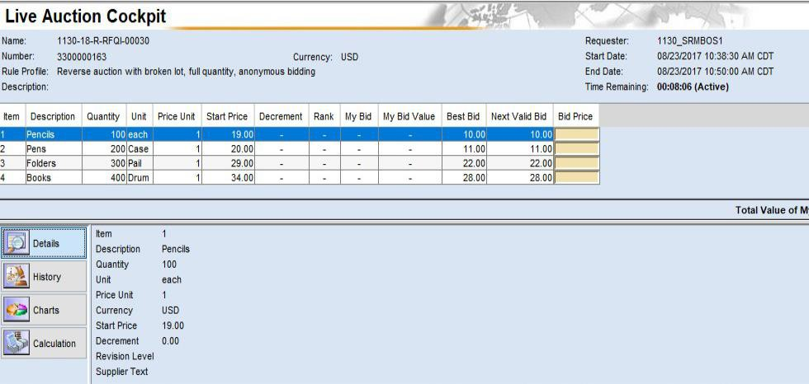

MAGIC Reverse Auction Bidders Instruction Guide

Field Name | Description
Start Date | Date and Time the Live Auction starts
End Date | Date and Time the Live Auction ends
Time Remaining | The time remaining for the Live Auction
Description | Line item description
Quantity | Line item quantity
Unit | Line item unit
Price Unit | Line item price per unit
Start Price | The initial price for the line item.
Best Bid | The lowest bid that has been submitted, to date, for that line item.  This field will be blank until the first bid has been submitted.
Next Valid Bid | The next price that is allowed to be bid for that line item. It is determined by subtracting the decrement amount from the best bid amount.
Bid Price | Your bid for the item. Your bid should be equal or less than the next valid bid field.  For instructions on how to enter your bid price, see the next page.

Submitting a Bid Response
The steps below must be completed for each separate line item you wish to bid on.
    - Click desired line item.

    - Enter the price in the Bid Price field(s) for the items you wish to bid on.

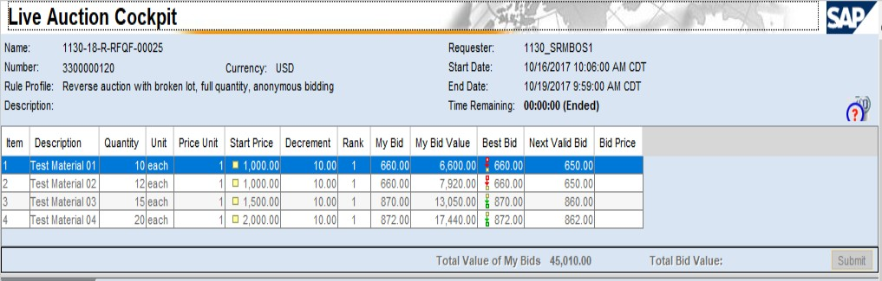

MAGIC Reverse Auction Bidders Instruction Guide

    - Click the Submit button. The submit button may be submitted after each line item price is entered or after you enter the price for all line items you wish to bid on.
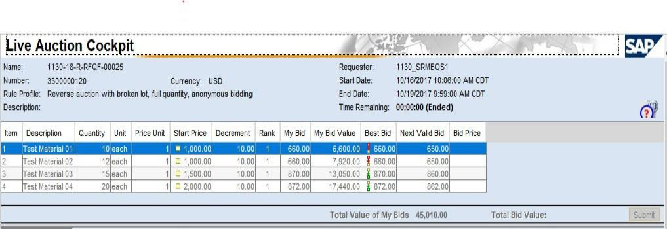

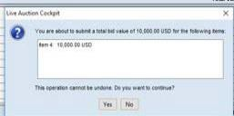
    - A confirmation pop-up window will be displayed. The bid value (by line item) will be display the total of the Unit Price times the Quantity for that item. If the bid amount(s) are correct, click Yes. If the bid amount(s) are incorrect, click No and repeat the steps above to enter the correct bid amounts.

  - A confirmation of a successful bid submission will be displayed in the Chat Window.
Note: Erroneous bids may be deleted by the agency during the live auction.
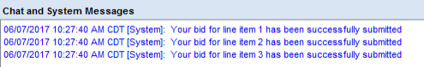

  - Repeat steps 1 – 5 for each desired line item.

MAGIC Reverse Auction Bidders Instruction Guide

Chat and System Messages

The Chat and System Messages area is used for viewing chat messages from an agency buyer and information messages automatically generated by MAGIC.
Below are helpful hints in using the chat feature:

A bidder CAN: | Send a message to an agency buyer.  Type the message in the message box and click Send.
 | See broadcast messages from the agency buyer to ALL bidders.
See messages regarding the status of the auction (e.g. paused,
resumed, or extended)
A bidder CANNOT: | Send a message to other bidders of the auction.
 | See messages sent to an agency by other bidders.
 | See messages sent to other bidders from the agency buyer.
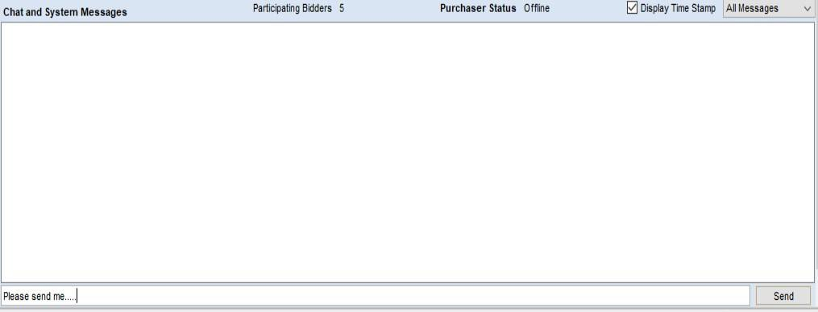

MAGIC Reverse Auction Bidders Instruction Guide

Pausing and/or Resuming an Auction
If necessary, the agency buyer can pause the Live Auction bidding. In such cases, the auction status will be changed from “Active” to “Paused”. A system alert will appear on the screen.
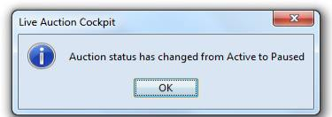
The countdown clock will not stop running while the auction is paused. The time remaining and end date / time are not affected or extended automatically.

When the agency buyer resumes the auction the auction status will be changed from “Paused” to “Active”. A system alert will appear on the screen.
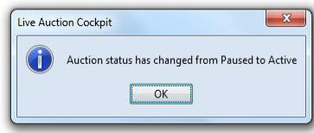

Once the auction has ended, a notification will display.

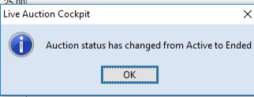

SECTION III SPECIFICATIONS
- Bidders must furnish all information requested in the bid specifications. Further, when required, each bidder must submit for bid evaluation cuts, sketches, descriptive literature and technical specifications covering the product offered. Reference to literature submitted with a previous bid or on file with MSVA will not satisfy this provision.
- The specifications set forth herein as “Section III” represent a minimum of required equipment and operational needs of the Mississippi Veteran Affairs. The bidder may propose options above and beyond these specifications that best suit MSVA’s interests as determined by the agency.
- The bidder agrees to begin delivery within 30 days of award. Failure to do so may result in cancellation of award. If cancellation of award occurs, new award will be made to the next lowest bidder meeting required specifications.
- Respond “Yes” or “No” to indicate compliance to the specifications for each listed criterion and add comments as needed. Submit completed specifications checklist with bid package.

SPECIFICATIONS CHECKLIST
Attachment 1

RFX #3140003765

Ford Transit 350 HR DRW Van
(MUST MEET OR EXCEED MINIMUM SPECIFICATIONS AND REQUIREMENTS)
 |  | CHASSIS
Yes | No | Ford Transit 350 HR DRW chassis - 10,360# GVWR, 148" WB EL3.5L
Yes | No | PFDI V6 gasoline engine
Yes | No | 10-Speed Automatic Transmission
Yes | No | 250-amp alternator
Yes | No | Power-assisted hydraulic front & rear disc brakes
Yes | No | 4-wheel anti-lock brake system
Yes | No | 25-gallon OEM fuel tank
Yes | No | Independent Macpherson strut front suspension with stabilizer bar
Yes | No | Leaf spring rear suspension
Yes | No | Advance Trac w/Roll Stability Control (RSC) w/Forward Collision Warning
Yes | No | Power steering
Yes | No | Cruise control
Yes | No | Dual batteries
Yes | No | Vinyl driver and co-pilot seats
Yes | No | Driver/Co-pilot sun visor
Yes | No | Tilt/Telescoping steering wheel
Yes | No | Power windows
Yes | No | Power door locks
Yes | No | Power mirrors
Yes | No | OEM chassis dash heater, A/C, and defroster
Yes | No | Oxford White
 |  | BODY
Yes | No | Driver and co-pilot running boards
Yes | No | Electric passenger entry bus door
Yes | No | Ford OEM 2-passenger seats with 3-pt passenger seat belts

Yes | No | Altro flooring
 |  | ADA
Yes | No | Braun Millennium wheelchair lift (800# capacity)
Yes | No | One (1) Q'Straint QRT-MAX retractable wheelchair securement system
Yes | No | Securement system storage box
Yes | No | Three (3) tiedown webbing loops
Yes | No | ADA interlock
Yes | No | ADA-compliant ramp and door entrance lighting
 |  | SAFETY
Yes | No | 5 lb. fire extinguisher
Yes | No | First aid kit
Yes | No | Emergency triangle kit
Yes | No | Body fluid clean up kit
Yes | No | Backup alarm
Yes | No | Belt cutter
 |  | ADDITIONS
Yes | No | Bus Camera System (1)
Yes | No | 2 Passenger forward facing folding cloth bench seat (2)
Yes | No | 1 Passenger forward facing folding cloth bench seat (1)
Yes | No | Metal Box
Yes | No | Delivery to Jackson, MS
 |  | FLOOR PLAN
Yes | No | Vehicle Length – 22’ Lift Position – Rear
Yes | No | WC Positions – 3
Yes | No | Total # Passengers – 8
Yes | No | CDL Required – No

FLOOR PLAN:

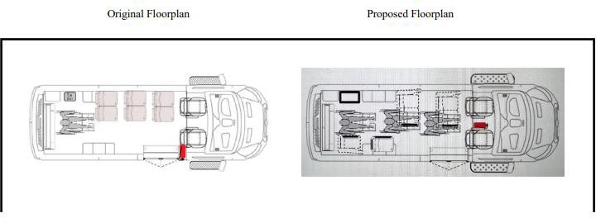

MS Veteran Affairs
660 North Street Suite 200, JACKSON, MS 39202

BID COVER SHEET

Attachment A

RFX #3140003765 – FORD TRANSIT 350 HR DRW VAN
The MSVA is seeking to receive bids for RFX #3140003765, which is for a FORD TRANSIT 350 HR DRW VAN. Bids are to be submitted online in MAGIC or by paper submission, on or before March 15, 2024 at 4:00 PM CT.

PLEASE MARK YOUR ENVELOPE:

RFX #3140003765
Opening Date: March 15, 2024, 4:00 PM CT Mississippi Veteran Affairs

ATTN: Edward Williams 660 North Street, Suite 200
Jackson, MS 39202 SEALED BID – DO NOT OPEN

Company Name: Quoted by: Signature:
Address: (Street/P.O. Box)

(City) (State) (Zip Code) Company Representative:
Telephone Number: Fax Number:

Email Address:

MS Veteran Affairs
660 North Street Suite 200, JACKSON, MS 39202

BID FORM

Attachment B

RFX #3140003765 – FORD TRANSIT 350 HR DRW VAN

Company | Company Representative | Telephone

The pricing quoted must be inclusive of, but not limited to the following:
- All required equipment and materials
- All required insurance
- All required overhead
- All required profit
- All required transportation
- All required labor
- All required business and professional licenses, permits, fees, etc. (if any)
- Any and all other costs associated with performing the services

The pricing must include ALL associated costs with no additional or hidden fees. The MSVA is requesting quotes for virgin paper as well as recycled paper.

BRIEF DESCRIPTION OF SERVICES TO BE CONDUCTED: RFX #3140003765 – FORD TRANSIT 350 HR DRW VAN
description Unit Price Total price
Total Price
By signing below, the Company Representative certifies that he/she has authority to bind the company, and further acknowledges on behalf of the company:

- That he/she has thoroughly read and understands this Invitation for Bids, RFX #3140003765, and the attachments herein;

- That the company meets all requirements and acknowledges all certifications contained in this Invitation for Bids, RFX #3140003765, and the attachments herein;

- That the company agrees to all provisions of this Invitation for Bids, RFX #3140003765, and the attachments herein;

- That the company will perform, without delay, the services required at the prices quoted in this Attachment B; and

- That, to the best of its knowledge and belief, the cost or pricing data submitted is accurate, complete, and current as of the submission date.

- That the company has, or will secure, at its own expense, applicable personnel who shall be qualified to perform the duties required to be performed under this Invitation for Bids.

Printed Name:

Signature/Date:

MS Veteran Affairs
660 North Street Suite 200, JACKSON, MS 39202

Execution of Bid

Attachment C

RFX #3140003765 – FORD TRANSIT 350 HR DRW VAN

EXECUTION OF BID MUST BE SIGNED IN INK

In compliance with this request for bid and subject to all the conditions and specifications listed herein, the undersigned offers and agrees to furnish any or all of the items upon which prices are quoted, at the price set opposite each item.
Bidder Information:
Company Name: Address:
(Street/P.O. Box)

(City) (State) (Zip Code)
Telephone Number: Fax Number:

Email Address:

Authorized Signature:
*(Member of Business/Corporation or Person Authorized to Sign on Behalf of Business)

Printed Name: Title: Date:

Acknowledgment of Amendments: (if applicable)

Amendment No. 1 Amendment No. 2

*Signature of bidder must be in ink

Printed Name/Title:

Signature/Date:

