MediaLab, Inc.
1745 North Brown Road
Suite 300
Lawrenceville, GA 30043

March 8, 2024

SOLE SOURCE CONFIRMATION

Demetria Chambers,

This letter is to certify that Document Control, InspectionProof, Compass, Compliance & CE, Personnel Documentation, and the Case Simulators are provided exclusively by MediaLab, Inc. MediaLab, Inc. is the sole source for Document Control, InspectionProof, Compass, Compliance & CE, Personnel Documentation, and the Case Simulators. Our products are not sold by any other company, organization, distributor, or other entity.

Sincerely,
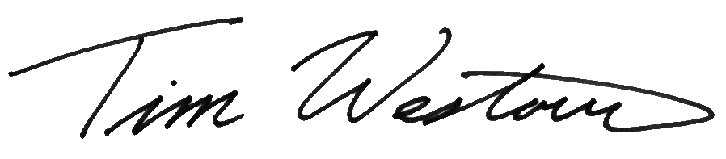
Tim Westover
Chief Operating Officer
MediaLab, Inc.

