Notice of Intent to Certify Sole Source

To: Interested Parties

From: William P. Stitt
Chief – Supply Chain Management

Date: April 2, 2018

Re: Sole Source Certification Number SS5170 for PeriCam PSI HR Laser Speckle Imager and related accessories.
Contact Email Address: solesource@umc.edu

Sole Source Certification Award Details

Regarding University of Mississippi Medical Center (UMMC) Sole Source Certification Number SS5170 for PeriCam PSI HR Laser Speckle Imager and related accessories, please be advised that UMMC intends to award the purchase to Perimed, Inc. as the sole source provider.

UMMC issues this notice in accordance with Mississippi state law, policy, and procedures for sole source procurements.

Sole Source Criteria

- Where the compatibility of equipment, accessories, or replacement parts is the paramount consideration (and manufacturer is the sole supplier).
- Where a sole supplier’s item is needed for trial use or testing.
- Where a sole supplier’s item is to be required when no other item will service the needs of UMMC.

Schedule

Task | Date
First Advertisement Date | March 20, 2018
Second Advertisement Date | March 27, 2018
Response Deadline from Objectors | April 3, 2018, at 3:00 p.m. Central Time
Notice of Award/No Award Posted | Not before April 9, 2018

Project Details

- Describe the commodity that the agency is seeking to procure:
The University of Mississippi Medical Center (UMMC) Department of Neurology seeks to purchase the Perimed PSI HR Laser Speckle Imager to be used in the laboratory. The Speckle Imager allows for real-time monitoring and imaging of tissue perfusion (blood flow). The imager is being offered with a high speed computer and PIM software. The system captures up to 100 images per second and has a wide field of view (allows for monitoring of blood flow in large areas such as whole rodent brain or multiple rodent brains).

- Explain why the commodity is the only one (1) that can meet the needs of the agency:
The Perimed PSI HR Laser Speckle Imager is the only imager that allows for imaging and monitoring of changes in tissue perfusion (blood flow) over a wide area (24 cm x 24 cm) in real time. This is needed in order to adequately monitor changes in blood flow in response to stroke or other manipulation. Additionally, this commodity is the only one that allows for selecting regions of interest before, during, and after imaging. No other commodity on the market allows for these measurements/capabilities.

- Explain why the source is the only person or entity that can provide the required commodity:
Perimed, Inc. is the sole manufacturer and supplier of the Perimed PSI HR Laser Speckle Imager and related accessories. They are not available from any other distributor. See supporting letter from Perimed, Inc., Attachment A.

- Explain why the amount to be expended for the commodity is reasonable:
The estimated amount to be expended is for the purchase of the PeriCam PSI HR Laser Speckle Imager is $62,000.00. This amount is within the expected price range for these products.

- Describe the efforts that the agency went through to obtain the best possible price for the commodity:
Through market intelligence, UMMC was able to negotiate best pricing for these products. All applicable discounts were explored and applied.

Submission Instructions and Format of Response from Objecting Parties

Interested parties who have reason to believe that the PeriCam PSI HR Laser Speckle Imager (hereafter, “Products”) should not be certified as a sole source should provide information in the Vendor Form for the State to use in determining whether or not to proceed with awarding the sole source to Axon Enterprise, Inc. The Vendor Form may be found at http://www.dfa.ms.gov/media/1591/objectiontosolesourcedetermination.pdf.

Objections must include the certification in Attachment B.

Comments will be accepted at any time prior to April 3, 2018, at 3:00 p.m. (Central Time) to solesource@umc.edu. Responses may be delivered via email to solesource@umc.edu. UMMC WILL NOT BE RESPONSIBLE FOR DELAYS IN THE DELIVERY OF RESPONSES. It is solely the responsibility of the Interested Parties that responses reach UMMC on time. Responses received after the deadline and responses that lack all required information will be rejected. UMMC reserves the right to inspect Interested Party’s commodity for comparison purposes.

If you have any questions concerning the information above or if we can be of further assistance, please contact solesource@umc.edu.

Attachment A: Vendor Correspondence
Attachment B: Objection Certification
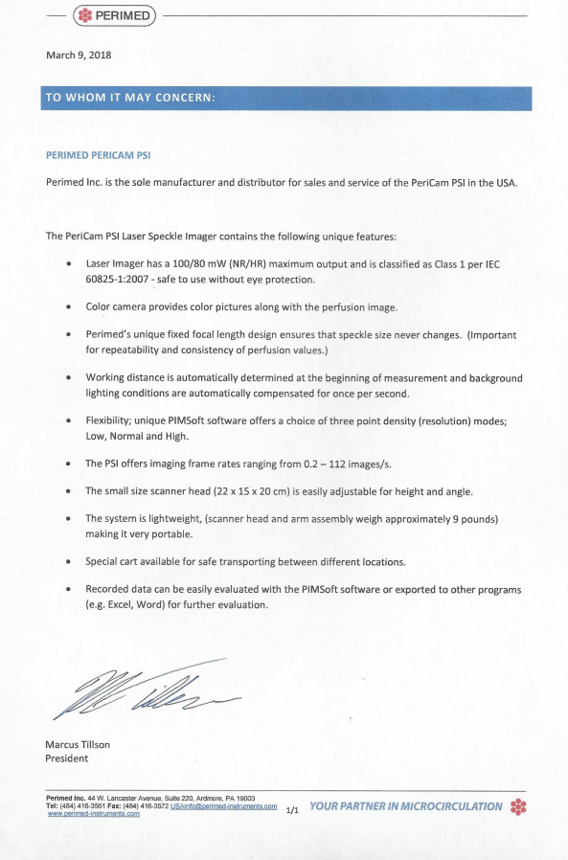
Attachment A
Attachment B

SUBMITTED IN RESPONSE TO
Sole Source Certification No. SS5170
Accepted until April 2, 2017, at 3:00 p.m.

I certify that the information contained in this objection is true and accurate to the best of my knowledge. I understand that UMMC will investigate all statements made in this objection and that any false or misleading information provided may result in adverse action.

__________________________________
Objector Name
Objector’s title

__________________________________
Date

