Notice of Intent to Certify Sole Source

To: Interested Parties

From: William P. Stitt
Chief – Supply Chain Management

Date: March 27, 2018

Re: Sole Source Certification Number SS5172 for Taser Basic 60 X2 Conducted Electrical Weapons (CEW).

Contact Email Address: solesource@umc.edu

Sole Source Certification Award Details

Regarding University of Mississippi Medical Center (UMMC) Sole Source Certification Number SS5172 for Taser Basic 60 X2 CEW and related accessories, please be advised that UMMC intends to award the purchase to Axon Enterprise, Inc. as the sole source provider.

UMMC issues this notice in accordance with Mississippi state law, policy, and procedures for sole source procurements.

Sole Source Criteria

- Where the compatibility of equipment, accessories, or replacement parts is the paramount consideration (and manufacturer is the sole supplier).
- Where a sole supplier’s item is needed for trial use or testing.
- Where a sole supplier’s item is to be required when no other item will service the needs of UMMC.

Schedule

Task | Date
First Advertisement Date | March 27, 2018
Second Advertisement Date | April 3, 2018
Response Deadline from Objectors | April 10, 2108, at 3:00 p.m. Central Time
Notice of Award/No Award Posted | Not before April 16, 2018
Project Details

- Describe the commodity that the agency is seeking to procure:
The University of Mississippi Medical Center (UMMC) Police Department seeks to continue to purchase the X2 Conducted Electrical Weapons and related accessories. The X2 CEW is a long range, multiple-shot Taser for law enforcement agencies. The X2 CEW features a static dual Laser, with an ARC switch (Arc display/Re-energize/Cartridge advance) that enables drive-stun with or without a Smart Cartridge installed.

- Explain why the commodity is the only one (1) that can meet the needs of the agency:
UPD currently owns the Basic 60 X2 CEW as a use of force option and have acquired in-house instructors. The X2 from Taser International is the only Taser with a long range (up to 35 feet) needed to keep officers at a safe distance from any threats and greater safety is provided to UMMC patients, employees, and visitors. The accessories for the X2 Conducted Electrical Weapon, including cartridges, holsters, dataport download kits, and battery packs, are specific to the X2 Conducted Electrical Weapon and are only available from the manufacturer.

- Explain why the source is the only person or entity that can provide the required commodity:
Axon, Inc. is the sole manufacturer and supplier of the X2 CEW and related accessories. They are not available from any other distributor. See supporting letter from Axon, Inc., Attachment A.

- Explain why the amount to be expended for the commodity is reasonable:
The estimated amount to be expended is for the purchase of the Taser Basic 60 X2CEW is $99,000.00 for the term of the contract. This amount is within the expected price range for these products.

- Describe the efforts that the agency went through to obtain the best possible price for the commodity:
Through market intelligence, UMMC was able to negotiate best pricing for these products. All applicable discounts were explored and applied.

Submission Instructions and Format of Response from Objecting Parties

Interested parties who have reason to believe that the Taser Basic 60 X2 Conducted Electrical Weapons (CEW (hereafter, “Products”) should not be certified as a sole source should provide information in the Vendor Form for the State to use in determining whether or not to proceed with awarding the sole source to Axon Enterprise, Inc. The Vendor Form may be found at
http://www.dfa.ms.gov/media/1591/objectiontosolesourcedetermination.pdf.

Objections must include the certification in Attachment B.

Comments will be accepted at any time prior to April 9, 2018, at 3:00 p.m. (Central Time) to solesource@umc.edu. Responses may be delivered via email to solesource@umc.edu. UMMC WILL NOT BE RESPONSIBLE FOR DELAYS IN THE DELIVERY OF RESPONSES. It is solely the responsibility of the Interested Parties that responses reach UMMC on time. Responses received after the deadline and responses that lack all required information will be rejected. UMMC reserves the right to inspect Interested Party’s commodity for comparison purposes.

If you have any questions concerning the information above or if we can be of further assistance, please contact solesource@umc.edu.

Attachment A: Vendor Correspondence
Attachment B: Objection Certification
Attachment A

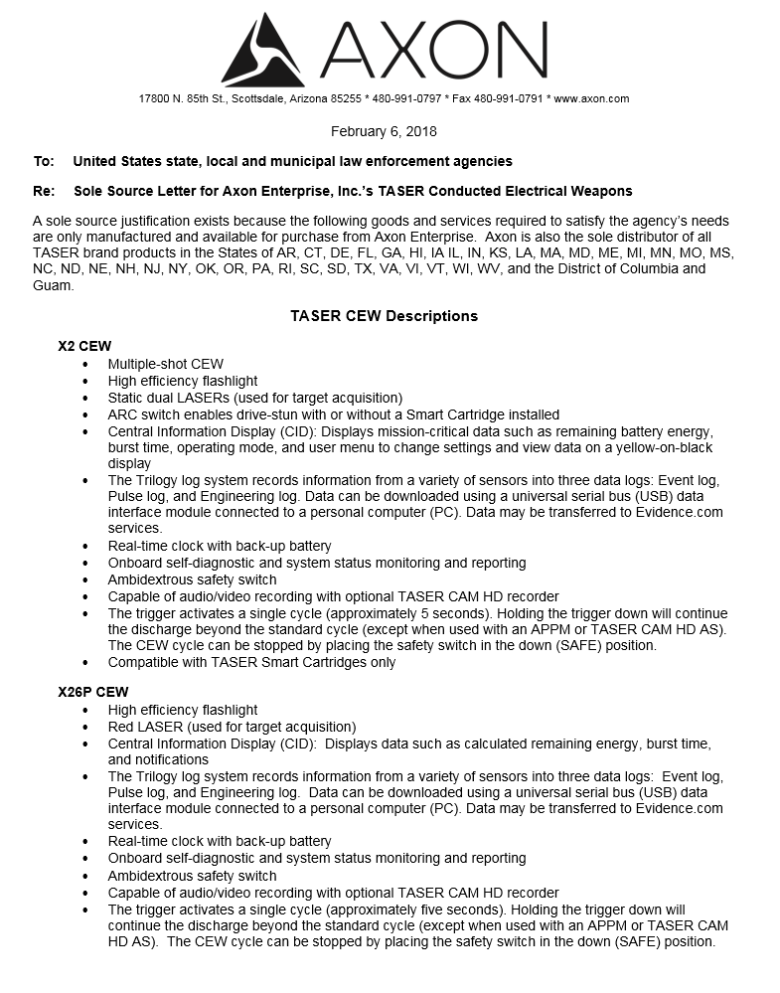

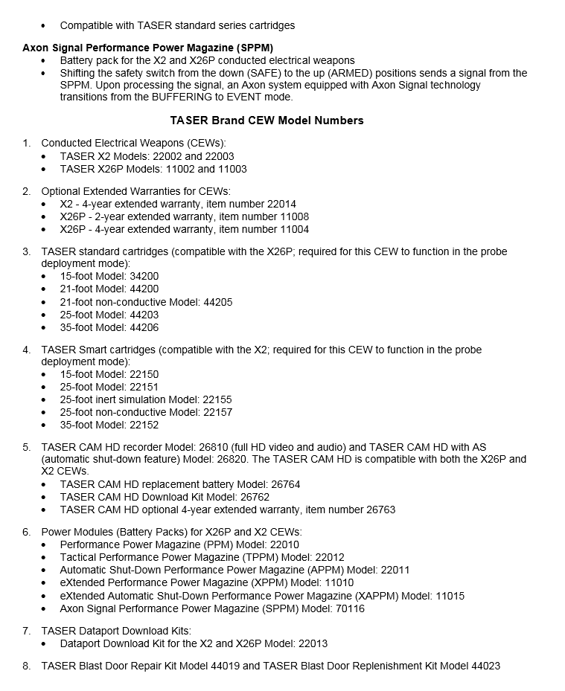

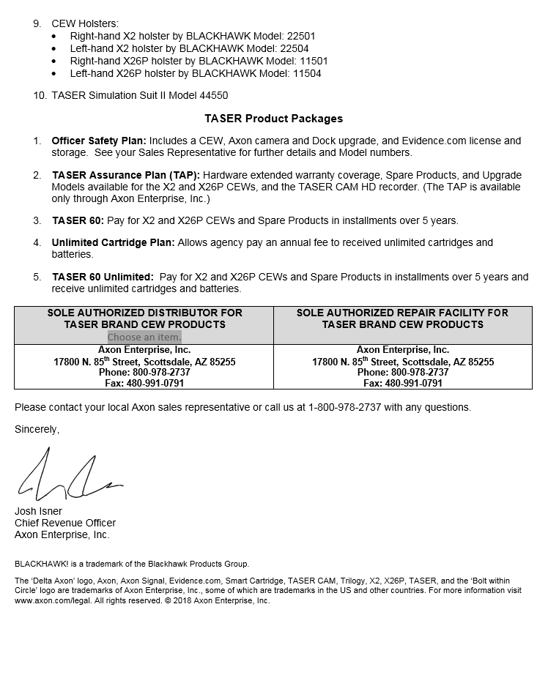

Attachment B

SUBMITTED IN RESPONSE TO
Sole Source Certification No. SS5172
Accepted until April 9, 2018, at 3:00 p.m.

I certify that the information contained in this objection is true and accurate to the best of my knowledge. I understand that UMMC will investigate all statements made in this objection and that any false or misleading information provided may result in adverse action.

__________________________________
Objector Name
Objector’s title

__________________________________
Date

