Notice of Intent to Certify Sole Source

To: Interested Parties

From: William P. Stitt
Chief – Supply Chain Management

Date: April 11, 2018

Re: Sole Source Certification Number SS5181 for MediBeacon NIC-kidney fluorescent detector and related accessories.

Contact Email Address: solesource@umc.edu

Sole Source Certification Award Details

Regarding University of Mississippi Medical Center (UMMC) Sole Source Certification Number SS5181 for MediBeacon NIC-kidney fluorescent detector and related accessories, please be advised that UMMC intends to award the purchase to MediBeacon as the sole source provider.

UMMC issues this notice in accordance with Mississippi state law, policy, and procedures for sole source procurements.

Sole Source Criteria

- Where the compatibility of equipment, accessories, or replacement parts is the paramount consideration (and manufacturer is the sole supplier).
- Where a sole supplier’s item is needed for trial use or testing.
- Where a sole supplier’s item is to be required when no other item will service the needs of UMMC.

Schedule

Task | Date
First Advertisement Date | April 11, 2018
Second Advertisement Date | April 18, 2018
Response Deadline from Objectors | April 25, 2018, at 3:00 p.m. Central Time
Notice of Award/No Award Posted | Not before May 2, 2018

Project Details

- Describe the commodity that the agency is seeking to procure:

The University of Mississippi Medical Center (UMMC) is seeking to procure MediBeacon NIC-kidney fluorescent detector and related accessories for transdermal monitoring of glomerular filtration rate (GFR) in rodents to be used in research. The MediBeacon system consists of a device and patch that are affixed externally to the animal along with a fluorescent tracer agent that is administered to track kidney function.

- Explain why the commodity is the only one (1) that can meet the needs of the agency:

The MediBeacon NIC-kidney fluorescent detector is the only option for researchers to measure GFR in rodents while conscious and without significant surgery. This will allow for better accuracy of GFR measurements with less stress to the rodent by avoiding surgery, anesthesia, and restraint. Utilization of the device with the fluorescent tracer agent is independent of blood sampling, urine collection, and laboratory assays which enables streamlined trial design and execution.

- Explain why the source is the only person or entity that can provide the required commodity:

MediBeacon is the sole manufacturer and supplier of the NIC-kidney fluorescent detector. They are not available from any other distributor. See supporting letter from MediBeacon, Attachment A.

- Explain why the amount to be expended for the commodity is reasonable:

The estimated amount to be expended is for the purchase of the NIC-kidney fluorescent detector and related accessories is $40,000.00. This amount is within the expected price range for these products.

- Describe the efforts that the agency went through to obtain the best possible price for the commodity:

Through market intelligence, UMMC was able to negotiate best pricing for these products. All applicable discounts were explored and applied.

Submission Instructions and Format of Response from Objecting Parties

Interested parties who have reason to believe that the MediBeacon NIC-kidney fluorescent detector and related accessories (hereafter, “Products”) should not be certified as a sole source should provide information in the Vendor Form for the State to use in determining whether or not to proceed with awarding the sole source to MediBeacon. The Vendor Form may be found at http://www.dfa.ms.gov/media/1591/objectiontosolesourcedetermination.pdf.

Objections must include the certification in Attachment B.

Comments will be accepted at any time prior to April 25, 2018, at 3:00 p.m. (Central Time) to solesource@umc.edu. Responses may be delivered via email to solesource@umc.edu. UMMC WILL NOT BE RESPONSIBLE FOR DELAYS IN THE DELIVERY OF RESPONSES. It is solely the responsibility of the Interested Parties that responses reach UMMC on time. Responses received after the deadline and responses that lack all required information will be rejected. UMMC reserves the right to inspect Interested Party’s commodity for comparison purposes.

If you have any questions concerning the information above or if we can be of further assistance, please contact solesource@umc.edu.

Attachment A: Vendor Correspondence
Attachment B: Objection Certification
Attachment A

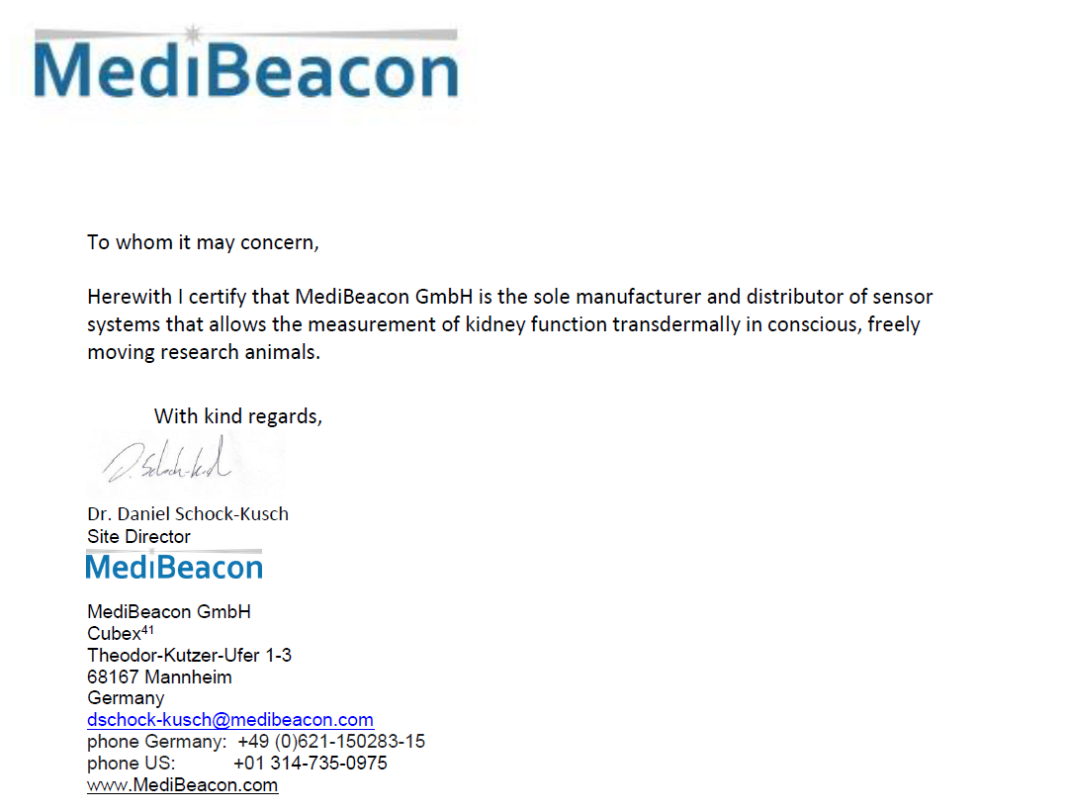
Attachment B

SUBMITTED IN RESPONSE TO
Sole Source Certification No. SS5181
Accepted until April 25, 2018, at 3:00 p.m.

I certify that the information contained in this objection is true and accurate to the best of my knowledge. I understand that UMMC will investigate all statements made in this objection and that any false or misleading information provided may result in adverse action.

__________________________________
Objector Name
Objector’s title

__________________________________
Date

