Notice of Intent to Certify Sole Source

To: Interested Parties

From: William P. Stitt
Chief – Supply Chain Management

Date: May 3, 2018

Re: Sole Source Certification Number SS5183 for Med Associates Self-administration Equipment for nonhuman primates.

Contact Email Address: solesource@umc.edu

Sole Source Certification Award Details

Regarding University of Mississippi Medical Center (UMMC) Sole Source Certification Number SS5183 for Med Associates Self-administration Equipment for nonhuman primates, please be advised that UMMC intends to award the purchase to Med Associates, Inc. as the sole source provider.

UMMC issues this notice in accordance with Mississippi state law, policy, and procedures for sole source procurements.

Sole Source Criteria

- Where the compatibility of equipment, accessories, or replacement parts is the paramount consideration (and manufacturer is the sole supplier).
- Where a sole supplier’s item is needed for trial use or testing.
- Where a sole supplier’s item is to be required when no other item will service the needs of UMMC.

Schedule

Task | Date
First Advertisement Date | May 3, 2018
Second Advertisement Date | May 10, 2018
Response Deadline from Objectors | May 17, 2018, at 3:00 p.m. Central Time
Notice of Award/No Award Posted | Not before May 24, 2018

Project Details

- Describe the commodity that the agency is seeking to procure:

The University of Mississippi Medical Center (UMMC) is seeking to expand current inventory of self-administration equipment. This includes levers and other operating equipment that allow nonhuman primates to lever-press for drug injections and other rewards. The department has nonhuman primate cages, made by Carter2. The caging is modular and allows for the insertion of steel cartridges within which the Med Associates equipment can be mounted. The caging systems are custom built and only work with Med Associates interfaces.

- Explain why the commodity is the only one (1) that can meet the needs of the agency:

UMMC Department of Neurobiology is doing ongoing behavioral research surrounding non-human primates using the Carter2 equipment and MedAssociates equipment. The department is seeking to begin a new research study that will utilize the Carter2 cages. Additional self-administration equipment that is compatible with the cages is needed for this project.

- Explain why the source is the only person or entity that can provide the required commodity:

The steel cartridges made by Carter2 are custom-fit for Med Associates. There is no other provider of self-administration equipment that can be used with these cartridges.

- Explain why the amount to be expended for the commodity is reasonable:

The estimated amount to be expended is for the purchase of the Carter2 Cage Cartridges and Related Accessories is $40,000. This amount is within the expected price range for these products.

- Describe the efforts that the agency went through to obtain the best possible price for the commodity:

Through market intelligence, UMMC was able to negotiate best pricing for these products. All applicable discounts were explored and applied.

Submission Instructions and Format of Response from Objecting Parties

Interested parties who have reason to believe that the Med Associates Self-administration Equipment for nonhuman primates (hereafter, “Products”) should not be certified as a sole source should provide information in the Vendor Form for the State to use in determining whether or not to proceed with awarding the sole source to Med Associates, Incorporated. The Vendor Form may be found at http://www.dfa.ms.gov/media/1591/objectiontosolesourcedetermination.pdf.

Objections must include the certification in Attachment B.

Comments will be accepted at any time prior to May 17, 2018, at 3:00 p.m. (Central Time) to solesource@umc.edu. Responses may be delivered via email to solesource@umc.edu. UMMC WILL NOT BE RESPONSIBLE FOR DELAYS IN THE DELIVERY OF RESPONSES. It is solely the responsibility of the Interested Parties that responses reach UMMC on time. Responses received after the deadline and responses that lack all required information will be rejected. UMMC reserves the right to inspect Interested Party’s commodity for comparison purposes.

If you have any questions concerning the information above or if we can be of further assistance, please contact solesource@umc.edu.

Attachment A: Vendor Correspondence
Attachment B: Objection Certification
Attachment A
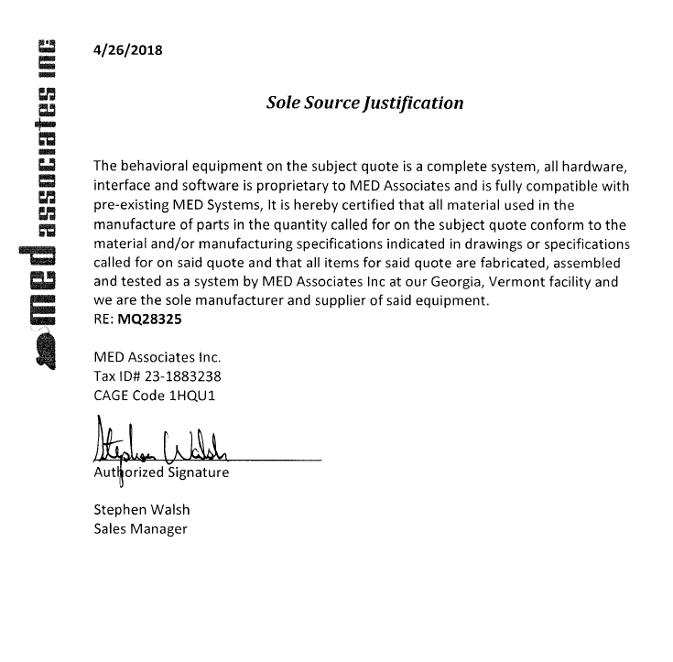

Attachment B

SUBMITTED IN RESPONSE TO
Sole Source Certification No. SS5183
Accepted until May 17, 2018, at 3:00 p.m.

I certify that the information contained in this objection is true and accurate to the best of my knowledge. I understand that UMMC will investigate all statements made in this objection and that any false or misleading information provided may result in adverse action.

__________________________________
Objector Name
Objector’s title

__________________________________
Date

