Notice of Intent to Certify Sole Source

To: Interested Parties

From: William P. Stitt
Chief – Supply Chain Management

Date: April 24, 2018

Re: Sole Source Certification Number SS5187 for Oroboros O2K FluoRespirometer and related accessories.

Contact Email Address: solesource@umc.edu

Sole Source Certification Award Details

Regarding University of Mississippi Medical Center (UMMC) Sole Source Certification Number SS5187 for Oroboros O2K FluoRespirometer and related accessories please be advised that UMMC intends to award the purchase to Oroboros Instruments Corporation as the sole source provider.

UMMC issues this notice in accordance with Mississippi state law, policy, and procedures for sole source procurements.

Sole Source Criteria

- Where the compatibility of equipment, accessories, or replacement parts is the paramount consideration (and manufacturer is the sole supplier).
- Where a sole supplier’s item is needed for trial use or testing.
- Where a sole supplier’s item is to be required when no other item will service the needs of UMMC.

Schedule

Task | Date
First Advertisement Date | April 24, 2018
Second Advertisement Date | May 1, 2018
Response Deadline from Objectors | May 8, at 3:00 p.m. Central Time
Notice of Award/No Award Posted | Not before May 15, 2018

Project Details

- Describe the commodity that the agency is seeking to procure:

The University of Mississippi Medical Center (UMMC) is seeking to procure Oroboros O2K FluoRespirometer and related accessories to be used for mitochondria and cell research. The instrument is a respirometer and fluorimeter combination. The respirometer allows for routine measurements of oxygen consumption and mitochondrial respiration to be made with specifications summarized under the term “high resolution respirometry”. The fluorimeter measures the magnitude of the membrane potential across the inner mitochondrial membrane, the rate of production of reactive oxygen, and the rate of adenosine triphosphate.

The Cell and Molecular Biology Research lab currently utilizes The Oroboros O2K FluoRespirometer; however, interest and demand for mitochondrial analyses in increasing to the point that one unit has become a limiting factor for funded research projects.

- Explain why the commodity is the only one (1) that can meet the needs of the agency:

The Oroboros O2K FluoRespirometer and related accessories is needed to continue to perform state-of-the-art, comprehensive measurements of mitochondrial function as part of the internal and collaborative research efforts of the Department of Cell and Molecular Biology at UMMC. The Oroboros O2k FluoRespirometer is the only device capable of making the needed measurements for two principal reasons:

- The O2k-FluoRespirometer is the most sensitive and the most accurate O2 electrode device available (accurate to ± 1.0 pmol O2 s-1 mL-1). The Oroboros O2k is the only device capable of performing “high resolution respirometry”, a practice becoming the gold-standard in medical research. The ability of the Oroboros Oxygraph to accurately measure slow rates of O2 consumption allows the researcher to accurately measure respiration by tissue samples, cultured cells and isolated mitochondria using amounts of biological material that can be readily obtained.

- Use of the O2k-FluoRespirometer enables the researcher to measure membrane potential, rates of H2O2 production or rates of ATP synthesis concurrent with the acquisition of rates of electron transfer. This capability is essential for state-of-the-art determinations of mitochondrial function and this capability is unique to the Oroboros O2k-FluoRespirometer.

- Explain why the source is the only person or entity that can provide the required commodity:

Oroboros is the only vendor offering a product with these capabilities. This is not available from any other distributor. See supporting letter Oroboros, Attachment A.

- Explain why the amount to be expended for the commodity is reasonable:

The estimated amount to be expended is for the purchase of the Oroboros O2K FluoRespirometer and related accessories is $150,000. This amount is within the expected price range for these products.

- Describe the efforts that the agency went through to obtain the best possible price for the commodity:

Through market intelligence, UMMC was able to negotiate best pricing for these products. All applicable discounts were explored and applied.

Submission Instructions and Format of Response from Objecting Parties

Interested parties who have reason to believe that the Oroboros O2K FluoRespirometer and related accessories (hereafter, “Products”) should not be certified as a sole source should provide information in the Vendor Form for the State to use in determining whether or not to proceed with awarding the sole source to Oroboros Instruments Corporation. The Vendor Form may be found at http://www.dfa.ms.gov/media/1591/objectiontosolesourcedetermination.pdf.

Objections must include the certification in Attachment B.

Comments will be accepted at any time prior to May 8, 2018, at 3:00 p.m. (Central Time) to solesource@umc.edu. Responses may be delivered via email to solesource@umc.edu. UMMC WILL NOT BE RESPONSIBLE FOR DELAYS IN THE DELIVERY OF RESPONSES. It is solely the responsibility of the Interested Parties that responses reach UMMC on time. Responses received after the deadline and responses that lack all required information will be rejected. UMMC reserves the right to inspect Interested Party’s commodity for comparison purposes.

If you have any questions concerning the information above or if we can be of further assistance, please contact solesource@umc.edu.

Attachment A: Vendor Correspondence
Attachment B: Objection Certification
Attachment A

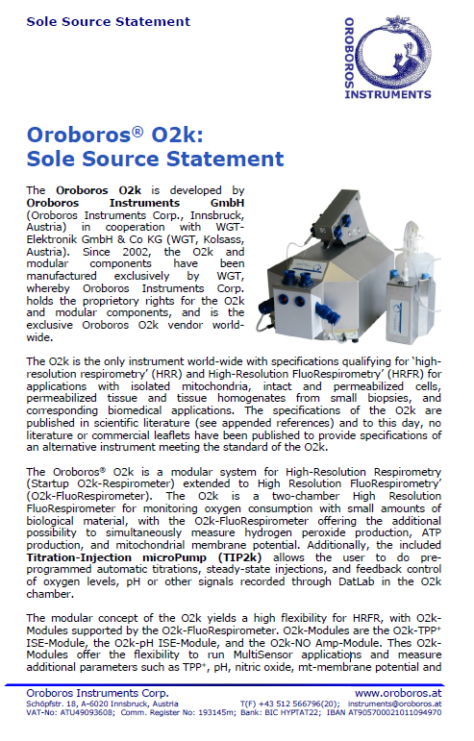
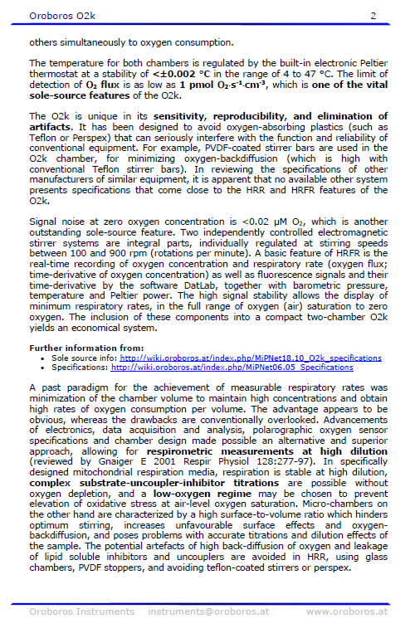
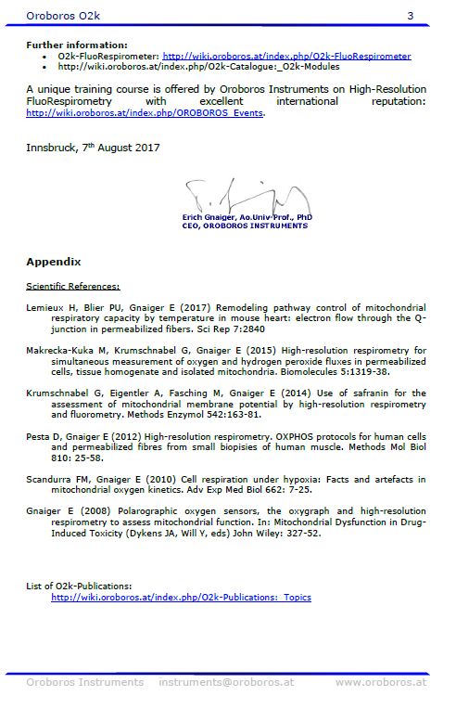
Attachment B

SUBMITTED IN RESPONSE TO
Sole Source Certification No. SS5187
Accepted until May 8, 2018, at 3:00 p.m.

I certify that the information contained in this objection is true and accurate to the best of my knowledge. I understand that UMMC will investigate all statements made in this objection and that any false or misleading information provided may result in adverse action.

__________________________________
Objector Name
Objector’s title

__________________________________
Date

