Notice of Intent to Certify Sole Source

To: Interested Parties

From: William P. Stitt
Chief – Supply Chain Management

Date: May 22, 2018

Re: Sole Source Certification Number SS5193 for Leica Microsystems TCS SP8LIA with confocal microscope and related accessories

Contact Email Address: solesource@umc.edu

Sole Source Certification Award Details

Regarding University of Mississippi Medical Center (UMMC) Sole Source Certification Number SS5193 for Leica Microsystems TCS SP8LIA with confocal microscope and related accessories, please be advised that UMMC intends to award the purchase to Leica Microsystems as the sole source provider.

UMMC issues this notice in accordance with Mississippi state law, policy, and procedures for sole source procurements.

Sole Source Criteria

- Where the compatibility of equipment, accessories, or replacement parts is the paramount consideration (and manufacturer is the sole supplier).
- Where a sole supplier’s item is needed for trial use or testing.
- Where a sole supplier’s item is to be required when no other item will service the needs of UMMC.

Schedule

Task | Date
First Advertisement Date | May 22, 2018
Second Advertisement Date | May 29, 2018
Response Deadline from Objectors | June 5, 2018, at 3:00 p.m. Central Time
Notice of Award/No Award Posted | Not before June 12, 2018

Project Details

- Describe the commodity that the agency is seeking to procure:

The University of Mississippi Medical Center (UMMC) is seeking to purchase the Leica SP8LIA with super-resolution confocal microscope and related accessories for use in the research lab.

- Explain why the commodity is the only one (1) that can meet the needs of the agency:

This is the only commercially available prism based spectral detection system. This system allows the researcher to precisely select the detection wavelengths in order to perform multi-spectral imaging. The system can be tuned to the exact emission peak for any dye, allowing for less laser intensity and preservation of the sample.

The system is equipped with Lightning, a super resolution technique which is only commercially available from Leica. This super-resolution technique is unique in that it does not use a global set of parameters; instead, it calculates an appropriate set of parameters for each voxel. This adaptive process allows for structures below 120nm to be resolved. This particular super resolution technique allows the researcher to go deeper into the sample than other available techniques, which is essential for thick tissue sections.

The system includes HyD detectors which are unique to Leica. The detectors have a GaAsP photocathode and a single step amplification resulting in a higher signal to noise ratio. This is required for Lightning to obtain resolution below 120nm. Each detector is spectrally tunable and capable of 1 nanometer steps with as small as 5 nm bandwidth. All detectors can be used simultaneously to capture a super resolution image with Lightning. These detectors also help to preserve samples by reducing the amount of laser intensity needed.

The Leica DMi8 is the only system that offers full removal of all DIC components from the light path during confocal imaging. This offers maximum light efficiency and image quality.

The Leica tandem scanner allows for fast scan speeds at high resolution. The resonant scanner offered by Leica is the only scanner with a 2448X2448 resolution. The dwell times of this scanner are shorter than other products which allows the researcher to zoom into the sample and acquire a z-stack with less photo bleaching. This scanner is more than double the resolution of other competing systems.
Leica offers optimal filling of the back aperture of the objective and concentric scanning allows Leica to use the largest FOV at 22mm. This allows for faster acquisition speeds and maintaining the sample viability.

- Explain why the source is the only person or entity that can provide the required commodity:

Leica Microsystems TCS SP8LIA with super-resolution confocal microscope and related accessories offers several unique features for the research lab:

- Lightning Adaptive Super Resolution. Simultaneous multi-channel super resolution beyond 120nm. Capable of going deep into the tissue.

- Optimal filling of the back aperture and concentric scanning allows Leica to use the largest FOV at 22mm. This allows for faster acquisition speeds and sample viability.

- The Leica SP8 with super Z galvometric stage with 10nm resolution. This allows for high-speed live XYZ sectioning at 10 Hz.

- HyD detectors unique to Leica for brilliant imaging: highly sensitive so ideal for high speed or live cell imaging.

- The Leica DMi8 is the only system that offers full removal of all DIC components from the light path during confocal imaging

- Leica spectral detection has a fully tunable detection range from 430 nm to 750 nm – independent from fixed filter barriers. It is completely gapless spectral imaging. This is patented by Leica.

- Leica LAS X offers a High Content Screening module. This allows for Rapid and reproducible results from automated microscopy and feedback analysis results to screening experiment via CAM interface.

- Explain why the amount to be expended for the commodity is reasonable:

The estimated amount to be expended is for the purchase of the Leica Microsystems TCS SP8LIA with confocal microscope and related accessories is $410,000. This amount is within the expected price range for these products.

- Describe the efforts that the agency went through to obtain the best possible price for the commodity:

Through market intelligence, UMMC was able to negotiate best pricing for these products. All applicable discounts were explored and applied.

Submission Instructions and Format of Response from Objecting Parties

Interested parties who have reason to believe that the TCS SP8LIA with super-resolution confocal microscope and related accessories (hereafter, “Products”) should not be certified as a sole source should provide information in the Vendor Form for the State to use in determining whether or not to proceed with awarding the sole source to Leica Microsystems. The Vendor Form may be found at http://www.dfa.ms.gov/media/1591/objectiontosolesourcedetermination.pdf.

Objections must include the certification in Attachment B.

Comments will be accepted at any time prior to June 5, 2018, at 3:00 p.m. (Central Time) to solesource@umc.edu. Responses may be delivered via email to solesource@umc.edu. UMMC WILL NOT BE RESPONSIBLE FOR DELAYS IN THE DELIVERY OF RESPONSES. It is solely the responsibility of the Interested Parties that responses reach UMMC on time. Responses received after the deadline and responses that lack all required information will be rejected. UMMC reserves the right to inspect Interested Party’s commodity for comparison purposes.

If you have any questions concerning the information above or if we can be of further assistance, please contact solesource@umc.edu.

Attachment A: Vendor Correspondence
Attachment B: Objection Certification
Attachment A
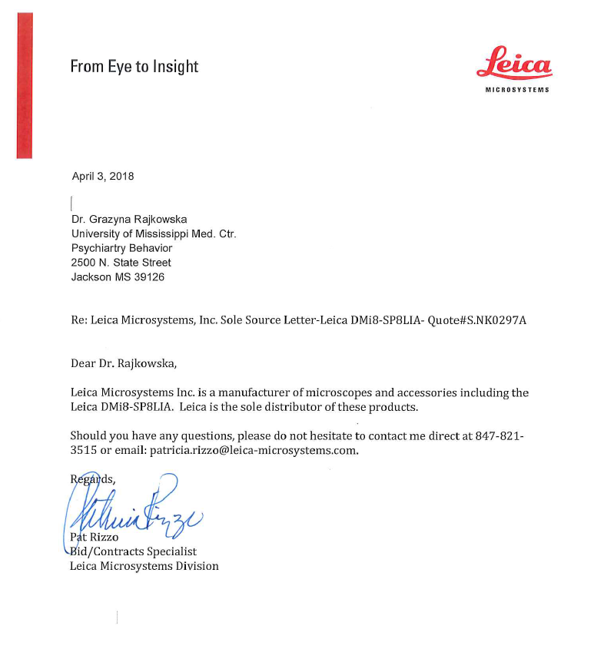

Attachment B

SUBMITTED IN RESPONSE TO
Sole Source Certification No. SS5193
Accepted until June 5, 2018, at 3:00 p.m.

I certify that the information contained in this objection is true and accurate to the best of my knowledge. I understand that UMMC will investigate all statements made in this objection and that any false or misleading information provided may result in adverse action.

__________________________________
Objector Name
Objector’s title

__________________________________
Date

