Notice of Intent to Certify Sole Source

To: Interested Parties

From: William P. Stitt
Chief – Supply Chain Management

Date: June 12, 2018

Re: Sole Source Certification Number SS5213 for the True Phantom Solutions Adult Human Head Phantom for Magnetic Resonance Imaging (MRI) and Computerized Tomography (CT) with customized brain

Contact Email Address: solesource@umc.edu

Sole Source Certification Award Details

Regarding University of Mississippi Medical Center (UMMC) Sole Source Certification Number SS5213 for Adult Human Head Phantom for MRI and CT with customized brain please be advised that UMMC intends to award the purchase to True Phantom Solutions, Incorporated as the sole source provider.

UMMC issues this notice in accordance with Mississippi state law, policy, and procedures for sole source procurements.

Sole Source Criteria

- Where the compatibility of equipment, accessories, or replacement parts is the paramount consideration (and manufacturer is the sole supplier).
- Where a sole supplier’s item is needed for trial use or testing.
- Where a sole supplier’s item is to be required when no other item will service the needs of UMMC.

Schedule

Task | Date
First Advertisement Date | June 12, 2018
Second Advertisement Date | June 19, 2018
Response Deadline from Objectors | June 26, at 3:00 p.m. Central Time
Notice of Award/No Award Posted | Not before July 3, 2018
Project Details

- Describe the commodity that the agency is seeking to procure:

The University of Mississippi Medical Center (UMMC) is seeking to procure the True Phantom Solutions Adult Human Head Phantom for MRI and CT with customized brain to be used for MRI-guided radiotherapy research. The customized phantom offers an anatomically correct skull and realistic brain phantom with up to two (2) inflatable tumors, cervical vertebrae, and realistic air cavities within the phantom.

- Explain why the commodity is the only one (1) that can meet the needs of the agency:

The purpose of custom realistic head and neck phantom is to simulate the real geometry of human head and neck region when imaged with both MRI and CT. The custom phantom is necessary because standard phantoms that are available only work in MRI or CT. The purpose of this research is to address the challenge that MRI has superior visualization of soft tissue tumors but suffers from 1) geometrical spatial distortion and 2) signal non-uniformity challenges that require combining information from both MRI with CT when planning for stereotactic radiosurgery. This custom phantom will be imaged using both CT and MRI using clinical imaging protocols. Standard phantoms cannot be used to address the research questions. The custom phantom also allows research and methods development that would not be possible with human subjects due to exposure to ionizing radiation.

- Explain why the source is the only person or entity that can provide the required commodity:

True Phantom Solutions, Inc. is the only vendor and Research and Development Company that produces brain, head, and neck phantoms with realistic bone structure, tissue mimicking, and accurate anatomy with high precision. This is not available from any other distributor. See supporting letter True Phantom Solutions, Inc. Attachment A.

- Explain why the amount to be expended for the commodity is reasonable:

The estimated amount to be expended is for the purchase of the Adult Human Head Phantom for MRI with customized brain is $11,500. This amount is within the expected price range for these products.

- Describe the efforts that the agency went through to obtain the best possible price for the commodity:

Through market intelligence, UMMC was able to negotiate best pricing for these products. All applicable discounts were explored and applied.

Submission Instructions and Format of Response from Objecting Parties

Interested parties who have reason to believe that the True Phantom Solutions Adult Human Head Phantom for MRI and CT with customized brain (hereafter, “Products”) should not be certified as a sole source should provide information in the Vendor Form for the State to use in determining whether or not to proceed with awarding the sole source to True Phantom Solutions, Inc. The Vendor Form may be found at http://www.dfa.ms.gov/media/1591/objectiontosolesourcedetermination.pdf.

Objections must include the certification in Attachment B.

Comments will be accepted at any time prior to June 26, 2018, at 3:00 p.m. (Central Time) to solesource@umc.edu. Responses may be delivered via email to solesource@umc.edu. UMMC WILL NOT BE RESPONSIBLE FOR DELAYS IN THE DELIVERY OF RESPONSES. It is solely the responsibility of the Interested Parties that responses reach UMMC on time. Responses received after the deadline and responses that lack all required information will be rejected. UMMC reserves the right to inspect Interested Party’s commodity for comparison purposes.

If you have any questions concerning the information above or if we can be of further assistance, please contact solesource@umc.edu.

Attachment A: Vendor Correspondence
Attachment B: Objection Certification
Attachment A

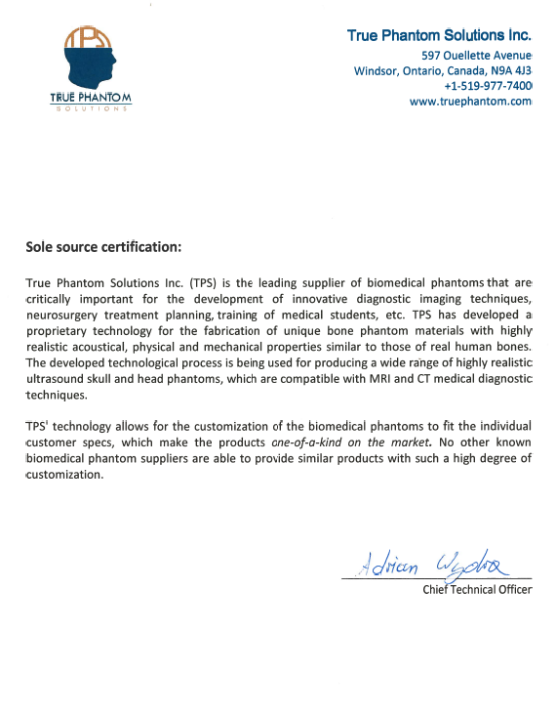

Attachment B

SUBMITTED IN RESPONSE TO
Sole Source Certification No. SS5123
Accepted until June 26 , 2018, at 3:00 p.m.

I certify that the information contained in this objection is true and accurate to the best of my knowledge. I understand that UMMC will investigate all statements made in this objection and that any false or misleading information provided may result in adverse action.

__________________________________
Objector Name
Objector’s title

__________________________________
Date

