Notice of Intent to Certify Sole Source

To: Interested Parties

From: William P. Stitt
Chief – Supply Chain Management

Date: June 19, 2018

Re: Sole Source Certification Number SS5217 for Illumina iSeq 100 with related kits and reagents

Contact Email Address: solesource@umc.edu

Sole Source Certification Award Details

Regarding University of Mississippi Medical Center (UMMC) Sole Source Certification Number SS5217 for Illumina iSeq 100 with related kits and reagents. Please be advised that UMMC intends to award the purchase to Illumina as the sole source provider.

UMMC issues this notice in accordance with Mississippi state law, policy, and procedures for sole source procurements.

Sole Source Criteria

- Where the compatibility of equipment, accessories, or replacement parts is the paramount consideration (and manufacturer is the sole supplier).
- Where a sole supplier’s item is needed for trial use or testing.
- Where a sole supplier’s item is to be required when no other item will service the needs of UMMC.

Schedule

Task | Date
First Advertisement Date | June 19, 2018
Second Advertisement Date | June 26, 2018
Response Deadline from Objectors | July 3, 2018 at 3:00 p.m. Central Time
Notice of Award/No Award Posted | Not before July 11, 2018

Project Details

- Describe the commodity that the agency is seeking to procure:

The Illumina iSeq100 instrument is a low throughput sequencing instrument that will provide cost effective next generation sequencing capabilities for various sequencing pipelines, including 16S microbiome sequencing, amplicon sequencing, small genome work, and/or quality control of sequencing libraries.

- Explain why the commodity is the only one (1) that can meet the needs of the agency:

The recently released Illumina iSeq100 instrument provides important capabilities that will fulfill a needed niche in the running of small number of sample through next generation sequencing pipelines. The UMMC Molecular and Genomics Core currently operates two Illumina instruments (Illumina MiSeq and Illumina NextSeq500) that provide medium to high-throughput sequencing capabilities; however, the cost to run small projects are not feasible on these instruments. The iSeq100 is the only instrument available that will provide a cost effective solution as well as seamlessly integrate with our current equipment. The data generated is exactly the same between all three Illumina instruments and just the scale (or amount of data) is different. In other words, a library prepared for one instrument can be utilized on the other instruments depending on the required amount of data. For example, a pilot study could be performed to determine if there are difference across experimental groups, if so, more data could be collected on the Illumina NextSeq500 or MiSeq. In addition, all the data generated on each instrument could be seamlessly merged for analysis using Illumina’s BaseSpace Cloud Computing Platform.

- Explain why the source is the only person or entity that can provide the required commodity:

The recently released Illumina iSeq100 instrument is solely manufactured and sold by Illumina. There are no other instrument commercially available that utilize the unique sequencing pipelines/applications (i.e. kits and reagents, sequencing chemistry, amplification method, etc.) that are available through Illumina. In addition, the Illumina instruments offer a seamless approach from data generation through analysis (BaseSpace Computing Pipeline). This instrument is completely compatible with current equipment which was invested in by UMMC. In other words, no other sequencing instrument would integrate with our instrumentation, thereby limiting its utility.
See supporting letter from Illumina, Inc. Attachment A.

- Explain why the amount to be expended for the commodity is reasonable:

The estimated amount to be expended for the purchase of the Illumina iSeq 100 with related kits and reagents is $60,000.00. This amount is within the expected price range for these products.

- Describe the efforts that the agency went through to obtain the best possible price for the commodity:

Through market intelligence, UMMC was able to negotiate best pricing for these products. All applicable discounts were explored and applied.

Submission Instructions and Format of Response from Objecting Parties

Interested parties who have reason to believe that Illumina iSeq 100 with related kits and reagents (hereafter, “Products”) should not be certified as a sole source should provide information in the Vendor Form for the State to use in determining whether or not to proceed with awarding the sole source to Illumina. The Vendor Form may be found at http://www.dfa.ms.gov/media/1591/objectiontosolesourcedetermination.pdf.

Objections must include the certification in Attachment B.

Comments will be accepted at any time prior to June 26, 2018, at 3:00 p.m. (Central Time) to solesource@umc.edu. Responses may be delivered via email to solesource@umc.edu. UMMC WILL NOT BE RESPONSIBLE FOR DELAYS IN THE DELIVERY OF RESPONSES. It is solely the responsibility of the Interested Parties that responses reach UMMC on time. Responses received after the deadline and responses that lack all required information will be rejected. UMMC reserves the right to inspect Interested Party’s commodity for comparison purposes.

If you have any questions concerning the information above or if we can be of further assistance, please contact solesource@umc.edu.

Attachment A: Vendor Correspondence
Attachment B: Objection Certification
Attachment A

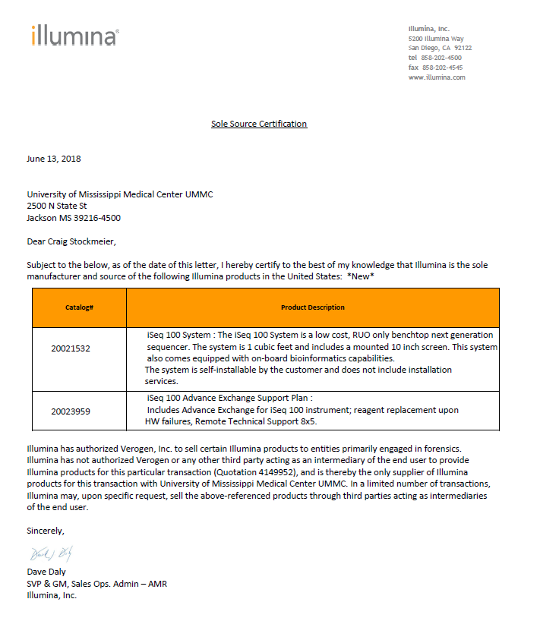

Attachment B

SUBMITTED IN RESPONSE TO
Sole Source Certification No. SS5217
Accepted until July 3, 2018, at 3:00 p.m.

I certify that the information contained in this objection is true and accurate to the best of my knowledge. I understand that UMMC will investigate all statements made in this objection and that any false or misleading information provided may result in adverse action.

__________________________________
Objector Name
Objector’s title

__________________________________
Date

