Notice of Intent to Certify Sole Source

To: Interested Parties

From: William P. Stitt
Chief – Supply Chain Management

Date: August 6, 2018

Re: Sole Source Certification Number SS5238 for the Energy Pod
Contact Email Address: solesource@umc.edu

Sole Source Certification Award Details

Regarding University of Mississippi Medical Center (UMMC) Sole Source Certification Number SS5238 for Energy Pod. Please be advised that UMMC intends to award the purchase to RestWorks as the sole source provider.

UMMC issues this notice in accordance with Mississippi state law, policy, and procedures for sole source procurements.

Sole Source Criteria

- Where the compatibility of equipment, accessories, or replacement parts is the paramount consideration (and manufacturer is the sole supplier).
- Where a sole supplier’s item is needed for trial use or testing.
- Where a sole supplier’s item is to be required when no other item will service the needs of UMMC.

Schedule

Task | Date
First Advertisement Date | August 6, 2018
Second Advertisement Date | August 13, 2018
Response Deadline from Objectors | August 20, at 3:00 p.m. Central Time
Notice of Award/No Award Posted | Not before August 27, 2018

Project Details

- Describe the commodity that the agency is seeking to procure:

The University of Mississippi Medical Center (UMMC) is seeking to procure the RestWorks Energy Pod for use in the School of Medicine. The Energy Pod is an ergonomically designed chair equipped with storage space, privacy visor, and i20 Technology developed for napping in the workplace.

- Explain why the commodity is the only one (1) that can meet the needs of the agency:

The Energy Pod is a power napping solution that has received national press from a number of prominent institutions. Studies have shown that taking brief naps can improve alertness, learning, and mood while decreasing stress. The School of Medicine has made a commitment to student wellness; this product supports the goals associated with that pledge.

- Explain why the source is the only person or entity that can provide the required commodity:

RestWorks is the only distributor of the Energy Pod. See supporting letter from RestWorks, Attachment A.

- Explain why the amount to be expended for the commodity is reasonable:

The estimated amount to be expended is for the purchase of the Energy Pod is $30,000.00. This amount is within the expected price range for these products.

- Describe the efforts that the agency went through to obtain the best possible price for the commodity:

Through market intelligence, UMMC was able to negotiate best pricing for these products. All applicable discounts were explored and applied.

Submission Instructions and Format of Response from Objecting Parties

Interested parties who have reason to believe that the Energy Pod (hereafter, “Products”) should not be certified as a sole source should provide information in the Vendor Form for the State to use in determining whether or not to proceed with awarding the sole source to RestWorks. The Vendor Form may be found at http://www.dfa.ms.gov/media/1591/objectiontosolesourcedetermination.pdf.

Objections must include the certification in Attachment B.

Comments will be accepted at any time prior to August 20, 2018, at 3:00 p.m. (Central Time) to solesource@umc.edu. Responses may be delivered via email to solesource@umc.edu. UMMC WILL NOT BE RESPONSIBLE FOR DELAYS IN THE DELIVERY OF RESPONSES. It is solely the responsibility of the Interested Parties that responses reach UMMC on time. Responses received after the deadline and responses that lack all required information will be rejected. UMMC reserves the right to inspect Interested Party’s commodity for comparison purposes.

If you have any questions concerning the information above or if we can be of further assistance, please contact solesource@umc.edu.

Attachment A: Vendor Correspondence
Attachment B: Objection Certification
Attachment A

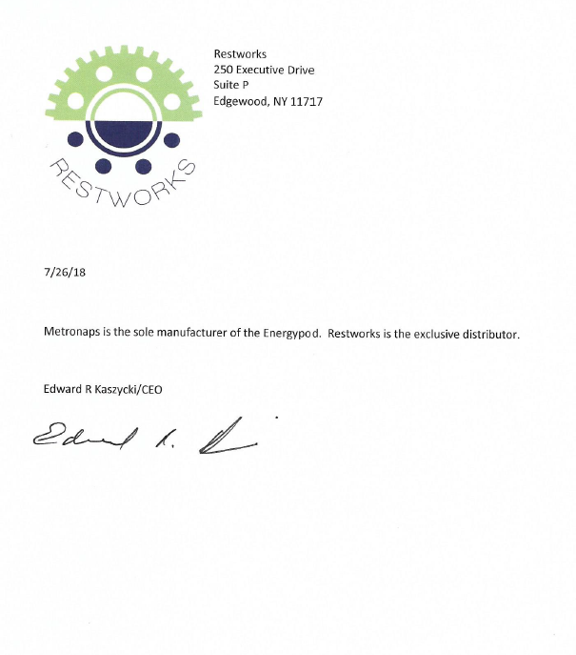

Attachment B

SUBMITTED IN RESPONSE TO
Sole Source Certification No. SS5238
Accepted until August 20, 2018, at 3:00 p.m.

I certify that the information contained in this objection is true and accurate to the best of my knowledge. I understand that UMMC will investigate all statements made in this objection and that any false or misleading information provided may result in adverse action.

__________________________________
Objector Name
Objector’s title

__________________________________
Date

