Notice of Intent to Certify Sole Source

To: Interested Parties

From: William P. Stitt
Chief – Supply Chain Management

Date: October 18, 2018

Re: Sole Source Certification Number SS5259_Zeiss LSM 880 Confocal laser scanning microscope with Airyscan
Contact Email Address: solesource@umc.edu

Sole Source Certification Award Details

Regarding University of Mississippi Medical Center (UMMC) Sole Source Certification Number SS5259 for Zeiss LSM 880 Confocal Laser scanning microscope with Airyscan and all related accessories. Please be advised that UMMC intends to award the purchase to Carl Zeiss Microscopy, LLC as the sole source provider.

UMMC issues this notice in accordance with Mississippi state law, policy, and procedures for sole source procurements.

Sole Source Criteria

- Where the compatibility of equipment, accessories, or replacement parts is the paramount consideration (and manufacturer is the sole supplier).
- Where a sole supplier’s item is needed for trial use or testing.
- Where a sole supplier’s item is to be required when no other item will service the needs of UMMC.

Schedule

Task | Date
First Advertisement Date | October 18, 2018
Second Advertisement Date | October 25, 2018
Response Deadline from Objectors | November 1, at 3:00 p.m. Central Time
Notice of Award/No Award Posted | Not before November 8, 2018

Project Details

- Describe the commodity that the agency is seeking to procure:

The University of Mississippi Medical Center (UMMC) is seeking to procure the Zeiss LSM880 NLO multiphoton 34-channel GaAsP Spectral Array Detector + FAST AiryScan Super resolution laser scanning confocal microscope system with accompanying computers and software to operate the equipment, acquire images and other data, and analyze the acquired data.

- Explain why the commodity is the only one (1) that can meet the needs of the agency:

In order to carry out proposed research, the Research lab is in need of an instrument capable of the following:

- An instrument that allows for the separation of emitted fluorescent light into 30 or more channels and super-resolution imaging, in particular super-resolution imaging of deep structures using multi-photon confocal microscopy. In order to meet research needs, the system must have super-resolution capability that works with laser light emission including multi-photon laser excitation and does not require the use of photo-switching or other specialized fluorophores, but rather works with standard fluorescent proteins that already present in laboratory models.
- The lab needs the capability to simultaneously image several fluorophores with overlapping emission spectra to the degree of at least 30 channels of separation, which can only be achieved by prism-based separation, a micro-lens array, and a spectral detector capable of filtering light in 10nm increments with a per window resolvability of 1nm in either direction.
- Researchers are seeking diffraction breaking of the excitation laser to provide the option of 4X scan speed over traditional laser point scanning for time-sensitive experiments, and we also need to operate at this speed with super-resolution (< 120nm lateral resolution).
- It is critical for intended future use that the system be upgradeable to be able to work with greater numbers of laser combinations. This system uses a twin-gate main beam splitter with two separate 13-position MBS wheels that allows for up to 50 different laser combinations.
- Tight control via software integration of laser intensities where, for standard confocal experiments using bright fluorophores, the laser power can be turned down to less than 0.005% and for low light fluorophores and/or deep imaging via multiphoton and/or for photo bleaching experiments the lasers can be powered up to 100% (i.e. we need the broadest dynamic range possible).
- Freely rotatable scan field from 0-360 degrees to correct for angular movements of cells over time with live imaging as well as to standardize images and reduce variability across samples.
- Absolute linear scanner movement to ensure equal pixel dwell-times, which is required for quantitative comparisons of fluorescent intensities and/or numbers of fluorescent molecules, both within and across samples.
- Image format resolution up to 8192 x 8192 for all PMT channels.

The Zeiss LSM 880 confocal laser-scanning microscope with Airyscan is the only product on the market that can perform all of the above functions.

- Explain why the source is the only person or entity that can provide the required commodity:

Carl Zeiss Microscopy, LLC is the only distributor of the Zeiss LSM 880 Confocal Laser scanning microscope with Airyscan. See supporting letter from Carl Zeiss Microscopy, LLC, Attachment A. Other super-resolution microscopes use cameras rather than GaASP detectors and therefore are not as sensitive as the proposed system. Still other systems offer super-resolution based on special fluorescent substrates that have the ability to switch from one color to another or switch between on and off states with low energy stimulation or other methods. The researcher requires the ability to look deeper into the tissues and cells with greater resolution at smaller structures and molecules. Additionally, the researcher will need have the ability to image at super resolution with very high speeds that are not achievable with systems other than the Zeiss AiryScan FAST module

- Explain why the amount to be expended for the commodity is reasonable:

The estimated amount to be expended is for the purchase of the Zeiss LSM 880 Confocal Laser scanning microscope with Airyscan is $800,000.00. This amount is within the expected price range for this equipment.

- Describe the efforts that the agency went through to obtain the best possible price for the commodity:

Through market intelligence, UMMC was able to negotiate best pricing for these products. All applicable discounts were explored and applied.

Submission Instructions and Format of Response from Objecting Parties

Interested parties who have reason to believe that the Zeiss LSM 880 Confocal Laser scanning microscope with Airyscan (hereafter, “Products”) should not be certified as a sole source should provide information in the Vendor Form for the State to use in determining whether or not to proceed with awarding the sole source to RestWorks. The Vendor Form may be found at http://www.dfa.ms.gov/media/1591/objectiontosolesourcedetermination.pdf.

Objections must include the certification in Attachment B.

Comments will be accepted at any time prior to November 1, 2018, at 3:00 p.m. (Central Time) to solesource@umc.edu. Responses may be delivered via email to solesource@umc.edu. UMMC WILL NOT BE RESPONSIBLE FOR DELAYS IN THE DELIVERY OF RESPONSES. It is solely the responsibility of the Interested Parties that responses reach UMMC on time. Responses received after the deadline and responses that lack all required information will be rejected. UMMC reserves the right to inspect Interested Party’s commodity for comparison purposes.

If you have any questions concerning the information above or if we can be of further assistance, please contact solesource@umc.edu.

Attachment A: Vendor Correspondence
Attachment B: Objection Certification
Attachment A

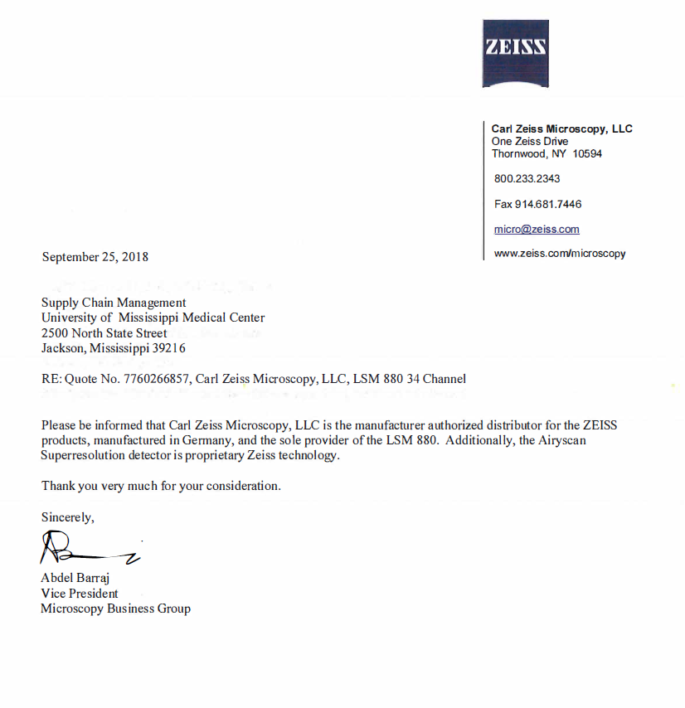

Attachment B

SUBMITTED IN RESPONSE TO
Sole Source Certification No. SS5259
Accepted until November 1, 2018, at 3:00 p.m.

I certify that the information contained in this objection is true and accurate to the best of my knowledge. I understand that UMMC will investigate all statements made in this objection and that any false or misleading information provided may result in adverse action.

__________________________________
Objector Name
Objector’s title

__________________________________
Date

