Notice of Intent to Certify Sole Source

To: Interested Parties

From: Jennifer Douglas
Administrative Director Category Management & Procurement
Supply Chain Management

Date: November 5, 2018

Re: Sole Source Certification Number SS5275_RNAScopes, reagent kits, and related accessories.

Contact Email Address: solesource@umc.edu

Sole Source Certification Award Details

Regarding University of Mississippi Medical Center (UMMC) Sole Source Certification Number SS5275 for RNAScopes, reagent kits, and related accessories. Please be advised that UMMC intends to award the purchase to Advanced Cell Diagnostics (ACD) as the sole source provider.

UMMC issues this notice in accordance with Mississippi state law, policy, and procedures for sole source procurements.

Sole Source Criteria

- Where the compatibility of equipment, accessories, or replacement parts is the paramount consideration (and manufacturer is the sole supplier).
- Where a sole supplier’s item is needed for trial use or testing.
- Where a sole supplier’s item is to be required when no other item will service the needs of UMMC.

Schedule

Task | Date
First Advertisement Date | November 5, 2018
Second Advertisement Date | November 12, 2018
Response Deadline from Objectors | November 19, at 3:00 p.m. Central Time
Notice of Award/No Award Posted | Not before November 26, 2018

Project Details

- Describe the commodity that the agency is seeking to procure:

The University of Mississippi Medical Center (UMMC) is seeking to purchase RNAScopes, reagent kits, and related accessories from Advanced Cell Diagnostics for use in Research. These products are used in various studies including drug development, cancer and stem cell research, as well as, neuroscience, cell biology, and immunology research.

Explain why the commodity is the only one (1) that can meet the needs of the agency:

The RNAScope is a proprietary RNA in situ hybridization assay based on signal amplification and background suppression technology. Signal amplification along with simultaneous background suppression results in single-RNA-molecule detection even in partially degraded samples. Single molecule detection at single-cell resolution enables researchers to quantify per cell expression level across heterogeneous cell populations.

- Explain why the source is the only person or entity that can provide the required commodity:

Advanced Cell Diagnostics is the sole manufacturer and supplier of RNAScopes, reagent kits, and related accessories. They are not available from any other distributor. See supporting letter from Advanced Cell Diagnostics. Attachment A.

- Explain why the amount to be expended for the commodity is reasonable:

The estimated amount to be expended is for the purchase of the ACD RNAScopes, reagents, and related accessories is $88,000.00. This amount is within the expected price range for these products.

- Describe the efforts that the agency went through to obtain the best possible price for the commodity:

Through market intelligence, UMMC was able to negotiate best pricing for these products. All applicable discounts were explored and applied.

Submission Instructions and Format of Response from Objecting Parties

Interested parties who have reason to believe that the (hereafter, “Products”) should not be certified as a sole source should provide information in the Vendor Form for the State to use in determining whether or not to proceed with awarding the sole source to Advanced Cell Diagnostics. The Vendor Form may be found at http://www.dfa.ms.gov/media/1591/objectiontosolesourcedetermination.pdf.

Objections must include the certification in Attachment B.

Comments will be accepted at any time prior to November 19, 2018, at 3:00 p.m. (Central Time) to solesource@umc.edu. Responses may be delivered via email to solesource@umc.edu. UMMC WILL NOT BE RESPONSIBLE FOR DELAYS IN THE DELIVERY OF RESPONSES. It is solely the responsibility of the Interested Parties that responses reach UMMC on time. Responses received after the deadline and responses that lack all required information will be rejected. UMMC reserves the right to inspect Interested Party’s commodity for comparison purposes.

If you have any questions concerning the information above or if we can be of further assistance, please contact solesource@umc.edu.

Attachment A: Vendor Correspondence
Attachment B: Objection Certification
Attachment A
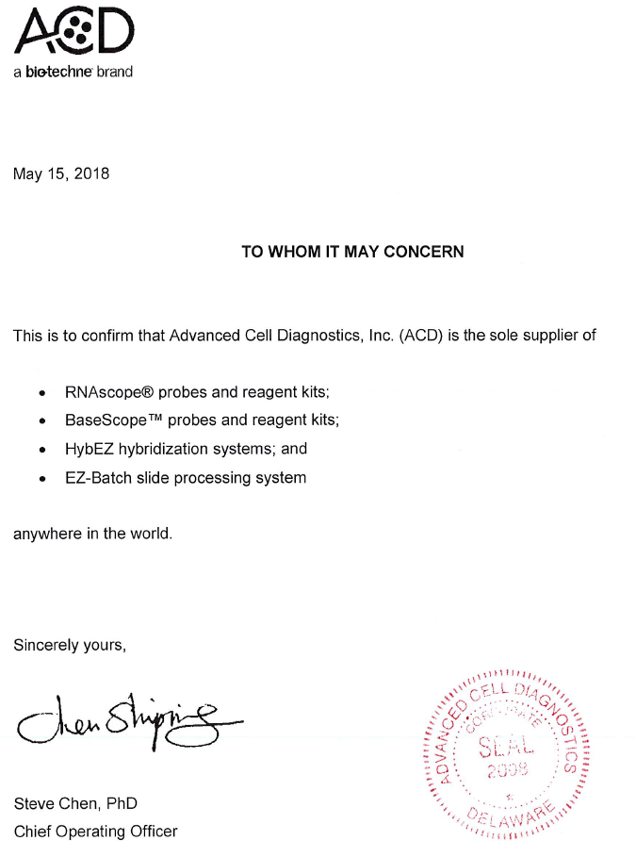

Attachment B

SUBMITTED IN RESPONSE TO
Sole Source Certification No. SS5275
Accepted until November 5, 2018, at 3:00 p.m.

I certify that the information contained in this objection is true and accurate to the best of my knowledge. I understand that UMMC will investigate all statements made in this objection and that any false or misleading information provided may result in adverse action.

__________________________________
Objector Name
Objector’s title

__________________________________
Date

