Notice of Intent to Certify Sole Source

To: Interested Parties

From: Jennifer Douglas
Administrative Director, Category Management and Procurement
Supply Chain Management

Date: November 5, 2018

Re: Sole Source Certification Number SS5282 for GSW (Gun Shot Wound) TOMManikin, GSW female manikin, and all related accessories

Contact Email Address: solesource@umc.edu

Sole Source Certification Award Details

Regarding UMMC Sole Source Certification Number SS5282 for GSW TOMManikin, GSW female manikin and all related accessories, please be advised that UMMC intends to award the purchase to Innovative Tactical Straining Solutions (ITTS) as the sole source provider.

UMMC issues this notice in accordance with Mississippi state law, policy, and procedures for sole source procurements.

Sole Source Criteria

- Where the compatibility of equipment, accessories, or replacement parts is the paramount consideration (and manufacturer is the sole supplier).
- Where a sole supplier’s item is needed for trial use or testing.
- Where a sole supplier’s item is to be required when no other item will service the needs of UMMC.

Schedule

Task | Date
First Advertisement Date | November 12, 2018
Second Advertisement Date | November 19, 2018
Response Deadline from Objectors | November 28, 2018, at 3:00 p.m. Central Time
Notice of Award/No Award Posted | Not before December 5, 2018

Project Details

- Describe the commodity that the agency is seeking to procure:

The University of Mississippi Medical Center (UMMC) seeks to purchase the TOMManikin, GSW female manikin, and all related accessories from ITTS. The male and female mid-fidelity manikins are constructed of solid silicone and welded steel frame/joints which allows dragging by a single extremity for trauma training of medical personnel with realistic height, weight, bilateral chest movement, anatomically and physiologically accurate pulses and customizable voice tracks.

- Explain why the commodity is the only one (1) that can meet the needs of the agency:

Due to the nature of training and work provided by the UMMC Public Service Division, ITTS is able to provide a lifelike, realistic, and durable mid-fidelity mannequin for training purposes. It can be used in entrapment, motor vehicle accident, and water rescue simulations without normal concerns of other models available on the market. It also is linked to a handheld computer where the instructor can monitor, adjust, and provide real time feedback to students. Multiple amputation and gunshot wound scenarios are also available and this model holds up to 1.5 gallons of simulated blood.

- Explain why the source is the only person or entity that can provide the required commodity:

ITTS manufactures the GSW TOMManikin, GSW female manikin, and all related accessories. ITTS is the sole manufacturer and supplier of GSW TOMManikin, GSW female manikin, and all related accessories. They are not available from any other distributor. See supporting letter from ITTS, Attachment A.

- Explain why the amount to be expended for the commodity is reasonable:

The estimated amount to be expended is for the purchase of the GSW TOMManikin, GSW female manikin, and all related accessories is $100,000.00. This amount is within the expected price range for these products.

- Describe the efforts that the agency went through to obtain the best possible price for the commodity:

Through market intelligence, UMMC was able to negotiate best pricing for these products. All applicable discounts were explored and applied.

Submission Instructions and Format of Response from Objecting Parties

Interested parties who have reason to believe that the GSW TOMManikin, GSW female manikin, and all related accessories, (hereafter, “Products”) should not be certified as a sole source should provide information in the Vendor Form for the State to use in determining whether or not to proceed with awarding the sole source to ITTS. The Vendor Form may be found at http://www.dfa.state.ms.us/Purchasing/documents/ObjectiontoSoleSourceDetermination.pdf.

Objections must include the certification in Attachment B.

Comments will be accepted at any time prior to Monday, November 19, 2018, at 3:00 p.m. (Central Time) to solesource@umc.edu. Responses may be delivered via email to solesource@umc.edu. UMMC WILL NOT BE RESPONSIBLE FOR DELAYS IN THE DELIVERY OF RESPONSES. It is solely the responsibility of the Interested Parties that responses reach UMMC on time. Responses received after the deadline and responses that lack all required information will be rejected. UMMC reserves the right to inspect Interested Party’s commodity for comparison purposes.

If you have any questions concerning the information above or if we can be of further assistance, please contact solesource@umc.edu.

Attachment A: Vendor Correspondence
Attachment B: Objection Certification

Attachment A

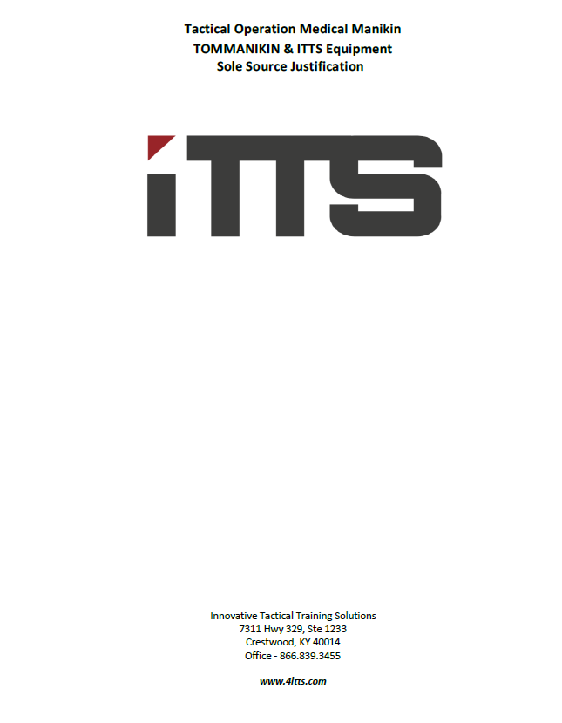
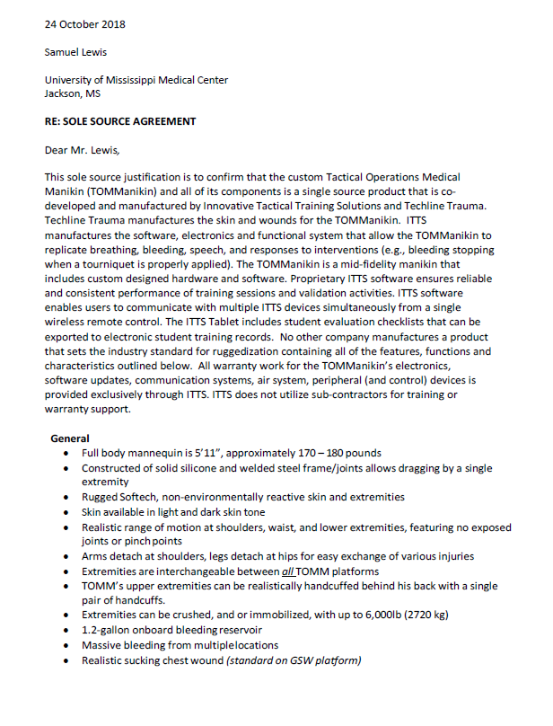

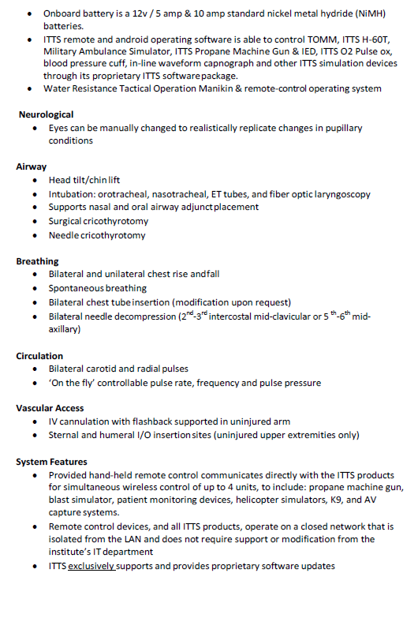

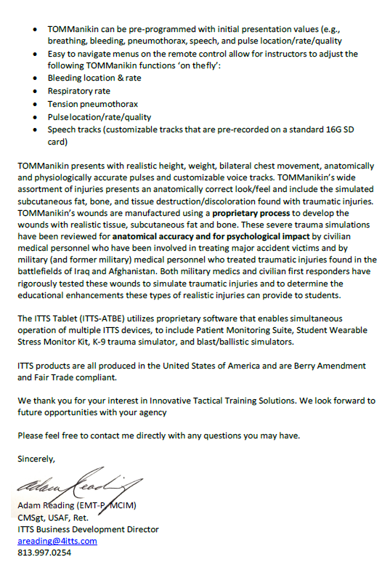

Attachment B

SUBMITTED IN RESPONSE TO
Sole Source Certification No. SS5282
Accepted until November 28, 2018, at 3:00 p.m.

I certify that the information contained in this objection is true and accurate to the best of my knowledge. I understand that UMMC will investigate all statements made in this objection and that any false or misleading information provided may result in adverse action.

__________________________________
Objector Name
Objector’s title

__________________________________
Date

