Notice of Intent to Certify Sole Source

To: Interested Parties

From: Jennifer Douglas
Administrative Director, Category Management and Procurement
Supply Chain Management

Date: December 10, 2018

Re: Sole Source Certification Number SS5295 for Mechatronik Chewing Simulator

Contact Email Address: solesource@umc.edu

Sole Source Certification Award Details

Regarding UMMC Sole Source Certification Number SS5295 for Mechatronik Chewing Simulator CS-4.4 and related components, please be advised that UMMC intends to award the purchase to Gold One Supplies as the sole source provider.

UMMC issues this notice in accordance with Mississippi state law, policy, and procedures for sole source procurements.

Sole Source Criteria

- Where the compatibility of equipment, accessories, or replacement parts is the paramount consideration (and manufacturer is the sole supplier).
- Where a sole supplier’s item is needed for trial use or testing.
- Where a sole supplier’s item is to be required when no other item will service the needs of UMMC.

Schedule

Task | Date
First Advertisement Date | December 10, 2018
Second Advertisement Date | December 17, 2018
Response Deadline from Objectors | December 26, 2018, at 3:00 p.m. Central Time
Notice of Award/No Award Posted | Not before January 3, 2018

Project Details

- Describe the commodity that the agency is seeking to procure:

The University of Mississippi Medical Center (UMMC) seeks to purchase Mechatronik CS-4.4 chewing simulator for use in dental research. This equipment simulates various chewing movements for materials testing of implants, bridges, crowns, composite material and jaw models.

- Explain why the commodity is the only one (1) that can meet the needs of the agency:

Mechatronik CS-4.4 chewing simulator with four stations, 250 N (newton) per station load capacity (individually adjustable), vertical and lateral programmable movement, individual station height adjustment, individual station failure detection, individual station wear detection, and option for future thermal cycling upgrade. Competing products are not equivalent in function because they load all stations with a single actuator, whereas the Mechatronik product allows individual failure detection, wear measurement, and load setting for each of its stations.

- Explain why the source is the only person or entity that can provide the required commodity:

Gold One Supplies is the sole manufacturer and supplier of the Mechatronik Chewing Simulator CS-4.4. They are not available from any other distributor. See supporting letter from Gold One Supplies, Attachment A.

- Explain why the amount to be expended for the commodity is reasonable:

The estimated amount to be expended is for the purchase of the Mechatronik Chewing Simulator CS-4.4 is $44,000.00. This amount is within the expected price range for these products.

- Describe the efforts that the agency went through to obtain the best possible price for the commodity:

Through market intelligence, UMMC was able to negotiate best pricing for these products. All applicable discounts were explored and applied.

Submission Instructions and Format of Response from Objecting Parties

Interested parties who have reason to believe that the Mechatronik Chewing Simulator CS-4.4, (hereafter, “Products”) should not be certified as a sole source should provide information in the Vendor Form for the State to use in determining whether or not to proceed with awarding the sole source to Gold One Supplies. The Vendor Form may be found at http://www.dfa.state.ms.us/Purchasing/documents/ObjectiontoSoleSourceDetermination.pdf.

Objections must include the certification in Attachment B.

Comments will be accepted at any time prior to Wednesday, December 26, 2018, at 3:00 p.m. (Central Time) to solesource@umc.edu. Responses may be delivered via email to solesource@umc.edu. UMMC WILL NOT BE RESPONSIBLE FOR DELAYS IN THE DELIVERY OF RESPONSES. It is solely the responsibility of the Interested Parties that responses reach UMMC on time. Responses received after the deadline and responses that lack all required information will be rejected. UMMC reserves the right to inspect Interested Party’s commodity for comparison purposes.

If you have any questions concerning the information above or if we can be of further assistance, please contact solesource@umc.edu.

Attachment A: Vendor Correspondence
Attachment B: Objection Certification

Attachment A
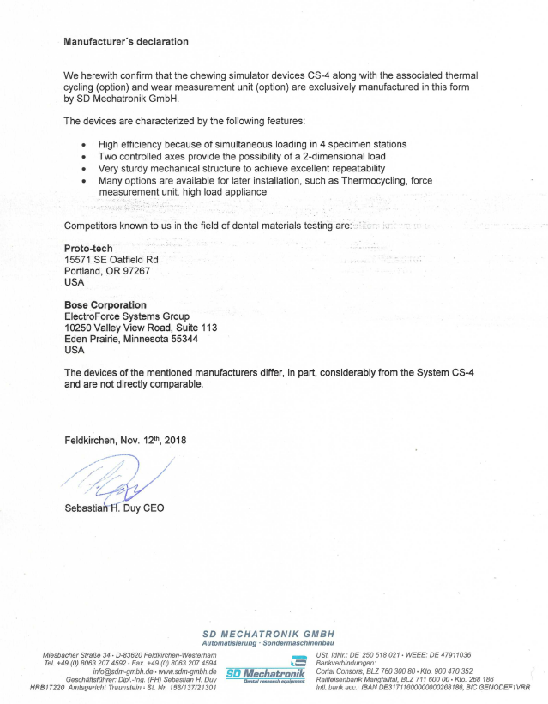
Attachment B

SUBMITTED IN RESPONSE TO
Sole Source Certification No. SS5295
Accepted until December 26, 2018, at 3:00 p.m.

I certify that the information contained in this objection is true and accurate to the best of my knowledge. I understand that UMMC will investigate all statements made in this objection and that any false or misleading information provided may result in adverse action.

__________________________________
Objector Name
Objector’s title

__________________________________
Date

