Notice of Intent to Certify Sole Source

To: Interested Parties

From: Jennifer Douglas
Administrative Director, Category Management and Procurement
Supply Chain Management

Date: April 11, 2019

Re: Sole Source Certification Number SS5321 for Flow Cytometry instruments

Contact Email Address: solesource@umc.edu

Sole Source Certification Award Details

Regarding UMMC Sole Source Certification Number SS5321 for BD FACSAria and FACSymphony, please be advised that UMMC intends to award the purchase to Becton, Dickson and Company as the sole source provider.

UMMC issues this notice in accordance with Mississippi state law, policy, and procedures for sole source procurements.

Sole Source Criteria

- Where the compatibility of equipment, accessories, or replacement parts is the paramount consideration (and manufacturer is the sole supplier).
- Where a sole supplier’s item is needed for trial use or testing.
- Where a sole supplier’s item is to be required when no other item will service the needs of UMMC.

Schedule

Task | Date
First Advertisement Date | April 11, 2019
Second Advertisement Date | April 18, 2019
Response Deadline from Objectors | April 25, 2019, at 3:00 p.m. Central Time
Notice of Award/No Award Posted | Not before May 3, 2019

Project Details

- Describe the commodity that the agency is seeking to procure:

The University of Mississippi Medical Center (UMMC) seeks to purchase a package of two flow cytometery instruments: a Becton Dickenson (BD) FACSymphony analyzer and a BD FACSARIA Fusion cell sorter with a biosafety hood. Such instruments are necessary for performing both clinical and basic science research, and are an important part of the infrastructure of an Academic Health Science Center. Flow cytometers are laboratory instruments that are used to analyze multiple physical and chemical characteristics of cells (or particles) that are suspended in fluid as they pass through a laser beam one cell at a time. The defined characteristics include cell size and granularity, amounts of specific markers on the cell surface and within the cell, or ongoing intracellular transient signaling events.

The BD FACSymphony analyzer is an automated cytometer equipped with five different lasers (UV 355nm, Violet 405nm, Blue 488nm, Yellow-Green, 561, and Red 637nm). This instrument quantitates the defined characteristics of single cells in a population, one cell at a time, at a maximum time-frame of approximately 40,000 cells per second.

The BD FACSAria Fusion cell sorter is matched to the FACSymphony and equipped with the same lasers. This FACSAria Fusion is used to physically sort cells based on the defined markers under sterile conditions into 96 well plates (1 cell/well, 10 cells/well, etc.) or other sized plates, or specific collection tubes. Sorted cells can also be placed directly onto microscope slides. The sterilely sorted cells can directly be used for research experiments or be placed in culture to expand that specific population for research purposes.

- Explain why the commodity is the only one (1) that can meet the needs of the agency:

Both the FACSymphony analyzer and FACSAria Fusion Cell sorter are considered state-of-the-art instruments. They utilize a patented gel-coupled cuvette flow cell which is in fixed alignment with the lasers, and this design ensures that the maximum signal and resolution is obtained for each cell parameter (characteristic) that is being analyzed. Such sensitivity and consistency is necessary when studying and sorting rare cell populations. Also, this true fixed alignment minimizes setup time for the user, and ensures that data collection will be consistent between experiments. Both the instruments are matched in their specific configurations of lasers, collection optics, filters, and detectors, and both use the FACDiva Software. These matched instruments will allow investigators to use the same assay design and protocols for identifying cell populations on the analyzer and then sorting for specific cell types on the Fusion Cell sorter. Importantly, this combination ensures that the collected data on both instruments is equivalent.

- Explain why the source is the only person or entity that can provide the required commodity:

Becton, Dickson and Company is the sole manufacturer and supplier of the BD FACSAria and FACSymphony. They are not available from any other distributor. See supporting letter from Becton, Dickson and Company, Attachment A.

- Explain why the amount to be expended for the commodity is reasonable:

The estimated amount to be expended is for the purchase of the BD FACSAria and FACSymphony is $1,050,000.00. This amount is within the expected price range for these products.

- Describe the efforts that the agency went through to obtain the best possible price for the commodity:

Through market intelligence, UMMC was able to negotiate best pricing for these products. All applicable discounts were explored and applied.

Submission Instructions and Format of Response from Objecting Parties

Interested parties who have reason to believe that the BD FACSAria and FACSymphony flow cytometer instruments, (hereafter, “Products”) should not be certified as a sole source should provide information in the Vendor Form for the State to use in determining whether or not to proceed with awarding the sole source to Becton, Dickson and Company. The Vendor Form may be found at http://www.dfa.state.ms.us/Purchasing/documents/ObjectiontoSoleSourceDetermination.pdf.

Objections must include the certification in Attachment B.

Comments will be accepted at any time prior to April 25, 2019, at 3:00 p.m. (Central Time) to solesource@umc.edu. Responses may be delivered via email to solesource@umc.edu. UMMC WILL NOT BE RESPONSIBLE FOR DELAYS IN THE DELIVERY OF RESPONSES. It is solely the responsibility of the Interested Parties that responses reach UMMC on time. Responses received after the deadline and responses that lack all required information will be rejected. UMMC reserves the right to inspect Interested Party’s commodity for comparison purposes.

If you have any questions concerning the information above or if we can be of further assistance, please contact solesource@umc.edu.

Attachment A: Vendor Correspondence
Attachment B: Objection Certification
Attachment A

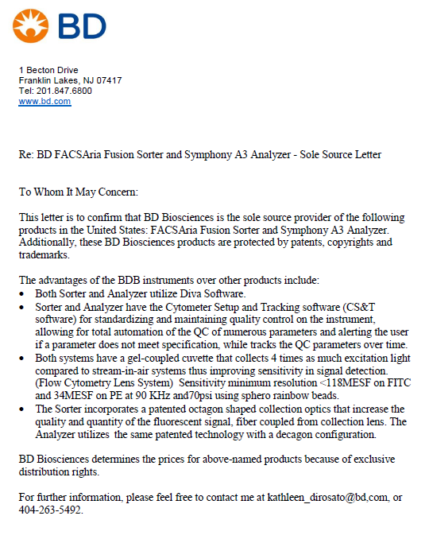

Attachment B

SUBMITTED IN RESPONSE TO
Sole Source Certification No. SS5321
Accepted until April 25, 2019, at 3:00 p.m.

I certify that the information contained in this objection is true and accurate to the best of my knowledge. I understand that UMMC will investigate all statements made in this objection and that any false or misleading information provided may result in adverse action.

__________________________________
Objector Name
Objector’s title

__________________________________
Date

