Notice of Intent to Certify Sole Source

To: Interested Parties

From: Jennifer Douglas
Administrative Director, Category Management and Procurement
Supply Chain Management

Date: January 10, 2019

Re: Sole Source Certification Number SS5307 for the MultiPrep System
Contact Email Address: solesource@umc.edu

Sole Source Certification Award Details

Regarding University of Mississippi Medical Center (UMMC) Sole Source Certification Number SS5307 for MultiPrep System. Please be advised that UMMC intends to award the purchase to Allied High Tech Products, Inc. as the sole source provider.

UMMC issues this notice in accordance with Mississippi state law, policy, and procedures for sole source procurements.

Sole Source Criteria

- Where the compatibility of equipment, accessories, or replacement parts is the paramount consideration (and manufacturer is the sole supplier).
- Where a sole supplier’s item is needed for trial use or testing.
- Where a sole supplier’s item is to be required when no other item will service the needs of UMMC.

Schedule

Task | Date
First Advertisement Date | January 10, 2019
Second Advertisement Date | January 17, 2019
Response Deadline from Objectors | January 25, 2019, at 3:00 p.m. Central Time
Notice of Award/No Award Posted | Not before February 1, 2019

Project Details

- Describe the commodity that the agency is seeking to procure:

The University of Mississippi Medical Center (UMMC) is seeking to procure the Allied High Tech Products MultiPrep System for use in the Biomedical Materials Science Department. The MultiPrep system is used in the School of Dentistry to polish research specimens to ensure that they are flat, level, and smooth.

- Explain why the commodity is the only one (1) that can meet the needs of the agency:

The department currently has the Allied High Tech MutliPrep system. The volume has grown such that a second polisher is required. It is necessary to purchase the same equipment due to the compatibility of attachments. The polishers will integrate by using the same specimen holders, polishing media, and calibration attachments.

- Explain why the source is the only person or entity that can provide the required commodity:

Allied High Tech Products, Inc is the only manufacturer and distributor of the MultiPrep System. See supporting letter, Attachment A.

- Explain why the amount to be expended for the commodity is reasonable:

The estimated amount to be expended is for the purchase of the MultiPrep polishing system is $25,000.00. This amount is within the expected price range for these products.

- Describe the efforts that the agency went through to obtain the best possible price for the commodity:

Through market intelligence, UMMC was able to negotiate best pricing for these products. All applicable discounts were explored and applied.

Submission Instructions and Format of Response from Objecting Parties

Interested parties who have reason to believe that the MultiPrep System (hereafter, “Products”) should not be certified as a sole source should provide information in the Vendor Form for the State to use in determining whether or not to proceed with awarding the sole source to Allied High Tech Products, Inc. The Vendor Form may be found at http://www.dfa.ms.gov/media/1591/objectiontosolesourcedetermination.pdf.

Objections must include the certification in Attachment B.

Comments will be accepted at any time prior to January 25, 2018, at 3:00 p.m. (Central Time) to solesource@umc.edu. Responses may be delivered via email to solesource@umc.edu. UMMC WILL NOT BE RESPONSIBLE FOR DELAYS IN THE DELIVERY OF RESPONSES. It is solely the responsibility of the Interested Parties that responses reach UMMC on time. Responses received after the deadline and responses that lack all required information will be rejected. UMMC reserves the right to inspect Interested Party’s commodity for comparison purposes.

If you have any questions concerning the information above or if we can be of further assistance, please contact solesource@umc.edu.

Attachment A: Vendor Correspondence
Attachment B: Objection Certification
Attachment A
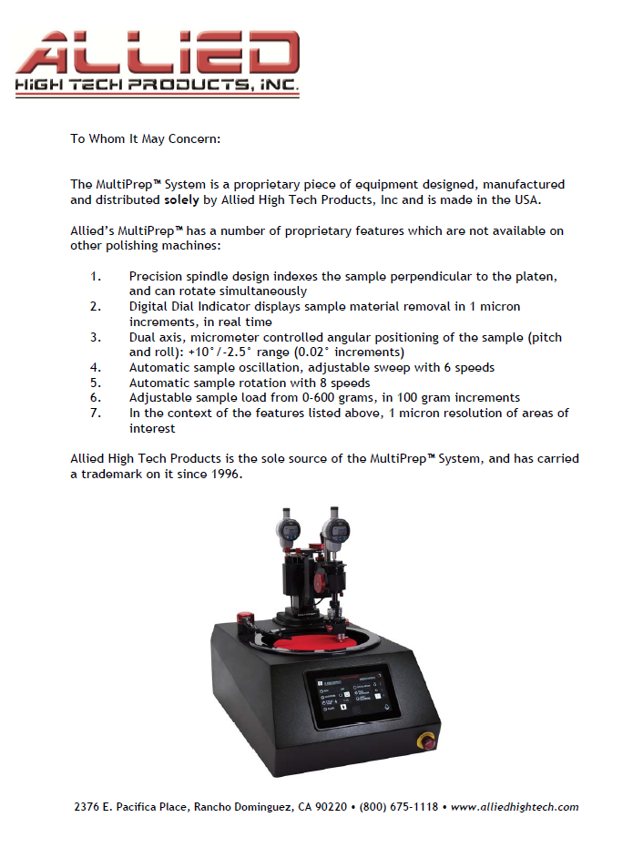
Attachment B

SUBMITTED IN RESPONSE TO
Sole Source Certification No. SS5307
Accepted until January 25, 2019, at 3:00 p.m.

I certify that the information contained in this objection is true and accurate to the best of my knowledge. I understand that UMMC will investigate all statements made in this objection and that any false or misleading information provided may result in adverse action.

__________________________________
Objector Name
Objector’s title

__________________________________
Date

