Notice of Intent to Certify Sole Source

To: Interested Parties

From: Jennifer Douglas
Administrative Director, Category Management and Procurement

Date: February 15, 2023

Re: Sole Source Certification Number SS5737 for NextSeq 1000 and NextSeq 2000 with all related components

Contact Email Address: solesource@umc.edu

Sole Source Certification Award Details

Regarding UMMC Sole Source Certification Number SS5737 for the NextSeq 1000 and NextSeq 2000 with all related components, please be advised that UMMC intends to award the purchase to Illumina. as the sole source provider.

UMMC issues this notice in accordance with Mississippi state law, policy, and procedures for sole source procurements.

Sole Source Criteria

- Where the compatibility of equipment, accessories, or replacement parts is the paramount consideration (and manufacturer is the sole supplier).
- Where a sole supplier’s item is needed for trial use or testing.
- Where a sole supplier’s item is to be required when no other item will service the needs of UMMC.

Schedule

Task | Date
First Advertisement Date | February 24, 2023
Second Advertisement Date | March 3, 2023
Response Deadline from Objectors | March 10, 2023 at 3:00 p.m. Central Time
Notice of Award/No Award Posted | Not before March 17, 2023

- Describe the commodity that the agency is seeking to procure:

The University of Mississippi Medical Center is seeking to purchase two (2) new next generation sequencing (NGS) instruments, the NextSeq 1000 and NextSeq 2000 with all related components for use in the Research setting. These instruments will add to the other Illumina instruments previously purchased by UMMC. These instruments will be used to conduct genetic and genomic analysis for clinical, translational, and research projects. This instrumentation will enhance genetic testing for COVID-19 as well as number of other sequencing assays currently run in the UMMC Molecular and Genomics Core (e.g., RNA sequencing, exome sequencing, single cell sequencing, microbiome/metagenomics). Based on the broad needs of UMMC users, the Illumina NextSeq systems offers the best methodology (scalable), greatest yield of reliable data (necessary for clinical use), and simplest and most straight-forward analysis of data generated.

- An explanation of why the commodity is the only one that can meet the needs of UMMC.

The UMMC Molecular and Genomics Core Facility currently performs genomic analysis using several Illumina sequencers including, iSeq100, MiSeq and NextSeq500. The NextSeq 1000 and the NextSeq 2000 are significant upgrades to the NextSeq 500, increasing capacity and generating data at significantly lower cost. These instruments will be compatible with our other sequencing instrument, which other sequencers on the market are not. Illumina instruments are the “gold standard” for NGS equipment, and no other company instrument provides sufficient flexibility, quality, reliability, and ease of use as the Illumina instruments.

- Explain why the source is the only person or entity that can provide the required commodity:

Illumina is the sole manufacturer and supplier of the NextSeq 1000 and NextSeq 2000. See supporting letter from Illumina, Attachment A.

- Explain why the amount to be expended for the commodity is reasonable:

The estimated annual amount to be expended for the purchase of the NextSeq 1000 and NextSeq 2000 with all related components is $450,000.00. This amount is within the expected price range for these products.

- Describe the efforts that the agency went through to obtain the best possible price for the commodity:

Pricing is compared against available market intelligence and identified discounts are pursued where applicable.

Submission Instructions and Format of Response from Objecting Parties

Interested parties who have reason to believe that the NextSeq 1000 and NextSeq 2000 with all related components, (hereafter, “Products”) should not be certified as a sole source should provide information in the Vendor Form for the State to use in determining whether or not to proceed with awarding the sole source to Illumina. The Vendor Form may be found at http://www.dfa.state.ms.us/Purchasing/documents/ObjectiontoSoleSourceDetermination.pdf.

Objections must include the certification in Attachment B.

Comments will be accepted at any time prior to March 10, 2023, at 3:00 p.m. (Central Time) to solesource@umc.edu. Responses may be delivered via email to solesource@umc.edu. UMMC WILL NOT BE RESPONSIBLE FOR DELAYS IN THE DELIVERY OF RESPONSES. It is solely the responsibility of the Interested Parties that responses reach UMMC on time. Responses received after the deadline and responses that lack all required information will be rejected. UMMC reserves the right to inspect Interested Party’s commodity for comparison purposes.

If you have any questions concerning the information above or if we can be of further assistance, please contact solesource@umc.edu.

Attachment A: Vendor Correspondence
Attachment B: Objection Certification

Attachment A

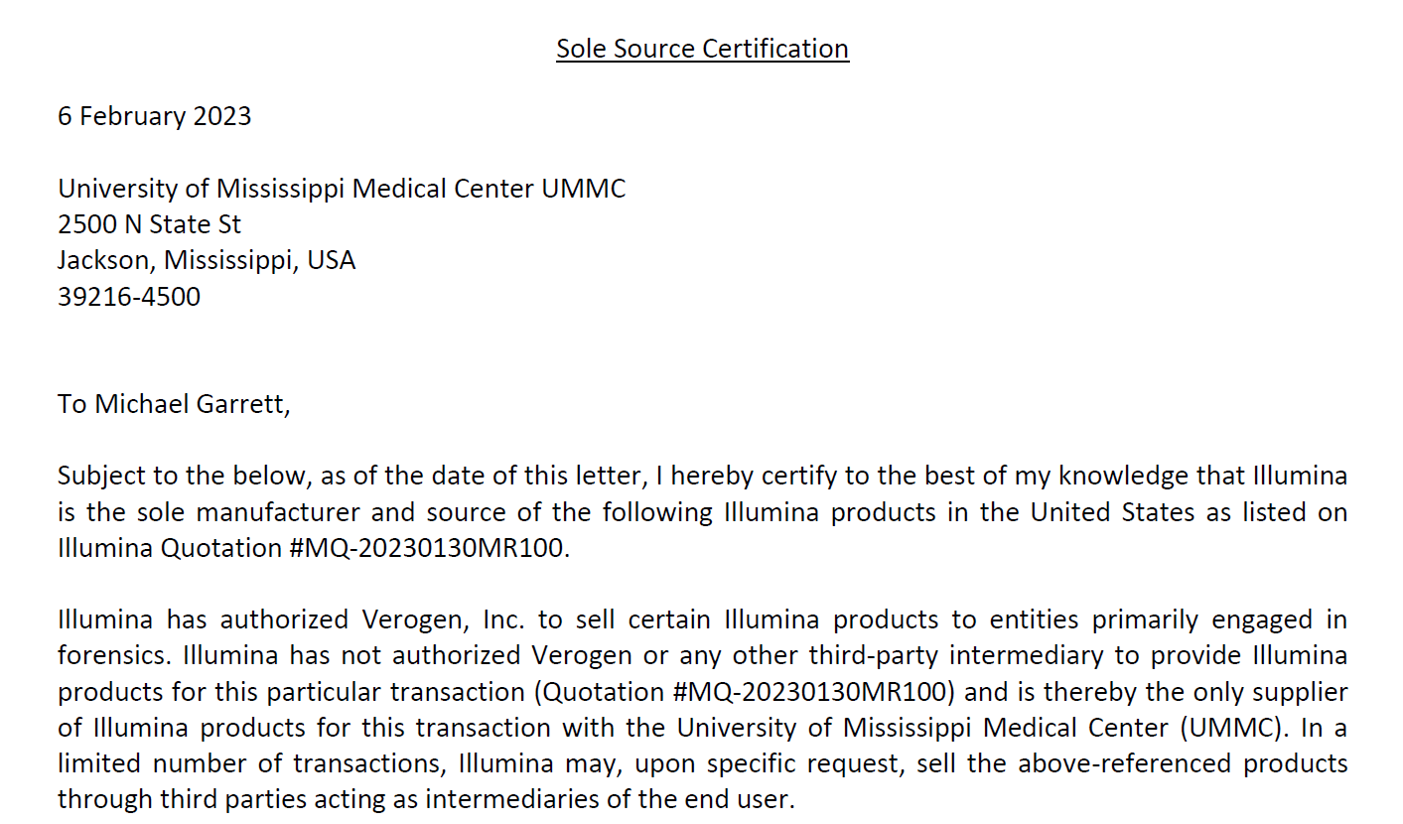

Attachment B

SUBMITTED IN RESPONSE TO
Sole Source Certification No. SS5737
Accepted until March 10, 2023 at 3:00 p.m.

I certify that the information contained in this objection is true and accurate to the best of my knowledge. I understand that UMMC will investigate all statements made in this objection and that any false or misleading information provided may result in adverse action.

__________________________________
Objector Name
Objector’s title

__________________________________
Date

