Notice of Intent to Certify Sole Source

To: Interested Parties

From: Jennifer Douglas
Administrative Director, Category Management and Procurement

Date: September 15, 2022

Re: Sole Source Certification Number SS5694 for Self-Administration Panel Cassettes

Contact Email Address: solesource@umc.edu

Sole Source Certification Award Details

Regarding UMMC Sole Source Certification Number SS5694 for Self-Administration Panel Cassettes, please be advised that UMMC intends to award the purchase to Carter 2 Systems, Inc. as the sole source provider.

UMMC issues this notice in accordance with Mississippi state law, policy, and procedures for sole source procurements.

Sole Source Criteria

- Where the compatibility of equipment, accessories, or replacement parts is the paramount consideration (and manufacturer is the sole supplier).
- Where a sole supplier’s item is needed for trial use or testing.
- Where a sole supplier’s item is to be required when no other item will service the needs of UMMC.

Schedule

Task | Date
First Advertisement Date | October 3,2022
Second Advertisement Date | October 10, 2022
Response Deadline from Objectors | October 17, 2022 at 3:00 p.m. Central Time
Notice of Award/No Award Posted | Not before October 24, 2022

- Describe the commodity that the agency is seeking to procure:

The University of Mississippi Medical Center (UMMC) seeks to purchase eight (8) Self- Administration panel cassettes from Carter2 Systems. These panels are custom designed to be used with existing Med-Associates primate self-administration equipment for research in primates.

- An explanation of why the commodity is the only one that can meet the needs of UMMC.

UMMC currently owns a cassette cart transfer tower and caging systems. The cassette transfer tower, self-administration panel cassettes, and caging systems all function together to create a functioning ergonomic system. These pieces are custom built and integrate only with equipment manufactured by Carter 2 Systems, Inc. The cassettes function by sliding onto existing socialization rack caging in place of a sidewall and will be used to mount and house primate self-administration equipment. The cassettes will also fit into the existing Carter 2 cassette tower, which is used to transport the cassettes.

- Explain why the source is the only person or entity that can provide the required commodity:

Carter 2 Systems is the sole manufacturer and supplier of the self-administration panel cassettes. They are not available from any other distributor. See supporting letter from Carter 2 Systems, Inc., Attachment A.

- Explain why the amount to be expended for the commodity is reasonable:

The estimated annual amount to be expended for the purchase of the Carter 2 Systems self-administration panel cassettes is $26,000.00. This amount is within the expected price range for these products.

- Describe the efforts that the agency went through to obtain the best possible price for the commodity:

Through market intelligence, UMMC was able to negotiate best pricing for these products. All applicable discounts were explored and applied.

Submission Instructions and Format of Response from Objecting Parties

Interested parties who have reason to believe that the Carter 2 Systems self-administration panel cassettes, (hereafter, “Products”) should not be certified as a sole source should provide information in the Vendor Form for the State to use in determining whether or not to proceed with awarding the sole source to Carter 2 Systems, Inc. The Vendor Form may be found at http://www.dfa.state.ms.us/Purchasing/documents/ObjectiontoSoleSourceDetermination.pdf.

Objections must include the certification in Attachment B.

Comments will be accepted at any time prior to October 17, 2022, at 3:00 p.m. (Central Time) to solesource@umc.edu. Responses may be delivered via email to solesource@umc.edu. UMMC WILL NOT BE RESPONSIBLE FOR DELAYS IN THE DELIVERY OF RESPONSES. It is solely the responsibility of the Interested Parties that responses reach UMMC on time. Responses received after the deadline and responses that lack all required information will be rejected. UMMC reserves the right to inspect Interested Party’s commodity for comparison purposes.

If you have any questions concerning the information above or if we can be of further assistance, please contact solesource@umc.edu.

Attachment A: Vendor Correspondence
Attachment B: Objection Certification

Attachment A

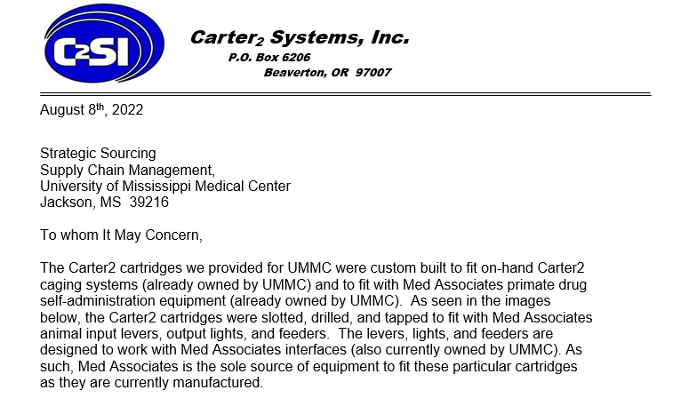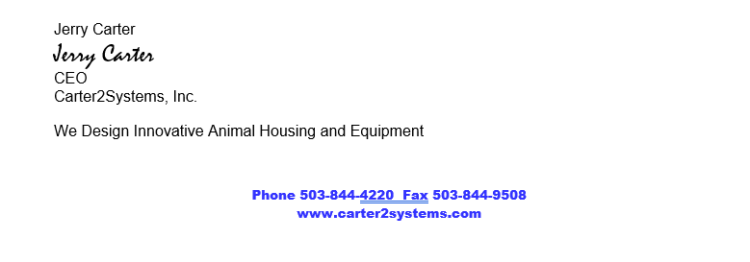

Attachment B

SUBMITTED IN RESPONSE TO
Sole Source Certification No. SS5694
Accepted until October 17, 2022 at 3:00 p.m.

I certify that the information contained in this objection is true and accurate to the best of my knowledge. I understand that UMMC will investigate all statements made in this objection and that any false or misleading information provided may result in adverse action.

__________________________________
Objector Name
Objector’s title

__________________________________
Date

