Notice of Intent to Certify Sole Source

To: Interested Parties

From: Jennifer Douglas
Administrative Director, Category Management and Procurement

Date: September 26, 2022

Re: Sole Source Certification Number SS5695 for Gaumard HAL Advanced Patient Simulators along with all related accessories and software

Contact Email Address: solesource@umc.edu

Sole Source Certification Award Details

Regarding UMMC Sole Source Certification Number SS5695 for Gaumard HAL advanced patient simulators along with all related accessories and software, please be advised that UMMC intends to award the purchase to Gaumard as the sole source provider.

UMMC issues this notice in accordance with Mississippi state law, policy, and procedures for sole source procurements.

Sole Source Criteria

- Where the compatibility of equipment, accessories, or replacement parts is the paramount consideration (and manufacturer is the sole supplier).
- Where a sole supplier’s item is needed for trial use or testing.
- Where a sole supplier’s item is to be required when no other item will service the needs of UMMC.

Schedule

Task | Date
First Advertisement Date | October 17, 2022
Second Advertisement Date | October 24, 2022
Response Deadline from Objectors | October 31, 2022 at 3:00 p.m. Central Time
Notice of Award/No Award Posted | Not before November 7, 2022

- Describe the commodity that the agency is seeking to procure:

The University of Mississippi Medical Center (UMMC) seeks to purchase two (2) HAL advanced patient simulators along with all related accessories and software from Gaumard for the use in the School of Nursing. The simulators will be used to help nursing providers of all levels develop specialized skills needed to effectively communicate, diagnose, and treat pediatric patients in all clinical areas.

- An explanation of why the commodity is the only one that can meet the needs of UMMC.

The School of Nursing currently utilizes the Gaumard simulators in their curriculum. The interoperability of this equipment is needed when transporting and utilizing simulation in multiple locations and environments. Currently the School of Nursing has one simulator and has plans to develop a large-scale simulation for use at multiple locations. The new locations will need to be equipped with the same simulators for continuity of training.

- Explain why the source is the only person or entity that can provide the required commodity:

Gaumard is the sole manufacturer and supplier of the Gaumard HAL advanced patient simulators along with all related accessories and software. They are not available from any other distributor. See supporting letter from Gaumard, Attachment A.

- Explain why the amount to be expended for the commodity is reasonable:

The estimated annual amount to be expended for the purchase of the Gaumard HAL advanced patient simulators along with all related accessories and software is $141,849.54. This amount is within the expected price range for these products.

- Describe the efforts that the agency went through to obtain the best possible price for the commodity:

Through market intelligence, UMMC was able to negotiate best pricing for these products. All applicable discounts were explored and applied.

Submission Instructions and Format of Response from Objecting Parties

Interested parties who have reason to believe that the HAL advanced patient simulators along with all related accessories and software, (hereafter, “Products”) should not be certified as a sole source should provide information in the Vendor Form for the State to use in determining whether or not to proceed with awarding the sole source to Gaumard. The Vendor Form may be found at http://www.dfa.state.ms.us/Purchasing/documents/ObjectiontoSoleSourceDetermination.pdf.

Objections must include the certification in Attachment B.

Comments will be accepted at any time prior to October 31, 2022, at 3:00 p.m. (Central Time) to solesource@umc.edu. Responses may be delivered via email to solesource@umc.edu. UMMC WILL NOT BE RESPONSIBLE FOR DELAYS IN THE DELIVERY OF RESPONSES. It is solely the responsibility of the Interested Parties that responses reach UMMC on time. Responses received after the deadline and responses that lack all required information will be rejected. UMMC reserves the right to inspect Interested Party’s commodity for comparison purposes.

If you have any questions concerning the information above or if we can be of further assistance, please contact solesource@umc.edu.

Attachment A: Vendor Correspondence
Attachment B: Objection Certification

Attachment A

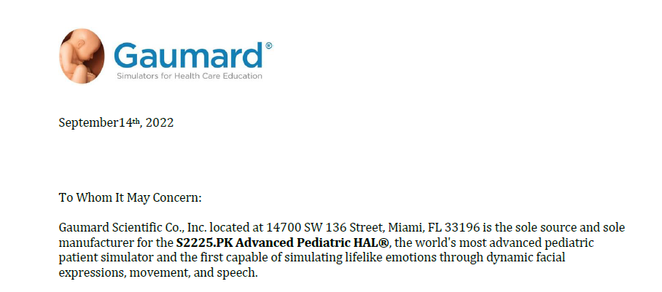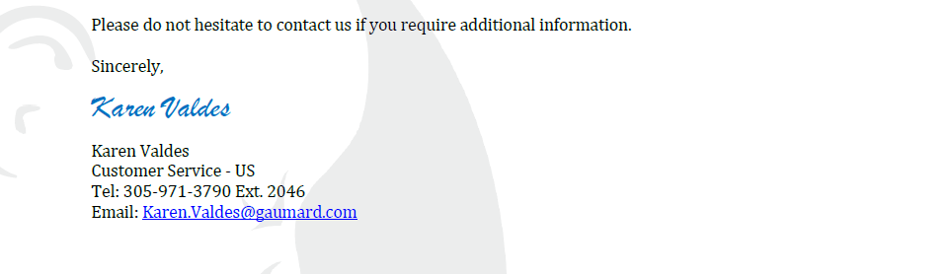

Attachment B

SUBMITTED IN RESPONSE TO
Sole Source Certification No. SS5695
Accepted until October 31, 2022 at 3:00 p.m.

I certify that the information contained in this objection is true and accurate to the best of my knowledge. I understand that UMMC will investigate all statements made in this objection and that any false or misleading information provided may result in adverse action.

__________________________________
Objector Name
Objector’s title

__________________________________
Date

