Notice of Intent to Certify Sole Source

To: Interested Parties

From: Jennifer Douglas
Administrative Director, Category Management and Procurement

Date: November 10, 2022

Re: Sole Source Certification Number SS5712 for Quantitative sensory testing device

Contact Email Address: solesource@umc.edu

Sole Source Certification Award Details

Regarding UMMC Sole Source Certification Number SS5712 for a quantitative sensory testing device, please be advised that UMMC intends to award the purchase to Medoc Advanced Medical Systems, Inc. as the sole source provider.

UMMC issues this notice in accordance with Mississippi state law, policy, and procedures for sole source procurements.

Sole Source Criteria

- Where the compatibility of equipment, accessories, or replacement parts is the paramount consideration (and manufacturer is the sole supplier).
- Where a sole supplier’s item is needed for trial use or testing.
- Where a sole supplier’s item is to be required when no other item will service the needs of UMMC.

Schedule

Task | Date
First Advertisement Date | December 12, 2022
Second Advertisement Date | December 19, 2022
Response Deadline from Objectors | December 27, 2022 at 3:00 p.m. Central Time
Notice of Award/No Award Posted | Not before January 3, 2022

- Describe the commodity that the agency is seeking to procure:

The University of Mississippi Medical Center (UMMC) seeks to purchase one (1) quantitative sensory testing device. This device is designed for research use in the investigation and evaluation of chronic pain conditions and various neuropathies.

- An explanation of why the commodity is the only one that can meet the needs of UMMC.

The Psychiatry department previously purchased a TSA-2 unit from Medoc Advanced Medical Systems, Inc. which did not provide the portability needed for studies. The TSA2 quantitative sensory testing device is the only portable device that can deliver heat and cold stimuli through a thermode with software that can program temperature changes up to 10 degrees Celsius per second. Due to the National Institute on Minority Health and Health Disparities (NIMHD) funded grant in place for the Psychiatry department, the device will need to have portability and a stimulus delivery feature in which Medoc Advanced Medical Systems, Inc. is the only supplier that can provide those functions.

- Explain why the source is the only person or entity that can provide the required commodity:

Medoc Advanced Medical Systems is the sole manufacturer and supplier of the TSA2 quantitative sensory testing device. They are not available from any other distributor. See supporting letter from Medoc Advanced Medical System, Inc., Attachment A.

- Explain why the amount to be expended for the commodity is reasonable:

The estimated annual amount to be expended for the purchase of the TSA2 quantitative sensory testing device is $25,000.00. This amount is within the expected price range for these products.

- Describe the efforts that the agency went through to obtain the best possible price for the commodity:

Through market intelligence, UMMC was able to negotiate best pricing for these products. All applicable discounts were explored and applied.

Submission Instructions and Format of Response from Objecting Parties

Interested parties who have reason to believe that the quantitative sensory testing device, (hereafter, “Products”) should not be certified as a sole source should provide information in the Vendor Form for the State to use in determining whether or not to proceed with awarding the sole source to Medoc Advanced Medical Systems. The Vendor Form may be found at http://www.dfa.state.ms.us/Purchasing/documents/ObjectiontoSoleSourceDetermination.pdf.

Objections must include the certification in Attachment B.

Comments will be accepted at any time prior to December 27, 2022, at 3:00 p.m. (Central Time) to solesource@umc.edu. Responses may be delivered via email to solesource@umc.edu. UMMC WILL NOT BE RESPONSIBLE FOR DELAYS IN THE DELIVERY OF RESPONSES. It is solely the responsibility of the Interested Parties that responses reach UMMC on time. Responses received after the deadline and responses that lack all required information will be rejected. UMMC reserves the right to inspect Interested Party’s commodity for comparison purposes.

If you have any questions concerning the information above or if we can be of further assistance, please contact solesource@umc.edu.

Attachment A: Vendor Correspondence
Attachment B: Objection Certification

Attachment A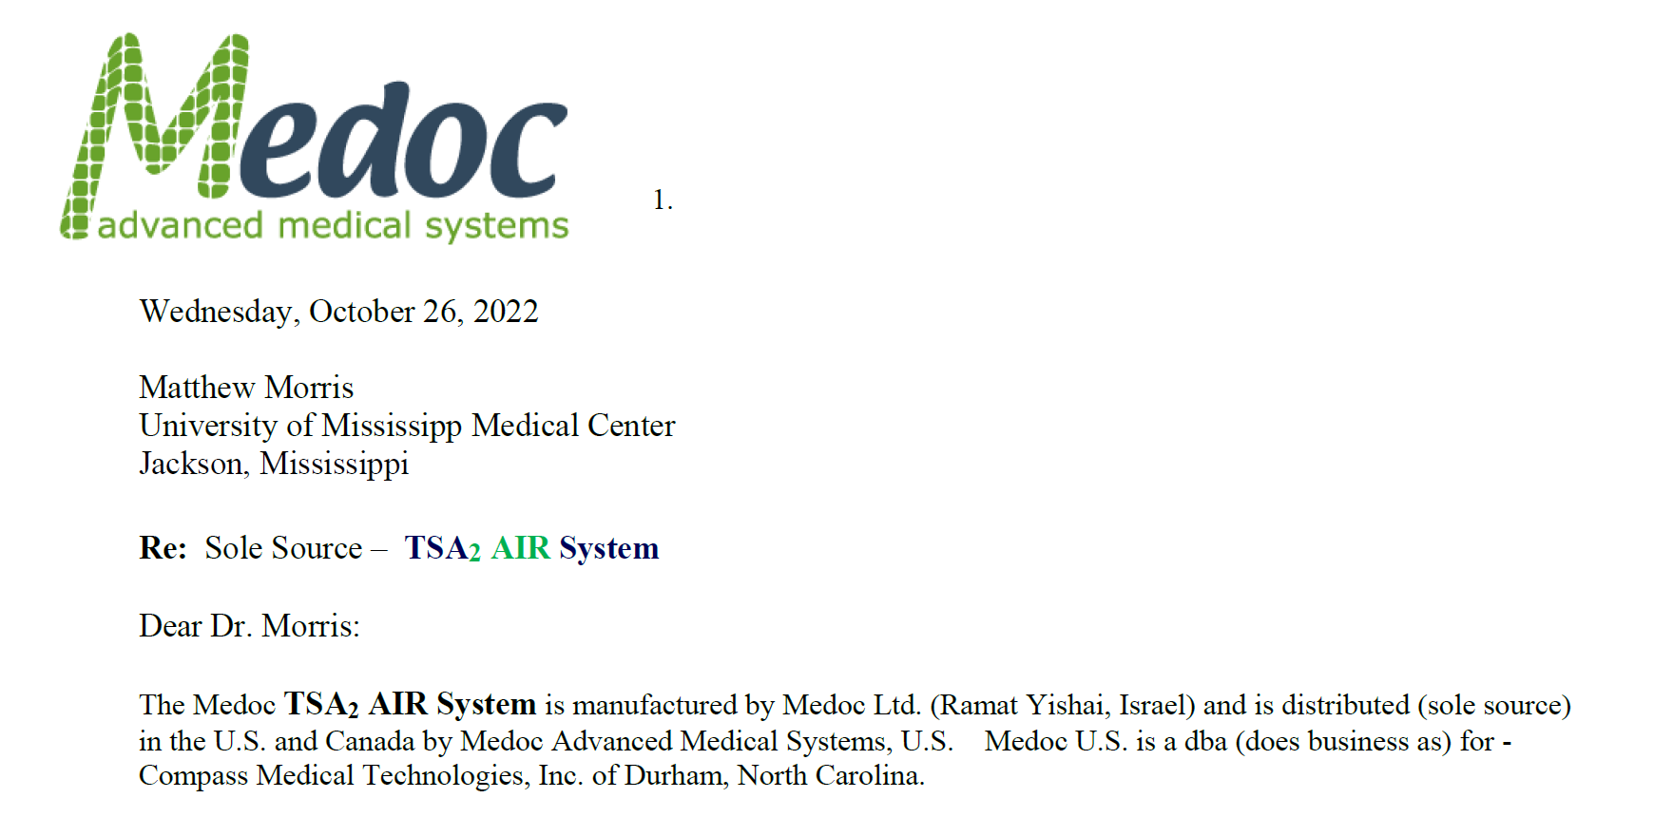 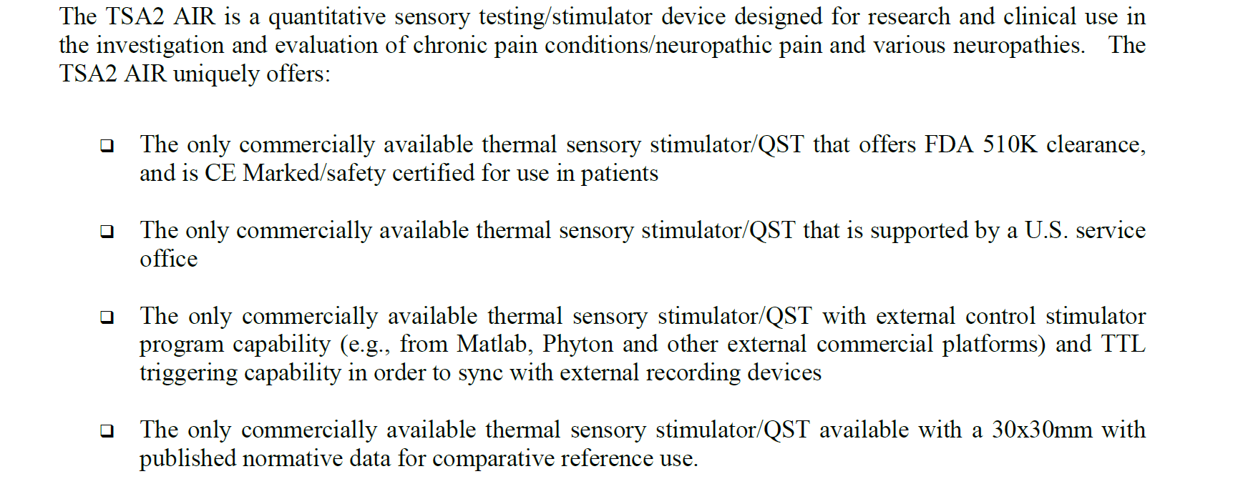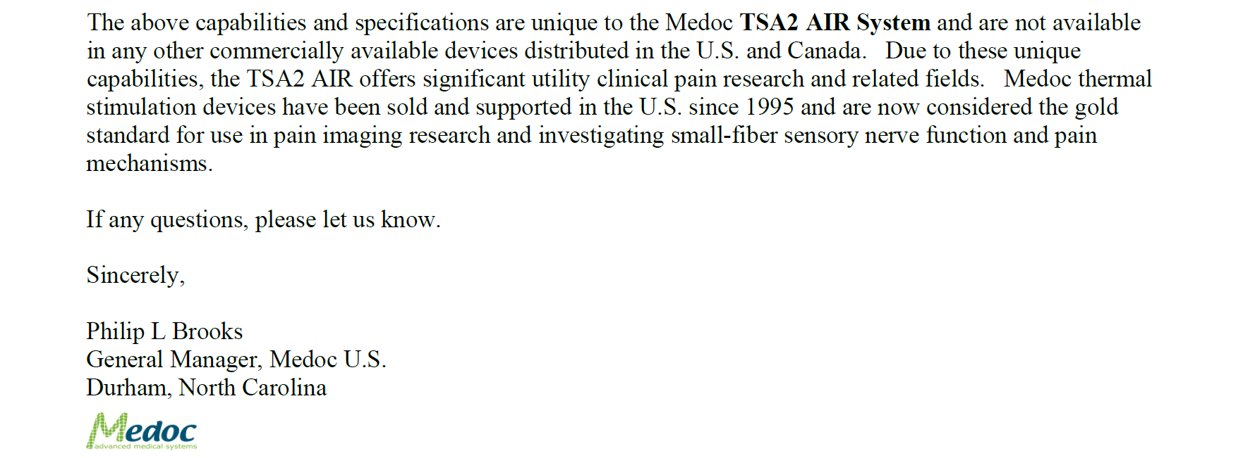

Attachment B

SUBMITTED IN RESPONSE TO
Sole Source Certification No. SS5712
Accepted until December 27, 2022 at 3:00 p.m.

I certify that the information contained in this objection is true and accurate to the best of my knowledge. I understand that UMMC will investigate all statements made in this objection and that any false or misleading information provided may result in adverse action.

__________________________________
Objector Name
Objector’s title

__________________________________
Date

