Notice of Intent to Certify Sole Source

To: Interested Parties

From: Jennifer Douglas
Administrative Director, Category Management and Procurement

Date: December 7, 2022

Re: Sole Source Certification Number SS5721 for Pressure Myograph System

Contact Email Address: solesource@umc.edu

Sole Source Certification Award Details

Regarding UMMC Sole Source Certification Number SS5721 for a Pressure Myograph System, please be advised that UMMC intends to award the purchase to Danish Myo Technology (DMT) as the sole source provider.

UMMC issues this notice in accordance with Mississippi state law, policy, and procedures for sole source procurements.

Sole Source Criteria

- Where the compatibility of equipment, accessories, or replacement parts is the paramount consideration (and manufacturer is the sole supplier).
- Where a sole supplier’s item is needed for trial use or testing.
- Where a sole supplier’s item is to be required when no other item will service the needs of UMMC.

Schedule

Task | Date
First Advertisement Date | December 29, 2022
Second Advertisement Date | January 6, 2023
Response Deadline from Objectors | January 13, 2023 at 3:00 p.m. Central Time
Notice of Award/No Award Posted | Not before January 23, 2023

- Describe the commodity that the agency is seeking to procure:

The University of Mississippi Medical Center (UMMC) seeks to purchase one (1) pressure myograph system. This specialized research instrument is used for characterization of compliance and vascular function in vascular tissues.

- An explanation of why the commodity is the only one that can meet the needs of UMMC.

The 114P pressure myograph system is needed to measure small arteries, veins, and other vessels physiological function and properties. This specific device is the only one available that focuses on coronary microvascular dysfunction in heart failure with preserved ejection fraction. In order to meet the requirements with the National Institutes of Health (NIH), the 114P pressure myograph system is needed to complete the study.

- Explain why the source is the only person or entity that can provide the required commodity:

DMT is the sole manufacturer and supplier of the 114P Pressure Myograph System. They are not available from any other distributor. See supporting letter from DMT, Attachment A.

- Explain why the amount to be expended for the commodity is reasonable:

The estimated annual amount to be expended for the purchase of the p114P Pressure Myograph System is $40,000.00. This amount is within the expected price range for these products.

- Describe the efforts that the agency went through to obtain the best possible price for the commodity:

Through market intelligence, UMMC was able to negotiate best pricing for these products. All applicable discounts were explored and applied.

Submission Instructions and Format of Response from Objecting Parties

Interested parties who have reason to believe that the Pressure Myograph System, (hereafter, “Products”) should not be certified as a sole source should provide information in the Vendor Form for the State to use in determining whether or not to proceed with awarding the sole source to DMT. The Vendor Form may be found at http://www.dfa.state.ms.us/Purchasing/documents/ObjectiontoSoleSourceDetermination.pdf.

Objections must include the certification in Attachment B.

Comments will be accepted at any time prior to January 13, 2023, at 3:00 p.m. (Central Time) to solesource@umc.edu. Responses may be delivered via email to solesource@umc.edu. UMMC WILL NOT BE RESPONSIBLE FOR DELAYS IN THE DELIVERY OF RESPONSES. It is solely the responsibility of the Interested Parties that responses reach UMMC on time. Responses received after the deadline and responses that lack all required information will be rejected. UMMC reserves the right to inspect Interested Party’s commodity for comparison purposes.

If you have any questions concerning the information above or if we can be of further assistance, please contact solesource@umc.edu.

Attachment A: Vendor Correspondence
Attachment B: Objection Certification

Attachment A

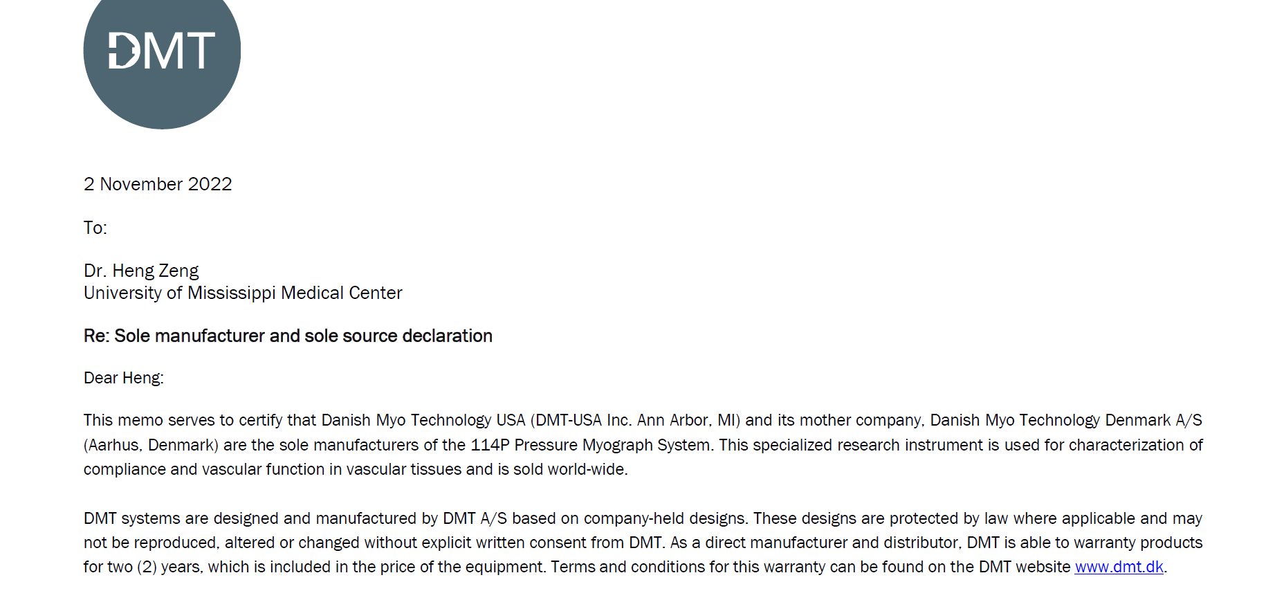
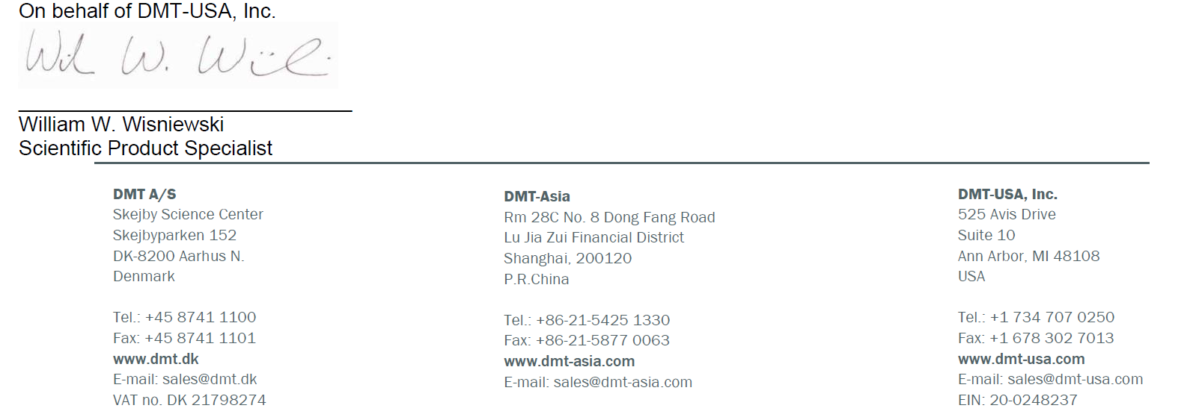

Attachment B

SUBMITTED IN RESPONSE TO
Sole Source Certification No. SS5721
Accepted until January 13, 2023 at 3:00 p.m.

I certify that the information contained in this objection is true and accurate to the best of my knowledge. I understand that UMMC will investigate all statements made in this objection and that any false or misleading information provided may result in adverse action.

__________________________________
Objector Name
Objector’s title

__________________________________
Date

