Notice of Intent to Certify Sole Source

To: Interested Parties

From: Jennifer Douglas
Administrative Director, Category Management and Procurement

Date: January 31, 2023

Re: Sole Source Certification Number SS5733 for Doppler Flow Velocity System

Contact Email Address: solesource@umc.edu

Sole Source Certification Award Details

Regarding UMMC Sole Source Certification Number SS5733 for Doppler Flow Velocity System, please be advised that UMMC intends to award the purchase to Scintica. as the sole source provider.

UMMC issues this notice in accordance with Mississippi state law, policy, and procedures for sole source procurements.

Sole Source Criteria

- Where the compatibility of equipment, accessories, or replacement parts is the paramount consideration (and manufacturer is the sole supplier).
- Where a sole supplier’s item is needed for trial use or testing.
- Where a sole supplier’s item is to be required when no other item will service the needs of UMMC.

Schedule

Task | Date
First Advertisement Date | February 6, 2023
Second Advertisement Date | February 13, 2023
Response Deadline from Objectors | February 21, 2023 at 3:00 p.m. Central Time
Notice of Award/No Award Posted | Not before February 28, 2023

- Describe the commodity that the agency is seeking to procure:

The University of Mississippi Medical Center (UMMC) seeks to purchase a Doppler Flow Velocity System. The Doppler Flow Velocity System is a real-time pulsed Doppler spectrogram acquisition data analysis tool designed specifically for measuring cardiovascular function in mice and rats.

- An explanation of why the commodity is the only one that can meet the needs of UMMC.

Other ultrasound systems that are designed for human use are not suitable to work on mice and rats because of the high heart rates, high blood velocities and the small vessel sizes involved. Ultrasound systems designed for the use with rodents use transducer probes of relatively large diameter. By using small diameter transducers, the Doppler Flow Velocity System allows flow velocity measurements in vessels unavailable to any other available systems and reduces errors to below physiological variability.

- Explain why the source is the only person or entity that can provide the required commodity:

Scintica is the sole manufacturer and supplier of the Doppler Flow Velocity System. They are not available from any other distributor. See supporting letter from Scintica, Attachment A.

- Explain why the amount to be expended for the commodity is reasonable:

The estimated annual amount to be expended for the purchase of the Doppler Flow Velocity System is $45,000.00. This amount is within the expected price range for these products.

- Describe the efforts that the agency went through to obtain the best possible price for the commodity:

Pricing is compared against available market intelligence and identified discounts are pursued where applicable.

Submission Instructions and Format of Response from Objecting Parties

Interested parties who have reason to believe that the Doppler Flow Velocity System, (hereafter, “Products”) should not be certified as a sole source should provide information in the Vendor Form for the State to use in determining whether or not to proceed with awarding the sole source to Scintica. The Vendor Form may be found at http://www.dfa.state.ms.us/Purchasing/documents/ObjectiontoSoleSourceDetermination.pdf.

Objections must include the certification in Attachment B.

Comments will be accepted at any time prior to February 21, 2023, at 3:00 p.m. (Central Time) to solesource@umc.edu. Responses may be delivered via email to solesource@umc.edu. UMMC WILL NOT BE RESPONSIBLE FOR DELAYS IN THE DELIVERY OF RESPONSES. It is solely the responsibility of the Interested Parties that responses reach UMMC on time. Responses received after the deadline and responses that lack all required information will be rejected. UMMC reserves the right to inspect Interested Party’s commodity for comparison purposes.

If you have any questions concerning the information above or if we can be of further assistance, please contact solesource@umc.edu.

Attachment A: Vendor Correspondence
Attachment B: Objection Certification

Attachment A

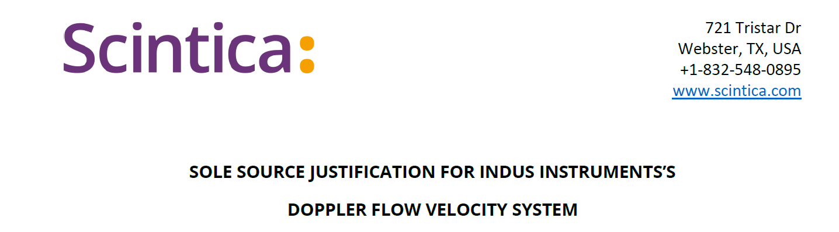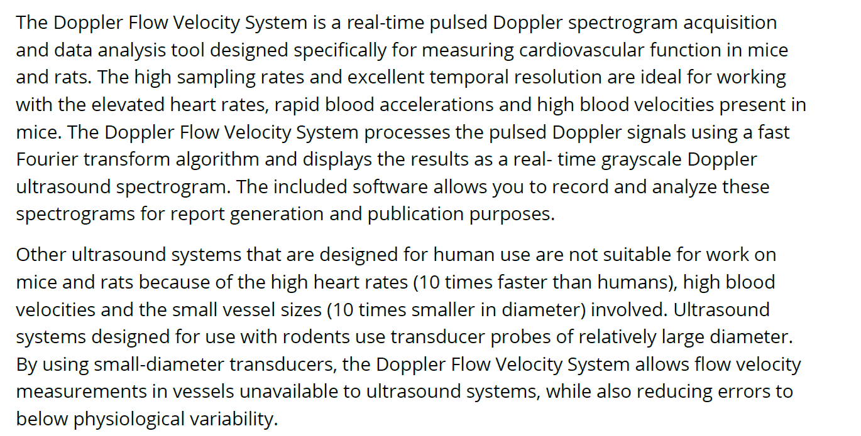
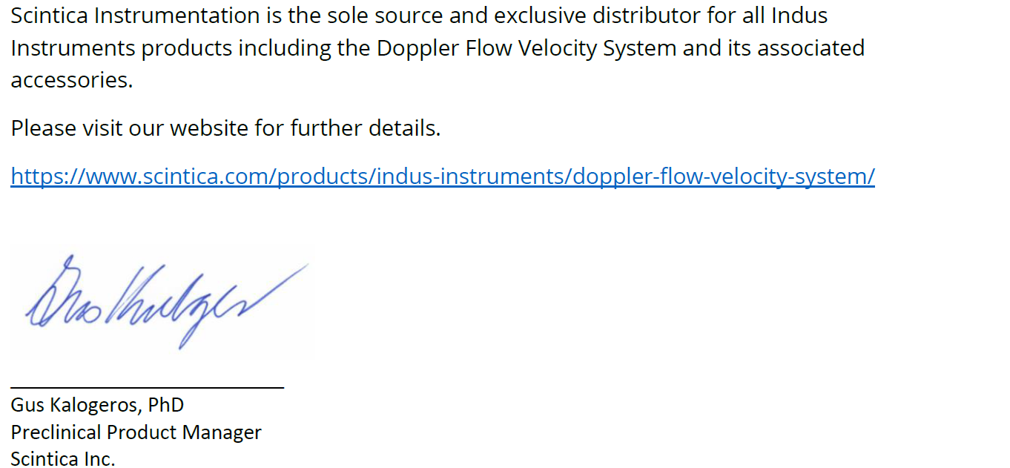
Attachment B

SUBMITTED IN RESPONSE TO
Sole Source Certification No. SS5733
Accepted until February 21, 2023 at 3:00 p.m.

I certify that the information contained in this objection is true and accurate to the best of my knowledge. I understand that UMMC will investigate all statements made in this objection and that any false or misleading information provided may result in adverse action.

__________________________________
Objector Name
Objector’s title

__________________________________
Date

