Notice of Intent to Certify Sole Source

To: Interested Parties

From: Jennifer Douglas
Administrative Director, Category Management and Procurement

Date: April 5, 2023

Re: Sole Source Certification Number SS5754 for Replacement Blowers and Vents for Micro-Ventilated Rodent Racks

Contact Email Address: solesource@umc.edu

Sole Source Certification Award Details

Regarding UMMC Sole Source Certification Number SS5754 for Replacement Blowers and Vents for Micro-Ventilated Rodent Racks, please be advised that UMMC intends to award the purchase to Allentown, Inc. as the sole source provider.

UMMC issues this notice in accordance with Mississippi state law, policy, and procedures for sole source procurements.

Sole Source Criteria

- Where the compatibility of equipment, accessories, or replacement parts is the paramount consideration (and manufacturer is the sole supplier).
- Where a sole supplier’s item is needed for trial use or testing.
- Where a sole supplier’s item is to be required when no other item will service the needs of UMMC.

Schedule

Task | Date
First Advertisement Date | April 17, 2023
Second Advertisement Date | April 24, 2023
Response Deadline from Objectors | May 1, 2023 at 3:00 p.m. Central Time
Notice of Award/No Award Posted | Not before May 8, 2023

- Describe the commodity that the agency is seeking to procure:

The University of Mississippi Medical Center (UMMC) seeks to purchase replacement blowers and vents for Micro-Ventilated Rodent Racks made by Allentown, Inc. for the use in the Department of Laboratory Animal Facilities. The requested replacement blowers and vents will be used to repair six (6) micro-ventilated rodent racks which house rodents for research purposes.

- An explanation of why the commodity is the only one that can meet the needs of UMMC.

UMMC currently owns blowers and vents for Micro-Ventilated Rodent Racks from Allentown, Inc. that are used in research now. The micro-ventilated racks require the blowers and vents to circulate air throughout the rack. Without proper air flow the rodents would not be able to survive and thrive in the research setting. Allentown blowers and vents are required in this instance to be compatible with the existing Allentown Micro-Ventilated rodent racks, serving as replacement parts, and a component with the existing Allentown Micro-Ventilated Rodent Racks.

- Explain why the source is the only person or entity that can provide the required commodity:

Allentown, Inc. is the sole manufacturer and supplier of this Replacement Blowers and Vents for Micro-Ventilated Rodent Racks. They are not available from any other distributor. See supporting letter from Allentown, Inc., Attachment A.

- Explain why the amount to be expended for the commodity is reasonable:

The estimated annual amount to be expended for the purchase of the Replacement Blowers and Vents for Micro-Ventilated Rodent Racks is $60,000.00. This amount is within the expected price range for these products.

- Describe the efforts that the agency went through to obtain the best possible price for the commodity:

Pricing is compared against available market intelligence and identified discounts are pursued where applicable.

Submission Instructions and Format of Response from Objecting Parties

Interested parties who have reason to believe that the Replacement Blowers and Vents for Micro-Ventilated Rodent Racks, (hereafter, “Products”) should not be certified as a sole source should provide information in the Vendor Form for the State to use in determining whether or not to proceed with awarding the sole source to Allentown, Inc. The Vendor Form may be found at http://www.dfa.state.ms.us/Purchasing/documents/ObjectiontoSoleSourceDetermination.pdf.

Objections must include the certification in Attachment B.

Comments will be accepted at any time prior to May 1, 2023 at 3:00 p.m. (Central Time) to solesource@umc.edu. Responses may be delivered via email to solesource@umc.edu. UMMC WILL NOT BE RESPONSIBLE FOR DELAYS IN THE DELIVERY OF RESPONSES. It is solely the responsibility of the Interested Parties that responses reach UMMC on time. Responses received after the deadline and responses that lack all required information will be rejected. UMMC reserves the right to inspect Interested Party’s commodity for comparison purposes.

If you have any questions concerning the information above or if we can be of further assistance, please contact solesource@umc.edu.

Attachment A: Vendor Correspondence
Attachment B: Objection Certification

Attachment A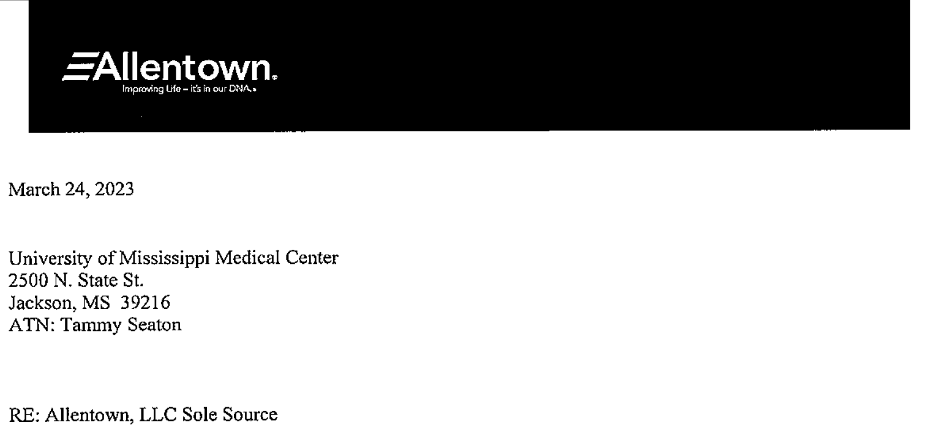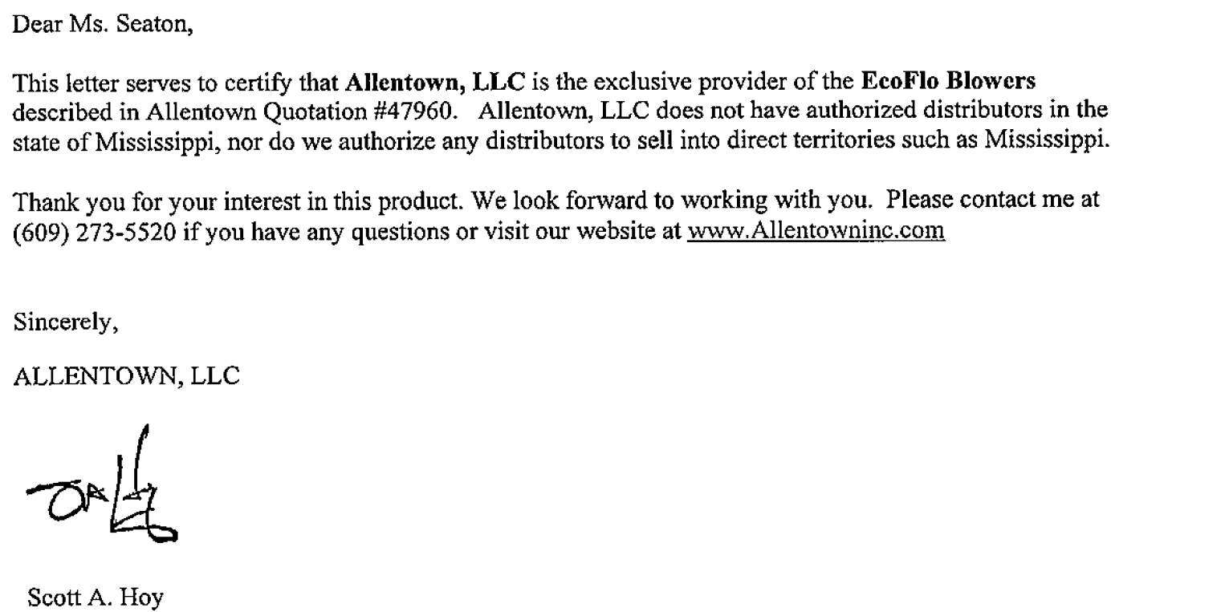

Attachment B

SUBMITTED IN RESPONSE TO
Sole Source Certification No. SS5754
Accepted until May 1, 2023 at 3:00 p.m.

I certify that the information contained in this objection is true and accurate to the best of my knowledge. I understand that UMMC will investigate all statements made in this objection and that any false or misleading information provided may result in adverse action.

__________________________________
Objector Name
Objector’s title

__________________________________
Date

