Notice of Intent to Certify Sole Source

To: Interested Parties

From: Jennifer Douglas
Administrative Director, Category Management and Procurement

Date: June 7, 2023

Re: Sole Source Certification Number SS5775 for Thromboelastgraphy (TEG) 6S Analyzer

Contact Email Address: solesource@umc.edu

Sole Source Certification Award Details

Regarding UMMC Sole Source Certification Number SS5775 for Thromboelastography (TEG) 6S Analyzer, please be advised that UMMC intends to award the purchase to Haemonetics as the sole source provider.

UMMC issues this notice in accordance with Mississippi state law, policy, and procedures for sole source procurements.

Sole Source Criteria

- Where the compatibility of equipment, accessories, or replacement parts is the paramount consideration (and manufacturer is the sole supplier).
- Where a sole supplier’s item is needed for trial use or testing.
- Where a sole supplier’s item is to be required when no other item will service the needs of UMMC.

Schedule

Task | Date
First Advertisement Date | June 27, 2023
Second Advertisement Date | July 5, 2023
Response Deadline from Objectors | July 12, 2023 at 3:00 p.m. Central Time
Notice of Award/No Award Posted | Not before July 19, 2023

- Describe the commodity that the agency is seeking to procure:

The University of Mississippi Medical Center (UMMC) seeks to purchase one (1) Thromboelastography (TEG) 6S Analyzer for examining the physical properties involved in clot formation providing kinetic readouts for clot initiation, clot formation kinetics, maximal clot formation, clot lysis, as well as specific measures of platelet inhibition and fibrinogen function.

- An explanation of why the commodity is the only one that can meet the needs of UMMC.

UMMC currently uses the TEG 6S Analyzer in clinical use in humans for both patient care and clinical trials. Results between the TEG 6S and any other viscoelastic clot formation assays device will not be comparable.

- Explain why the source is the only person or entity that can provide the required commodity:

Haemonetics is the sole manufacturer and supplier of this Thromboelastography (TEG) 6S Analyzer. They are not available from any other distributor. See supporting letter from Haemonetics, Attachment A.

- Explain why the amount to be expended for the commodity is reasonable:

The estimated annual amount to be expended for the purchase of the Thromboelastography (TEG) 6S Analyzer is $48,000.00. This amount is within the expected price range for these products.

- Describe the efforts that the agency went through to obtain the best possible price for the commodity:

Pricing is compared against available market intelligence and identified discounts are pursued where applicable.

Submission Instructions and Format of Response from Objecting Parties

Interested parties who have reason to believe that the Thromboelastography (TEG) 6S Analyzer, (hereafter, “Products”) should not be certified as a sole source should provide information in the Vendor Form for the State to use in determining whether or not to proceed with awarding the sole source to Haemonetics The Vendor Form may be found at http://www.dfa.state.ms.us/Purchasing/documents/ObjectiontoSoleSourceDetermination.pdf.

Objections must include the certification in Attachment B.

Comments will be accepted at any time prior to July 12, 2023, at 3:00 p.m. (Central Time) to solesource@umc.edu. Responses may be delivered via email to solesource@umc.edu. UMMC WILL NOT BE RESPONSIBLE FOR DELAYS IN THE DELIVERY OF RESPONSES. It is solely the responsibility of the Interested Parties that responses reach UMMC on time. Responses received after the deadline and responses that lack all required information will be rejected. UMMC reserves the right to inspect Interested Party’s commodity for comparison purposes.

If you have any questions concerning the information above or if we can be of further assistance, please contact solesource@umc.edu.

Attachment A: Vendor Correspondence
Attachment B: Objection Certification

Attachment A

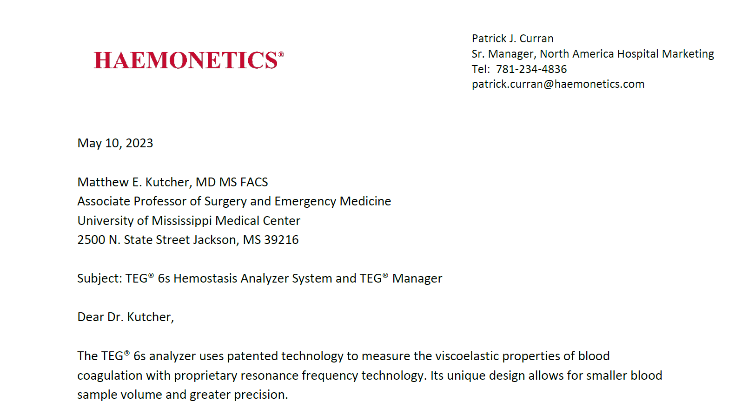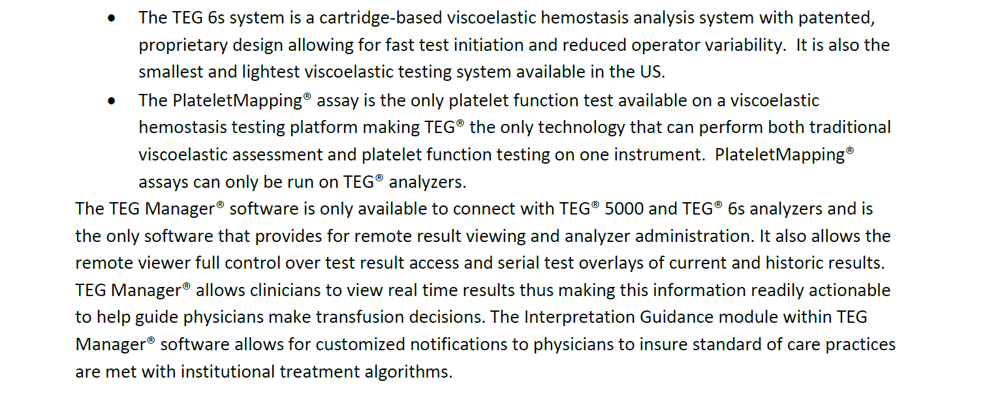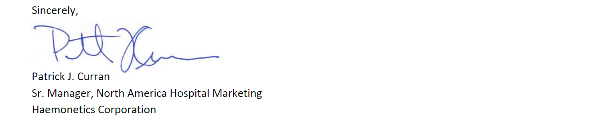

Attachment B

SUBMITTED IN RESPONSE TO
Sole Source Certification No. SS5775
Accepted until July 12, 2023 at 3:00 p.m.

I certify that the information contained in this objection is true and accurate to the best of my knowledge. I understand that UMMC will investigate all statements made in this objection and that any false or misleading information provided may result in adverse action.

__________________________________
Objector Name
Objector’s title

__________________________________
Date

