Notice of Intent to Certify Sole Source

To: Interested Parties

From: Jennifer Douglas
Administrative Director, Category Management and Procurement

Date: June 12, 2023

Re: Sole Source Certification Number SS5780 for Microfluidic Chamber and components

Contact Email Address: solesource@umc.edu

Sole Source Certification Award Details

Regarding UMMC Sole Source Certification Number SS5780 for Microfluidic Chamber and components, please be advised that UMMC intends to award the purchase to Fluxion as the sole source provider.

UMMC issues this notice in accordance with Mississippi state law, policy, and procedures for sole source procurements.

Sole Source Criteria

- Where the compatibility of equipment, accessories, or replacement parts is the paramount consideration (and manufacturer is the sole supplier).
- Where a sole supplier’s item is needed for trial use or testing.
- Where a sole supplier’s item is to be required when no other item will service the needs of UMMC.

Schedule

Task | Date
First Advertisement Date | July 7, 2023
Second Advertisement Date | July 14, 2023
Response Deadline from Objectors | July 21, 2023 at 3:00 p.m. Central Time
Notice of Award/No Award Posted | Not before July 28, 2023

- Describe the commodity that the agency is seeking to procure:

The University of Mississippi Medical Center (UMMC) seeks to purchase one (1) Microfluidic chamber and components. This system assesses platelet aggregation under modifiable flow conditions in a plate well-based in vitro system allowing control of the surface to which platelets bind as well as the media in which platelets circulate.

- An explanation of why the commodity is the only one that can meet the needs of UMMC.

UMMC Department of Vascular Biology and Hematology Core currently owns an inverted microscope which will allow the Microfluidic chamber to perform cellular-level imaging via fluorescence or light microscopy. This is the only device that will integrate with the inverted microscope and allow full control over substrate coating and flow conditions that’s needed. This device is supported by the National Institutes of Health (NIH) in order to advance the vascular and blood-based research needs.

- Explain why the source is the only person or entity that can provide the required commodity:

Fluxion is the sole manufacturer and supplier of this Microfluidic Chamber and components. They are not available from any other distributor. See supporting letter from Fluxion, Attachment A.

- Explain why the amount to be expended for the commodity is reasonable:

The estimated annual amount to be expended for the purchase of the Microfluidic Chamber and components is $22,000.00. This amount is within the expected price range for these products.

- Describe the efforts that the agency went through to obtain the best possible price for the commodity:

Pricing is compared against available market intelligence and identified discounts are pursued where applicable.

Submission Instructions and Format of Response from Objecting Parties

Interested parties who have reason to believe that the Microfluidic Chamber and components, (hereafter, “Products”) should not be certified as a sole source should provide information in the Vendor Form for the State to use in determining whether or not to proceed with awarding the sole source to Fluxion. The Vendor Form may be found at http://www.dfa.state.ms.us/Purchasing/documents/ObjectiontoSoleSourceDetermination.pdf.

Objections must include the certification in Attachment B.

Comments will be accepted at any time prior to July 21, 2023, at 3:00 p.m. (Central Time) to solesource@umc.edu. Responses may be delivered via email to solesource@umc.edu. UMMC WILL NOT BE RESPONSIBLE FOR DELAYS IN THE DELIVERY OF RESPONSES. It is solely the responsibility of the Interested Parties that responses reach UMMC on time. Responses received after the deadline and responses that lack all required information will be rejected. UMMC reserves the right to inspect Interested Party’s commodity for comparison purposes.

If you have any questions concerning the information above or if we can be of further assistance, please contact solesource@umc.edu.

Attachment A: Vendor Correspondence
Attachment B: Objection Certification

Attachment A
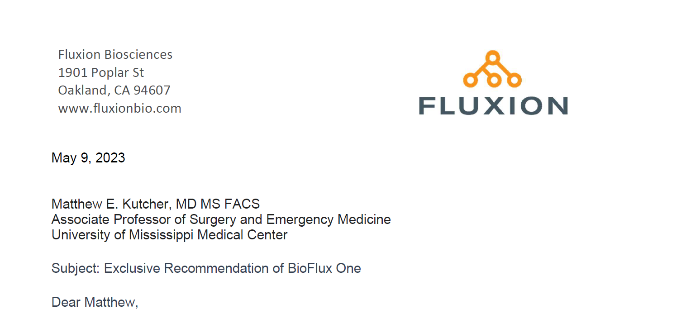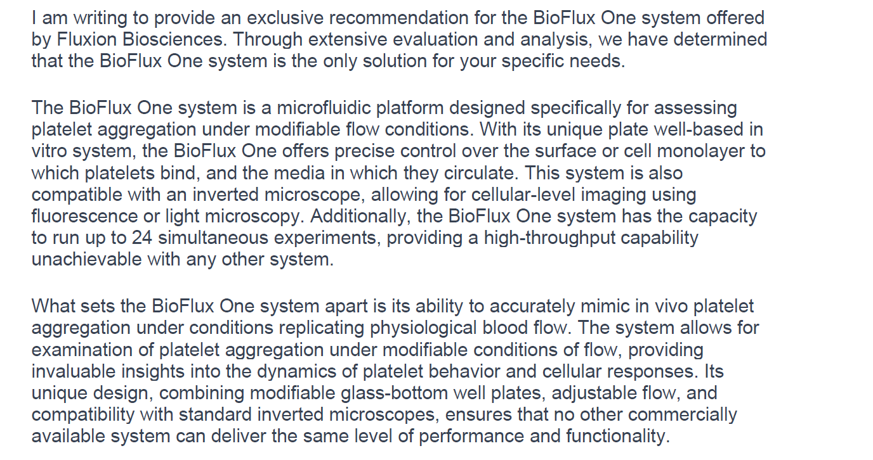
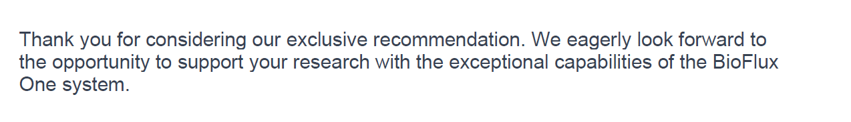
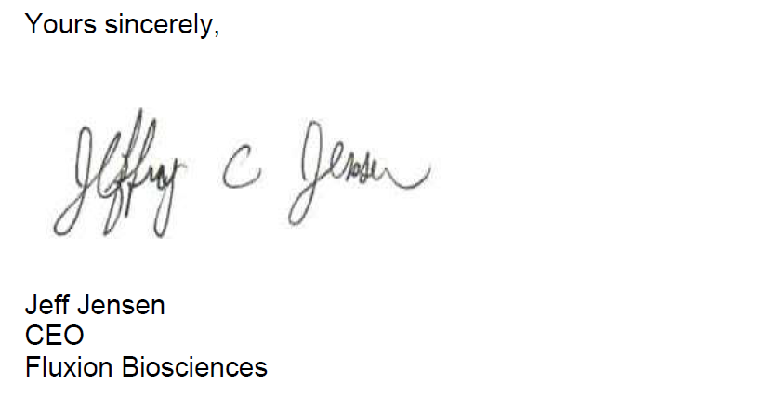
Attachment B

SUBMITTED IN RESPONSE TO
Sole Source Certification No. SS5780
Accepted until July 21, 2023 at 3:00 p.m.

I certify that the information contained in this objection is true and accurate to the best of my knowledge. I understand that UMMC will investigate all statements made in this objection and that any false or misleading information provided may result in adverse action.

__________________________________
Objector Name
Objector’s title

__________________________________
Date

