Notice of Intent to Certify Sole Source

To: Interested Parties

From: Jennifer Douglas
Administrative Director, Category Management and Procurement

Date: February 16, 2024

Re: Sole Source Certification Number SS5845 for Microwave Peptide Synthesizer and all associated components

Contact Email Address: solesource@umc.edu

Sole Source Certification Award Details

Regarding UMMC Sole Source Certification Number SS5845 for Microwave Peptide Synthesizer and all associated components, please be advised that UMMC intends to award the purchase to CEM Corporation as the sole source provider.

UMMC issues this notice in accordance with Mississippi state law, policy, and procedures for sole source procurements.

Sole Source Criteria

- Where the compatibility of equipment, accessories, or replacement parts is the paramount consideration (and manufacturer is the sole supplier).
- Where a sole supplier’s item is needed for trial use or testing.
- Where a sole supplier’s item is to be required when no other item will service the needs of UMMC.

Schedule

Task | Date
First Advertisement Date | February 27, 2024
Second Advertisement Date | March 5, 2024
Response Deadline from Objectors | March 14, 2024 at 3:00 p.m. Central Time
Notice of Award/No Award Posted | Not before March 21, 2024

Project Details

- A description of the commodity that UMMC is seeking to procure.
The Liberty Lite 2.0 system from CEM is an automated microwave peptide synthesizer based on high efficiency solid phase peptide synthesis. The Prodigy Prep-HPLC is a peptide purification HPLC that features automated peptide purification, sectioning, and analytical detection. Together these instruments allow the Mass Spectrometry core at UMMC to synthesize peptide standards for the many projects that utilize the core.

- An explanation of why the commodity is the only one that can meet the needs of UMMC.
The Mass Spectrometry Core at UMMC offers targeted proteomic panels as a service to researchers from many departments at UMMC. Each of these projects require the utilization of an isotopically labeled and an unlabeled peptide standard. The Liberty Lite and Prodigy systems will equip the Mass Spectrometry Core to synthesis these standards in-house removing the current 3-5 week wait times and allows us to build custom peptide libraries at scale for both drug development and analysis of targeted proteomics. The equipment in question utilizes patented microwave driven peptide synthesis instead of conventional thermal based methods. No other instrument combination on the market will match what CEM can do. This increases the output of the instrument leading to more peptides per day. CEM Corporation is the only company that provides turnkey peptide synthesis optimized for our needs. Both the peptide synthesis machinery (Liberty Lite 2.0) and the purification (Prodigy Prep) instruments are designed to work together as an automated system.

- An explanation of why the source is the only person or entity that can provide the required commodity.

The Liberty Lite 2.0 and Prodigy Prep-HPLC are sold and distributed exclusively by CEM Corporation at the address listed above. There are no agents or dealers authorized to represent these products in North America.

- Reference vendor’s sole source letter as Attachment A.

- An explanation of why the amount to be expended for commodity is reasonable.
The estimated amount to be expended is for the purchase of the Liberty Lite 2.0 and Prodigy Prep-HPLC systems is $136,383.51. This amount is within the expected price range for these products.

Submission Instructions and Format of Response from Objecting Parties

Interested parties who have reason to believe that the Imaging Flow Cytometer and all associated components, (hereafter, “Products”) should not be certified as a sole source should provide information in the Vendor Form for the State to use in determining whether or not to proceed with awarding the sole source to CEM Corporation. The Vendor Form may be found at http://www.dfa.state.ms.us/Purchasing/documents/ObjectiontoSoleSourceDetermination.pdf.

Objections must include the certification in Attachment B.

Comments will be accepted at any time prior to March 14, 2024, at 3:00 p.m. (Central Time) to solesource@umc.edu. Responses may be delivered via email to solesource@umc.edu. UMMC WILL NOT BE RESPONSIBLE FOR DELAYS IN THE DELIVERY OF RESPONSES. It is solely the responsibility of the Interested Parties that responses reach UMMC on time. Responses received after the deadline and responses that lack all required information will be rejected. UMMC reserves the right to inspect Interested Party’s commodity for comparison purposes.

If you have any questions concerning the information above or if we can be of further assistance, please contact solesource@umc.edu.

Attachment A: Vendor Correspondence
Attachment B: Objection Certification

Attachment A
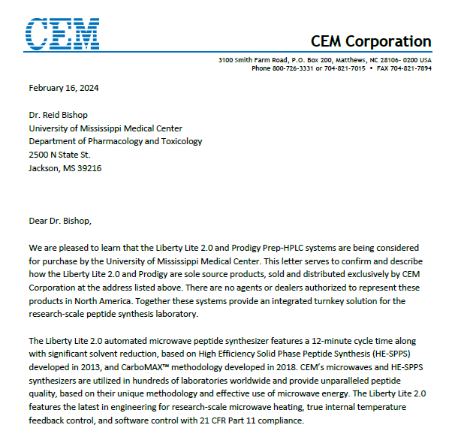

Attachment B

SUBMITTED IN RESPONSE TO
Sole Source Certification No. SS5845
Accepted until March 14, 2024 at 3:00 p.m.

I certify that the information contained in this objection is true and accurate to the best of my knowledge. I understand that UMMC will investigate all statements made in this objection and that any false or misleading information provided may result in adverse action.

__________________________________
Objector Name
Objector’s title

__________________________________
Date

