Notice of Intent to Certify Sole Source

To: Interested Parties

From: Jennifer Douglas
Administrative Director, Category Management and Procurement

Date: February 9, 2024

Re: Sole Source Certification Number SS5846 for Lung Fluid Monitoring System and all associated components

Contact Email Address: solesource@umc.edu

Sole Source Certification Award Details

Regarding UMMC Sole Source Certification Number SS5846 for Lung Fluid Monitoring System and all associated components, please be advised that UMMC intends to award the purchase to Sensible Medical as the sole source provider.

UMMC issues this notice in accordance with Mississippi state law, policy, and procedures for sole source procurements.

Sole Source Criteria

- Where the compatibility of equipment, accessories, or replacement parts is the paramount consideration (and manufacturer is the sole supplier).
- Where a sole supplier’s item is needed for trial use or testing.
- Where a sole supplier’s item is to be required when no other item will service the needs of UMMC.

Schedule

Task | Date
First Advertisement Date | February 20, 2024
Second Advertisement Date | February 27, 2024
Response Deadline from Objectors | March 6, 2024 at 3:00 p.m. Central Time
Notice of Award/No Award Posted | Not before March 13, 2024

Project Details

- Describe the commodity that the agency is seeking to procure:

ReDS is a portable device that uses chest harness that emits/detects radar passed through the patient’s right lung. This device can estimate the density of fluid/edema within a person’s lung which in turn is as surrogate marker of their total body fluid status.

- Explain why the commodity is the only one (1) that can meet the needs of the agency:

This is the only FDA-approved device on the market that uses this technology to detect lung fluid which will be utilized in observational research here at UMMC.

- Explain why the source is the only person or entity that can provide the required commodity:

Sensible Medical is the distributor of this device/technology (i.e. ReDS). As such, it is necessary to obtain the device through them.

- Explain why the amount to be expended for the commodity is reasonable:

The estimated amount to be expended is for the purchase of the ReDS System is $55,000. This amount is within the expected price range for these products.

- Describe the efforts that the agency went through to obtain the best possible price for the commodity:

Through market intelligence, UMMC was able to negotiate best pricing for these products. All applicable discounts were explored and applied.

Submission Instructions and Format of Response from Objecting Parties

Interested parties who have reason to believe that the Lung Fluid Monitoring System and all associated components, (hereafter, “Products”) should not be certified as a sole source should provide information in the Vendor Form for the State to use in determining whether or not to proceed with awarding the sole source to Sensible Medical. The Vendor Form may be found at http://www.dfa.state.ms.us/Purchasing/documents/ObjectiontoSoleSourceDetermination.pdf.

Objections must include the certification in Attachment B.

Comments will be accepted at any time prior to March 6, 2024, at 3:00 p.m. (Central Time) to solesource@umc.edu. Responses may be delivered via email to solesource@umc.edu. UMMC WILL NOT BE RESPONSIBLE FOR DELAYS IN THE DELIVERY OF RESPONSES. It is solely the responsibility of the Interested Parties that responses reach UMMC on time. Responses received after the deadline and responses that lack all required information will be rejected. UMMC reserves the right to inspect Interested Party’s commodity for comparison purposes.

If you have any questions concerning the information above or if we can be of further assistance, please contact solesource@umc.edu.

Attachment A: Vendor Correspondence
Attachment B: Objection Certification

Attachment A

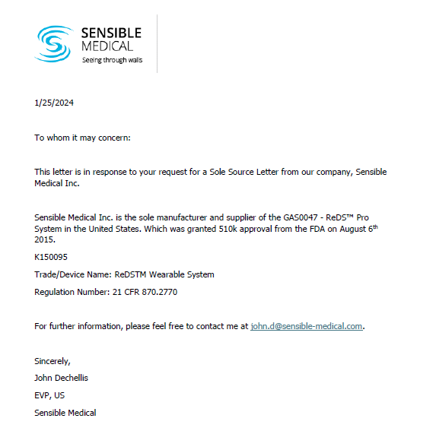

Attachment B

SUBMITTED IN RESPONSE TO
Sole Source Certification No. SS5846
Accepted until March 6, 2024 at 3:00 p.m.

I certify that the information contained in this objection is true and accurate to the best of my knowledge. I understand that UMMC will investigate all statements made in this objection and that any false or misleading information provided may result in adverse action.

__________________________________
Objector Name
Objector’s title

__________________________________
Date

